Workstream 2 — universe: test appendix
breadth-thrust-etf — detailed test designs, defences and full results
Thursday, 2 July 2026 — companion to reviews/2026-07-02_ws2_universe.docx
This appendix details every test run in the Workstream 2 session: the question each test answers, the pre-registered design, the three ways each backtest could have been silently wrong and the defence coded against each, and the full result grids including sub-period Sharpe. Every number in this document is read programmatically from the committed data/ws2_*.json artefacts at build time — there is no manual transcription. Reproduction commands are listed in section 9.

1. Harness and baselines
All tests inherit the WS1 harness (scripts/ws1_common.py) unchanged: fixed evaluation window 2018-11-08 to 2026-06-16, split-half at 2022-09-08, deployed per-sleeve one-way costs (A 2 / B 2 / C 5 / D 9 bps) with a 2x stress on every variant, weekly Friday rebalancing, and the six-regime sub-period grid (the 2026 stub is reported but not counted). The cheap-reflex bar on every candidate: (i) train/test split with the ranking preserved out of sample; (ii) at least 4 of 6 sub-periods not worse than the comparator; (iii) survives 2x cost. The decision number is always the BLEND-level impact at 35/35/10/20.
Deployed baselines were rebuilt at W=200 through the deployed engines and cached (scripts/ws2_common.py). Regression check against the WS1 harness:
Baseline (deployed formulation) | A | B | C | D
Sleeve Sharpe, fixed window | +0.99 | +1.01 | +0.73 | +0.87
Ungated 35/35/10/20 blend Sharpe +1.196 — exact match to the WS1 surface at W=200 (+1.196). Any experiment below that fails this reproduction would have been invalid; none did.

2. Test 1 — candidate panel and ticker verification
Question: are the Workstream 2 candidate tickers real, correctly identified, USD total return, and alive? Sources: (1) yfinance metadata from the fetch; (2) data/ishares_catalogue.csv; (3) BlackRock product pages / aggregator pages for lines absent from the catalogue. Panel: 16 lines fetched from 2003-01-01, adjusted close (dividends folded in).
Ticker | Role | First data | Verification
EWZ | country | 2003-01-02 | yfinance “iShares MSCI Brazil ETF” = catalogue “iShares MSCI Brazil”
EWW | country | 2003-01-02 | yfinance + web: BlackRock/iShares product page 239670 'iShares MSCI Mexico ETF' (ER 0.50%)
EWY | country | 2003-01-02 | yfinance “iShares MSCI South Korea ETF” = catalogue “iShares MSCI South Korea”
INDA | country | 2012-02-03 | yfinance “iShares MSCI India ETF” = catalogue “iShares MSCI India”
EWT | country | 2003-01-02 | yfinance “iShares MSCI Taiwan ETF” = catalogue “iShares MSCI Taiwan”
EWA | country | 2003-01-02 | yfinance “iShares MSCI Australia ETF” = catalogue “iShares MSCI Australia”
EWS | country | 2003-01-02 | yfinance + web: BlackRock/iShares product page 239678 'iShares MSCI Singapore ETF' (ER 0.50%)
EWG | country | 2003-01-02 | yfinance “iShares MSCI Germany ETF” = catalogue “iShares MSCI Germany”
EWU | country | 2003-01-02 | yfinance “iShares MSCI United Kingdom ETF” = catalogue “iShares MSCI United Kingdom”
EWJ | country | 2003-01-02 | yfinance “iShares MSCI Japan ETF” = catalogue “iShares MSCI Japan”
FM | frontier | 2012-09-12 | EXCLUDED — Multiple sources (etf.com, Yahoo profile, investing.com): 'iShares Frontier and Select EM ETF' — fund LIQUIDAT…
EEM | em_broad | 2003-04-14 | yfinance “iShares MSCI Emerging Markets ETF” = catalogue “iShares MSCI Emerging Markets”
IEMG | em_broad | 2012-10-24 | yfinance “iShares Core MSCI Emerging Markets ETF” = catalogue “iShares Core MSCI EM”
EFA | benchmark | 2003-01-02 | yfinance “iShares MSCI EAFE ETF” = catalogue “iShares MSCI EAFE”
SPY | context | 2003-01-02 | yfinance “State Street SPDR S&P 500 ETF Trust” (deployed incumbent)
SHY | cash | 2003-01-02 | yfinance “iShares 1-3 Year Treasury Bond ETF” (deployed incumbent)
FM detail: yfinance returned a stub issuer-level name (“iShares Inc.”), which triggered the web check; multiple sources confirm the iShares Frontier and Select EM ETF completed liquidation in January 2025 (last price in panel 2025-01-08, matching). A dead fund cannot be held through the evaluation window, and its 2023-24 tail reflects wind-down mechanics (Nigeria FX repatriation delays), not index tracking — EXCLUDED from the candidate universe. Survivorship note: the remaining candidates are all live funds today, so any backtest on this panel inherits a mild live-fund bias; this is recorded in the verification artefact.

3. Test 2 — correlation matrix and overlap control
Question: where does the current blend hold the same exposure twice, and which candidates duplicate incumbents? Design: 72 lines — Sleeve A trading proxies, all of B, C via the deployed loader (CNY FX and expense drags applied), D converted EUR→USD with the deployed FX series, plus country/EM and commodity candidates — weekly Friday returns, 397 observations full window and 52 trailing-year, pairwise minimum 52 (full) / 40 (1y) observations.
Three silent-failure modes and defences: (1) FX mismatch — raw EUR series against USD would manufacture fake decorrelation; D is converted with the deployed converter series. (2) Asynchronous closes — European/Asian closes print hours before New York and depress daily correlation; weekly returns absorb most of it (residual noted in the artefact). (3) Short or stale overlap — late-inception names would show noise correlations on few points; pairwise minimums enforce coverage and the one dead candidate was excluded outright.
Adopted rule: cluster at pairwise weekly corr >= 0.8 (full window, connected components); keep most liquid per cluster; reject candidates > 0.9 vs an incumbent unless distinct exposure argued in writing.

3.1 All pairs above 0.90 (full window)
Pair | Corr | Roles (a) | Roles (b) | Reading
EEM / IEMG | 0.998 | B, cand | cand | candidate auto-reject
XLRE / VNQ | 0.990 | A(proxy of IUSP) | B | cross-sleeve or within-B — see verdicts
EFA / VGK | 0.984 | B, cand | B | cross-sleeve or within-B — see verdicts
VGK / EWG | 0.966 | B | cand | candidate auto-reject
DBC / GSG | 0.958 | B, comm(base) | comm | commodity candidate vs incumbent/each other
XLI / PAVE | 0.954 | A(proxy of IUIS) | C | cross-sleeve or within-B — see verdicts
DBE / GSG | 0.948 | comm | comm | commodity candidate vs incumbent/each other
EFA / EWG | 0.946 | B, cand | cand | candidate auto-reject
VGK / EWU | 0.943 | B | cand | candidate auto-reject
DBC / DBE | 0.939 | B, comm(base) | comm | commodity candidate vs incumbent/each other
SPY / QQQ | 0.930 | A(proxy of CSP1), B | A(proxy of CNDX), B | cross-sleeve or within-B — see verdicts
EFA / EWU | 0.930 | B, cand | cand | candidate auto-reject
ICLN / TAN | 0.930 | C | C | within-C — prune tested
IJR / PAVE | 0.924 | A(proxy of IDP6), B | C | cross-sleeve or within-B — see verdicts
TLT / IEF | 0.918 | B | B | cross-sleeve or within-B — see verdicts
GSG / USO | 0.910 | comm | comm | commodity candidate vs incumbent/each other
SPY / XLY | 0.908 | A(proxy of CSP1), B | A(proxy of IUCD) | cross-sleeve or within-B — see verdicts
CIBR / SKYY | 0.901 | C | C | within-C — prune tested

3.2 Clusters at 0.80 and the keep rule
Keep | Cluster members (liquidity-ranked; tiers approximate, catalogue vintage 2026-05)
EFA | EFA, IEMG, EEM, IJR, SPY, QQQ, VGK, VNQ, ITA, XLI, XLB, XLF, XLC, XLY, SOXX, EWJ, EWT, EWY, PAVE, CIBR, ARKK, XBI, XLRE, BOTZ, EWU, EWG, EWA, PHO, SKYY, ARKG, JETS, EXV3, WOOD, MOO, EWS
DBC | DBC, USO, GSG, DBE
SHY | SHY, TLT, IEF
XLV | XLV, IHI
GLD | GLD, GDX
ICLN | ICLN, TAN
LIT | LIT, REMX
The 28-member US-beta cluster is the structural fact of the blend: most DM country candidates (EWT, EWY, EWU, EWG, EWA, EWS) sit INSIDE it, which is independent evidence that a DM-heavy country sleeve would re-buy existing beta.

3.3 Candidate flags and blend look-through
Candidate | Incumbent | Corr
EWG | VGK | 0.966
EWU | VGK | 0.943
IEMG | EEM | 0.998
DBE | DBC | 0.939
GSG | DBC | 0.958

Blend look-through (ungated) | Mean weight | Max weight | Held by A and B jointly
SPY | 4.0% | 10.4% | 43% of weeks
QQQ | 6.8% | 24.1% | 43% of weeks
IJR | 2.1% | 13.7% | 3% of weeks
US-beta cluster (28 blend lines) | 46.8% | 83.5% | —
Trailing-year pairs that are NOT in the full-window list (context only): DBE/USO 0.946, EEM/EWT 0.908, EWT/IEMG 0.908, EEM/EWY 0.906, EWY/IEMG 0.902, IEF/SHY 0.901. Taiwan and Korea have converged onto broad EM — the recent EM trade is a semiconductor trade.
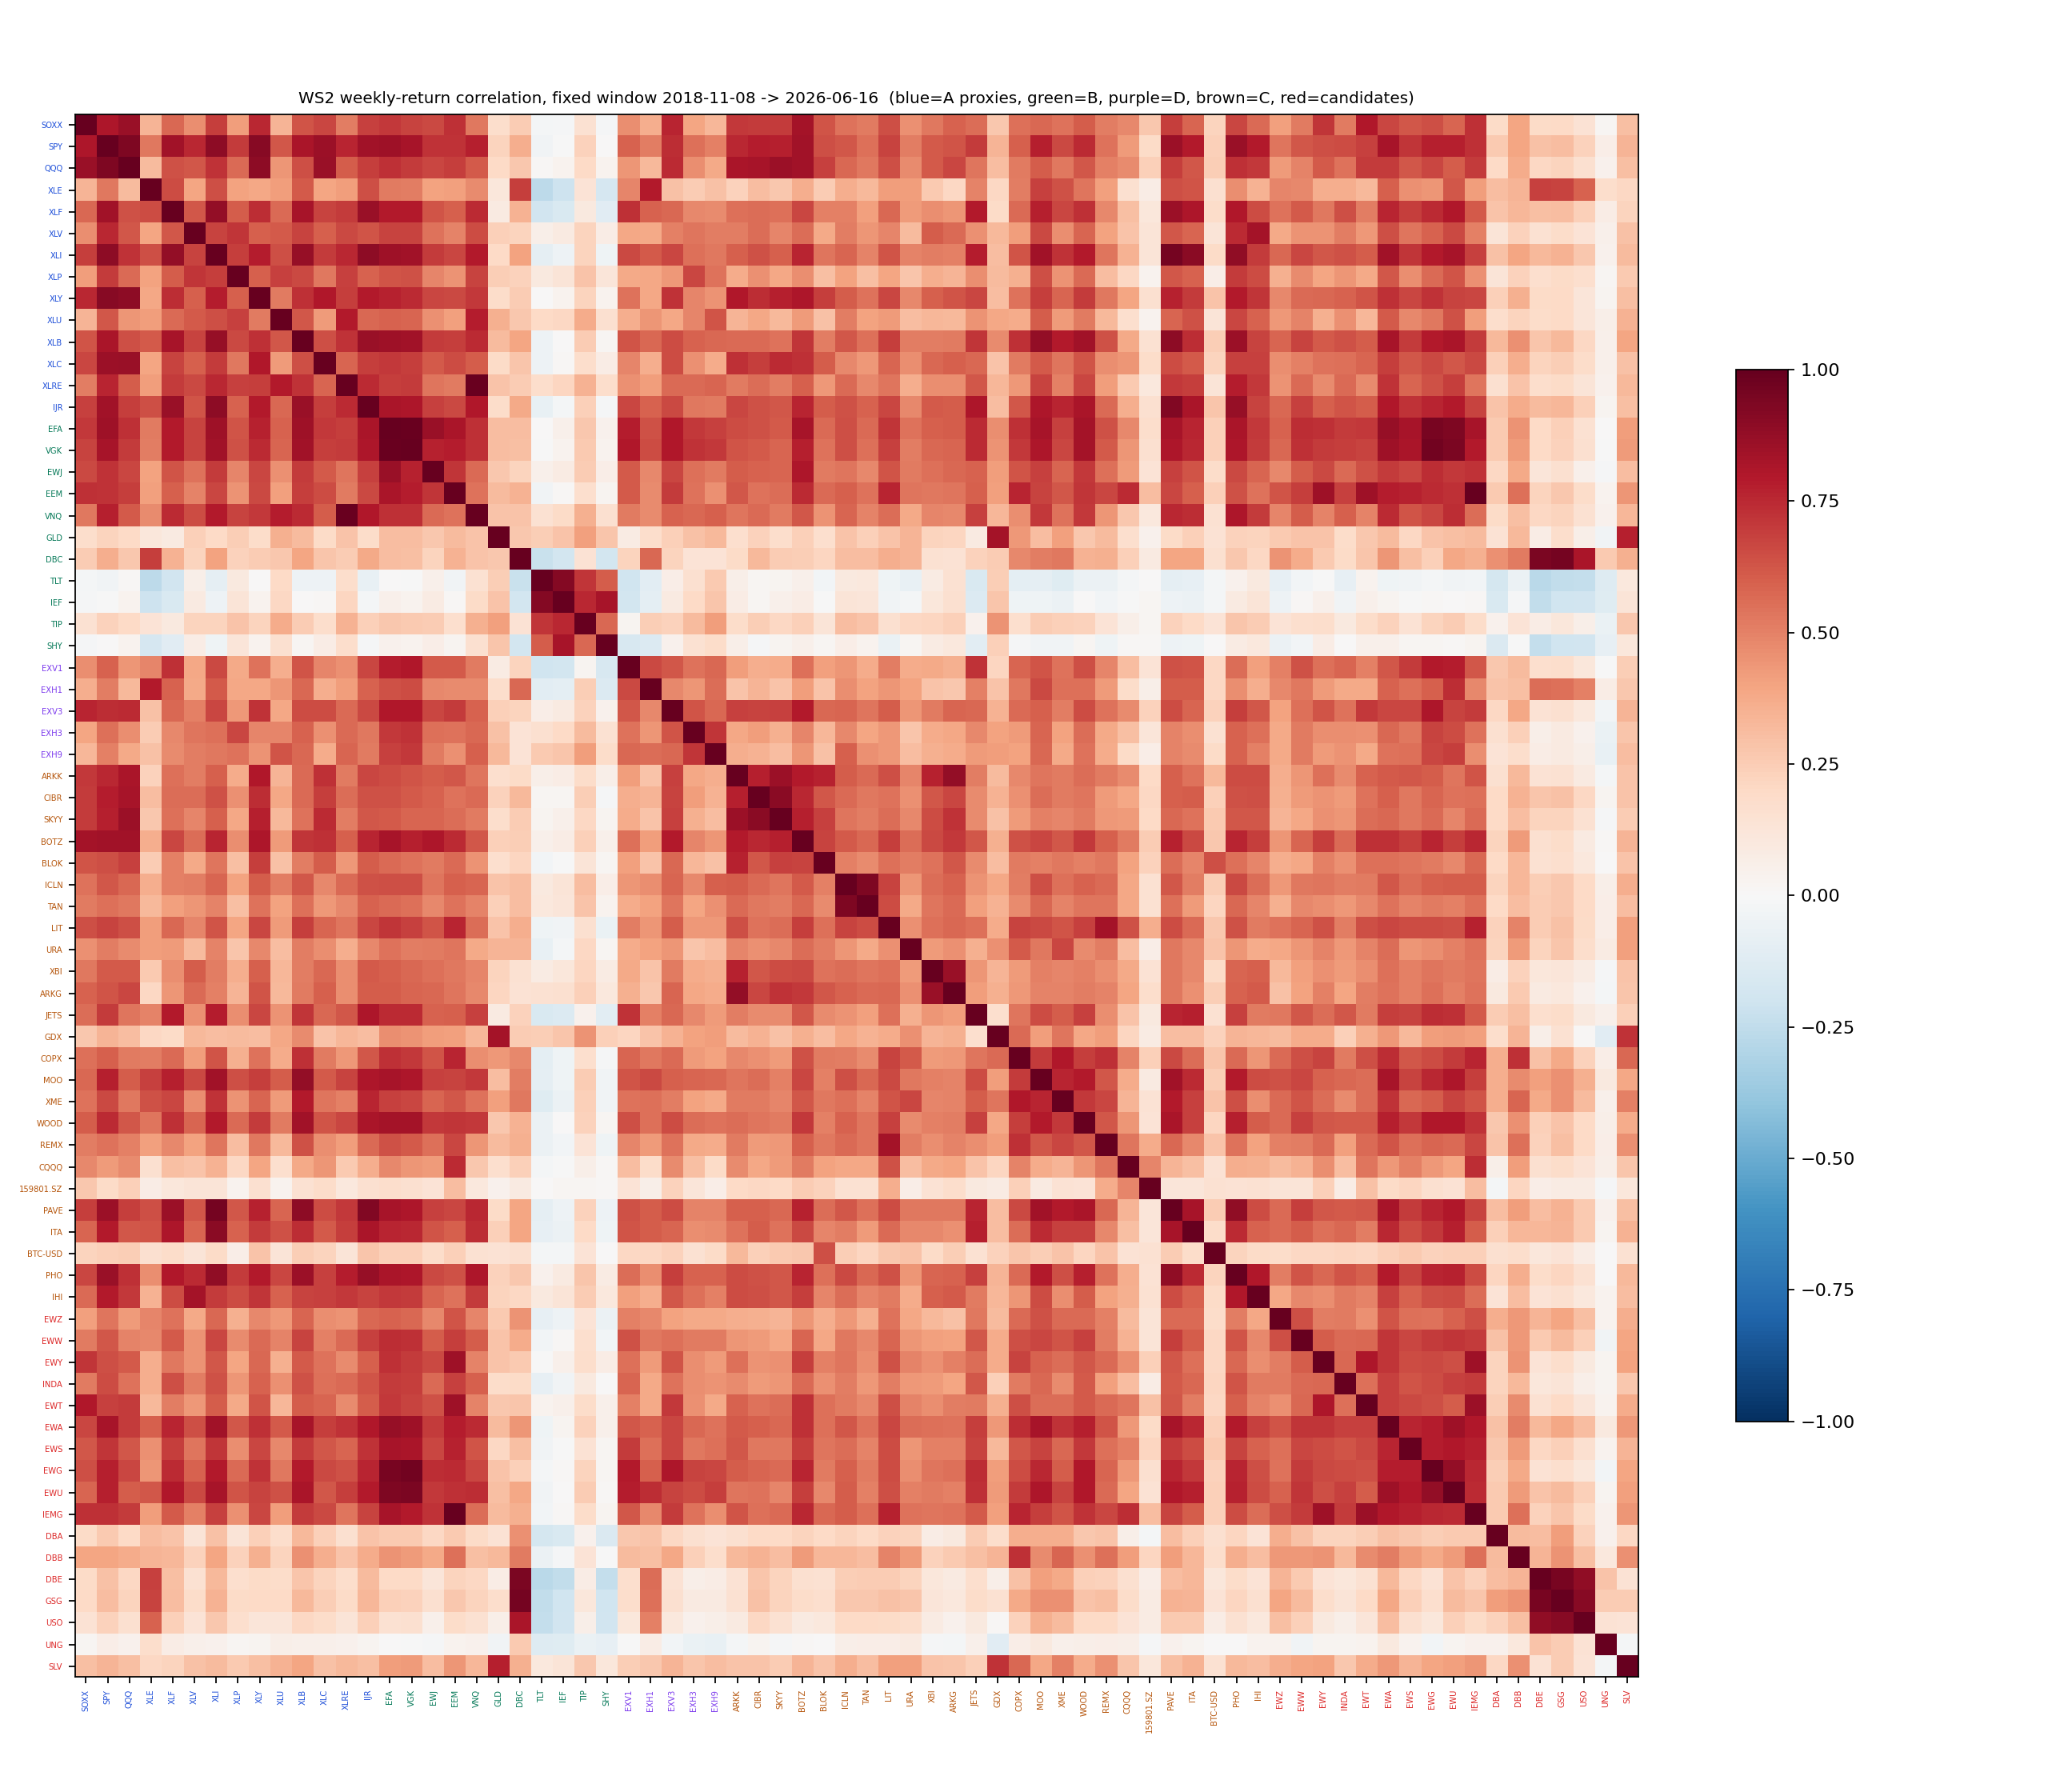
Figure 1 — weekly-return correlation matrix, full fixed window. Full numeric matrix: data/ws2_correlation.json (corr_full).

4. Test 3 — pre-registered within-sleeve prunes
Question: do the within-sleeve >0.9 pairs justify removing incumbents, per the IUIT/CNDX precedent? Exactly two bundles were pre-registered from correlation evidence alone; no other combinations were run. Defences: deployed engines only (look-ahead); column drops cannot change the calendar (window); pruning mechanically reduces turnover so costs cannot flatter the variant. Note: dropping C names changes the Phase 27 gate denominator to 22 — the mechanical consequence, not a re-tune.
Configuration | Full | 2x | Train | Test | Max DD / turn
Deployed B (baseline) | +1.01 | — | +1.01 | +1.01 | -13.3% / —
P1: B drop VGK | +1.01 | +0.99 | +1.05 | +0.98 | -13.2% / 12.1x
Deployed C (baseline) | +0.73 | — | +0.79 | +0.67 | -36.1% / —
P2: C drop TAN,SKYY,PAVE | +0.62 | +0.59 | +0.57 | +0.68 | -40.7% / 18.7x
Sub-period Sharpe (pruned sleeve vs its deployed baseline):
Regime | B deployed | P1 B−VGK | C deployed | P2 C−3
2019 pre-Covid | +1.64 | +1.79 | +0.54 | -0.17
2020 Covid recovery | +0.93 | +0.99 | +1.60 | +1.55
2021 rally | +1.64 | +1.66 | +0.52 | +0.55
2022 inflation shock | -0.61 | -0.64 | -0.94 | -1.30
2023 AI rally | +0.98 | +0.90 | -0.43 | -0.56
2024-25 recent | +1.12 | +1.08 | +1.13 | +1.08
2026 YTD (stub, not counted) | +1.30 | +1.37 | +0.62 | +0.89
Blend-level deltas: P1 +0.004 full / -0.003 test, consistency 3/6; P2 -0.021 full / +0.001 test, consistency 1/6. VERDICTS: P1 REJECT (a wash — a deployed-config change on a wash loses to the incumbent); P2 REJECT (actively harmful — the dropped names carried the train half). Corollary: correlation redundancy alone is not sufficient grounds to remove an incumbent, mirroring the Phase 16 SLV lesson in the other direction.

5. Test 4 — country momentum sleeve
Question: does a top-K country price-momentum basket beat holding EEM+EFA net of cost (the review prompt's bar)? Pre-registered design: the deployed B formulation — graded (close−MA200)/MA200, top-K by signal share among positive names, SHY deficit floor (this IS the own-200d risk gate; no separate vol gate, zero new knobs after WS1 killed vol-normalisation) — on U10 = EWZ EWW EWY INDA EWT EWA EWS EWG EWU EWJ; headline K=3 (Idea 3 / Phase 23 precedent); 5 bps one-way on ALL turnover including cash legs (conservative); U11 (+EEM) and K∈{2,4} reported, not selected. Benchmark: 50/50 EEM+EFA weekly-rebalanced at 2 bps, evaluated on the identical calendar.
Three silent-failure modes and defences: (1) look-ahead — deployed engine, prior-day signal row, weights shifted one day; (2) window inconsistency — one fixed window for every variant AND the benchmark, panel warm since 2003 (asserted ≥9 of 10 signals valid at the first rebalance); (3) cost/TR realism — uniform 5 bps including cash legs overstates cost, 2x stress, adjusted closes carry dividends, benchmark pays its own rebalancing cost.
Configuration | Full | 2x | Train | Test | Max DD | Turn
50/50 EEM+EFA benchmark | +0.60 | — | +0.18 | +1.16 | -33.8% | —
EEM buy-and-hold | +0.54 | — | +0.16 | +1.04 | -39.8% | —
EFA buy-and-hold | +0.61 | — | +0.20 | +1.16 | -33.9% | —
U10 K=2 | +0.74 | +0.70 | +0.03 | +1.30 | -38.6% | 19.8x
U10 K=3 (headline) | +0.70 | +0.65 | -0.04 | +1.27 | -35.3% | 17.3x
U10 K=4 | +0.66 | +0.61 | -0.09 | +1.23 | -31.4% | 17.2x
U11+EEM K=2 | +0.70 | +0.66 | -0.03 | +1.28 | -38.6% | 20.3x
U11+EEM K=3 | +0.66 | +0.61 | -0.10 | +1.25 | -35.3% | 18.3x
U11+EEM K=4 | +0.64 | +0.59 | -0.09 | +1.20 | -31.4% | 17.9x
Sub-period Sharpe, headline vs benchmark:
Regime | Benchmark 50/50 | U10 K=3
2019 pre-Covid | +1.21 | -0.09
2020 Covid recovery | +0.60 | +1.11
2021 rally | +0.29 | +0.32
2022 inflation shock | -0.79 | -2.08
2023 AI rally | +0.95 | +1.06
2024-25 recent | +1.25 | +1.22
2026 YTD (stub, not counted) | +1.52 | +2.62
Decision bar (pre-registered) | Result
Full-window Sharpe ≥ benchmark | PASS
Test-half Sharpe ≥ benchmark | PASS
≥4 of 6 sub-periods ≥ benchmark | FAIL — 3/6
2x cost ≥ benchmark full-window | PASS
Overall | KILL — no blend variant run
Long-window context (2004 start, same configuration) reconciling with the Idea 3 rejection: 2004-2010: sleeve +0.91 vs benchmark +0.50; 2011-2013: sleeve +0.08 vs benchmark +0.23; 2014-2021: sleeve +0.25 vs benchmark +0.37; 2022-now: sleeve +0.74 vs benchmark +0.61. The sleeve wins only in EM-favoured regimes — a regime bet the Phase 22 overlay already expresses at 10% of NAV with 11 switches. Drawdown detail (U10 K=3): worst rolling 12m -31.2%, longest underwater 1114 trading days, 2022 drawdown -33.8% — worse than the benchmark on every one.

6. Test 5 — commodity-spot expansion on the fixed window
Question: does the in-flight thread's proposal (B + DBA/DBB/DBE; C + DBC/DBA/DBB/DBE at 10 bps) survive the WS1 harness standard? Method review of the original run (2026-07-01): engine faithful (validated to 1e-9 against the deployed engine, RE-ASSERTED on the fixed window this session), roll cost correctly inside the ETF NAV; but the inner-join dropna() truncated the C comparison to 2020-11, the headline was MAR on its own windows, and there was no split, sub-period grid or blend view. Its own evidence was already uniformly negative: dMAR negative at every start year 2008-2023 and negative even at ZERO add-cost. Fixed-window re-run (end 2026-06-12, commodity cache bound; baseline re-sliced to the identical end):
Configuration | Full | 2x | Train | Test | Max DD
Deployed B (this window) | +1.00 | — | +1.01 | +1.00 | -13.3%
B + DBA/DBB/DBE | +0.91 | +0.87 | +1.15 | +0.66 | -16.2%
Deployed C (this window) | +0.73 | — | +0.79 | +0.67 | -36.1%
C + DBC/DBA/DBB/DBE | +0.72 | +0.67 | +0.89 | +0.53 | -46.7%
Sub-period Sharpe, widened vs deployed:
Regime | B deployed | B widened | C deployed | C widened
2019 pre-Covid | +1.64 | +1.63 | +0.54 | +0.03
2020 Covid recovery | +0.93 | +1.01 | +1.60 | +2.82
2021 rally | +1.64 | +1.42 | +0.52 | +0.62
2022 inflation shock | -0.61 | +0.50 | -0.94 | -0.96
2023 AI rally | +0.98 | +0.62 | -0.43 | -1.37
2024-25 recent | +1.12 | +0.75 | +1.13 | +1.09
2026 YTD (stub, not counted) | +1.26 | +1.16 | +0.58 | +0.74
Blend variant | dFull | dTest | Consistency vs baseline
B widened | -0.007 | -0.095 | 3/6
C widened | +0.005 | -0.016 | 3/6
both widened | -0.008 | -0.124 | 2/6
VERDICT: KILL at sleeve and blend level. The widened B's improvement is train-half-only (+1.15 train vs +0.66 test) — a backward-looking bet on the 2021-22 commodity bull, the exact in-sample-only pattern the cheap reflex screens for. The correlation matrix independently shows the adds are mostly duplicate beta (DBE/GSG 0.94-0.96 to incumbent DBC) with wider spreads. GLD + DBC remain Sleeve B's commodity expression.

7. Test 6 — EEM coherence (2x2 ablation)
Question: EEM sits in Sleeve B AND in the Phase 22 overlay — which single role should it have? Design: 2x2 ablation on the fixed window, ungated decision numbers; the Phase 22 tilt reimplemented faithfully (EEM/SPY 50/200 golden cross, 10pp funded from B, 5 bps per flip, state shifted one day); B re-run without EEM through the deployed engine (2 bps + 2x). The Phase 19 gate applied afterwards as context — the gate reimplementation VALIDATED by reproducing the committed gated Sharpe (+1.286 vs +1.287). The third prompt option (decompose EM into a country sleeve) was killed in Test 4, so no fifth cell exists.
Cell | Full | Train | Test | Max DD | Gated | vs V0
V0 status quo | +1.202 | +0.920 | +1.540 | -23.6% | +1.279 | 6/6
V1 overlay-only | +1.210 | +0.933 | +1.544 | -23.6% | +1.289 | 5/6
V2 B-member-only | +1.201 | +0.947 | +1.509 | -23.6% | +1.286 | 4/6
V3 neither | +1.207 | +0.964 | +1.506 | -23.6% | +1.295 | 3/6
Sub-period Sharpe per cell:
Regime | V0 | V1 | V2 | V3
2019 pre-Covid | +2.05 | +2.14 | +2.17 | +2.27
2020 Covid recovery | +1.03 | +1.02 | +1.03 | +1.02
2021 rally | +1.36 | +1.38 | +1.42 | +1.45
2022 inflation shock | -0.10 | -0.10 | -0.10 | -0.10
2023 AI rally | +0.88 | +0.88 | +0.92 | +0.93
2024-25 recent | +1.71 | +1.72 | +1.66 | +1.67
2026 YTD (stub, not counted) | +2.39 | +2.37 | +2.32 | +2.28
Sleeve B without EEM (deployed engine): full +1.02 (2x +1.00), train +1.07, test +0.98, max DD -13.2% — B does not need EEM (deployed B +1.01).
Double-count quantification under V0: mean look-through EEM 4.5% of NAV, peak 15.0%; tilt ON 29% of days; B held EEM on 45% of days; BOTH held it simultaneously on 26% of days; 11 tilt switches ever.
DECISION: adopt V1 (overlay-only). All four cells sit within 0.009 full-window Sharpe — inside noise — so the choice is architectural: V1 ends the double-count, is weakly dominant ungated (best full and test, 5/6 consistency vs V0), leaves B no worse, and preserves the Phase 22 EM-turn expression whose walk-forward validation is on file. Choosing V3 on its +0.006 gated edge would be sequential tuning on noise. The tilt's own keep/kill (11 switches — few distinct bets) is reserved for the Workstream 3 overlay audit.

8. Trend map and factor check
The factor-gap claim was computed, not assumed: weekly correlation to SPY on the fixed window — QUAL +0.985 (auto-reject under the >0.9 rule), USMV +0.896, MTUM +0.889, VLUE +0.892 (ON the flag boundary). A factor sleeve is therefore marginal by construction and would add a factor-timing degree of freedom with a weak prior; deferred behind a written distinct-exposure bar. Remaining gaps: frontier (uninvestable, FM dead), non-US rates (no clean USD-listed vehicle set; low priority), ex-US DM sectors beyond D's five (point-in-time constituent cost; deferred), credit (deliberate, HYG removal documented).
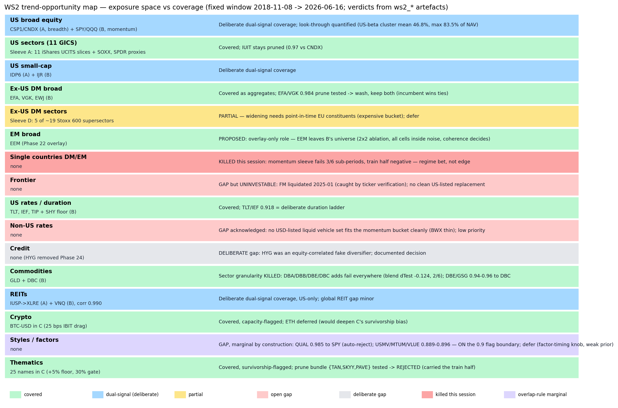
Figure 2 — trend-opportunity map with per-bucket verdicts and artefact basis.

9. Trial register detail and reproduction
Counting convention (as WS1): each evaluated configuration counts once; 2x cost is a stress report of the same configuration; benchmarks count; correlation/look-through/trend-map are descriptive (zero trials); diagnostic sub-baskets used only to measure correlation between two sub-portfolios are excluded by convention.
Group | Configurations | Count
Country sleeve | U10 K2/K3/K4; U11 K2/K3/K4; 50/50 EEM+EFA benchmark | 7
Commodity re-run | B widened; C widened; blend B / C / both | 5
Commodity thread (retro-logged, 2026-07-01) | B widened; C widened; 7 narrow-B subsets (DBE; DBB; DBA; DBE+DBB; DBA+DBB+DBE; +GSG; +USO+UNG); 2 diversification sub-sleeves | 11
Prunes | P1 sleeve + blend; P2 sleeve + blend | 4
EEM coherence | V0-V3 blend cells; B without EEM | 5
Session total |  | 32
Cumulative (WS1 ~139 + WS2 32) |  | ~171
Reproduction (from the repository root; the fetch needs network, everything else runs offline from committed caches):
- python scripts/run_ws2_fetch_panel.py — candidate panel + verification JSON
- python scripts/ws2_common.py — baseline cache (add --force to rebuild); asserts blend +1.196
- python scripts/run_ws2_correlation.py — matrix, clusters, look-through, Figure 1
- python scripts/run_ws2_country_sleeve.py — Test 4
- python scripts/run_ws2_commodity_fixed.py — Test 5
- python scripts/run_ws2_prune_tests.py — Test 3
- python scripts/run_ws2_eem_coherence.py — Test 6
- python scripts/run_ws2_trend_map.py — Figure 2

Personal research artefact. All performance figures are simulated backtests in USD, net of stated costs; nothing in this document is investment advice.

