WS6 — Single-name implementation of Sleeve A
Technical findings record — verdict KEEP-ETF
Sunday, 19 July 2026

Project / context | breadth-thrust-etf — Personal. Navigo explicitly out of scope (personal-use data licences cannot be load-bearing in a CMS process).
Review scope | WS6: can Sleeve A ETF positions be expressed as constituent baskets without degrading the evidence base (Design 1, trend-screened replication), and does within-sector top-N selection add anything beyond a momentum placebo (Design 2, WS5 bar)?
Evaluation window | 2018-10 to 2026-06; 1,937 trading days (split halves 983 / 954); 389 weekly W-FRI rebalances; sector layer frozen at deployed Phase 20.1 K=7 so arms differ only in expression.
Data basis | Membership: own point-in-time iShares snapshots (weekly, 2018 onward) with A3 true weights (4,836 snapshot files, all parsed from local raw cache, zero network). Prices: Norgate Platinum including delisted instruments; (ticker, date) resolved to instrument via A1/A2 layer.
Method basis | Pre-registered 8-arm register, BINDING kickoff signed 2026-07-17; three amendments (A1, A2, A3) logged pre-results under gate STOPs with zero register arms computed; full-vector name-level costs, sweep {2, 5, 10, 20} bps, 2x binding.
Repository commits | Engine chain b12d0f9, 54f0f14 (A1), dbb6543 (A2), 61359de (A3); gate reports 24aa6d0, 05561d6, 998df92; register COMPLETE 320a4bc; kickoff amendments in vault (46d41f7 latest).
Running memo | RESEARCH_MEMO.md, section "Workstream 6" (2026-07-19).
Outcome | VERDICT KEEP-ETF — both adoption designs fail their pre-registered bars; zero deployed changes.

Executive summary
- VERDICT KEEP-ETF. Design 1 (screened replication, I1) fails three of four frozen ADOPT-D1 bars: net Sharpe drag 0.083 at 5 bps (bar 0.05), 0.137 at 2x (bar 0.10), screen-drag 0.062 versus the unscreened control (bar 0.03). Design 2 (top-10 strength, I2) beats its momentum placebo by +0.003 against a +0.10 bar and sits below the unscreened basket outright.
- The binding cost is the trend screen, not single-naming. The unscreened true-weight control (I0) tracks the deployed sleeve within every numeric fidelity bar it can be read against: drag 0.022 at 5 bps and 0.068 at 2x, weekly correlation 0.996, tracking error 1.6 per cent, turnover 1.04x. It was a frozen control, not a registered adoptable arm, and is not promoted post hoc.
- The screen buys what it advertises — lowest drawdown among baskets (28.0 versus 30.6 per cent) — at a Sharpe price double its allowance. Split-half confirms the drag in both halves (-0.084 / -0.041).
- Selection is momentum in behaviour if not in name: I2-versus-P2 selection Jaccard 0.678 (formally under the 0.8 disguise bar) but weekly return correlation 0.988. The WS5 verdict transfers to the implementation layer.
- Evidence integrity: the coverage gate stopped the study twice (68 then 6 failing line-year cells) before any result was computed; both stops were cleared by completing the data layer at an unchanged 97 per cent bar (worst final cell 0.9963). The replication gate then rejected equal-weight baskets (IUCD 0.919, IUCM 0.947) and was cleared by true-weight baskets at an unchanged 0.95 bar. All bars survived the study untouched.

Verified architecture
The register harness (scripts/run_ws6_single_name.py) drives the engine (scripts/single_name_impl.py) over the deployed sector layer: Phase 20.1 sector-relative breadth, K=7, weekly W-FRI, signals read at t-1 exactly as deployed. Every arm holds the same sector positions; arms differ only in how a held sector line is expressed. E0 holds the ETF (deployed 2-9 bps cost model). Basket arms hold constituents priced on Norgate instruments resolved per membership date (A1 delisted-suffix candidates and life-interval disambiguation; A2 base-ticker tenure rule for recycled tickers plus verified rename table, every entry NDU-verified and commented). Baskets weight the top-M=15 cap-rank pool by true snapshot weight renormalised over resolved members (A3); screened arms renormalise surviving weights; a line with fewer than three passing names falls back to the ETF for that week (12 of 2,096 line-weeks on I1; 1 on every other screened arm). Costs are charged on the full name-level weight vector, so sector rotation, screen churn and membership churn all pay.

Findings

F1 — Gate chain: two coverage stops, one replication stop, bars unchanged
The study STOP-ed three times before the register ran, each stop logged as a kickoff amendment with zero results computed. The full machine-readable history is embedded in data/ws6_results.json (gate_history).
Run | G1 coverage (97% bar) | G2 replication (0.95 bar) | Resolution
1 | STOP — 68 line-year cells fail; worst IUCM 2018 = 0.577; coverage rising toward recent years (survivorship signature) | not reached | A1: (ticker, date) to Norgate instrument — delisted -YYYYMM suffixes, life-interval rule, verified rename table (54f0f14)
2 | STOP — 6 cells fail (IUSP 2018-2022, IUCM 2018 = 0.923) | not reached | A2: base-ticker tenure rule for recycled bases (HR, DOC, RPT, COR) + rename-at-death completions incl. OPI to OPITQ (dbb6543)
3 | PASS in full; worst cell 0.9963 | STOP — IUCD 0.9193, IUCM 0.9468; equal weight misprices mega-cap-concentrated heterogeneous lines | A3: true-weight baskets; Step-0 weights stage, all 4,836 snapshots from local cache (61359de); ZH sign-off 2026-07-19
4 | PASS; worst 0.9963 | PASS all 11 lines: 0.9588 (IUSP) to 0.9985 (IUES) | Register run once; status COMPLETE (320a4bc)

Every gate was cleared by completing the data or design layer at the unchanged bar — never by lowering it. The equal-weight rejection at run 3 is itself a finding: an equal-weight top-15 basket is not a faithful stand-in for a cap-weighted sector ETF where mega-cap concentration meets low intra-sector co-movement (IUCD, IUCM); semiconductors pass at 0.992 despite concentration because the names co-move.

F2 — The register: eight arms across the cost sweep
Net Sharpe at the pre-registered basis (5 bps one-way per unit weight change; 2x = 10 bps binding). E0 keeps the deployed 2-9 bps ETF cost model and is constant across the sweep. MaxDD, correlation, tracking error and turnover at 5 bps.
Arm | Sharpe @5 | Sharpe @2x | MaxDD | corr vs E0 | TE ann | turnover xE0
E0 deployed ETF baseline | 1.005 | 1.005 | 30.6% | 1.000 | 0.0% | 1.00
I0 unscreened replication (control) | 0.983 | 0.937 | 30.3% | 0.996 | 1.6% | 1.04
I1 screened replication (Design 1) | 0.921 | 0.868 | 28.0% | 0.985 | 3.2% | 1.20
I1-all no top-M cap (report-only) | 0.928 | 0.876 | 26.8% | 0.985 | 3.2% | 1.15
I2 top-10 strength (Design 2) | 0.885 | 0.814 | 27.8% | 0.948 | 6.1% | 1.79
P2 top-10 momentum placebo | 0.882 | 0.810 | 28.8% | 0.953 | 5.9% | 1.81
I2-N15 top-15 strength (report-only) | 0.961 | 0.897 | 27.2% | 0.965 | 4.9% | 1.55
P2-N15 top-15 placebo (report-only) | 0.929 | 0.863 | 27.9% | 0.965 | 5.0% | 1.60

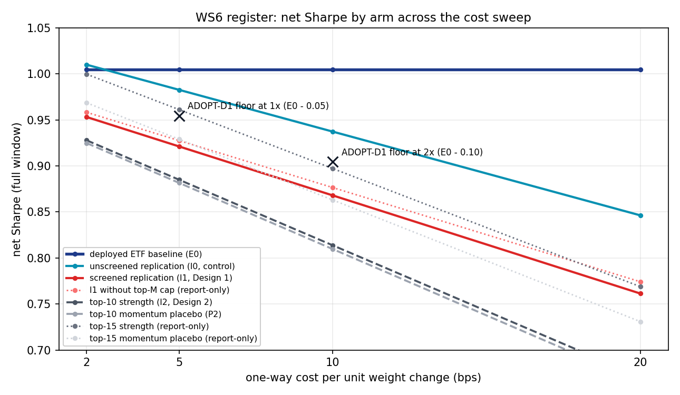
Net Sharpe by arm as the one-way cost assumption rises from 2 to 20 bps. The two crosses mark the pre-registered ADOPT-D1 floors (E0 minus 0.05 at 5 bps; E0 minus 0.10 at 10 bps). Only the unscreened control (teal) stays above both floors; the deployable Design 1 arm (red) sits below both; the selection arms (grey, dashed) rank lowest and decay fastest because they turn over 1.8 times the baseline. E0 (navy) is flat because it keeps the deployed ETF cost model.

F3 — Design 1 against the frozen ADOPT-D1 bars
Bar | Threshold | I1 value | Outcome
Net Sharpe at 5 bps >= E0 - 0.05 | 0.955 | 0.921 | FAIL
Net Sharpe at 2x >= E0 - 0.10 | 0.905 | 0.868 | FAIL
MaxDD <= E0 + 2pp | 32.6% | 28.0% | PASS
Weekly correlation vs E0 >= 0.95 | 0.950 | 0.985 | PASS
Screen-drag: I1 >= I0 - 0.03 | 0.953 | 0.921 | FAIL

The decomposition is the finding. Single-naming itself costs little: I0 gives up 0.022 Sharpe at 5 bps and 0.068 at 2x, inside both floors, with correlation 0.996 and tracking error 1.6 per cent. The trend screen then subtracts a further 0.062 — double its 0.03 allowance — in exchange for 2.2pp less drawdown. The screen, not the basket, fails Design 1. Split-half places the screen drag in both halves (-0.084 first, -0.041 second), so it is not a single-regime artefact: excluding below-trend names systematically misses their recoveries in a universe where held sectors are, by construction of the sleeve signal, already trending.

F4 — Design 2 against the frozen ADOPT-D2 bars
ADOPT-D2 requires I2 to clear every D1 bar against E0, beat BOTH I1 and the momentum placebo P2 by at least +0.10 net Sharpe, survive 2x costs, and differ from the placebo in selection (Jaccard below 0.8).
Test | Requirement | I2 outcome | Verdict
D1 bars vs E0 | all four | Sharpe 0.885 (floor 0.955); corr 0.948 (floor 0.95) | FAIL
Margin over placebo P2 | +0.10 | +0.003 | FAIL
Margin over I1 | +0.10 | -0.036 | FAIL
Selection Jaccard vs P2 < 0.8 | < 0.8 | 0.678 | PASS
MaxDD <= I1 + 2pp | 30.0% | 27.8% | PASS

The Jaccard pass is cosmetic: the two arms pick different names 32 per cent of the time yet produce weekly returns correlated at 0.988 — different labels on the same portfolio behaviour. The report-only N15 variant beats its placebo by +0.032, one third of the bar. This is the WS5 result reproduced at the implementation layer: per-name trend strength in an already-trending sector is momentum plus noise, and neither earns a seat.

F5 — Consistency and disclosure
Arm | First-half Sharpe | Second-half Sharpe
E0 | 0.767 | 1.352
I0 | 0.709 | 1.380
I1 | 0.625 | 1.339
I1-all | 0.659 | 1.311
I2 | 0.550 | 1.309
P2 | 0.584 | 1.260
I2-N15 | 0.634 | 1.400
P2-N15 | 0.612 | 1.350

Cross-arm ordering is preserved in both halves; every arm is stronger in the second half (shared window effect, as in prior workstreams). Worst single-name weeks, reported as sleeve-level contribution: I1 — ABBV 2020-03-20 at -3.07 per cent, XOM 2022-06-17 at -1.77 per cent, XOM 2023-10-06 at -1.60 per cent; I2 — XOM 2022-06-17 at -2.95 per cent, TSLA 2021-02-26 at -1.86 per cent, XOM 2022-09-23 at -1.85 per cent. This is the concentration tail single-naming introduces and the ETF never shows; the screen does reduce it (lowest MaxDD of the baskets) at the Sharpe price quantified in F3. Costs are a judgement estimate (5 bps one-way per unit weight change for large-cap US names, flagged uncertain in the kickoff); the 2x binding point exists precisely because of that uncertainty.

Decisions
Component | Decision | Basis
Sleeve A ETF expression (E0) | KEEP | Both alternatives fail pre-registered bars (F3, F4); zero deployed changes.
Design 1 — screened replication (I1) | REJECT | Fails D1 bars 1, 2 and 4; screen-drag 0.062 vs 0.03 allowance (F3).
Design 2 — top-N selection (I2) | REJECT | Fails every margin; +0.003 over placebo vs +0.10 bar; return correlation with placebo 0.988 (F4).
I0 — unscreened replication (control) | FLAGGED | Passes all numeric fidelity bars (F3) but was not a registered adoptable arm; any revisit requires a new one-arm pre-registration carrying an explicit seen-data caveat, ops and corporate-actions scoping, and staged parallel-run after the 2026-08-07 Norgate soak closes.
A1/A2 instrument-resolution layer | KEEP | Coverage 68 failing cells to zero at an unchanged 97 per cent bar; every rename and tenure entry NDU-verified and commented; reusable for any future constituent study.
A3 true-weight basket stage | KEEP | Cleared G2 at the unchanged bar (IUCD 0.919 to 0.962, IUCM 0.947 to 0.973); complete validated weights table now a standing data asset.

Trial register
Eight pre-registered arms evaluated across four cost points (32 cells), register run exactly once, no post-hoc selection among arms — the verdict rule was frozen before any result was computed. The three amendments were data- and design-layer responses to gate STOPs, each logged with zero register arms run. No parameter was searched: the screen state (close above SMA200), strength rank (close/SMA200 - 1), N in {10, 15 report-only}, M=15 and all bars were fixed at kickoff. Two coverage-gate re-tests and one replication-gate re-test were consumed by the amendment chain; a deflated-Sharpe haircut therefore charges 32 reported cells and zero searched configurations.

Artefact register
- data/ws6_results.json — COMPLETE register, gates, four-run gate history, disclosure tables (committed 320a4bc).
- scripts/single_name_impl.py + tests/test_single_name_impl.py — engine and 33 selftests; resolution layer A1/A2; true-weight baskets A3 (chain b12d0f9, 54f0f14, dbb6543, 61359de).
- scripts/run_ws6_single_name.py — register harness with FAIL_STOP gates (ENGINE_COMMIT 61359de).
- scripts/fetch_ws6_weights.py — Step-0 weights stage (cache-first, validated; zero network on the filed run).
- scripts/plot_ws6_register.py + reviews/charts/ws6_register_cost_sweep.png — record chart, reproducible from the committed results file.
- RESEARCH_MEMO.md — Workstream 6 section (2026-07-19).
- C:/dev/KICKOFF_ws6-single-name-implementation.md — BINDING pre-registration; amendments A1/A2/A3 in section 5b (vault 46d41f7).
- Gate reports: commits 24aa6d0 (run 1), 05561d6 (run 2), 998df92 (run 3).

Next phase
None for WS6 — the workstream is closed with zero deployed changes. Optional successor, at owner discretion: a one-arm pre-registration of unscreened true-weight replication (I0-as-deployable) motivated by book structure rather than alpha, carrying the seen-data caveat stated in Decisions, an ops and corporate-actions workload assessment, and a staged parallel-run gate behind the 2026-08-07 Norgate soak review. Separately, WS7 (Sleeve C seat review) remains pre-registered for 2026-10-02.

Prepared by | Claude (Fable 5) — T4 verdict application per kickoff plan table
Reviewed and approved by | Zhenghao Phua — pending
Date | 2026-07-19 (Sunday)
Next review | None — workstream closed. Successor study optional per Next phase.

Personal research artefact. Not investment advice, not affiliated with any regulated fund or licensed activity. All figures are simulated net of stylised costs; the 5 bps constituent cost basis is a judgement estimate flagged uncertain in the pre-registration.

