Did we tune this strategy to the past?
A plain-language summary of the settings review of the four-book ETF rotation strategy
Thursday, 2 July 2026 · companion to the technical review record

The question | This strategy was built by trial and error on 2018-2026 market data. The danger with any backtest is settings that fit the past but fail in the future. This review stress-tested every important setting to see whether any of them is a lucky number.
The answer | No setting was changed, for a good reason: every setting sits in a broad stable range, and every 'smarter' alternative we tested performed worse on data the models had never seen. Around 139 tests were run and logged.
How it was tested | Fixed 7.6-year window (November 2018 to June 2026), realistic trading costs (also re-tested at double costs), and history split in half — nothing was tuned to the period after September 2022, so results there are the closest a backtest gets to an honest exam.

The strategy in plain terms
The portfolio runs four rotation books side by side. Each holds the strongest funds in its universe and reviews its holdings weekly:
- US sectors (35%) — sector funds ranked by how many of their member stocks are in an uptrend.
- Global asset classes (35%) — equities, bonds, gold, commodities and property funds ranked by price trend; parks in short-term Treasuries when trends are weak.
- Thematics (10%) — AI, clean energy, biotech, bitcoin and similar funds; the same trend ranking with an extra entry hurdle and its own exit brake.
- European sectors (20%) — ranked like the US sector book.
Two safety mechanisms sit on top: a market-breadth brake that moves half the portfolio into short-term Treasuries when most S&P 500 stocks have broken down, and an emerging-markets tilt that adds exposure when emerging markets are trending ahead of the US.
Every book defines ‘trend’ the same way: is the price above its average of the last 200 trading days — roughly ten months? That one number, and the trigger levels of the safety mechanisms, are what this review examined.

Five findings
1. The ten-month trend measure is the right speed, and it is not a lucky number.
We re-ran the entire strategy at thirteen trend speeds, from one month to fifteen months, on identical data and costs. Fast settings were clearly worse — they were whipsawed in the choppy 2022 market. Everything from ten months upward performed within a hair’s breadth of everything else. The chart below is the whole story.
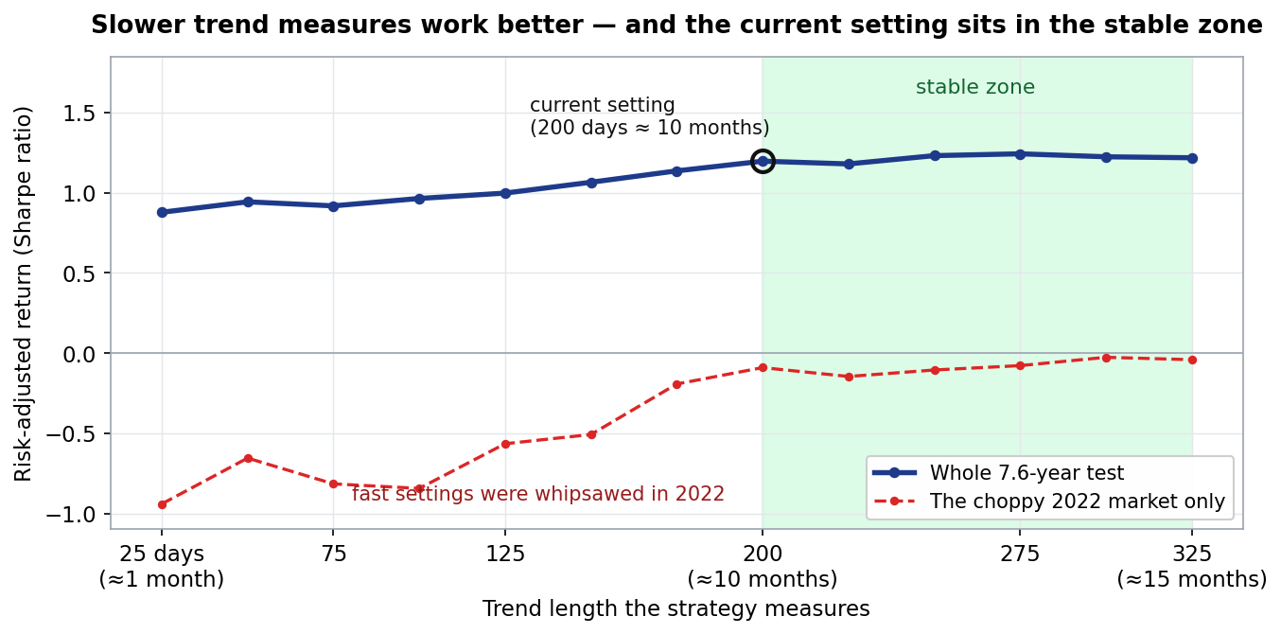
How to read this: ‘risk-adjusted return’ is the Sharpe ratio — yearly return divided by yearly volatility; higher is better, and on 7.6 years of data differences smaller than about 0.4 are statistical noise. The current setting is circled; the shaded zone is where results are all within noise of the best.
2. Leaving the setting alone beats re-tuning it.
We simulated a manager who re-tunes the trend speed every January using only information available at the time. That manager finished behind the one who never touched it (risk-adjusted return 1.17 versus 1.18; re-tuning each book separately was worse still at 1.11). With hindsight, a slightly slower setting would have scored 1.23 — but no honest, real-time process captures that. The practical lesson for allocators: in this strategy, discipline beats optimisation.
3. More sophisticated signal mathematics made results worse, not better.
Sixteen of seventeen ‘smarter’ variants — adjusting signals for volatility, blending several trend speeds — reduced returns on the held-out half of history. Applied across the whole portfolio they would have cut the risk-adjusted return from 1.20 to 0.89. The simple version of the signal is the strong version.
4. The safety brake is robust, not lucky — a long-standing caveat is retired.
The brake’s trigger levels were originally chosen from a small search, which fairly raised the question of overfitting. We tested all 25 sensible trigger combinations: every single one improved both returns and the worst peak-to-trough loss versus running without the brake (roughly −16% with it, −24% without). The chosen levels sit in the middle of that safe range. The brake works because of what it does, not because of the numbers picked.
5. The thematic book is the weakest link; one tempting simplification was examined and declined.
Removing the thematic book’s +5% entry hurdle would have improved returns on unseen data but deepened that book’s worst loss from −36% to −48%, all of it in the 2022 downturn. Return said yes; risk said no. The hurdle stays, and the final stage of the review subsequently kept it and placed the thematic book on formal watch.

What an allocator should take away
- The engine settings are stable: nowhere does performance depend on a finely-tuned number, and the review actively tried to find one.
- Every attempt to improve the strategy by being cleverer — re-tuning, volatility adjustment, signal blending — failed on unseen data. The deployed version earned its simplicity.
- The honest remaining risks are not settings: the thematic book is the weakest component (now on watch), the simulated history is only 7.6 years, and every figure in this document is a backtest, not a live track record.

Document of record: the full technical review (reviews/2026-07-02_ws0-ws1_ma-robustness.docx) contains the methodology, all tables and the audit trail. Personal research artefact; all performance figures are simulated backtests in USD, net of stated costs; nothing in this document is investment advice.

