Is the fund list right — nothing missing, nothing held twice?
Universe review of the four-book ETF rotation strategy — plain-language summary
Friday, 3 July 2026 · summary of the review conducted on 2 July 2026

The questions | Three questions about the fund list: is any lasting trend beyond the portfolio's reach; is any bet accidentally held twice; and should country funds or commodity funds be added?
The answers | Nothing worth adding is missing — every candidate addition failed on data the models had never seen. One accidental double position was found and fixed: emerging markets was held two ways at once and is now held one way only. Everything else stays exactly as it was.
How it was tested | Fixed 7.6-year window (November 2018 to June 2026) with everything after September 2022 held out as an honest exam; every candidate had to beat a simple benchmark after costs, work in at least four of six market regimes, and survive doubled trading costs. 32 configurations tested.

1. Emerging markets was held two ways at once — that is now fixed.
The EM fund sat inside the global asset-class book while the EM overlay added the same exposure again on top, so the true EM position peaked at 15% of the portfolio — half as much again as the intended 10% — and both routes held it simultaneously on roughly a quarter of all days.
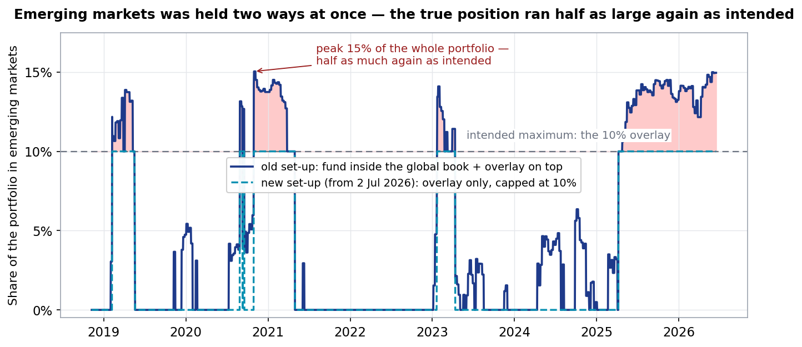
Navy: how much emerging markets the portfolio actually held under the old set-up. Teal dashes: the new set-up, live since 2 July 2026 — the overlay is the only EM position, so the line can never exceed 10%. Red shading marks the excess.
2. The fix is housekeeping, not a performance bet.
All four possible arrangements of the EM position produce the same whole-portfolio result within the margin of error, so the choice was made on clarity of risk — one mechanism, one attributable bet — rather than on any return claim.
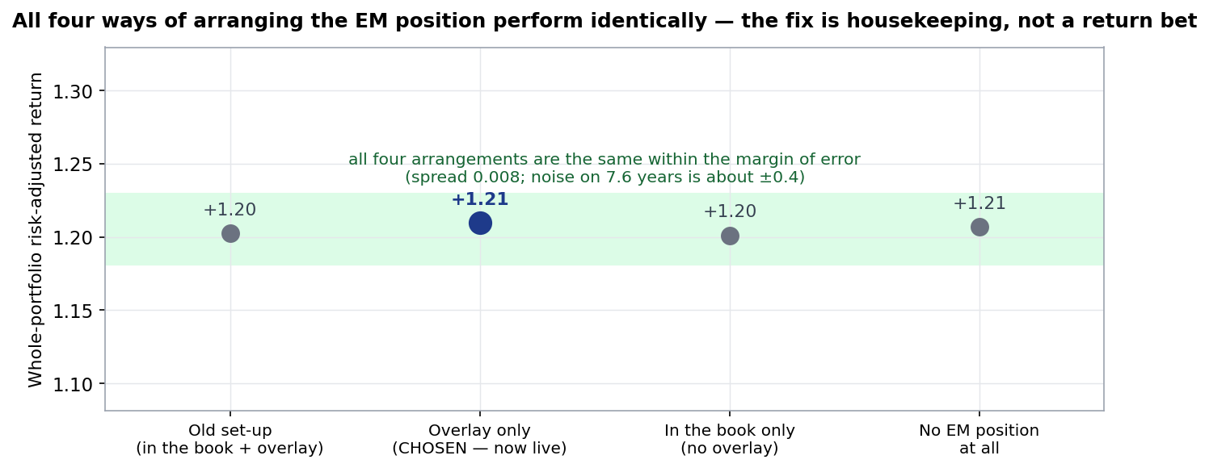
Risk-adjusted return = Sharpe ratio (return per unit of volatility; higher is better). The spread across the four options is under 0.01 against a margin of error of roughly ±0.4 on 7.6 years — statistically identical. The chosen arrangement also leaves the global book no worse on its own (+1.02 without the EM fund vs +1.01 with).
3. Country funds were tested and declined — they only work when EM is already winning.
A rotation across ten single-country funds beats a simple half-EM, half-developed benchmark over the full window (+0.70 vs +0.60) but lost the entire first half of the sample and wins in only three of six market regimes — a fair-weather strategy that duplicates the EM overlay with more moving parts.
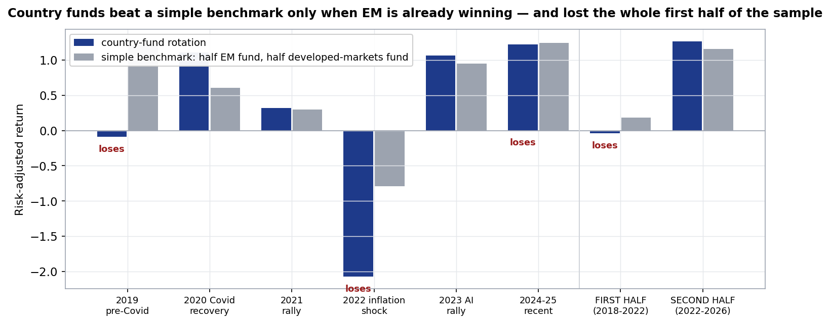
Navy: the candidate country-fund rotation. Grey: the do-nothing benchmark (half EM fund, half developed-markets fund). The pre-registered pass bar required at least four regime wins of six; it scored three, so the idea was declined without further tuning.
4. Commodity funds were tested and declined — the case lived in the rear-view mirror.
Adding commodity-sector funds improved the first half of the sample (which contains the 2021-22 commodity boom) and made the held-out second half clearly worse at every level — the signature of an idea fitted to the past — and the verdict stands even with the extra trading assumed to cost nothing.
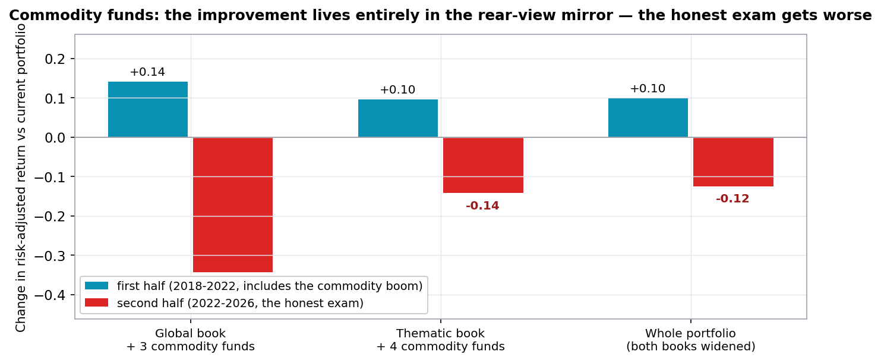
Each pair shows the change in risk-adjusted return from adding the commodity funds: teal = first half of history, red = the held-out second half. Improvement that appears only in the first half is hindsight, not edge.
5. Nothing on the wider map is missing.
Every part of the investable landscape is either covered by one of the four books, deliberately excluded with the reasoning on record, or was tested this session and declined — including a frontier-markets fund that turned out to have been liquidated in January 2025, caught by the review's own data checks.
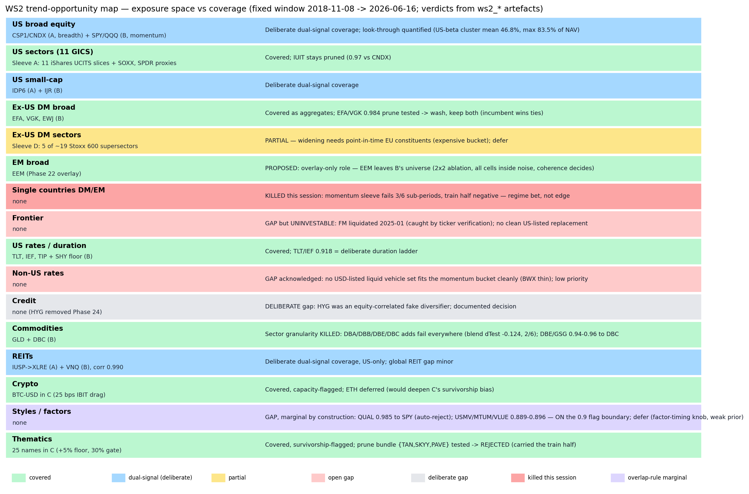
The full opportunity map. Green = covered; blue = deliberately covered twice by two different signals; amber = partial; grey = deliberate gap with documented reasoning; red = open gap or tested-and-declined; violet = blocked by the duplicate-holdings rule.

What an allocator should take away
- The fund list was audited end to end — every holding against every other, and every candidate against the holdings — and survived with one housekeeping fix and no additions.
- Additions were declined on evidence, not conservatism: each failed on data the models had never seen — the same discipline that has kept the settings unchanged.
- The honest caveats stand: the portfolio averages roughly half its weight in one US-equity cluster (peaking above 80%), the thematic book remains the weakest component, and every figure is a simulated backtest, not a live record.

Appendix — the work behind the summary
These are the working exhibits behind the findings, included to show the depth of testing. Labels are technical; the captions carry the message.
A1. Everything that was tested.
Every candidate change faced the same three-part exam — beat the benchmark on unseen data, work in at least four of six regimes, survive doubled costs — and thirty-one of thirty-two configurations failed to justify a change; the thirty-second was the EM housekeeping fix.
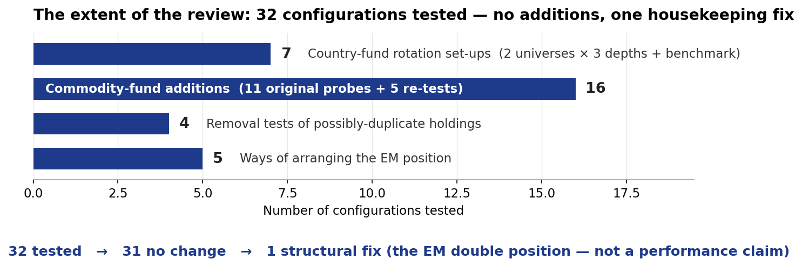
Configurations tested by category. The one change made claims no performance improvement.
A2. Every fund compared with every other.
The 72-fund correlation matrix behind the duplicate-holdings rule: any candidate moving in near-lockstep with an existing holding (correlation above 0.9) was rejected by rule — the same rule that had earlier removed a duplicated technology fund from the US book.
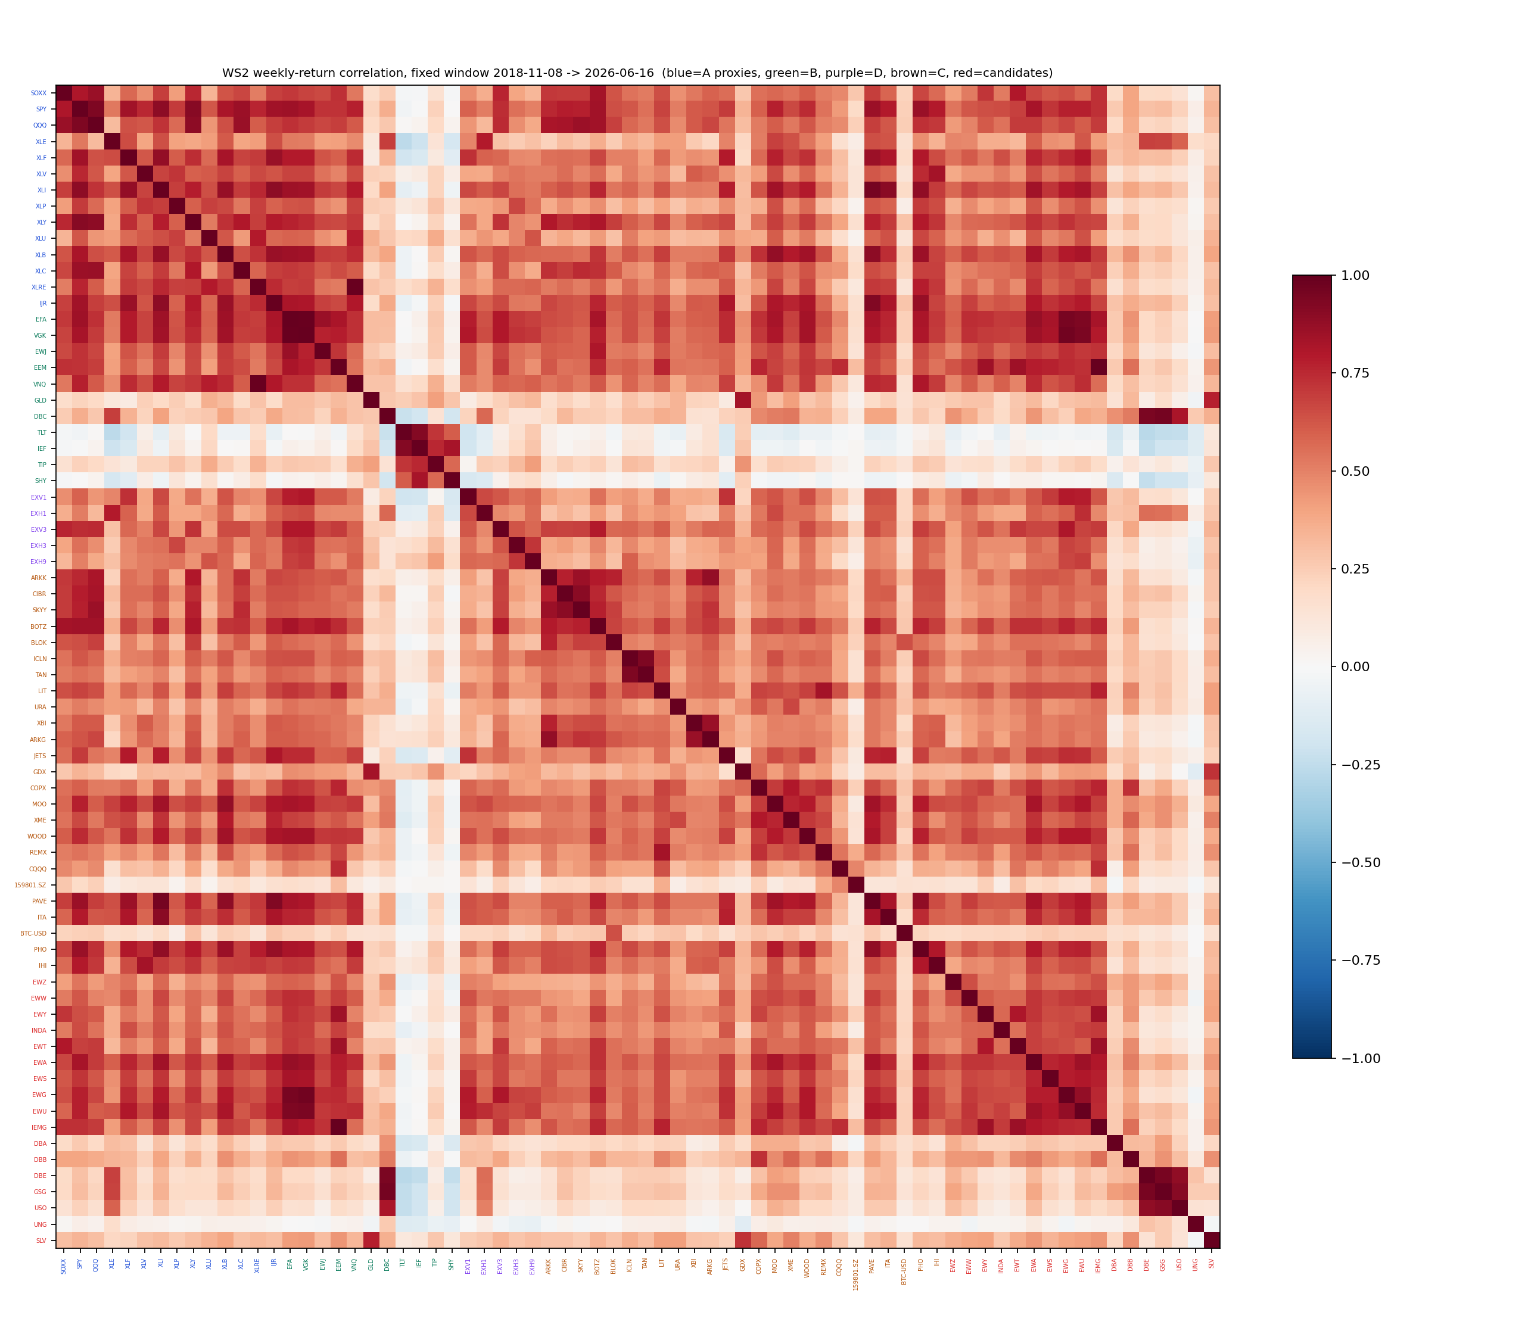
Red = moves together; blue = moves opposite. Label colours mark the four books and the candidates. The tight red blocks are families of near-identical funds — exactly what the rule screens against; the broad-EM candidate was rejected at 0.998 correlation to the fund already held.
A3. The honest concentration number.
Measuring overlap across the books for the first time shows the portfolio averages 47% of its weight in one cluster of US-equity-linked funds, peaking at 83% in strong markets — a deliberate consequence of two books reading the same market through different signals, now quantified and handed to the closing robustness review.
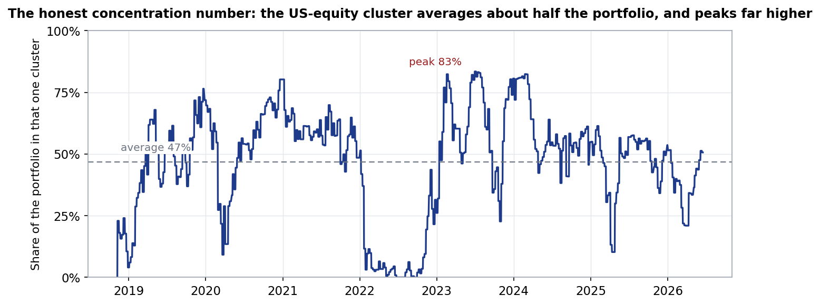
Share of the portfolio in the US-equity cluster over time. The dips towards zero are the books stepping aside into cash in weak markets — the system working as designed.

The wider programme. This review covered the fund list. The settings review (filed 2 July, summarised 3 July) found no setting worth changing, and the closing robustness review (filed 2 July) re-tested the final configuration across roughly 217 registered trials and kept it unchanged. All three records sit in the project's reviews/ folder.
Document of record: reviews/2026-07-02_ws2_universe.docx, with the full test detail in reviews/2026-07-02_ws2_test-appendix.docx (methodology, tables, audit trail). Personal research artefact; all figures are simulated backtests in USD net of stated costs; nothing in this document is investment advice.

