Does the strategy survive a hostile audit?
breadth-thrust-etf — the final robustness review, in plain language (Workstream 3 of 3)
Friday, 3 July 2026

The question | After roughly 217 tested configurations across three review sessions, is the strategy's track record genuine skill-in-design, or the residue of trying many things on one history?
The answer | It survives. The result is three to four times what trial-and-error luck alone would produce; every re-tuned version of the strategy would have LOST to the version left alone; the edge survives triple trading costs. Nothing was changed.
How it was tested | Four independent attacks: (1) a statistical penalty for every configuration ever tried; (2) forcing the strategy to re-choose all its settings each year using only information available at the time; (3) re-running history with each safety mechanism replaced by 1,000 randomly-timed copies; (4) doubling and tripling all trading costs.
Reading the numbers | 'Risk-adjusted return' is return per unit of volatility (Sharpe ratio; higher is better; measured over this window the margin of error is roughly ±0.4, so differences of ±0.01 are noise). 'Drawdown' is the peak-to-trough loss. 'Out of sample' means judged only on data the settings had never seen.

The headline: the review's most valuable finding is that discipline, not tuning, is the source of the edge. Every version of this strategy that chased what had just worked lost to the version that changed nothing.

1. Leaving it alone beat every re-tuned version
A strategy allowed to re-choose ALL of its settings each year — always picking whatever looked best on the data so far — would have earned a risk-adjusted return of +0.97 from 2022 to 2026, versus +1.17 for the deployed settings left untouched, because each January it bought whatever had just had its best run.
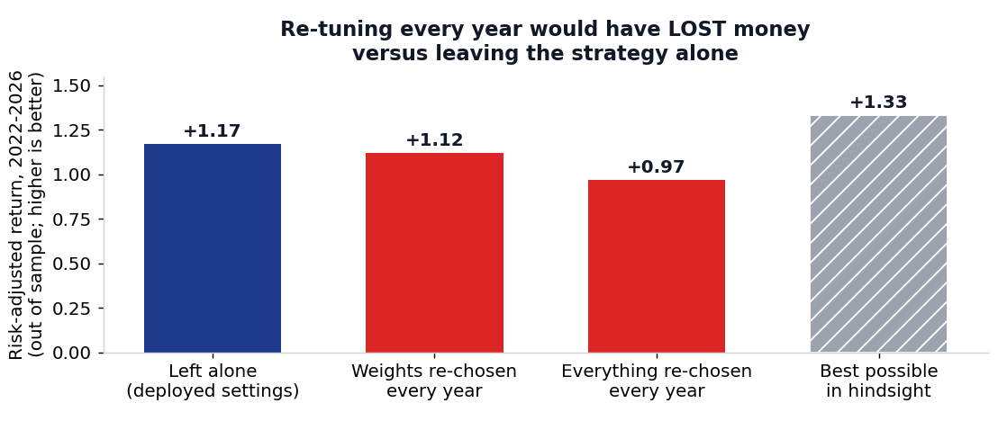
Judged only on data after the choice was made (2022-2026). The grey bar is the best any fixed setting could have done with perfect hindsight — no honest process reaches it.

2. The result is too large to be luck
If the ~217 recorded configuration tests (and a liberal allowance for the untracked earlier ones) had produced nothing but noise, the best-looking of them would still show a risk-adjusted return of about +0.29 to +0.42 — the strategy's actual +1.29 is three to four times that.
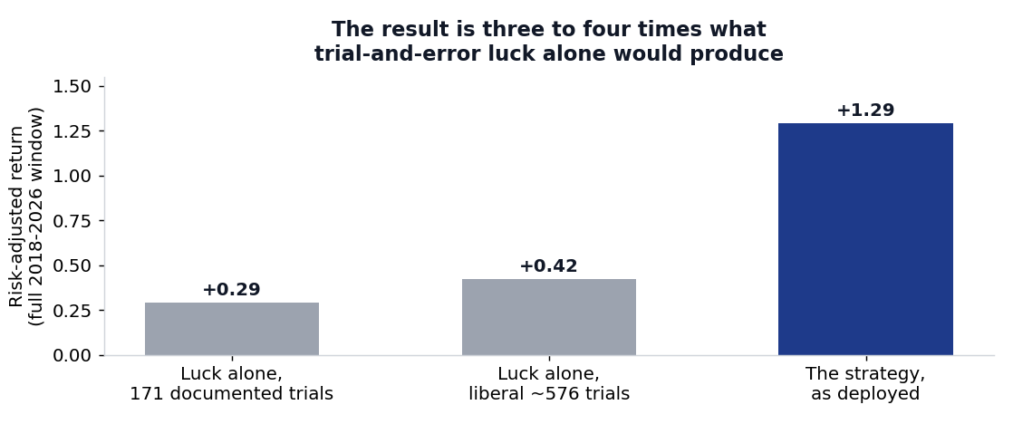
The grey bars answer 'what would the best result look like if the strategy had no real edge and we simply kept the luckiest attempt?'.

3. The safety brake earns its premium — its timing is real
The de-risking brake (it moves half the portfolio to short-term Treasuries when market breadth collapses) costs about 0.6% of return per year and avoided 7 percentage points of worst-case loss — and its timing beat 92% of one thousand randomly-timed copies of itself.
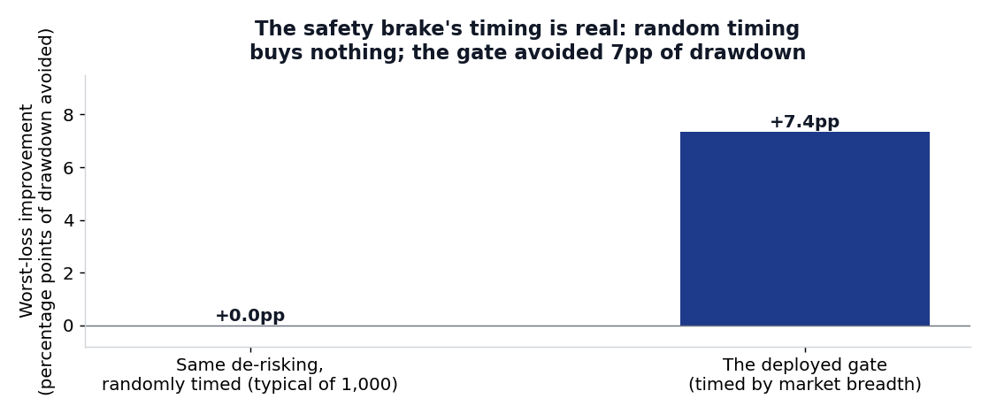
Same brake, same amount of time de-risked — only the timing differs. Random timing typically buys no drawdown protection at all.

4. The emerging-markets tilt is a position, not proof of skill
The tilt has made only 6 bets in seven years and its lifetime contribution is statistically indistinguishable from chance (a coin-flip 0.56 probability that its average effect is positive) — it is kept because it is the portfolio's only emerging-markets exposure, and it is now labelled a position, never counted as edge.
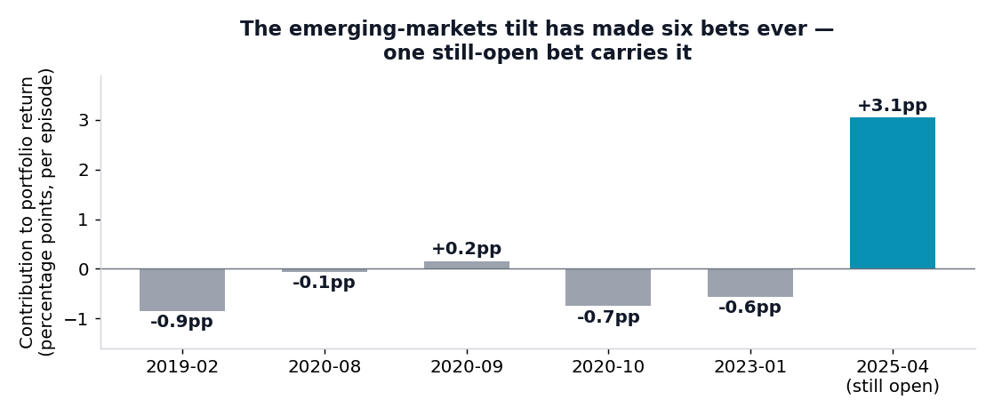
Contribution per bet, in percentage points of portfolio return. One still-open bet accounts for the entire positive tally; if it reverses, the tilt's keep/drop question reopens.

5. Trading costs do not explain the edge
With every trade charged a realistic line-by-line spread, the strategy holds a risk-adjusted return of +1.23; at DOUBLE those costs +1.16; at TRIPLE +1.09 — costs would need to reach roughly 6x realistic levels before doing nothing (equal-weight baskets of the same funds) becomes the better choice.
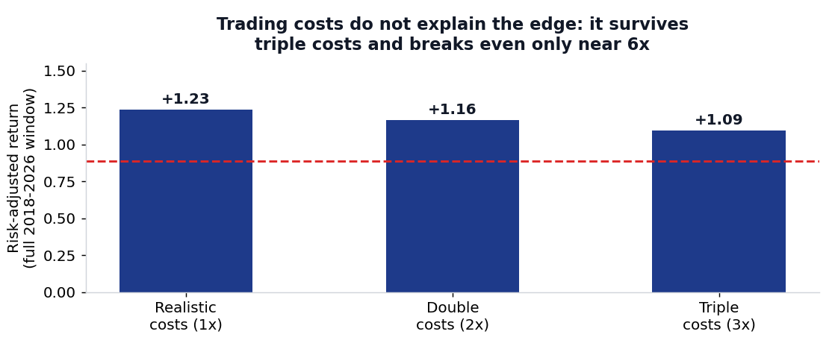
The dashed red line is the do-nothing alternative — buying and holding equal amounts of the same funds (risk-adjusted return +0.89).

6. What changed, and what is on watch
Nothing changed — both shortlisted refinements were declined on evidence (one made 2022 losses worse out of sample; the other improved results by less than the noise floor). Three items are on watch: the thematic book must re-justify its 10% seat at the next review (at realistic costs it no longer beats simply holding its own basket, and one coin — Bitcoin — supplied 23% of its historical contribution); the Europe book is the most cost-sensitive and its execution will be monitored; and one housekeeping fix (a data-staleness guard on the tilt's input feed) awaits approval.
Timing note for any new capital: the strategy is 1.3% below its recent high after a strong year (trailing twelve months stronger than 91% of its own history) — the house entry rule says add after a flat or weak stretch, not now.

Appendix — the work behind this summary
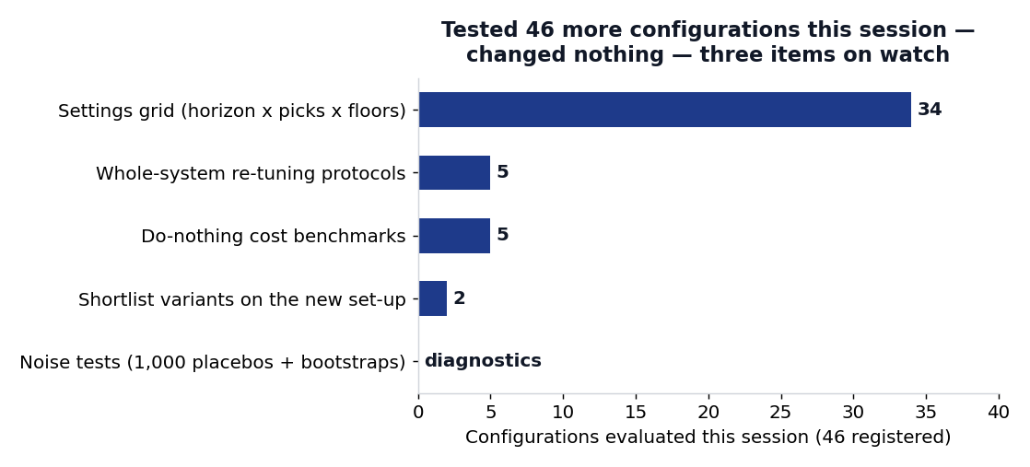
This session: 46 configurations registered, none adopted, three items on watch. Across the full three-session review: roughly 217 configurations tested and zero changes made.
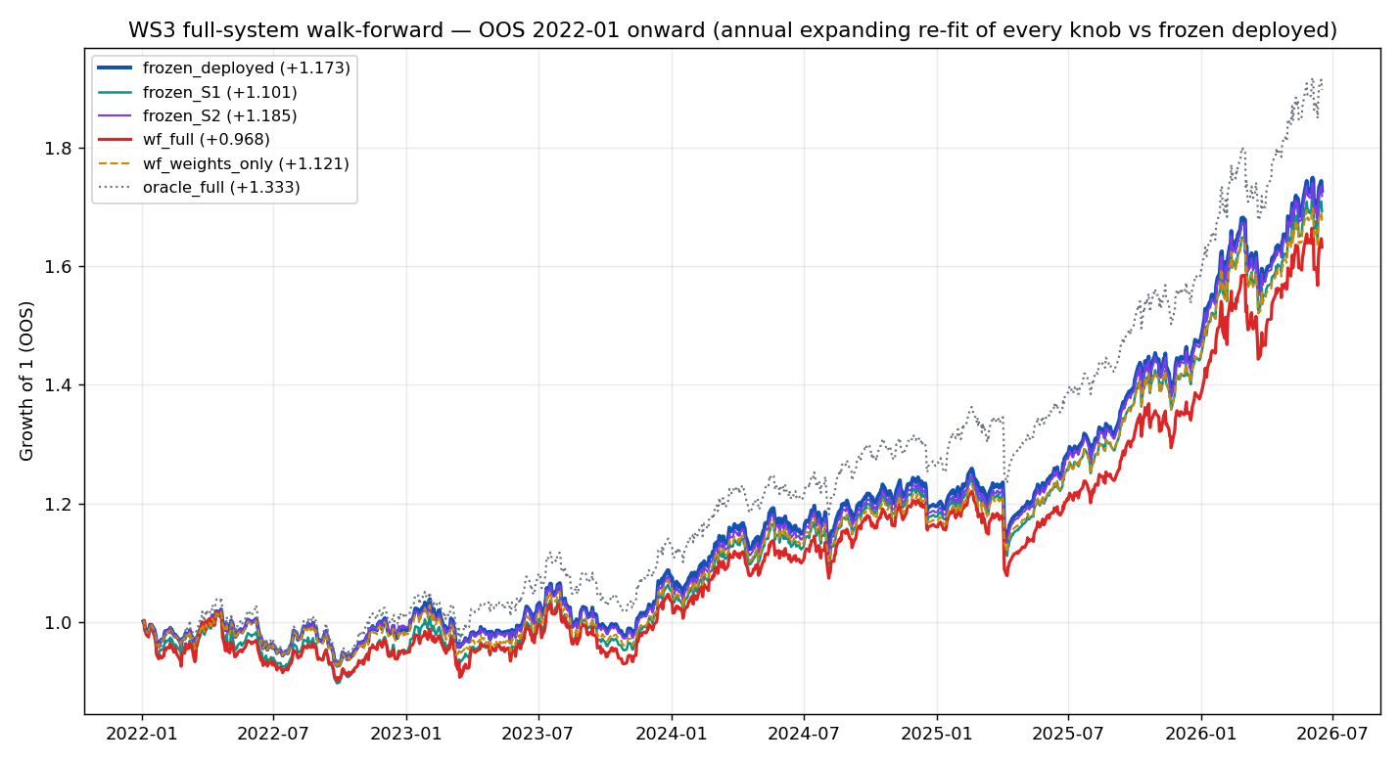
Working chart: growth of 1 from 2022 for each protocol. 'frozen_deployed' is the strategy left alone; 'wf_full' re-chooses every setting annually; 'oracle_full' is the impossible hindsight best. The technical record explains each protocol.
Sibling records: the formulation review (2026-07-02_ws0-ws1_ma-robustness.docx, with its own summary) and the universe review (2026-07-02_ws2_universe.docx, test appendix and summary). Full method, tables and per-component verdicts: reviews/2026-07-03_ws3_heavy-gate.docx. Every figure in this summary is read programmatically from the committed data/ws3_*.json artefacts.

Prepared by | Claude Code research session (Fable 5), under direction of Zhenghao Phua
Reviewed and approved by
Date
Next review | Scheduled maintenance review (thematic-book seat; Europe-book execution)

Personal research artefact. All performance figures are simulated backtests in USD, net of stated costs; nothing in this document is investment advice.

