WS7 — Norgate point-in-time history extension
Held-out out-of-sample test of the breadth-thrust conviction meter, 1990–2017
Saturday, 1 August 2026

Project / context | breadth-thrust-signal — Personal research. The Norgate licence is personal-use-only; no vendor series values are published and nothing is routed through Navigo.
Review scope | Extend the conditional forward-return study from 8 to 36 years using Norgate daily point-in-time S&P 500 membership; test the frozen Phase 0 specification on a genuinely held-out window.
Evaluation window | Panel 1990-01-02 to 2026-07-31 (9,212 days); effective study window 1990-12-28 to 2026-07-31 (8,961 days after the burn-in gate). Held-out test window 1990-12-28 to 2017-12-31 (6,805 days), never previously examined. Filed Phase 0 window was 2,109 days.
Data basis | Norgate Data, watchlist 'S&P 500 Current & Past' (1,299 ever-members, 646 delisted). TOTALRETURN close for direction, moving averages and 52-week high/low; NONE-basis raw volume for the up-volume ratio. Membership 498–507 names every day; member-with-price coverage complete.
Method basis | Phase 0 engine unchanged. No threshold tuned. One logged deviation: the median leg of the decision rule was tightened to the 95th-percentile bootstrap bar, agreed at sign-off before running.
Pre-registration | C:/dev/KICKOFF_ws7-norgate-history-extension.md, committed vault-docs@9d7c233 before any result was computed; sign-off cleared @c417b3e.
Repository commits | breadth-thrust-signal@886a7e6 (data layer, burn-in gate, guards); @a949d29 (pre-registered run).
Running memo | RESEARCH_MEMO.md, WS7 section
Outcome | REVIEWED — the >=3 / six-month trigger FAILS out of sample and is rejected; the conviction grouping is vindicated; the filed Phase 0 numbers receive an erratum.

1. Executive summary
- The pre-registered decision FAILS out of sample. On a held-out window never previously examined (1990-12-28 to 2017-12-31; 70 events, 48 clusters), score >= 3 at six months returns 75.0% against a 78.0% bootstrap 95th percentile. Both legs were required; the median leg passed. Verdict FAIL, as it also failed in-sample, now on 4.25 times the data.
- The conviction inversion was noise; the four-dimension grouping is vindicated. Phase 0's backwards lift (0.885 at >=1 down to 0.500 at >=4) does not reproduce: rank correlation is +0.40 held-out and +0.20 pooled.
- The extension is sound and closes a caveat recorded as unresolved. Norgate gives daily survivorship-free membership from 1990 with complete delisted coverage, against 111 of 715 ever-members unfetchable on the previous path.
- A look-ahead gate was tested before any result was computed, and passed. The constituent flag transitions on the effective date, verified against three index changes with wide announcement-to-effective gaps.
- The engine is not looser than the canonical definition. Across 1990–2003, thirteen years the literature reports as silent, the Zweig leg fires on 7 days in 6 episodes.
- A burn-in defect was found in the FILED Phase 0 record. D2 and D3 cannot fire in a panel's first year, capping the score at 2; four of 26 filed events sit there. The headline effect is small (-2.1pp at >=1) and the inversion survives it.
- The filed event set is substantially an artefact of its data layer. Only 16 of 26 events survive daily point-in-time membership; at >=3 seven of fourteen dates coincide, moving the twelve-month median from +23.05% to +13.28%. An erratum is appended, not a supersession.

2. Verified data layer
Phase 0 assumed that extending before 2018 required a reconstructed membership history and would be lower-confidence. A probe of the local installation disproved that assumption. The extension is not a weaker version of the filed run; it is strictly cleaner on every axis that was previously flagged as a caveat.
Property | Filed Phase 0 layer | WS7 Norgate layer
Membership source | iShares CSP1 weekly Friday snapshots, forward-filled | Daily index constituent series
Earliest membership | 2018-01 | 1990-01-02
Usable study days | 2,109 | 8,961
Delisted members | 111 of 715 unfetchable | 646 carried with full history
Member-with-price coverage | Incomplete; leak documented | Complete on every sampled date
Members per day | ~500 (post-2018 only) | 498 to 507 across 36 years

Look-ahead gate (build step 0). Norgate's constituent flag transitions on the effective date, not the announcement date. Verified against TSLA (2020-12-21), META (2013-12-23) and BRK.B (2010-02-16), each landing on the documented effective date despite announcement-to-effective gaps of three to five weeks, and corroborated by adds and drops clustering 35% and 39% on Mondays against a 20% null. No mask shift was applied; applying one would have introduced the look-ahead it was intended to remove.
Licence containment. This repository is public and the Norgate licence is personal-use-only. The vendor cache is held outside the repository at C:\dev\.norgate-store\, where the vault ignore rule makes it structurally uncommittable rather than merely ignored. No vendor series values appear in this record; every figure here is derived analysis.

3. Finding 0 — a burn-in defect in the filed record
This was found while validating the new layer, not sought. The validity gate admitted days on which two of the four dimensions were mechanically incapable of firing: D2 needs 50 observations before a 50-day average exists, and D3 needs 252 before a 52-week high does. For the first year of any panel the score is therefore capped at 2 by construction, and days in that window are not score-2 days but score-unknown days.
In the filed Phase 0 record, D3 first fires on 2019-01-10 — two trading days after the 252-day boundary at 2019-01-08. That is not coincidence. Four of the 26 filed events sit inside the burn-in and none could have scored above 2.
Threshold, six-month horizon | Filed win rate | Burn-in events excluded | Change
>= 1 | 88.5% | 86.4% | -2.1pp
>= 2 | 86.4% | 85.0% | -1.4pp
>= 3 | 78.6% | 78.6% | 0.0pp
>= 4 | 50.0% | 50.0% | 0.0pp

The effect on the headline is small and the conviction inversion survives the correction, so this is recorded as a defect rather than a retraction. Detection required tracking computability explicitly: the new-highs series is a sum of booleans and reads zero during burn-in, which is indistinguishable from a genuine day with no new highs. A missing value would have been the kinder failure mode. The validity gate now requires every dimension to be computable, and three tests hold the invariant.

4. H1 — held-out out-of-sample test
The frozen Phase 0 specification was applied, entirely unchanged, to a window that played no part in its design and had never been examined. The decision rule was fixed in the pre-registration: at score >= 3 and a six-month horizon, both the median and the win rate must clear the 95th percentile of their bootstrap band.
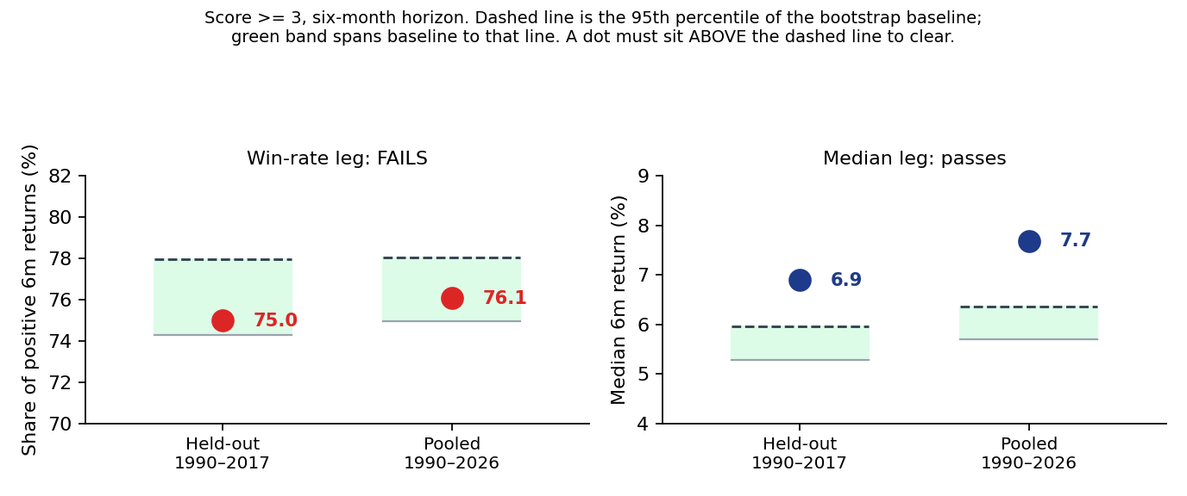
The pre-registered decision, held-out and pooled. Each dot is the conditional result at score >= 3 over six months; the dashed line is the 95th percentile of the moving-block bootstrap baseline and the green band spans the baseline to that line. A dot must sit above the dashed line to clear. The win-rate leg fails in both windows; the median leg passes in both. Because both legs were required, the verdict is FAIL.
Horizon | Threshold | Events | Clusters | Win rate | Band 95th | Median | Band 95th
1m | >= 3 | 32 | 28 | 75.0% | 66.2% | +1.78% | +1.33%
6m | >= 1 | 70 | 48 | 75.7% | 78.0% | +6.89% | +5.96%
6m | >= 2 | 54 | 40 | 72.2% | 78.0% | +6.29% | +5.96%
6m | >= 3 | 32 | 28 | 75.0% | 78.0% | +6.89% | +5.96%
6m | >= 4 | 8 | 8 | 87.5% | 78.0% | +12.20% | +5.96%
12m | >= 3 | 32 | 28 | 87.5% | 82.7% | +13.49% | +11.83%
12m | >= 4 | 8 | 8 | 100.0% | 82.7% | +19.96% | +11.83%

Reported, and explicitly NOT a rescue of the failed test. The >= 3 signal clears both legs at one month and at twelve months, in the held-out window and again pooled, while failing at the pre-registered six months. Acting on that would be horizon-shopping after a failed test. If the twelve-month reading is to be claimed it needs its own pre-registered study on data not yet used — and the held-out window is now spent, so that means new data or a weaker, explicitly pooled claim. It is recorded here so it is not rediscovered later as though new.

Cluster discipline. Thrusts cluster after bear markets, so a raw event count is not a count of independent observations. Every figure above carries its distinct-episode count, and the pre-registration forbids calling any result beyond noise on single-digit clusters. The >= 4 bucket holds 8 events in 8 episodes; its large lift is reported but is not treated as established.

5. H1b — conviction monotonicity
Phase 0 reported win-rate lift running backwards in conviction, which is the wrong direction for a conviction meter and would undercut the premise that more corroborating dimensions mean a stronger signal. The pre-registration made this a falsification test rather than a caveat: if the inversion reproduced out of sample, the meter would be reported as a binary signal rather than a graded one.
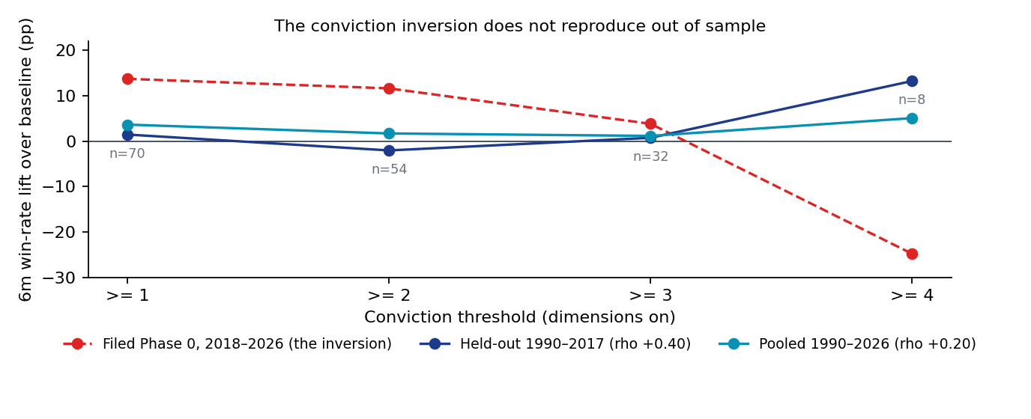
Six-month win-rate lift over baseline at each conviction threshold. The red dashed line is the filed 2018–2026 result whose downward slope was the concern. Neither the held-out nor the pooled window reproduces it; both slope mildly upward. The inversion was an artefact of an eight-year sample. Event counts for the held-out series are annotated — the >= 4 point rests on 8 episodes and is not load-bearing.
The rank correlation between threshold and six-month lift is +0.40 held-out and +0.20 pooled, against the strongly negative ordering of the filed record. The four-dimension grouping is not falsified. The meter is simply not strong enough at >= 3 to clear the noise band at six months — a different and narrower criticism than the one Phase 0 raised against itself.

6. H3 and H3b — anchor validation
The anchor list was fixed before the run from Tom Aspray, 'Only Seventh Buy Signal Since 2000', Forbes, 9 April 2023. Sources disagree on the canonical list and those disagreements are logged rather than reconciled away: a Greg Morris list surfaced in search omits both May 2004 and October 2015, but could not be retrieved directly and is not treated as verified. Practitioner counts since 1945 range from 18 to 19 depending on whether a simple or exponential average is used and whether the universe is NYSE all-issues or common only.
Anchor | Result | Corroboration
May 2004 | MISS | Contested — omitted by the unverified second list
March 2009 | MATCH | Corroborated across sources
October 2011 | MATCH | Corroborated across sources
October 2013 | MATCH | Corroborated across sources
October 2015 | MATCH | Contested by the same second list
2019-01-10 and 2019-01-04 | MATCH | Reported separately, never merged
2023-11-03 | MATCH | Existing repository anchor

The single miss is precisely the anchor the second source omits, so the engine agrees with the list that excludes 2004. That is a convergence worth noting, but one anchor is not evidence for either list and it is not treated as such.

6.1 The silent-period negative test
The literature reports no Zweig Breadth Thrust between August 1984 and March 2009. On that reading the first nineteen years of the held-out window carry at most one published anchor, so positive validation across 1990–2003 is impossible. The silence is itself testable: an implementation looser than canonical would fire where the literature reports nothing.
Across 1990-12-28 to 2003-12-31 the Zweig leg fires on 7 days forming 6 de-duplicated episodes: 1996-08-02, 1996-09-13, 1996-09-16, 2002-10-21, 2003-03-21, 2003-10-07 and 2003-12-01. Single digits, as pre-registered. The EMA(10) large-cap proxy is not materially looser than the canonical NYSE simple-average definition. This test could only ever have failed the implementation; it did not.

7. H4 — reconciliation against the filed record
Rerunning the filed calendar window on the new layer produces a materially different event set. The index series is not the cause: Yahoo and Norgate price series for the benchmark differ by at most 0.12% across the overlap.
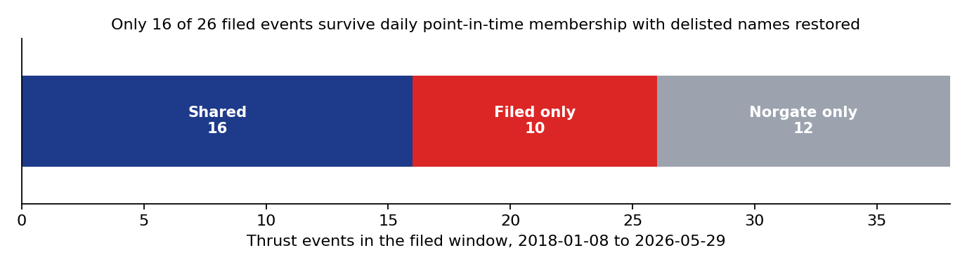
Thrust events in the filed window under each data layer. Only 16 of the 26 filed events also appear under daily point-in-time membership with delisted names restored. Ten filed events disappear and twelve new ones appear. The event set — not merely the summary statistics — is substantially a property of the membership source.
Threshold | Horizon | Filed n | Norgate n | Filed win | Norgate win | Median change
>= 1 | 6m | 26 | 28 | 88.5% | 85.7% | -1.8pp
>= 1 | 12m | 26 | 28 | 84.6% | 85.7% | -2.1pp
>= 2 | 6m | 22 | 23 | 86.4% | 87.0% | -1.7pp
>= 2 | 12m | 22 | 23 | 86.4% | 87.0% | -5.9pp
>= 3 | 6m | 14 | 14 | 78.6% | 78.6% | -1.4pp
>= 3 | 12m | 14 | 14 | 85.7% | 85.7% | -9.8pp

At >= 3 both runs carry fourteen events, but only seven dates coincide, which moves the twelve-month median from +23.05% to +13.28% while leaving the win rate unchanged. Six rows breach the pre-registered erratum bands. The cause is the layer Phase 0 itself documented as a known caveat: weekly Friday snapshots forward-filled onto a daily calendar, compounded by the missing delisted names.
Erratum, not supersession. Per sign-off item 3, the filed Phase 0 record and the WS4 H2 rows that reuse it receive an appended correction note recording both the burn-in defect and this reconciliation. The original records stand as filed. WS7's own results are unaffected — they use the clean layer throughout.

8. Decisions
Component | Decision | Basis
>= 3 at six months as a standalone timing trigger | REJECT | H1 held-out fails the win leg (75.0% against 78.0%); H2 pooled agrees
Four-dimension conviction grouping | KEEP | H1b: inversion does not reproduce; rho +0.40 held-out, +0.20 pooled
Canonical frozen thresholds | KEEP | H3b: not looser than canonical; H3: five of six anchors match
Norgate as the project data layer | ADOPT | Complete coverage, daily point-in-time membership, 4.25x window
Filed Phase 0 numbers | ERRATUM | H4: only 16 of 26 events survive the layer change
>= 3 at one and twelve months | FLAGGED, no action | Clears both legs but was not the pre-registered horizon

9. Trial register
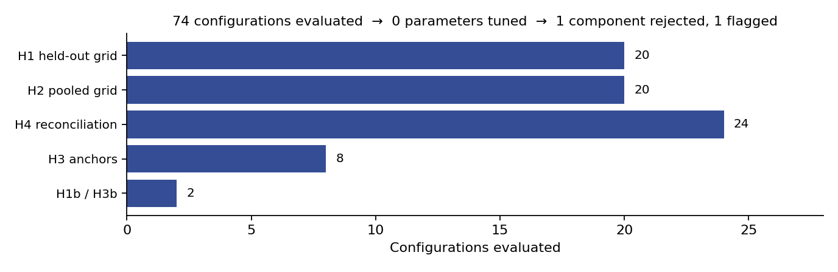
Configurations evaluated by test. The point of the exhibit is the funnel beneath it: a large evaluated surface, no parameter tuned, and a single component rejected on a pre-registered rule rather than on the most flattering cut of the data.
Seventy-four configurations were evaluated and no parameter was tuned. H1 covered four thresholds across five horizons (20 cells); H2 repeated that grid pooled (20); H4 compared eight reconciliation rows across three layer variants (24); H3 tested eight anchors; H1b and H3b contributed one statistic each. Every threshold, window, band and anchor was fixed in the pre-registration and committed to version control before the first result existed, which is what makes the held-out claim meaningful. One deviation is logged: the median leg was tightened from Phase 0's undefined 'meaningfully above' to the 95th-percentile bootstrap bar, agreed at sign-off before the run.

10. Artefact register
Artefact | Path
Pre-registration | C:/dev/KICKOFF_ws7-norgate-history-extension.md (vault-docs@9d7c233, sign-off @c417b3e)
Data layer | scripts/norgate_provider.py
Study run | scripts/ws7_extension.py
Charts | scripts/ws7_charts.py, reviews/charts/ws7_*.png
Results | reviews/2026-08-01_ws7_results.json
Tests | tests/test_norgate_layer.py (10 tests; suite 16, all passing)
Running memo | RESEARCH_MEMO.md, WS7 section
Commits | breadth-thrust-signal@886a7e6, @a949d29

11. Next phase
- The held-out window is now spent. It cannot be reused to test the twelve-month reading H1 surfaced, and any such study must either wait for genuinely new data or state plainly that its evidence is pooled rather than held out.
- Do not re-open the >= 3 six-month decision on this evidence. The rule was fixed in advance and it failed twice, in-sample and out.
- Apply the erratum to the filed Phase 0 record and the WS4 H2 rows that reuse it.
- The engine's EMA(10) formulation differs from the canonical ten-day simple average cited in the literature. H3b shows this does not make it looser in practice, but the ambiguity is on the record and should be resolved by documentation rather than by re-fitting.

Prepared by | Claude Code research session, under direction of Zhenghao Phua
Reviewed and approved by
Date
Next review | On the arrival of new out-of-sample data, or when a twelve-month study is pre-registered

Personal research artefact. Not investment advice. Not affiliated with any regulated fund. Vendor data used under a personal-use licence; no vendor series values are reproduced in this record.

