WS8 — is the breadth thrust deployable net of costs?
Tilt backtest against a cost-matched null, and replication across three cross-sections
Saturday, 1 August 2026

Project / context | breadth-thrust-signal — Personal research. Norgate licence is personal-use-only; no vendor series values published, nothing routed through Navigo.
Review scope | WS7 measured statistical lift and never ran a net-of-cost backtest. WS8 asks whether the one cell that survived WS7 — fresh events at score >= 3, one month forward — is deployable, and whether the mechanism replicates on cross-sections other than the S&P 500.
Evaluation window | S&P 500 1990-12-28 to 2026-07-31 (8,961 valid-breadth days). Replication: S&P SmallCap 600 1995-10-26 to 2026-07-31 (7,740 days); Russell 2000 1991-07-01 to 2026-07-31 (8,834 days).
Data basis | Norgate point-in-time constituents for all three universes: 1,299 / 2,633 / 11,129 ever-members. TOTALRETURN close for direction and moving averages; NONE-basis raw volume for the up-volume ratio. 27,528 series pulled, zero failures.
Method basis | Engine constants unchanged. Unlevered tilt overlay on a 60/40 base, 10bp per unit of allocation change. Primary benchmark is a cost-matched random-entry null, not static 60/40.
Pre-registration | C:/dev/KICKOFF_ws8-thrust-tilt-deployability.md, committed vault-docs@8740710 before any result was computed.
Repository commits | breadth-thrust-signal@34e4466
Running memo | RESEARCH_MEMO.md, WS8 section
Outcome | REVIEWED — mechanism CONFIRMED and replicated; deployment as an exposure tilt REJECTED in all three universes.

1. Executive summary
- The tilt FAILS its pre-registered decision. Net Sharpe 0.709 against a cost-matched random-entry null whose 95th percentile is 0.751 — and below that null's median of 0.718, so the timing loses to randomly-placed tilts of identical size and frequency.
- It is not a marginal failure. All 18 variants underperform the untilted 60/40 base of 0.743, monotonically worse with larger tilts and longer holds. Both eras agree (-0.041 pre-2009, -0.029 post), so this is not era-dependence.
- The mechanism is nonetheless REAL and REPLICATES. Rebuilt on two further point-in-time universes, the same cell shows a positive median lift in both: +1.04pp in the S&P SmallCap 600 (beyond noise on both legs, 42 episodes) and +0.21pp in the Russell 2000 (positive but within noise).
- Small-cap breadth carries the STRONGER signal — +1.04pp against +0.72pp for the S&P 500. A thrust across 600 smaller names is a more meaningful statement about participation than the same reading across 500 mega-caps.
- Why the two findings coexist: the 1-month mean lift is +0.44pp against a median lift of +0.72pp while volatility runs 1.16x baseline. A portfolio compounds means and pays for variance, so the statistic that survived every WS7 test is the one a portfolio cares about least.
- The entire return gain is passive long-bias. The observed +0.14pp of CAGR matches the arithmetic for ANY 20pp tilt held 10.6% of the time (0.106 x 0.20 x 6.4% = +0.136pp) to four thousandths of a percentage point.
- Three further structures were killed by diagnostics before any strategy was built — an EDD re-entry accelerator, a state-conditional overlay, and a defensive-state override whose apparent lift proved to be a composition artefact. The graveyard is recorded in section 2 so it is not re-tread.

2. What was already dead before the backtest ran
Three candidate structures were eliminated at the diagnostic stage. Recording them matters more than usual here, because two of them looked promising on first inspection and one produced a large, entirely spurious number.
Structure | Why it died
EDD re-entry accelerator | The 42-day cooldown floor binds on only 9.0% of days, in episodes of median length six — it bites only once the raw score has already collapsed. Fresh thrusts landing while it binds: four to seven in 28 years.
State-conditional overlay | Median lift +2.6 to +13.0pp in 1990–2008 against +0.2 to −1.9pp in 2009–2026. Post-GFC the state base rate is 80–95%: dip-buying worked unconditionally, leaving nothing for a thrust to add.
Defensive-state override | A pooled +4.58pp six-month lift that is a COMPOSITION ARTEFACT. The condition holds on 34% of defensive days pre-2009 but 93% post-2009, so the conditional sample over-samples the better era. Split: +5.99pp on seven episodes pre-2009, −0.46pp post. The lift exists in neither era.
Risk-reduction or leverage framing | Forward maximum drawdown after a thrust is equal to or worse than baseline at every horizon, so there is no risk benefit to fund leverage.
Long-horizon holds | A twelve-month hold is in the market 95.3% of days at >=1 — buy-and-hold wearing a signal.

The shared root cause is that the conviction score is not scarce: it is on 63% of days at >= 2 and 36% at >= 3. Conditioning on something usually true cannot carry much information, and in the post-2009 era it is true almost always. The composition artefact above is the same fact wearing a disguise, and it was caught only by splitting the sample — which is now a standing requirement on every pooled conditional figure in this project.

3. The tilt backtest
An unlevered overlay on a 60/40 base rebalanced monthly: on a fresh event with score >= 3, raise equity by 20pp for 21 trading days, then revert. Costs are 10bp per unit of allocation change. Leverage was excluded a priori because WS7 established there is no drawdown benefit to fund it.
The benchmark is the design point. Tilting toward equities in a market that rises three-quarters of the time wins whether or not the signal carries information, so static 60/40 is the wrong comparison. The primary benchmark is a cost-matched random-entry null: the same tilt count, size, duration and costs, placed by random circular rotation of the realised tilt series. Rotation preserves the clustering of real events exactly and destroys only the alignment with market state — which is the thing under test.
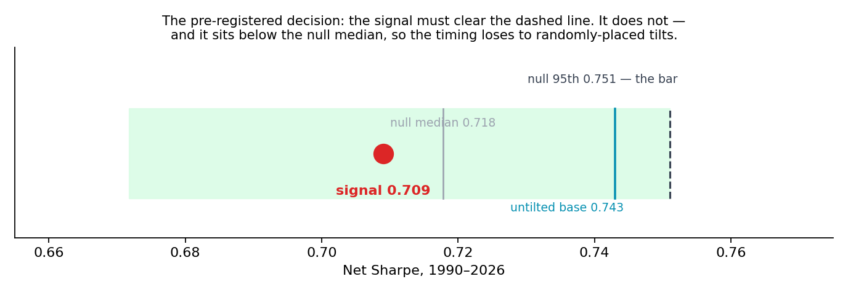
The pre-registered decision. The red dot is the signal-timed portfolio; the green band spans the 5th to 95th percentile of 2,000 randomly-timed tilts of identical size and frequency. To pass, the dot had to sit right of the dashed line. It sits left of the null's own median, and left of the untilted base.
Portfolio | Net Sharpe | CAGR | Volatility | Max drawdown
Untilted 60/40 base | 0.743 | 7.79% | 10.48% | −33.8%
Headline V1 (+20pp, 21 days) | 0.709 | 7.93% | 11.19% | −37.1%
Random-entry null, 95th pct | 0.751 | — | — | —
Random-entry null, median | 0.718 | — | — | —
100% equity | 0.509 | 9.19% | 18.04% | −56.8%

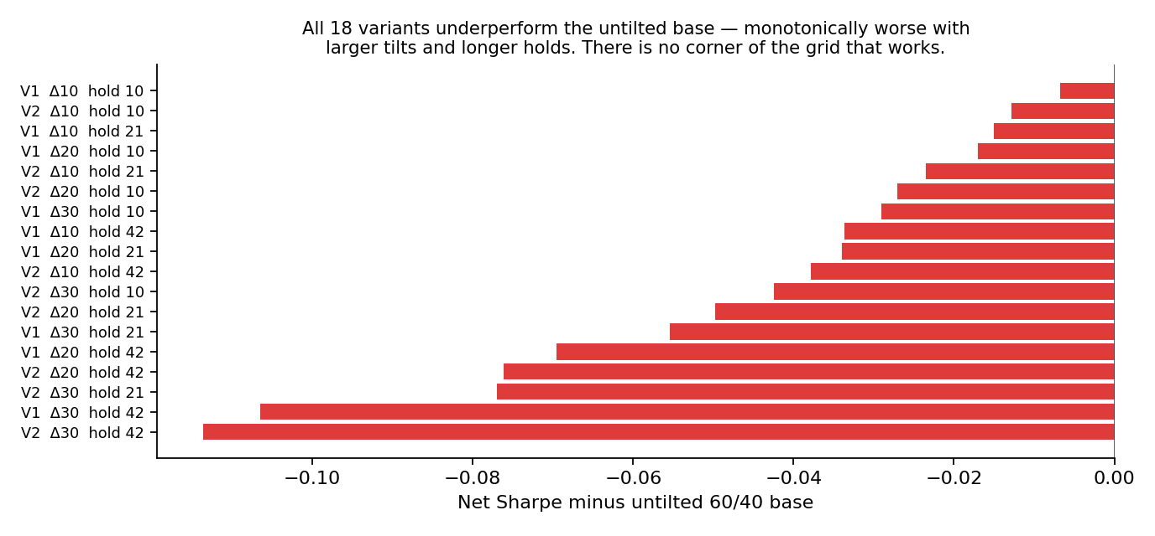
Every variant tested, ranked. All 18 fall below the untilted base, and the ordering is monotone in both tilt size and hold length — the more of the signal you act on, the worse the outcome. There is no corner of the grid that works, which is what distinguishes this from an unlucky parameter choice.

4. Why a real signal produces no portfolio value
The two findings in this record are not in tension, and the reconciliation is the most useful thing WS8 produces.
Measure, 1-month forward | Baseline | After a >= 3 event | Difference
Median return | +1.254% | +1.969% | +0.716pp
Mean return | +0.843% | +1.284% | +0.441pp
Standard deviation | 4.47% | 5.18% | 1.16x

A portfolio compounds the mean and pays for the variance. The median lift — the statistic that survived every test in WS7 — is the one a portfolio cares about least, and it overstates the mean lift by more than half. Pair a +0.44pp mean edge with 16% more volatility and the risk-adjusted result is negative.
The independent confirmation: the return gain is pure long-bias. The tilt added +0.14pp of CAGR. The expected gain from ANY 20pp equity tilt held 10.6% of the time is 0.106 × 0.20 × (10.4% − 4%) = +0.136pp. Observed matches expected to four thousandths of a percentage point, so the signal's timing contributed nothing measurable. Three separate lines — the null comparison, the variant sweep and this arithmetic — converge on the same conclusion.
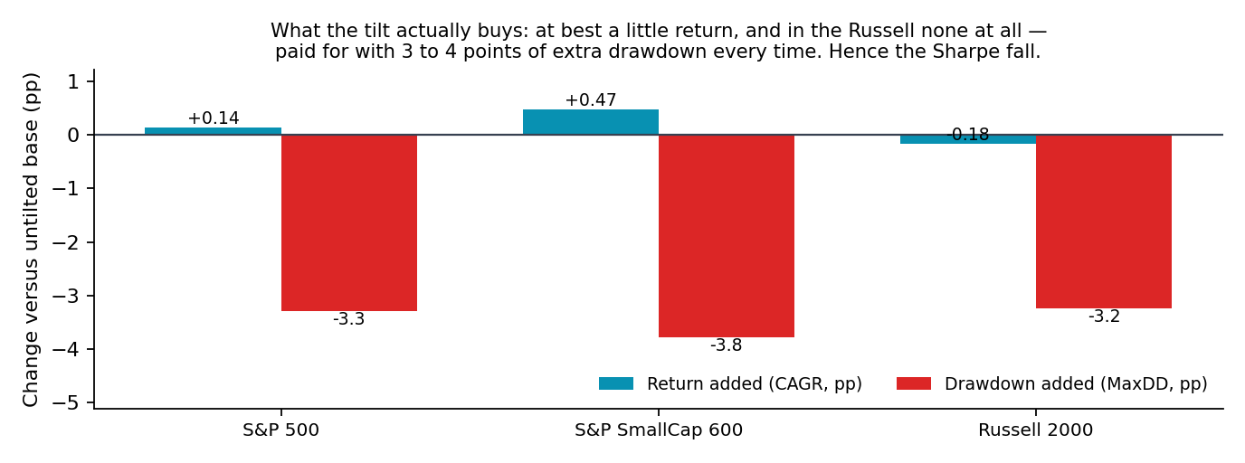
What the tilt buys in each universe. Return added is small or, in the Russell 2000, negative; extra drawdown is three to four percentage points every time. That is the trade that drives Sharpe down in all three.

5. Cross-sectional replication
The S&P 500 window was spent by WS7, so the only genuinely fresh test of the mechanism comes from a different cross-section. The four dimensions were rebuilt on two further point-in-time universes, each trading its own index, so the test is of the mechanism rather than of a cross-market signal.
Universe | Window | Events | Episodes | Median | Baseline | Lift | Beyond noise
S&P 500 (WS7 cell) | 1990–2026 | 46 | 41 | +1.97% | +1.25% | +0.72pp | both legs
S&P SmallCap 600 | 1995–2026 | 48 | 42 | +2.46% | +1.42% | +1.04pp | both legs
Russell 2000 | 1991–2026 | 21 | 19 | +1.59% | +1.38% | +0.21pp | neither

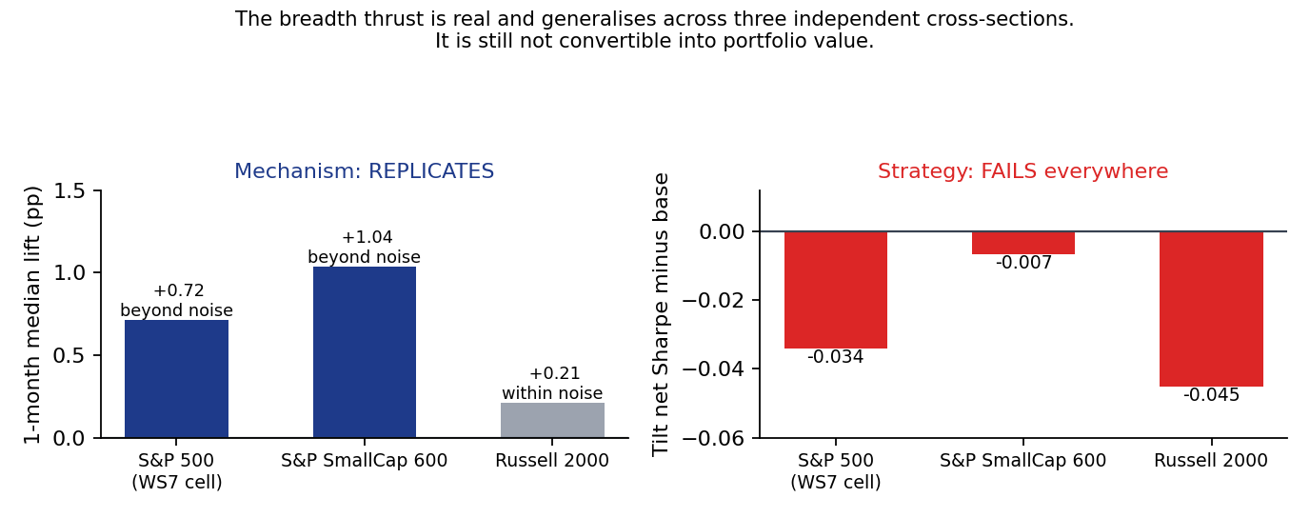
The two halves of the verdict. Left: the median one-month lift replicates in both fresh universes, most strongly in the S&P SmallCap 600 where it clears the noise band on 42 distinct episodes. Right: the same signal, run as a tilt, loses to the untilted base in every one of the three.
The gate passes, and one result is worth more than the gate. Small-cap breadth carries a LARGER lift than large-cap — +1.04pp against +0.72pp — and clears the noise band on a healthy episode count. That is economically coherent: a thrust across 600 smaller names is a more meaningful statement about market participation than the same reading across 500 mega-caps, where a handful of index heavyweights dominate the return the signal is trying to predict. The Russell 2000 read is the weakest of the three and is reported as positive-but-within-noise, not as confirmation.

6. Deviations from the specification
Two, both forced by data rather than chosen, both guarded, both logged in code at the point of use.
Deviation | Reason and guard
Bond leg is a synthetic constant-maturity 10-year Treasury total return, not IEF | IEF begins 2002-07-26 and the window opens 1990. Splicing at 2002 would put a seam mid-sample, so one consistent methodology is used throughout. Guard: validated against IEF over the 6,041-day overlap — correlation 0.957, annual return gap −0.39pp. The decision is near-insensitive in any case, because the signal portfolio and its null share the same bond leg.
Count-based thresholds scaled by universe size for replication | The McClellan floor (−50 net advances) and net new highs (>20) are counts, not ratios. On a 1,950-name Russell they represent a quarter of the fraction they do on a 500-name S&P, so the literal reading would make the signal roughly four times looser — the opposite of a faithful replication. Guard: both scaled and literal runs are reported, and scale = 1.0 leaves every filed S&P 500 result bit-identical, verified by re-running the WS7 H1 decision.

7. Decisions
Component | Decision | Basis
Thrust as an exposure-tilt strategy | REJECT | Fails its null and its own median; all 18 variants below base; fails in all three universes
Thrust as a real breadth phenomenon | CONFIRMED | Replicates beyond noise in the S&P 600 on 42 episodes; positive in the Russell 2000
Small-cap breadth as the stronger read | FLAGGED | +1.04pp against +0.72pp large-cap; the one live thread left
EDD integration | REJECT | Intervention surface is four to seven events in 28 years
Frozen engine constants | KEEP | Untouched; scaling only restores their meaning across universes

8. Trial register and artefacts
23 configurations evaluated, 0 parameters tuned, 0 selected for deployment. 18 tilt variants on the S&P 500, four replication runs (two universes × two scaling modes), and one null of 2,000 draws. Tilt size, hold length, base weights, cost model and the decision rule were all fixed in the pre-registration and committed to version control before this code existed. Both deviations are logged above rather than folded silently into the result.
Artefact | Path
Pre-registration | C:/dev/KICKOFF_ws8-thrust-tilt-deployability.md (vault-docs@8740710)
Backtest | scripts/ws8_tilt.py
Replication | scripts/ws8_replication.py, scripts/ws8_fetch_universes.py
Charts | scripts/ws8_charts.py, reviews/charts/ws8_*.png
Results | reviews/2026-08-01_ws8_results.json, reviews/2026-08-01_ws8_replication.json
Running memo | RESEARCH_MEMO.md, WS8 section

9. Next phase
- Nothing further on the tilt. It failed its null, its base and every variant, in three independent universes.
- The one live thread is the S&P SmallCap 600 result. Small-cap breadth carries the stronger signal, and whether it is monetisable in a small-cap vehicle rather than as an SPX tilt has not been asked. That needs its own pre-registration and should not be bolted onto this one.
- Do not revisit the EDD integration or the state-conditional overlay without new evidence; both are recorded as dead with their reasons.
- Standing requirement adopted from this workstream: every pooled conditional figure in this project carries a composition check. The defensive-state artefact was large, plausible and entirely spurious, and only splitting the sample exposed it.

Prepared by | Claude Code research session, under direction of Zhenghao Phua
Reviewed and approved by
Date
Next review | Only if a small-cap-vehicle study is pre-registered

Personal research artefact. Not investment advice. Not affiliated with any regulated fund. Vendor data used under a personal-use licence; no vendor series values are reproduced in this record.

