WS4 — Breadth stress-test (primer replication on own data)
breadth-thrust-signal · equity-defense-dashboard · pre-registered spec KICKOFF_ws4-breadth-stresstest.md
Friday, 3 July 2026

Project / context | breadth-thrust-signal + equity-defense-dashboard (Personal); WS4 of the BofA Quantitative Primer operationalisation
Review scope | Mapping audit of deployed breadth reads; H1 level-vs-change information content; H2 level-quartile contrast vs the reused Phase 0 thrust study; H3 narrowness replication; H4 defence-composite attribution
Evaluation window | H1/H2: 2,109 valid-breadth days 2018-01-08 to 2026-05-29. H3: 255 months 2004-05 to 2025-07. H4: 7,167 days 1998-01-05 to 2026-07-02 plus a 2014-onward subwindow
Data basis | Point-in-time CSP1 constituent breadth (raw ma_breadth); Phase 0 SPX series; SPY/RSP adjusted closes (Yahoo Finance); committed EDD daily rows
Method basis | forward_returns.py machinery (one-day lag guard, moving-block bootstrap, 2,000 draws, block 21, seed 42); EDD engine replicated exactly (0 score mismatches; equity curves match stored bt to the cent); repo cost model 10 bps per unit of allocation change
Repository commits | breadth-thrust-signal 0e9ec6a; equity-defense-dashboard e0079e5; spec and ledger in vault-docs
Running memo | breadth-thrust-signal/RESEARCH_MEMO.md
Outcome | Narrowness-as-bearish debunked on own data; washout-level entries carry beyond-noise lift (gate design supported); thrust study stands; EDD Blowup and VIX legs add nothing net of costs — Blowup ON NOTICE; no configuration changed

Executive summary
- The audit found no narrowness-as-warning reading in any deployed signal: D1–D4 are thrust-type; the Phase 19 gate and the EDD Blowup count read washout and stress participation, a different object from the narrow leadership the primer debunks.
- H3 (narrowness replication): months where trailing-12m SPY beat RSP by more than 0 / +2 / +5ppt were followed by positive 12-month SPY returns 82.4% / 85.3% / 95.1% of the time, against an unconditional 85.1% — no bearish information, directionally replicating the primer.
- H1: breadth LEVEL carries small beyond-noise CONTRARIAN information at 1m–6m (−0.9ppt to −1.8ppt forward return per +1σ of level; R² at most 3.6%) — low breadth precedes higher returns. The 21-day change adds little on its own.
- H2: fresh washout entries (level crossing below the 0.440 quartile) beat the bootstrap noise band at 1m (76.5% vs 67.4% base) and 6m (84.8% vs 74.8%); strength entries carry nothing (6m 65.7%, below base). The Phase 0 thrust study is reused and stands as filed.
- H4: with the EDD engine replicated to the cent, removing the Blowup stress count changes ΔSharpe −0.006 and ΔMaxDD 0.0ppt — ON NOTICE per the pre-registered bands; the VIX term-structure leg is similar (−0.011); the three trend/momentum legs are load-bearing (removal takes MaxDD from −24.9% to −36%/−40%).
- No deployed configuration was changed. Findings feed the next scheduled review.

Verified map — what the deployed signals actually read
The stress-test memo (2026-06-17) was written without code access and feared a narrowness-as-warning reading inside the deployed signals. The audit of the actual implementations found none. Code beats docs; the corrected map is the load-bearing finding of the workstream.
Signal | Implementation (verbatim source) | Read type
D1 A/D thrust | Zweig EMA(10) of A/(A+D) crosses 0.40 to 0.615 within 10 sessions; OR Deemer 10d cumulative A/D above 1.90; OR McClellan oscillator below −50 then above 0 within 20 sessions (compute_breadth.py:192-234) | Thrust (change)
D2 %>50dMA thrust | Share above 50d MA surges from below 25% to above 75% within 15 sessions (:237-241) | Thrust (change)
D3 NH/NL thrust | NH/(NH+NL) below 10% to above 50% in 10 sessions; OR net new highs from negative to above +20 in 10 sessions (:244-262) | Thrust (change)
D4 up-volume | Up-volume at least 90% of total on one or more of the trailing 5 sessions (:265-270) | Participation surge
Phase 19 gate | CSP1 share above 50d MA; de-risk 50% to SHY below 20%, re-engage above 50%, hysteresis (run_risk_overlay.py:95-114) | Washout LEVEL
EDD Blowup | Rolling 8-day count of S&P names down at least 7%, threshold 115, 89-stock sample scaled to 500 (compute_signals.py:35-92) | Stress-count LEVEL

The washout and stress LEVEL reads measure crash participation, not leadership concentration. They are tested on their own merits in H1 and H4 rather than condemned by association with the debunked narrowness claim.

Findings

H1 — breadth level vs breadth change
Standardised OLS of forward index returns on the raw breadth level and on its 21-day change, one-day lag, with a moving-block bootstrap 90% interval on the slope. The level series is taken raw from breadth_csp1.json and never derived from the thrust pipeline state.
Horizon | Level slope /1σ | Level boot 90% | Change slope /1σ | Change boot 90%
1m | −0.94ppt SIG | [−1.50, −0.32] | −0.43ppt ns | [−0.99, +0.12]
3m | −1.33ppt SIG | [−2.49, −0.12] | −0.43ppt ns | [−1.54, +0.58]
6m | −1.78ppt SIG | [−3.27, −0.22] | −1.42ppt SIG | [−2.77, −0.21]
12m | −2.15ppt ns | [−4.79, +0.63] | +0.33ppt ns | [−2.14, +2.28]

The level slope is negative and beyond bootstrap noise at 1m to 6m: LOW breadth precedes HIGHER forward returns. The memo paraphrase that level carries nothing is not supported; what level carries is washout mean-reversion, consistent with both the primer (narrowness mean-reverts) and the Phase 19 gate design. R-squared never exceeds 3.6% — context, not a timing engine. Non-overlapping subsamples agree in sign at every horizon.

H2 — level-quartile entries vs the reused thrust study
Fresh entries into the bottom and top level quartiles (Q1 0.440, Q3 0.724; 21-day de-cluster; one-day lag), against the same moving-block bootstrap baseline as Phase 0. Thrust rows are quoted from the filed Phase 0 study, not recomputed.
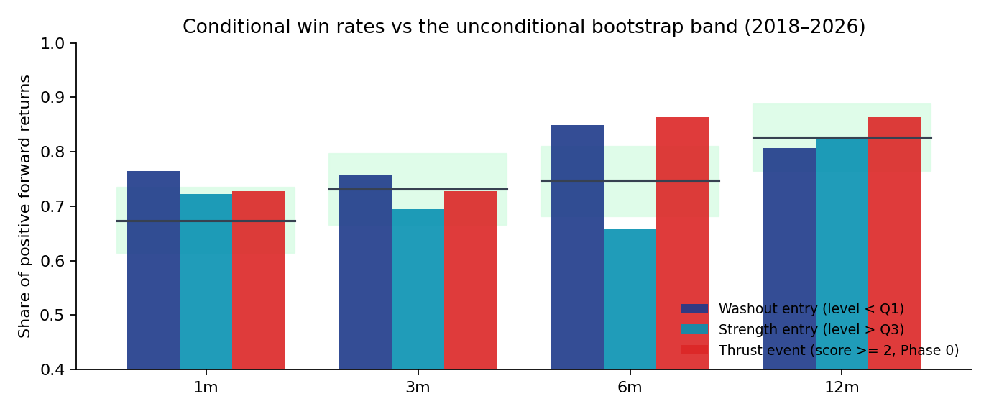
Share of positive forward returns by condition and horizon. Bars: washout entries (navy), strength entries (teal), Phase 0 thrust events at score 2 or more (red). The green band behind each group is the unconditional bootstrap 5–95% range with its median line: a bar clearing the band is beyond noise. Washout entries clear it at 1m and 6m; strength entries never do.
Condition | n | 1m win (base 67.4%) | 6m win (base 74.8%) | 12m win (base 82.7%)
Washout entry | 34 | 76.5% beyond noise | 84.8% beyond noise | 80.6% ns
Strength entry | 36 | 72.2% ns | 65.7% ns | 82.4% ns
Thrust, score ≥2 (reused) | 22 | 72.7% ns | 86.4% (median lift passes) | 86.4% ns

H3 — narrowness replication (reference exhibit)
A month is mega-cap-led when trailing-12m SPY total return beats equal-weight RSP by more than the threshold. Subsequent 12-month SPY return sign, monthly observations 2004-05 to 2025-07 (n=255; unconditional positive share 85.1%). Pre-registered as a reference replication with no decision attached; effective independent sample is 8 to 11 years.
Threshold | Flagged months | Subsequent 12m positive | Episodes
>0ppt | 136 (~11.3y) | 82.4% | 15
>+2ppt | 102 (~8.5y) | 85.3% | 13
>+5ppt | 41 (~3.4y) | 95.1% | 8

Narrow leadership carried no bearish information on own data; at the strongest threshold the subsequent positive share was above the unconditional base. Directionally replicates the primer finding (roughly 76% positive on their 1986-onward window). The graveyard entry in regime-library now records these numbers.

H4 — defence-composite attribution (equity-defense-dashboard)
The S5 composite engine was replicated exactly before any variant ran: recomputed scores equal the stored compositeScore on all 7,167 rows, and the recomputed equity curves match the stored bt.comp and bt.compIef to the cent. The one subtlety was the source expression rolling[i].get(key, CASH_RATE) or CASH_RATE, which coerces defensive returns of exactly 0.0 to the cash rate. The repo cost model applies: 10 bps per unit of allocation change, changes below 0.01 free.
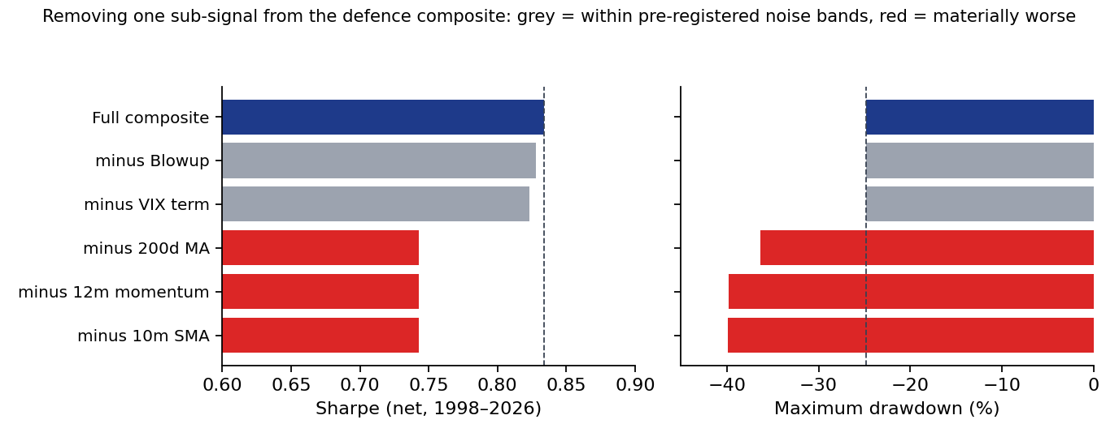
Leave-one-out on the five-sub-signal composite, full window 1998–2026, IEF defensive leg, net of costs. Left: Sharpe. Right: maximum drawdown. Navy = deployed full composite; grey = removal stays within the pre-registered noise bands (Sharpe within 0.05, drawdown within 2ppt); red = removal is materially worse. The Blowup stress count and the VIX term-structure leg are grey — the composite does not need them; the three trend and momentum legs are red — they carry the drawdown protection.
Variant | Sharpe | CAGR | MaxDD | Switches
Full composite | 0.834 | 10.15% | −24.9% | 103
minus Blowup | 0.828 | 10.22% | −24.9% | 93
minus VIX term | 0.823 | 10.30% | −24.9% | 83
minus 200d MA | 0.743 | 9.90% | −36.3% | 80
minus 12m momentum | 0.743 | 9.19% | −39.8% | 122
minus 10m SMA | 0.743 | 9.51% | −39.9% | 98

The 2014-onward subwindow shows the era-dependence the spec flagged: removing trend legs IMPROVES post-2014 results (Sharpe up to 0.950 vs 0.794 full) because a V-shaped era penalises defence, while the full window prices their bear-market value. The minus-Blowup delta is within band in both windows (−0.006 full, −0.023 post-2014). Solo runs through the composite allocation map are degenerate (one sub-signal cannot reach the score-2 trigger); the solo view is the repo standalone strategies S1–S4, quoted in the results JSON.

Decisions
Component | Decision | Basis
D1–D4 thrust dimensions | KEEP | H2: Phase 0 study reused, stands as filed
Phase 19 washout gate design | KEEP — no action (closed at WS3) | H1 contrarian level slope; H2 washout lift beyond noise
Narrowness-as-bearish concept | REJECT — graveyard | H3: 82–95% positive vs 85.1% base
EDD Blowup sub-signal | ON NOTICE | H4: ΔSharpe −0.006, ΔMaxDD 0.0ppt, within bands
EDD VIX term-structure leg | FLAGGED (informational) | H4: ΔSharpe −0.011, within bands
EDD trend/momentum legs | KEEP | H4: removal takes MaxDD to −36%/−40%

Scope guard held: no deployed configuration was changed by this workstream. The ON-NOTICE and FLAGGED items are documentation states that feed the next scheduled review of the equity-defense-dashboard.

Trial register
Approximately 65 configurations were evaluated and none selected for deployment: 8 regressions (H1), 10 level-conditional rows plus 20 reused thrust rows (H2), 3 thresholds (H3), and 44 attribution runs (H4: 11 variants by 2 defensive legs by 2 windows). Quartile boundaries, the 21-day de-cluster window and the decision bands were fixed in the pre-registered spec before any test ran; no parameter was tuned to the data.

Artefact register
- Spec: C:/dev/KICKOFF_ws4-breadth-stresstest.md (pre-registered 2026-07-03)
- Scripts: breadth-thrust-signal/scripts/ws4_stresstest.py and ws4_charts.py; equity-defense-dashboard/scripts/ws4_attribution.py
- Results: breadth-thrust-signal/reviews/2026-07-03_ws4_results.json; equity-defense-dashboard/reviews/2026-07-03_ws4_attribution.json
- Charts: breadth-thrust-signal/reviews/charts/ws4_h2_winrates.png, ws4_h4_loo.png (generated by committed script)
- Running memo: breadth-thrust-signal/RESEARCH_MEMO.md
- Commits: breadth-thrust-signal 0e9ec6a; equity-defense-dashboard e0079e5
- Graveyard update: regime-library/indicators/graveyard-breadth-narrowness.yaml (H3 numbers recorded)

Next phase
Feed the Blowup ON-NOTICE and VIX-leg findings into the next scheduled equity-defense-dashboard review. The washout-entry lift found in H2 is a candidate future study as an entry-timing overlay; it requires its own pre-registered spec and must not be bolted onto this record. The factor-regime-lab kickoff proceeds separately after its interview.

Prepared by | Claude (research analyst)
Reviewed and approved by | Phua Zhenghao — pending
Date | 2026-07-03 (Friday)
Next review | Next scheduled equity-defense-dashboard review

Internal research record. Hypothetical, net-of-assumed-cost backtests on historical data; results reflect the stated windows and assumptions and are not indicative of future performance. Not investment advice and not for external distribution.

