Buy the Dip — full-history evaluation record
Phase 1 anchor replication · Phase 2b design and validation · Phase 3b replication
Saturday, 4 July 2026

Project / context | buy-the-dip (Personal). CrackingMarkets strategy-family reconstruction on Norgate full-depth data (Platinum active 2026-07-04, term to 2027-01-04).
Review scope | Post-subscription runbook steps 0-3; Phase 1 anchor replication; Phase 2b design battery and single validation pass; Phase 3b design battery, full-window replication and anchor-miss investigation.
Evaluation windows | Phase 1: 2000-01 to 2024-09 (anchor) and to 2026-07 (record). Phase 2b: design 2000-2017, validation 2018 to 2026-07, executed once. Phase 3b: design 1994-2017, source window 1994 to 2025-01, record to 2026-07.
Data basis | Norgate point-in-time index constituency with delisted securities (SPX universe 1,299 names, NDX 479; both set-identical to vendor watchlists). TOTALRETURN series for signals and fills; unadjusted series for absolute price screens.
Method basis | Pre-registered designs PHASE2_DESIGN.md / PHASE3_DESIGN.md (frozen 2026-07-03, before full-history data existed); positional exits; costs 7 bps per side in the portfolio engines; baseline costless to match the published anchor.
Repository commits | 736a732 (engine controls, pre-approval) · c20735f (results, records, dashboard).
Running memo | RESEARCH_MEMO.md (project root).
Outcome | Phase 1 PASS. Phase 2b validation gates NOT MET — weekly variant not taken forward. Phase 3b anchors not replicated within tolerances; dominant driver identified and quantified; character replicates.

1. Executive summary
- Phase 1 (published daily baseline) replicates: 25,603 trades and 57.04% winners on 2000-01 to 2024-09 against the published ~25,000 and 56.81%, average win +3.19% versus average loss −2.93%, zero symbol failures. The anchor requires one open position per symbol; entering on every signal bar gives 52,129 trades at 57.22%, so the source’s "overlapping trades allowed" is portfolio-level concurrency, not same-symbol pyramiding.
- The replication is insensitive to the undisclosed adjustment basis: capital-only adjustment gives 24,639 trades and 56.62% winners — the published anchors sit between the two bases.
- Phase 2b validation (2018-01 to 2026-07, executed once, no iteration): every configuration fails the pre-registered gates — primary Sharpe 0.548 and profit factor 1.42, below-high trigger 0.479 / 1.30, below-high plus breadth 0.498 / 1.32 (gates: at least 0.7 and 1.5). The design-segment ranking inverted out of sample; the weekly variant is not taken forward.
- Phase 3b design segment (1994-2017) is plateau-stable around the source defaults (primary 10.6% p.a., Sharpe 1.07, maximum drawdown −13.2%, usage 7.7%); the S&P 500 transplant strengthens the mechanism (14.2% p.a., Sharpe 1.39, usage 11.3%).
- Phase 3b full-window replication fails the acceptance gate under the pre-registered order-placement convention (CAGR 9.84% versus 19.17%; usage 7.32% versus ~13.9% on the source window). The registered investigation identifies the free-slot placement convention as the dominant driver: an all-signals placement variant reaches 15.37% CAGR and 9.27% usage — roughly 60% of the CAGR gap — with the per-trade profile intact. The residual is attributed to the source’s non-compounding fixed-capital form and undisclosed costs.
- Forty-five backtest executions this session; zero configurations taken forward; one engine convention (baseline no-reentry) adopted on anchor-match evidence rather than performance.

2. Verified data layer and engine map
Runbook steps 0-2 preceded every result. The NDU archive was verified complete by breadth checks, not a single-symbol probe: 14,421 current plus 21,046 delisted symbols; a 40-name delisted sample shows first bars distributed 1990-2021 with none clustered at 2024 or later; MSFT’s first S&P 500 member-day reads 1994-06-07, its true join date; Nasdaq 100 constituency begins 1993-10-01, which both covers the Phase 3 design segment and explains the source’s 1994 start.
- Depth gate: the weekly engine hard-failed on the warm trial-depth cache before any refresh ("Cache depth mismatch", exit 1); the same guard is now wired into the baseline engine via a pre-sweep probe.
- Universes: full membership scans over 35,467 candidates rebuilt both lists (SPX 542 to 1,299; NDX 125 to 479), each set-identical to the vendor watchlist — two independent construction paths agreeing symbol for symbol. The trial watchlist quirk resolved itself post-subscription.
- Calendar conventions: $NDX (1985 onward) is the Phase 3 calendar and benchmark because $NDXTR only begins 1999-03; %IRX (1960 onward) backs the T-bill cash alternate.
- Absolute price screens ($5 minimum, dollar-volume) read the unadjusted traded series; back-adjusted screens would exclude early-history compounders (AAPL’s 2000 total-return close is about $0.11). Sensitivity shows the effect is small for S&P large caps (378 versus 375 trades).

3. Findings

F1 — the published baseline replicates, and the convention matters more than the indicator
Wilder RSI(5) under 20 with close above the 200-day average, five-bar positional exits, point-in-time membership: the win rate lands within a quarter point of the published figure under either entry convention, but the trade count only matches under one open position per symbol. Dip episodes persist for several days, so per-signal stacking roughly doubles the count without changing per-trade statistics. The trial window’s apparent two-times trade rate was this convention, not the 2025 regime.
Configuration (2000-01 to 2024-09) | Trades | Win % | Avg win % | Avg loss %
Published anchor | ~25,000 | 56.81 | win > loss | —
No re-entry (adopted default) | 25,603 | 57.04 | +3.19 | −2.93
Per-signal stacking | 52,129 | 57.22 | +3.16 | −2.90
No re-entry, capital-only adjustment | 24,639 | 56.62 | +3.20 | −2.90

F2 — Phase 2b design segment: two alternates repaired 2000-02 and led the shortlist
The v1 primary’s entire −29.3% maximum drawdown sits in the 2000-02 bear (104 trades at 38.5% winners; the capitalisation-weighted 40-week gate whipsawed). The below-high dip trigger and the breadth gate each repaired that episode through a distinct mechanism and beat the primary on every headline metric at the same trade rate; their combination reached Sharpe 1.10, drawdown −15.9% and profit factor 2.34 on the design segment — a profile sitting on top of the published live-model statistics. The registered honesty checks moved in the pre-registered directions (weekly-close monitoring flatters; next-open entry is slightly better than same-close; costs move little). High-NATR ranking is decisively worse in this portfolio-with-stops context (Sharpe 0.43), resolving the ranking-direction question in favour of the live model’s low-volatility preference.

F3 — Phase 2b validation: the ranking inverted and every gate failed
The single validation pass ran exactly three configurations. All three failed the Sharpe and profit-factor gates while passing drawdown and trade-rate; hit rates fell from 56-62% in design to 48-51%. The unmodified primary validated best — the design-segment selection added negative value out of sample, which is precisely the failure mode the two-segment protocol exists to catch. Per the pre-registration there is no iteration: the weekly variant is not taken forward, and any successor requires a fresh pre-registration.
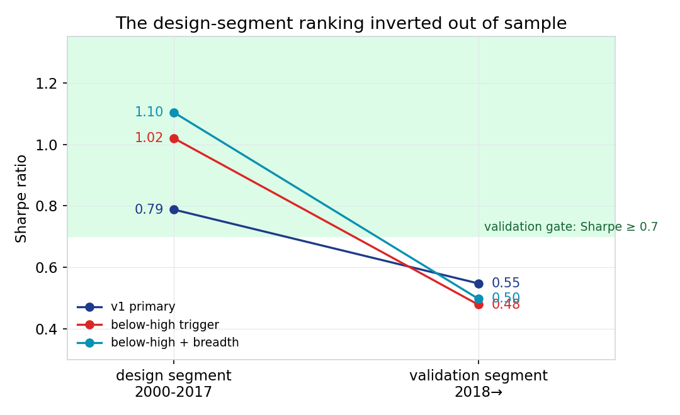
Sharpe by segment for the three validated configurations. The green region is the validation pass zone (at least 0.7). The steepest design-segment improvements collapse hardest out of sample; the ranking inverts.
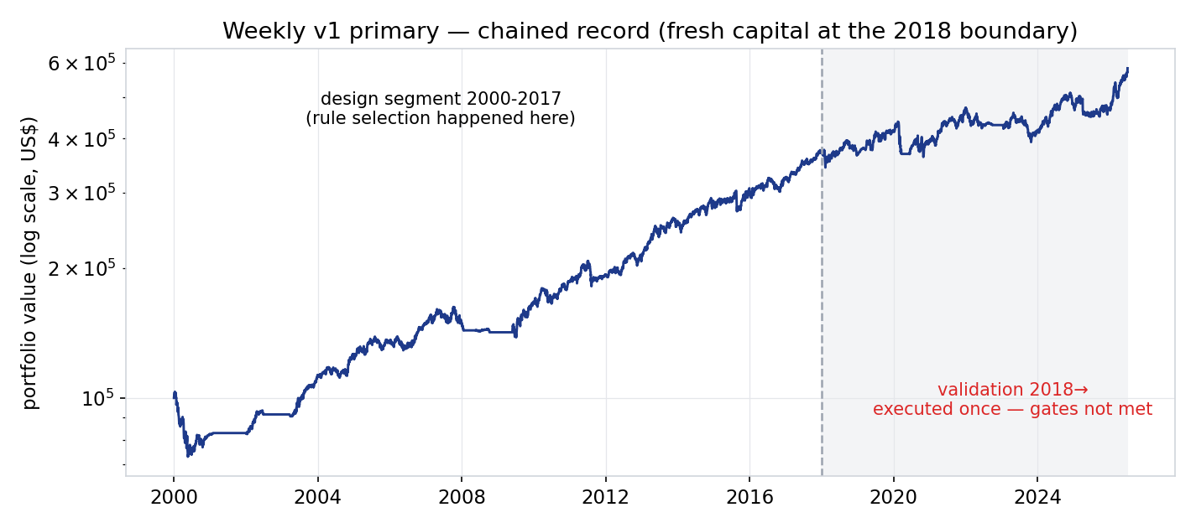
The published dashboard record: design and validation segments of the v1 primary chain-linked with fresh capital at the 2018 boundary. The chained curve’s own Sharpe (0.707) is incidental; the gate applies to the validation segment alone (0.548).

F4 — Phase 3b design segment: the source defaults are stable, not fitted
Every registered dial sits on a flat or defensibly-shaped plateau around the published defaults: dip depth flat across −2/−3/−4%; target multiple flat; the volatility filter and the liquidity screen nearly redundant; strict-touch fill and strict-target sensitivities indistinguishable from the defaults. Entry depth is the one cliff — 0.5 x ATR fills too easily and takes −30.7% drawdown — and the published 0.9 sits on the safe side. Pricing gap-through fills at the limit rather than the open costs about 2.4 CAGR points, so a visible share of the edge lives in gap-down fills; a real resting order does receive the better open price, so the default convention stands. The strategy earned +103% through 2000-02 at −11.9% drawdown — it monetises panic volatility, as the source claims.

F5 — Phase 3b anchors: not replicated within tolerances; the driver is order placement
Under the pre-registered free-slot placement convention the source window returns half the anchor CAGR at half the usage with materially lower drawdown and an in-family per-trade profile — a participation signature, not a signal difference. The registered investigation order (fill model first) identified the convention: placing orders only for free slots forfeits fills in exactly the volatility clusters the model monetises. The all-signals variant closes most of the gap; the residual (−3.8 CAGR points against a ±3 gate; −4.6 usage points against ±4) is attributed to the source’s fixed-capital, non-compounding form — simple annualisation on fixed capital reads above compound CAGR for a profitable strategy — and its undisclosed cost model. Character replicates cleanly: 68-69% winners, profit factor 1.8-1.9, one-to-two-day winners, drawdown well inside the published figure throughout.
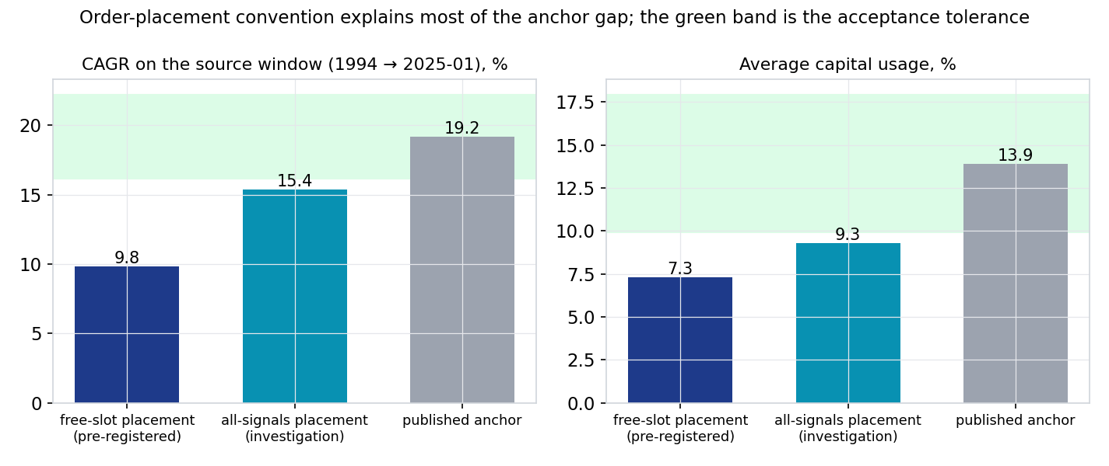
CAGR and average capital usage on the source window (1994 to 2025-01) under the two placement conventions, against the published anchors. The green bands are the pre-registered acceptance tolerances (±3 CAGR points, ±4 usage points).

4. Decisions
Component | Decision | Basis
Baseline entry convention | ADOPT no-reentry default | Anchor trade count matches only under one open position per symbol (F1); per-signal retained behind a flag.
Weekly variant (all configurations) | REJECT — not taken forward | Validation gates failed for primary and both shortlisted alternates; ranking inverted out of sample (F3). Successor requires a fresh pre-registration.
Weekly validation segment | CLOSED | Touched once by exactly three pre-registered configurations; no iteration.
Daily limit variant replication | RECORD as not-replicated-within-tolerances | Dominant driver identified and quantified (F5); residual attributed to undisclosed engine and metric conventions; character replicates.
Order placement conventions | KEEP BOTH, documented | Free-slots is the conservative deployable reading; all-signals is the faithful reading of the source backtester.
Price-screen basis | ADOPT unadjusted series | Back-adjusted screens exclude early-history compounders; logged as an implementation clarification of the registered rule.
Publication | PUBLISHED with verdicts on-page | Dashboard carries the chained record and the gates-not-met banner; derived aggregates only, licensed raw data excluded (commit c20735f).

5. Trial register
Forty-five backtest executions across approximately forty distinct configurations: Phase 1 conventions and sensitivities (4); Phase 2b design battery including the combination (18); Phase 2b validation, executed once (3); Phase 3b design battery including the transplant and the all-signals investigation (18); Phase 3b full-window replication under both placement conventions (2). Zero configurations were selected for deployment, so no deflated-Sharpe haircut is charged against a deployed claim; the register exists to charge any future revival of these families for this search.
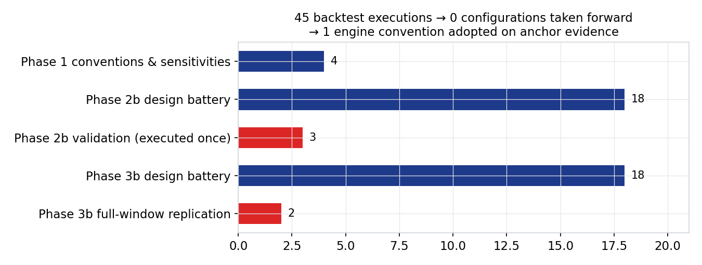
Executions per family. Red bars touch validation-era data and were run exactly once each under owner approval; blue bars are design-segment or anchor-window work.

6. Artefact register
- Engines and controls: scripts/backtest_baseline.py, scripts/backtest_weekly.py, scripts/backtest_daily_limit.py, scripts/providers.py (63 tests passing).
- Run records (derived aggregates, committed): data/baseline_anchor_*, data/baseline_noreentry_full_summary.json, data/baseline_anchor_capital_summary.json, data/weekly_design_*_summary.json, data/weekly_valid_*, data/daily_limit_full_*, data/daily_limit_full_allsignals_*, data/dl_design_*_summary.json, plus headline trade and equity CSVs.
- Dashboard: template.html and docs/index.html (chained record, verdict banner), data/dashboard.json via scripts/pipeline.py.
- Design documents with appended verdict records: PHASE2_DESIGN.md (validation record), PHASE3_DESIGN.md (replication record). README status entries 2026-07-04; open issues 1/2/3/4/6/7 closed, issue 8 opened and answered.
- Charts: scripts/record_charts.py writes reviews/assets/*.png from committed data.
- Running memo: RESEARCH_MEMO.md. Commits: 736a732, c20735f.

7. Next phase
- Weekly family: dormant. Reopening requires a fresh pre-registration that inherits this trial register; the validation segment stays closed to iteration.
- Daily limit family: the replication record is complete. Any deployment question would start from the free-slots (conservative) record at small size and would need its own pre-registration; the stacking study with the weekly variant is moot.
- Dashboard: a daily-variant panel and a visual validation-boundary marker are queued as mechanical template work for an Opus-fast session per the project session-model guidance.
- Norgate: renewal or right-sizing decision due December 2026 (shared with em-rotation-lab).

Prepared by | Claude (Fable 5), buy-the-dip research session 2026-07-04
Reviewed and approved by | Zhenghao Phua — validation and publication approved in-session 2026-07-04; record sign-off pending
Date | 2026-07-04 (Saturday)
Next review | Event-driven: any revival pre-registration, or the December 2026 Norgate renewal decision

Personal research artefact. Not investment advice. All statistics are backtested results on survivorship-bias-free point-in-time data with the stated cost and fill conventions; published-source figures are quoted for comparison only and remain the source’s own claims.

