Crypto-Breadth v3.1 — robustness review
Deflated Sharpe · full-config walk-forward · cost stress · weak-patch autopsy · concentration & gate ablations
Saturday, 4 July 2026

Project / context | Crypto-Breadth (Personal research); public repo phuazz/crypto-breadth
Review scope | Deployed-to-repo v3.1 (Binance USDT 25-coin cross-sectional momentum + breadth gate + per-coin trend filters): Phase B (deflated Sharpe, full-config walk-forward, cost/execution stress, weak-patch autopsy, C.2 vol-target overlay), C.3 concentration, C.4 gate ablation
Evaluation window | 2018-01-01 → 2026-07-03 daily; IS 2018–2020, OOS 2021+; full-config walk-forward re-fit per anchor year 2020–2026
Data basis | data/prices.parquet (Binance USDT spot), frozen; no new vendor. Substrate carries a survivorship caveat (§3.1)
Method basis | v3.1 engine frozen as the review baseline; realistic costs 10–50 bps/side; rule PR-1 pre-registered before data; deflated-Sharpe haircut over ~50 reconstructed trials
Repository commits | 45c2d9a → f816527 (7 commits, 2026-07-04)
Running memo | RESEARCH_MEMO.md (PR-1 + post-hoc amendment; REVIEW CLOSE)
Outcome | REVIEWED — KEEP (amended): edge real, deploy as a small crypto sleeve; original −30%-rule verdict was do-not-deploy

1. Executive summary
- KEEP (amended). v3.1's edge is statistically real and beats passive crypto risk-adjusted — full-sample Sharpe 1.35 vs BTC 0.61 and 60/40 0.66; OOS (2021+) Sharpe 1.43. Deploy as a small diversifier sleeve.
- Not a multiple-testing fluke. Deflated Sharpe ≥ 0.999 across N = 10–200 reconstructed trials (≈50 base) — the edge clears the noise floor after charging for the search.
- Parameters are not overfit. A 60-config annual re-fit (full-config walk-forward) loses only +0.08 Sharpe OOS versus the frozen config; (30,90,180) + top-4 was in-sample-best in all seven anchor years.
- Cost-robust. Full Sharpe holds 1.35 → 1.21 from 10 to 50 bps/side; OOS 1.43 → 1.28.
- Drawdown is deep but not disqualifying. −44.8% (peak Dec-2024 → trough Jun-2026), far shallower than passive crypto (BTC −81%, 60/40 −85%). The original −30% deploy ceiling was removed post-hoc as an equity frame mis-applied to crypto (§5).
- Three caveats govern sizing, not the decision: a survivorship-optimistic headline (25-coin universe hindsight-selected; 40/40 era-liquid deaths absent), a 2021-concentrated track (+1882% one year), and an on-notice 2025–26 weak patch.
- The modification path failed. Concentration (C.3a) hurts; a majors time-series engine (C.3b) is weaker and no shallower. The breadth gate is validated (load-bearing; beats a BTC-200d filter).

2. Verified architecture
The reviewed engine (scripts/backtest.py, frozen) is a weekly cross-sectional momentum book: composite risk-adjusted momentum over 30/90/180 days, top-4 equal-weight, gated by the share of the investable universe above its 50-day moving average (tiered 0/30/60/100% gross), with a strict per-coin trend-entry filter and an asymmetric daily trend-exit. Signals observed at close T, traded at close T+1; 10 bps/side. The universe is a rolling-liquidity gate over 25 Binance USDT pairs.
Drift from the written record (code beats docs): the README claimed the rolling gate 'removes the survivorship bias of any hand-picked fixed list'. It does not — the 25 names are themselves a hindsight-selected set (§3.1). Corrected in the README in this review.

3. Findings

3.1 Survivorship & data substrate (Phase 2)
The universe is a fixed, hindsight-selected 25-coin list, not a point-in-time construction: no coin ever delists (every name runs to the panel end), and 40 of 40 well-known 2019–2021 Binance USDT era-majors are absent — the candidate pool is under 40% of the true era-liquid set, with the gap concentrated in the alt-heavy years (2019, 2021). The survivorship-selection bias is therefore optimistic and material; it cannot be point-estimated without the full Binance listing (out of scope under the no-new-vendor rule) and is carried as an upper-bound caveat. Mitigants: the two most violent deaths (LUNA worst 1-day −100%, FTT −75%) are honestly captured, the Binance→CryptoCompare handover shows no discontinuity, and interior data gaps are handled by the investability mask.

3.2 Statistical significance — deflated Sharpe
Reconstructed trial count ≈ 50 (sensitivity OAT ~33 + vol-target grid 12 + walk-forward grid 6 + structural ladder ~5, net of overlaps). Trial-Sharpe dispersion from the 60-config grid = 0.124 annual. The deflated Sharpe stays at or above 0.999 for every assumed N from 10 to 200 — the edge is far above the multiple-testing noise floor and is not an artefact of the search. (This is orthogonal to the survivorship bias, which concerns the level, not the significance.)
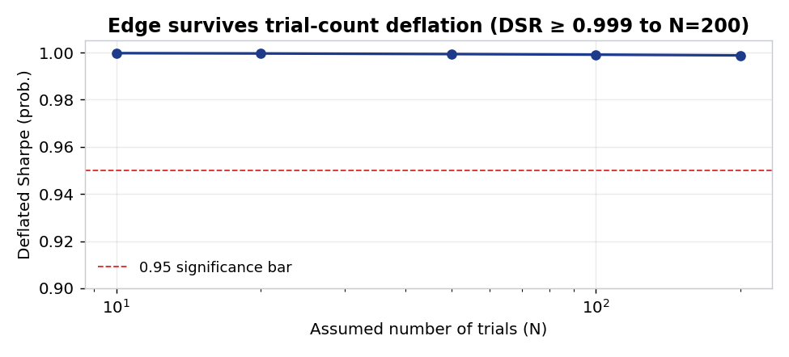
Deflated Sharpe (probability the true Sharpe exceeds the search-adjusted threshold) against the assumed number of trials. It stays ≥ 0.999 even at N = 200, well above the 0.95 bar (dashed).

3.3 Parameter robustness — full-config walk-forward
A 60-config factorial (momentum lookbacks × top-N × breadth-MA window) was re-selected annually on an expanding in-sample window and chained out-of-sample. Re-fitting scores Sharpe 1.357 versus the frozen 1.437 — it loses +0.080, well inside the 0.30 tolerance. (30,90,180) + top-4 was in-sample-best in all seven anchors; only the breadth-MA window wavered (70 in 2020–21, the default 50 thereafter). The parameters are not overfit.
Walk-forward | OOS Sharpe | Result
Frozen production config | 1.437 | baseline
Annual full-config re-fit | 1.357 | loses +0.080 (≤ 0.30 → pass)

3.4 Cost & execution stress
The daily trend-exit lifts turnover, so costs matter; the edge nonetheless survives taker-level fees.
Fee (bps/side) | Full Sharpe | OOS Sharpe | Full CAGR
10 (maker baseline) | 1.351 | 1.429 | 75.6%
20 | 1.315 | 1.391 | 72.3%
30 | 1.279 | 1.354 | 69.2%
50 (mid-size taker) | 1.206 | 1.280 | 63.0%

3.5 Weak-patch autopsy (C.1) — regime, not decay
The strategy made a new all-time high (214×) on 2024-12-02, then drew down −44.8% into 2026-06. In the weak patch the breadth gate is actively de-risking (average gross exposure 0.40 vs 0.63 in a good period; 42% in cash vs 26%), and the momentum score has not inverted (held-vs-eligible forward-5-day spread stays +0.15%). But the edge has thinned ~85% (good-period spread +1.02%, hit-rate 42%): the book needs alt-dispersion — fat-right-tail alt winners — and a BTC-dominated 2025–26 offered none. Diagnosis: a severe regime episode, not signal inversion; the strategy is on notice. The return profile is dominated by 2021 (+1882%), which is also the most survivorship-inflated year.
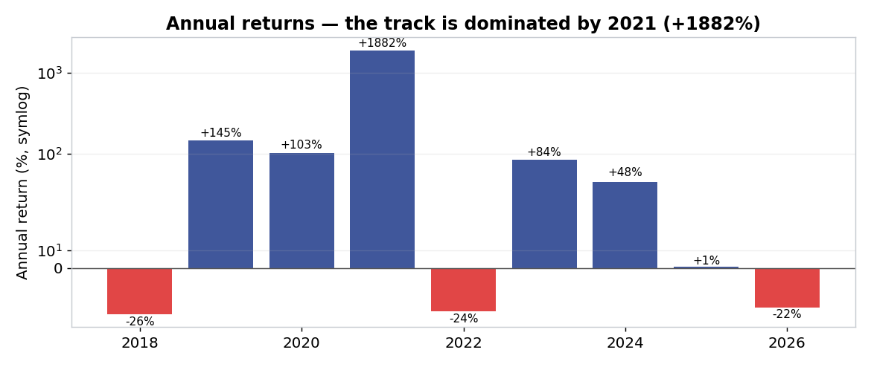
Annual returns (symmetric-log scale so every year is legible). 2021's +1882% dominates the whole track; strip it and the deployable edge is far more pedestrian.

3.6 Risk profile versus passive crypto — the deployability case
Judged against the correct benchmark — other crypto exposures, not equities — v3.1 dominates passive crypto on both risk-adjusted return and drawdown. This is the basis for the amended KEEP.
Series | Full Sharpe | Max drawdown
Strategy v3.1 | 1.35 | −44.8%
BTC buy-and-hold | 0.61 | −81.2%
60/40 BTC-ETH | 0.66 | −85.5%

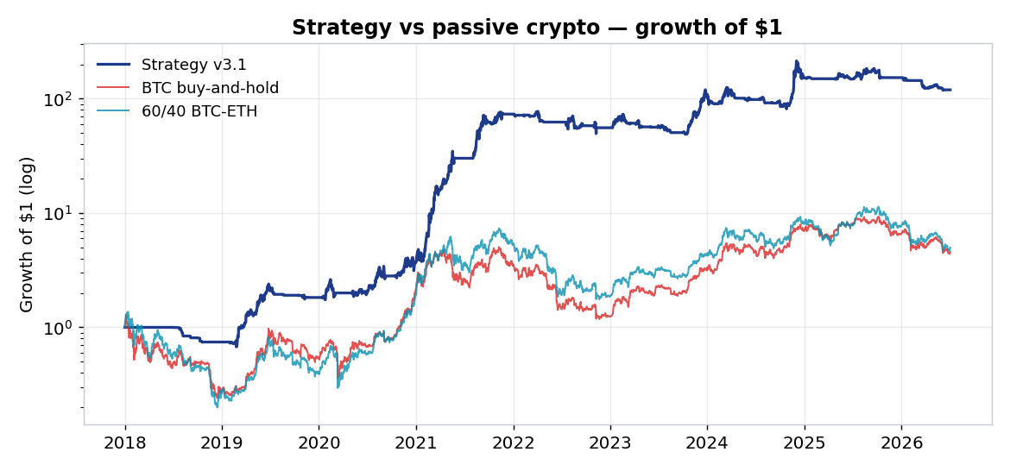
Growth of $1 (log scale). The strategy compounds far above BTC and 60/40 over the full sample; the outperformance is concentrated in the alt years.
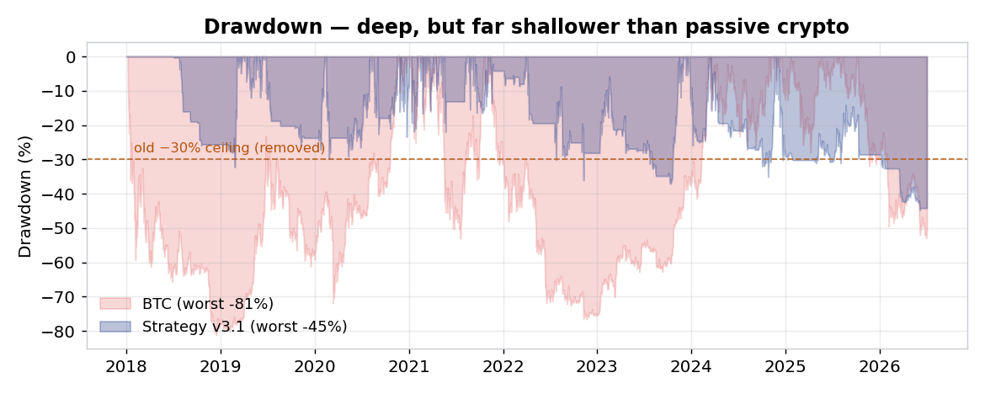
Drawdown. The strategy's worst is −45% versus BTC's −81%; deep in absolute terms but roughly half of passive crypto. The dashed line marks the removed −30% ceiling.

3.7 C.2 vol-target overlay (registered arm)
The risk-overlay-lab round-1 winner (EWMA estimator, 0.10 band, cap 1.0, weekly) transferred onto the crypto book trims the tail but does not transform it: MaxDD reaches −33% at best (target 30%, at a Sharpe cost to 1.04) and −35 to −38% at higher targets. The equity-book overlay does not fully transfer because the crypto tail (excess kurtosis 17.5, single-day gaps) outruns a lagged vol estimate. Overlay = optional tail-trimming, not a structural fix.

3.8 C.3 concentration (Phase 4) — rejected
Neither concentration arm produces a better book. Shrinking the eligible pool by trailing ADV monotonically degrades the cross-sectional engine (Sharpe 1.35 at 25 names → 0.84 at 4; drawdown worsens) — starving the ranker of breadth starves the signal. A new majors time-series-momentum engine (BTC+ETH / top-5-ADV × MA / MA-rising / 12−1 TSMOM × equal-weight / vol-target) is lower-Sharpe on every variant (best 0.87) and no shallower (best −50.6%); the deep drawdowns are genuine single-day gap risk (worst −74% = the COVID crash), which a weekly long-only filter cannot dodge. No deployable candidate emerged.

3.9 C.4 gate ablation (Phase 5) — validated
The gate is the single most important component: removing it collapses Sharpe by 0.61 (1.35 → 0.74) and blows the drawdown out by 38 points (−45% → −83%). The breadth gate beats a simple BTC-200-day filter full-sample (+0.17 Sharpe, shallower drawdown), so it earns its complexity. Two honest caveats: the tiering is redundant (a binary breadth gate matches the graduated one), and in the 2024+ weak patch the BTC filters edged breadth — the gate's superiority is regime-dependent.

4. Findings summary
Component / test | Result | Bearing on the verdict
Deflated Sharpe (N 10–200) | ≥ 0.999 | Edge is real (not a search artefact)
Full-config walk-forward | loses +0.08 OOS | Parameters not overfit
Cost stress (10–50 bps) | Sharpe 1.35 → 1.21 | Cost-robust
Weak-patch autopsy | regime, on notice | Score not inverted; on watch
Risk vs passive crypto | Sharpe 1.35 vs 0.61 | Deployment case
C.2 vol-target overlay | MaxDD → −33% best | Optional tail-trim
C.3a concentration | monotonically worse | Rejected
C.3b majors engine | weaker, −50%+ | Rejected
C.4 breadth gate | load-bearing; beats BTC-200d | Validated

5. Pre-registration amendment (the −30% ceiling)
The pre-registered rule (PR-1) set a hard −30% MaxDD deployment ceiling. On the results this proved binding — v3.1 (−44.8%) and every overlay / concentration / majors variant fail it. At the owner's instruction the ceiling was removed post-hoc and logged transparently (not a silent rewrite) to preserve pre-registration integrity. Rationale: −30% imported an equity-style drawdown frame onto a crypto book; the correct benchmark is passive crypto (BTC −81%, 60/40 −85%), against which −44.8% is far shallower. Effect: under the original frozen rule the verdict was MODIFY / do-not-deploy; under the amended rule it is KEEP / deployable as a small sleeve. Both are on the record. The 0.30 OOS Sharpe-loss tolerance is unchanged.

6. Decisions
Component | Decision | Basis
v3.1 strategy (as-is) | KEEP — deploy small | Real edge; beats passive crypto; caveats govern sizing
Breadth gate | KEEP | Load-bearing; beats BTC-200d filter
Gate tiering (0/30/60/100) | SIMPLIFY (optional) | Binary gate matches the graduated one
C.2 vol-target overlay | OPTIONAL | Trims tail to ~−33%; does not transform
C.3a concentration | REJECT | Monotonically degrades the ranker
C.3b majors engine | REJECT | Weaker and no shallower
−30% MaxDD ceiling | REMOVED (amended) | Equity frame mis-applied to crypto
Deployment sizing | FLAGGED | Small sleeve; survivorship + 2021 concentration + on-notice

7. Trial register
95 configurations were evaluated across the arms and logged in results/trial_registry.jsonl (99 rows including references): Phase-B full-config grid 60, C.2 overlay 5, C.3a shrink 5, C.3b majors engine 20, C.4 gate 5. None was selected by an out-of-sample metric; the deflated-Sharpe haircut in §3.2 charges for the search. No production parameter was changed by the review.
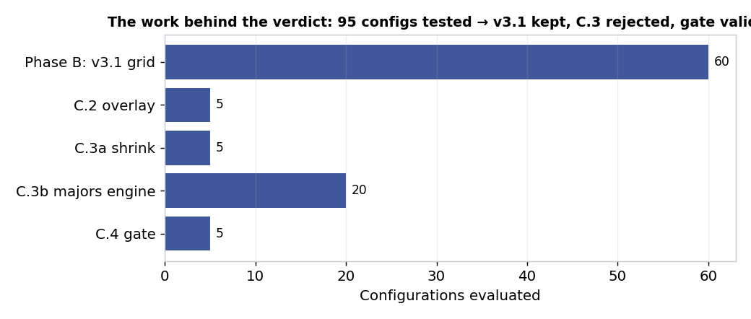
Configurations evaluated per arm. 95 tested → v3.1 kept unchanged, C.3 rejected, the gate validated. Rigour with restraint: the search did not move the production parameters.

8. Artefact register
- Harnesses: scripts/research/phase_b_review.py, phase_c3_concentration.py, phase_c4_gate.py, survivorship_audit.py, make_review_charts.py (all committed).
- Results: results/phase_b_review.{json,md}, phase_c3_concentration.{json,md}, phase_c4_gate.{json,md}, survivorship_audit.{json,md}, trial_registry.jsonl.
- Tests: tests/ (19 pytest engine unit tests); CI .github/workflows/tests.yml.
- Memo & policy: RESEARCH_MEMO.md, DATA_INTEGRITY_POLICY.md, CLAUDE.md.
- Repository: phuazz/crypto-breadth, commits 45c2d9a → f816527. Dashboard: phuazz.github.io/crypto-breadth.

9. Next phase
- If deployed: a small crypto diversifier sleeve, sized so a −45% book move is tolerable at the portfolio level.
- C.5 (perpetual-futures short / hedge) — parked; the only mechanism that can materially cut the crypto tail, for a larger allocation.
- Optional: apply the C.2 vol-target overlay for tail-trimming; simplify the gate to binary.
- Truly untouched out-of-sample begins 2027-01-01.

Prepared by | Claude Code research session, under direction of Zhenghao Phua
Reviewed and approved by
Date
Next review | On material regime change, or before any capital deployment

Personal research artefact. All performance figures are simulated backtests, net of stated costs, and carry a documented optimistic survivorship-selection bias; nothing here is investment advice.

