Crypto-Breadth v3.1 — what the review found
Plain-language summary for allocation review
Saturday, 4 July 2026

In one sentence | This crypto strategy has a genuine edge and beats simply holding Bitcoin — but its gains lean heavily on one boom year and it can still lose about 45%, so it belongs as a small, eyes-open sleeve, not a core holding.
Decision | KEEP — deploy small. (An earlier drawdown limit that would have blocked it was judged wrong for crypto and removed; that is on the record.)

1. The questions, and the answers
The question | The answer | How it was tested
Is the edge real, or luck from trying many versions? | Real — it survives a penalty for the ~50 versions tried. | Deflated Sharpe (edge after charging for the search)
Would we have picked these settings in advance? | Yes — re-choosing them each year barely changes the result. | Expanding-window walk-forward, 60 settings
Does it beat just holding crypto? | Yes — better return per unit of risk, and half the drawdown. | Versus Bitcoin and a 60/40 Bitcoin-Ether mix, after fees
What is the catch? | One year (2021) does most of the work, the test universe flatters it, and it is in a bad patch now. | Universe audit + year-by-year + recent-patch autopsy

Terms: 'risk-adjusted return' = return per unit of price swings, higher is better (Bitcoin ≈ 0.6, this strategy ≈ 1.35). 'Drawdown' = worst peak-to-trough loss. 'Sleeve' = a small book within a larger portfolio.

2. What we found

2.1 It beats simply holding crypto
Over 2018–2026 the strategy compounded far above Bitcoin and a 60/40 Bitcoin-Ether mix, at a better return-per-risk (1.35 versus 0.6).
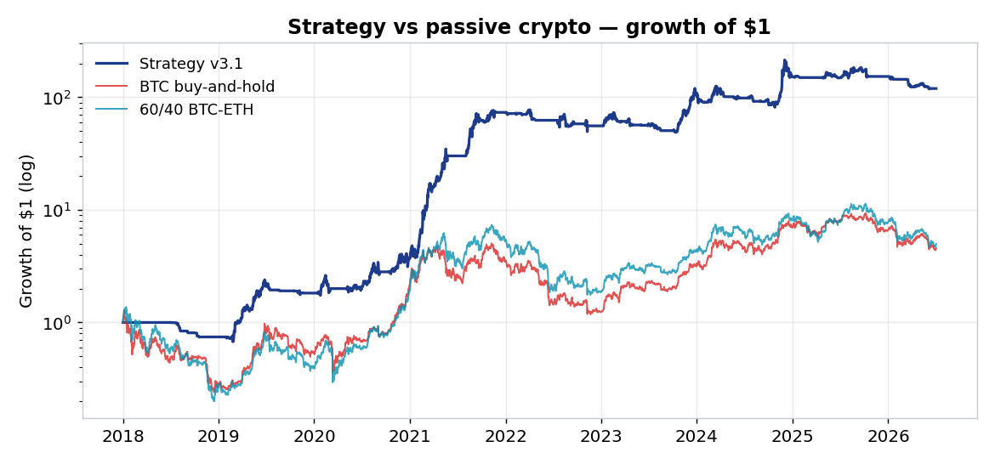
Growth of $1, log scale (each gridline is 10×). The dark line is the strategy; red is Bitcoin, teal is 60/40. Higher is better.

2.2 Its worst loss is about half of Bitcoin's
The strategy's deepest fall is about −45%, versus roughly −81% for holding Bitcoin — deep in absolute terms, but far shallower than passive crypto.
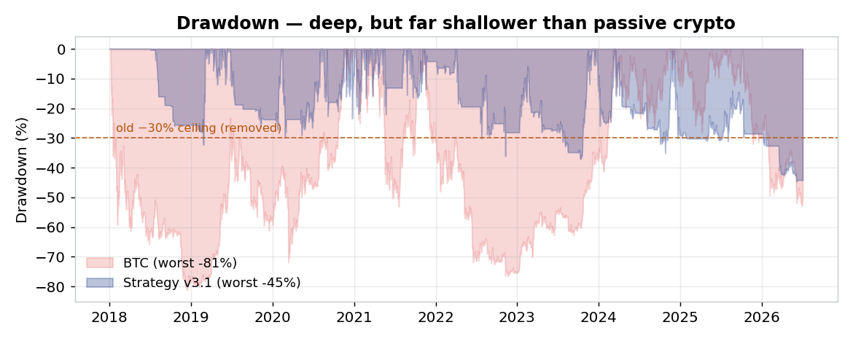
How far below the previous high each sits, over time. Shallower (closer to zero) is better; the strategy (dark) stays well above Bitcoin (red).

2.3 But one boom year does most of the work
2021 returned about +1882% and dominates the whole record; strip it out and the edge is far more ordinary — a reason to size the position modestly.
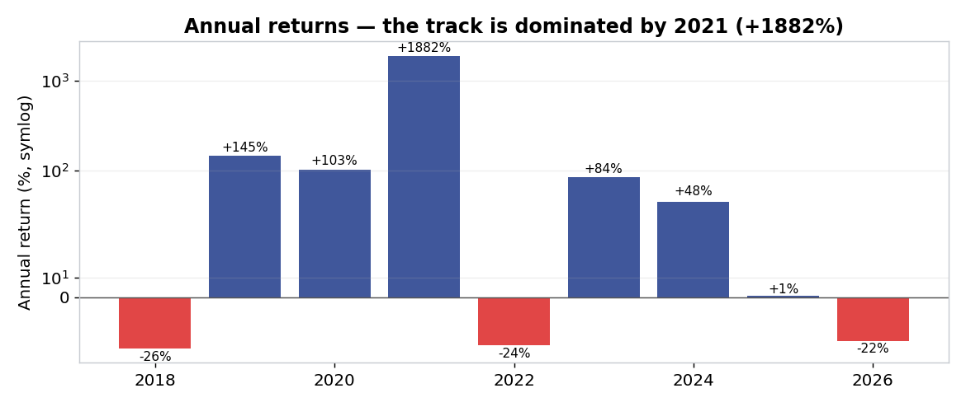
Return each calendar year (compressed scale so small and huge years both show). One year dwarfs the rest.

2.4 The edge is not a fluke of trying many versions
After charging for the roughly fifty strategy versions explored, the edge is still overwhelmingly likely to be real (well above the usual confidence bar).
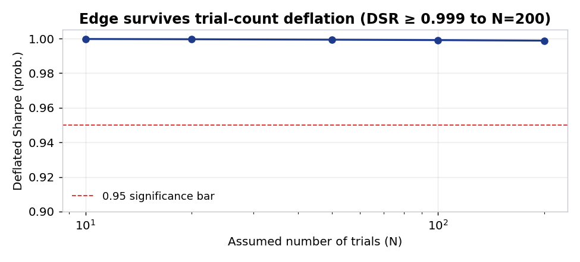
Confidence the edge is real (vertical) as we assume more versions were tried (horizontal). It stays near-certain even at 200; the dashed line is the usual 95% bar.

3. The work behind this summary
Ninety-five strategy versions were tested across five lines of attack. None changed the production settings; two proposed 'improvements' (concentrating the coins, and a Bitcoin-Ether-only trend engine) were tested and rejected, and the core risk filter was confirmed as the most important part.
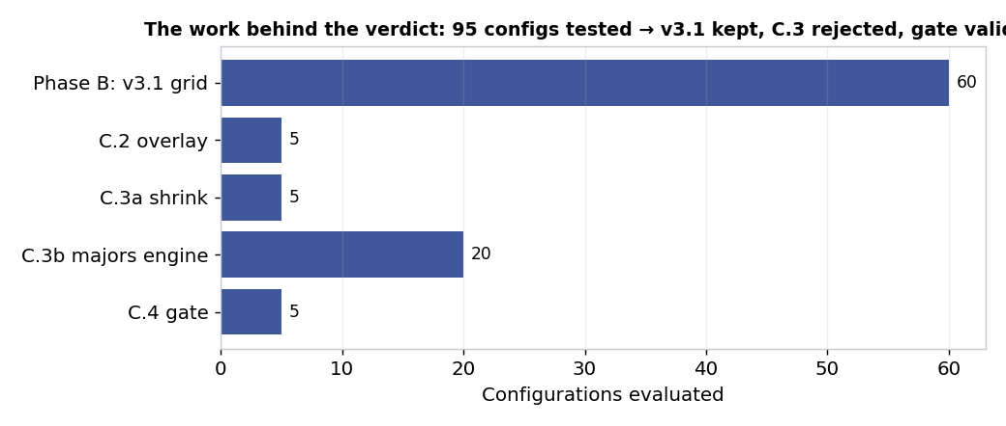
Versions tested per line of attack. The point is restraint: a large search did not move the live settings, and the two candidate changes did not survive.
Full detail and every figure sit in the technical record (2026-07-04_phaseB-C3-C4_v3.1-robustness-review.docx) and the public repository / dashboard (phuazz.github.io/crypto-breadth).

Personal research artefact. All figures are simulated backtests, net of fees, and carry a documented optimistic bias (the test universe excludes coins that later died); nothing here is investment advice.

