horizontal line

**Group 4**

Alejandro Suntay, James Talbott, Nirmalya Ghosh, Phuc To

Ready2Plate

**6th June 2021**

# OVERVIEW

This is the simple instruction for building and running our application, in both GUI and console.

# INSTRUCTION

## Setting Up The Database

Following are the steps to set up the Ready2Plate database.

1. In My SQL Workbench GUI, select Server → Data Import.
2. In the Data Import interface, choose Import from Self-contained File, and lead the program to where the dump file ready2plate.sql is located.
3. Select Start Import to generate the Ready2Plate database. Our dump file already has the Create Schema, so no other options need to be selected.

## Setting Up QueryRunner

Following are the steps to set up the enhanced QueryRunner application.

1. An executable .jar file is included in the submission. Executing it should bring up the GUI application. A QueryConsole.bat script is included that uses the .jar to bring up the console app.
2. If the .jar does not work, import the project, contained in queryrunner.zip, into a java-enabled IDE and run QueryRunner.java, using run configurations to add the -console argument to bring up the console version.

## Graphical User Interface - QueryRunner

To access the graphical interface, run queryrunner with no command-line arguments.

1. Log into the database by ensuring the prefilled hostname and username are correct, entering the password, and pressing the Connect button.
2. Once connected, use the dropdowns to select a role and query, fill in the appropriate parameters, and click Run Query to execute it.

DBMS output is displayed in the upper right and table output is displayed in the lower right when applicable.

NOTE:

* Date parameters should be entered in yyyy-mm-dd format. The data contains dates from the beginning of May through the end of June of 2021.
* Make sure to have a Database Schema named **ready2plate**. QueryRunner won’t connect without the desired schema name.

## Summary of Queryrunner changes

# Significant UI overhaul

# Now reads queries from input files, included.

# Supports stored procedure calls containing update or select queries.

# Supports String, int, and Date argument types.

# Significant general cleaning and refactoring.

# Changes availability of queries based on selected role.

## Console Application - QueryConsole

This would be instruction specifically for IntelliJ.

1. Step 1: Adding command-line argument to the queryrunner
   1. Select Run tab from Taskbar → Edit configurations.
   2. In Program Argument, fill in “-console”

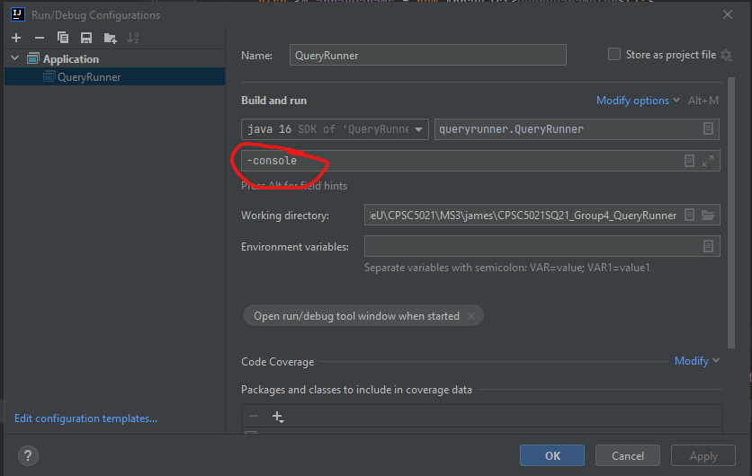

1. Step 2: Compile and run queryrunner, the interaction will happen in the console interface
   1. Log into the database by providing hostname, username, password, and database
   2. Execute **help** to see available commands.

### Quick Documentation, list of queries available to use in the QueryConsole:

**help** - to see all available commands

**set role *<role>*** - to see queries based on a role. Valid roles: *Customer, Staff, Kitchen Manager, Bar Manager, DB Admin*.

**show queries** - Once a valid role is selected, type this command to see all the queries available.

**run *<query number>*** - Based on the output of the above command, use this command with a valid query number. If there are any parameters, the CLI will ask you to input them. Once you have entered all the parameters correctly, it will display the table.