DenimFlow BO
Jeans Subcontracting Back Office with Dynamic Workflow
Project Proposal
Version 2.0
Table of Contents
Executive Summary 3
1. Overview and Business Problem 4
2. System Scope 5
3. Actors and Authorization (RBAC) 6
4. Dynamic Workflow: Core Concepts 6
5. Default Jeans Subcontracting Process 7
6. Overall Main Flow 12
6.1 Operation-level main flow 12
6.2 Detailed UML 2.0 Activity Diagram 13
7. Detailed Specification by Stage 20
Stage 0: Design and Publish the Workflow 20
Stage 1: Order Intake and Production Order Creation 20
Stage 1b: Custom Subcontracting Branch 20
Stage 2: Fabric and Color Selection 21
Stage 3: BOM and Material Allocation 21
Stage 4: Cutting 21
Stage 5: Sewing 21
Stage 6: Embroidery, Dyeing, Wash, Clean Wash and Finishing 22
Stage 7: QC and Rework 22
Stage 8: Packing and Handover 22
Operational Exceptions 23
8. State Machine 23
9. Mandatory Business Rules 24
10. Core Data Model 26
11. Preliminary Feature List 27
12. Applied Design Patterns 29

Executive Summary
DenimFlow BO is the internal Back Office system of a jeans subcontracting workshop. It manages the whole lifecycle of a subcontracting order, from fabric and color selection, cutting and sewing through dyeing, washing, finishing, QC and handover, and it runs on a configurable Dynamic Workflow: the chain of operations is stored as data, so the process can be changed without redeploying the system.
The problem. Jeans production differs from product to product, so a hard-coded process has to be changed every time an operation is added or removed. Fabric–color mistakes ruin whole lots, managers lose sight of work in progress, and a defect is hard to trace back to a fabric lot, an operation and a person.
The proposed solution
- A default 14-operation jeans process with optional dyeing, embroidery, effect wash, fabric inspection and sample approval.
- A custom subcontracting branch: feasibility review, a dedicated workflow, mandatory sample approval, and rejection of requests the workshop cannot meet.
- Clean wash by default, which the customer may skip to reduce cost. Skipping it requires the customer's signed acknowledgement and switches final QC to a separate QC Profile with its own shrinkage and color-fading thresholds.
- Gatekeepers between operations, rework loops with a limit, batch-level traceability and an immutable audit log.
Scope and size. One product type (jeans) and the subcontracting BO stage only. The system has 7 roles, 19 mandatory business rules and 29 functional requirements, of which 14 form the MVP.
How to read this document. Sections 1–3 set out the business problem, the scope and the roles. Sections 4–8 describe the Dynamic Workflow, the default process, the main flow, the stage-by-stage specification and the state machines. Sections 9–12 give the business rules, the core data model, the feature list and the design patterns. Assumptions to confirm and open questions are kept in a separate Appendix document.

1. Overview and Business Problem
The system is the internal Back Office (BO) of a garment subcontracting workshop. It manages the whole lifecycle of a jeans subcontracting order, from fabric and color selection, cutting and sewing through finishing and QC, and it runs on a configurable Dynamic Workflow.
Real-world problems of a jeans subcontracting workshop
- Rigid, hard-to-change processes: every product code has a different chain of operations. Plain jeans need no wash; washed, distressed or embroidered jeans need extra operations. If the process is hard-coded, every time an operation is added or removed the code has to be changed and redeployed.
- Fabric and color are easy to get wrong: denim differs in weight (oz), stretch (rigid / stretch), composition and color (indigo, black, grey…). Not every fabric–color pair is valid, and a wrong choice ruins an entire lot.
- Loss of control over WIP (Work In Progress): managers cannot tell which lot is at which operation, or how many pieces have been cut, sewn, found defective or reworked.
- Hard to trace: when QC finds a defect, it is very hard to determine which fabric lot, which operation and which person it came from.
System objectives
- Bring the whole lifecycle of a subcontracting order into a single data flow (order → materials → cutting → sewing → QC → handover).
- Let a Process Engineer create and edit workflows through configuration, and have the system run exactly according to that workflow.
- Place a gatekeeper between operations: the next operation opens only when the previous one has the full quantity, sufficient evidence and a QC pass.
- Trace by batch: which fabric, which operation, who did it, and when.
Expected outcomes
- A process change (adding, removing or reordering an operation) is a configuration and publish action, not a code release.
- Every order runs on one well-defined, versioned process, and running orders are never broken by later template edits.
- Managers can see where every lot is and how many pieces are good, defective or reworked.
- A defect can be traced to its fabric lot, operation, person and time.
Key risks and mitigations
Risk | Mitigation
The workflow engine is more complex than hard-coded logic | Keep the number of step types small (5), validate every template on publish (BR-01), and deliver the 14 MVP features first
A misconfigured template stalls or corrupts orders | Immutable versions (BR-02), a snapshot at Confirm (BR-03), and approval for any change to a running order (BR-13)
Floor staff skip data entry (quantities, evidence) | One worklist per station, minimal inputs, and evidence required only on the steps configured for it (BR-15)
Real workshop practice differs from the assumptions (for example dyeing mode and outsourcing) | Keep such choices as configuration (dyeMode, dyeSource, QC Profile thresholds) and track the assumptions in the Appendix document
Disputes when the customer skips clean wash | A signed acknowledgement, a dedicated QC Profile, and a handover record that states which profile was used (BR-19)

2. System Scope
The system covers one product type (jeans) and the subcontracting BO stage, from the moment the workshop receives an order until the finished goods are handed over.
Area | In scope | Out of scope
Product | Jeans, with multiple Styles (slim, straight, wide-leg…) and multiple sizes | Shirts, dresses, suits and other garment types
Production operations | Order intake, fabric–color selection, BOM calculation, material allocation, cutting, sewing, dyeing, wash, embroidery, clean wash (per workflow), custom subcontracting branch, finishing, QC, packing, handover | Fabric manufacturing, pattern design, CAD pattern making
Workflow | Template design, versioning, assignment by Style, runtime adjustment with approval | Designing workflows with a free-form programming language (scripting)
Tracking | WIP by lot (batch/bundle), good/defect/rework quantities, audit log, dashboard | Accounting, worker payroll, human resources
Commercial | Customer/brand information kept as a reference on the order | Online payment gateways, deposits, carrier integration, end-customer app (see the Appendix document)
Baseline assumptions (to be confirmed, see the separate Appendix document):
- A1. "BO" means an internal Back Office used inside the workshop; its users are workshop staff, not retail buyers.
- A2. The workshop takes subcontracting orders from customers/brands (the CMT model: Cut, Make, Trim); fabric may be supplied by the workshop or by the customer.
- A3. Each Production Order is tied to one jeans Style with multiple sizes, and may be split into several batches to run.

3. Actors and Authorization (RBAC)
The system has 7 roles, and each role sees and does only its own part of the work (RBAC, Role-Based Access Control: permissions attach to roles, not directly to individual people).
Actor | Role | Core functions
Admin | System administrator | Manage accounts, permissions and shared catalogs; view the Audit Log
Process Engineer | Process designer (Workflow Designer) | Create/edit Workflow Templates, publish new versions, assign templates to Styles, approve runtime workflow-change requests
Production Planner | Production planning | Create and confirm Production Orders, select fabric–color, calculate BOM, choose the workflow, split batches, track WIP, handle exceptions (hold, cancel, workflow-change requests)
Warehouse Keeper | Fabric and trim storekeeper | Receive/issue stock, inspect fabric lots, allocate materials to orders, confirm material issue to the cutting team
Station Operator | Operation team leader (cutting, sewing, dyeing, wash, finishing) | Pick up work at their own station, press start/complete, enter good/defect quantities, attach evidence
QC Inspector | Quality inspection | Inspect against a checklist, decide Pass / Fail / Rework, record defects
Manager | Workshop manager (view only) | WIP dashboard, progress reports, defect rate, run time of each operation
An important separation-of-duties rule: the person who designs the workflow (Process Engineer) may not confirm completion of a production operation, and the person who performs an operation (Station Operator) may not approve QC for their own operation.

4. Dynamic Workflow: Core Concepts
Dynamic Workflow means that the chain of operations of an order is described as data (a template) instead of being hard-coded, so a Process Engineer can change the process without the system being redeployed.
Concept | Meaning | Example for jeans
Workflow Template | A reference process attached to a group of Styles | "Jean Basic", "Jean Wash", "Jean Distressed + Embroidery"
Workflow Version | An immutable version of a template; editing creates a new version | Jean Wash v1, v2
Step Definition | One operation: name, type, responsible station, mandatory or optional, completion condition | Cutting, Sewing, Wash
Transition | An edge connecting two steps, optionally with a Condition | Cutting → Sewing
Condition | An expression that decides whether that branch is taken | The Wash step is entered only if washType != none
Gate (gatekeeper) | A condition that must hold before the next step opens | Full quantity, evidence attached, QC passed
Workflow Instance | The actual run of a Production Order, snapshotted from one version | The workflow of order PO-0012
Step Instance | The run of one step within an instance: status, quantity, assignee, time | The "Cutting" step of PO-0012
"Dynamic" shows up in 4 ways:
- Configurable: add, remove and reorder steps in the designer UI, with no code change.
- Conditional branching: only Styles with wash run the Wash step, and only Styles with embroidery run the Embroidery step.
- Parallel execution and rework loops: body cutting and pocket cutting can run at the same time; if QC fails, the order goes back to Sewing or Finishing.
- Runtime change: insert or skip a step for exactly one order; the Planner proposes, the Process Engineer approves, and the system writes an audit log.
Versioning rule: an order that has been created keeps the version in force at that moment (snapshot). Later edits to the template apply only to new orders and never break running orders.
Valid template (validation on publish): exactly one start step, at least one end step, every step has a path to an end step, no orphan steps, and no infinite loops (every rework loop must have a limit on the number of iterations).
Trade-offs of choosing a data-driven workflow:
- Pros: fast process changes, each Style can have its own flow, and it is easy to extend to other product types later.
- Cons: the engine is more complex than hard-coded logic, templates must be validated carefully, and testing is harder because the number of paths grows with the combinations of conditions.

5. Default Jeans Subcontracting Process
The default template "Jean Standard" has 14 operations and one branch right after order intake: if the customer requests a dedicated custom process, the order goes through a review and creates its own workflow before entering the main flow. Dyeing, embroidery, effect wash, fabric inspection and sample approval are optional steps; clean wash runs by default before finishing, and the customer may ask to skip it, which requires the customer's signed acknowledgement and switches final QC to a separate QC Profile (BR-19). This is an initial proposal based on a common jeans production process; it should be finalized against the actual workshop the system serves (see the Appendix document).
# | Operation | Step code | Responsible | Mandatory? | Gate for the step to count as complete
1 | Order intake and confirmation | ORDER_CONFIRM | Planner | Mandatory | Style, size run, quantity and due date are complete; it has been determined whether the order has a custom request; if the customer skips clean wash, the signed acknowledgement is attached (BR-19)
C | Custom branch: feasibility review and creation of a dedicated workflow | CUSTOM_REVIEW | Planner + Process Engineer | Conditional (customer requests custom) | The request is assessed as feasible (if infeasible, the order is rejected); the dedicated workflow is valid per BR-01 and approved by the Process Engineer (BR-17)
2 | Fabric and color selection | FABRIC_COLOR_SELECT | Planner | Mandatory | The fabric–color pair is valid per the compatibility table (Fabric–Color Matrix)
3 | BOM calculation and material allocation | BOM_ALLOCATE | Planner + Warehouse Keeper | Mandatory | Materials are fully allocated, or a purchase request has been created
4 | Incoming fabric inspection / shrinkage test | FABRIC_INSPECT | QC | Optional | Shrinkage is within the permitted threshold
5 | Pre-production sample approval | PP_SAMPLE | Planner + QC | Optional (mandatory for custom orders) | The sample is approved
6 | Fabric spreading and cutting | CUTTING | Cutting team | Mandatory | Cut quantity per size meets the plan (within tolerance) and bundle tags are attached
7 | Embroidery / print | EMBROIDERY | Embroidery team | Conditional | Runs only if the Style has embroidery; quantity is complete
8 | Sewing | SEWING | Sewing team | Mandatory | Sewn quantity does not exceed the cut quantity; passed in-line inspection
9 | Dyeing | DYEING | Dyeing team (internal or outsourced, per the proposal below) | Conditional (dyeRequired = true) | Full quantity received back; color matches the approved color standard; for partial dyeing, the position and size of the dyed area are correct
10 | Effect wash (distressing wash) | EFFECT_WASH | Wash team (internal or outsourced) | Conditional (washType != none) | Full quantity received back; the effect matches the sample
11 | Clean wash | CLEAN_WASH | Wash team | Runs by default (customer may skip) | When run: full quantity; shrinkage and color fading after washing are within threshold, ensuring the customer sees no difference after the first wash; when skipped: marked SKIPPED and the Skip-clean-wash QC Profile applies (BR-19)
12 | Finishing (thread trimming, pressing, label/button attachment) | FINISHING | Finishing team | Mandatory | Full quantity, evidence attached
13 | Final QC | FINAL_QC | QC Inspector | Mandatory | Passes the AQL (Acceptance Quality Limit) and the shrinkage and color-fading thresholds of the order's QC Profile (BR-19), including inspection after washing
14 | Packing and handover | PACK_HANDOVER | Planner / packing | Mandatory | Full good quantity, handover record issued
The Sewing operation is a sub-workflow: it can be broken down into child steps (back pocket attachment, body assembly, inseam/outseam closing, waistband and belt-loop attachment) for finer tracking. This level of detail is a design decision (see the Appendix document).
Clean wash and dyeing: clean wash is a wash that ensures the product shows no difference when the customer receives it and launders it for the first time. Dyeing is placed right after Sewing (garment dyeing), and clean wash is placed after the dyeing and wash steps to lock in shrinkage and color fading before finishing. If the workshop dyes fabric before cutting, the Process Engineer only needs to move the Dyeing step within the template; this is exactly the benefit of a data-driven workflow.
QC Profile when clean wash is skipped: a garment that has not been clean-washed is not yet stabilized, so it can shrink and fade more at the customer's first wash than a garment that has. Final QC therefore cannot use the same shrinkage and color-fading thresholds for both cases. The system defines two QC Profiles per Style, selected automatically from the order's skipCleanWash flag:
QC Profile | Applies when | Shrinkage and color-fading thresholds | Customer acknowledgement
FULL_PROCESS | Clean wash runs | Standard thresholds configured for the Style; the garment has been stabilized by clean wash | Not required
SKIP_CLEAN_WASH | The customer skips clean wash | Separate thresholds configured for the Style and agreed with the customer; they are expected to be looser than FULL_PROCESS because the garment has not been stabilized | Required: the signed acknowledgement must be attached before the order is confirmed (BR-19)
The Process Engineer configures the thresholds. This document deliberately gives no fixed numbers, because they depend on the fabric and on the workshop's practice (see the Appendix document).
Proposal for performing the Dyeing step: dyeing depends on the nature of the product and the requirements of the order, and has two modes.
Dyeing mode | Example | Proposed execution | Rationale and trade-off
Total (TOTAL) | Dyeing the whole garment one color | Outsourced (or internal if the workshop already has dyeing equipment) | Needs industrial dyeing equipment and wastewater treatment, so the investment is large. In return, it adds transport time and a risk of color deviation, so the Gate requires color comparison on receipt and reconciliation of sent/received quantities (BR-09)
Partial (PARTIAL) | Dyeing a few specific positions per drawing, for example leg openings, pockets, ombré effects | Internal | It is manual, low-volume work that needs control over the exact dyed area, so doing it in-house is easier to adjust and inspect. In return, it occupies the workshop's labor
The system stores dyeMode (TOTAL, PARTIAL) and dyeSource (INTERNAL, OUTSOURCED); defaults follow the table above, and the Planner can change them per order. This is a proposal; it should be confirmed against the capabilities of the actual workshop the system serves.

6. Overall Main Flow

6.1 Operation-level main flow
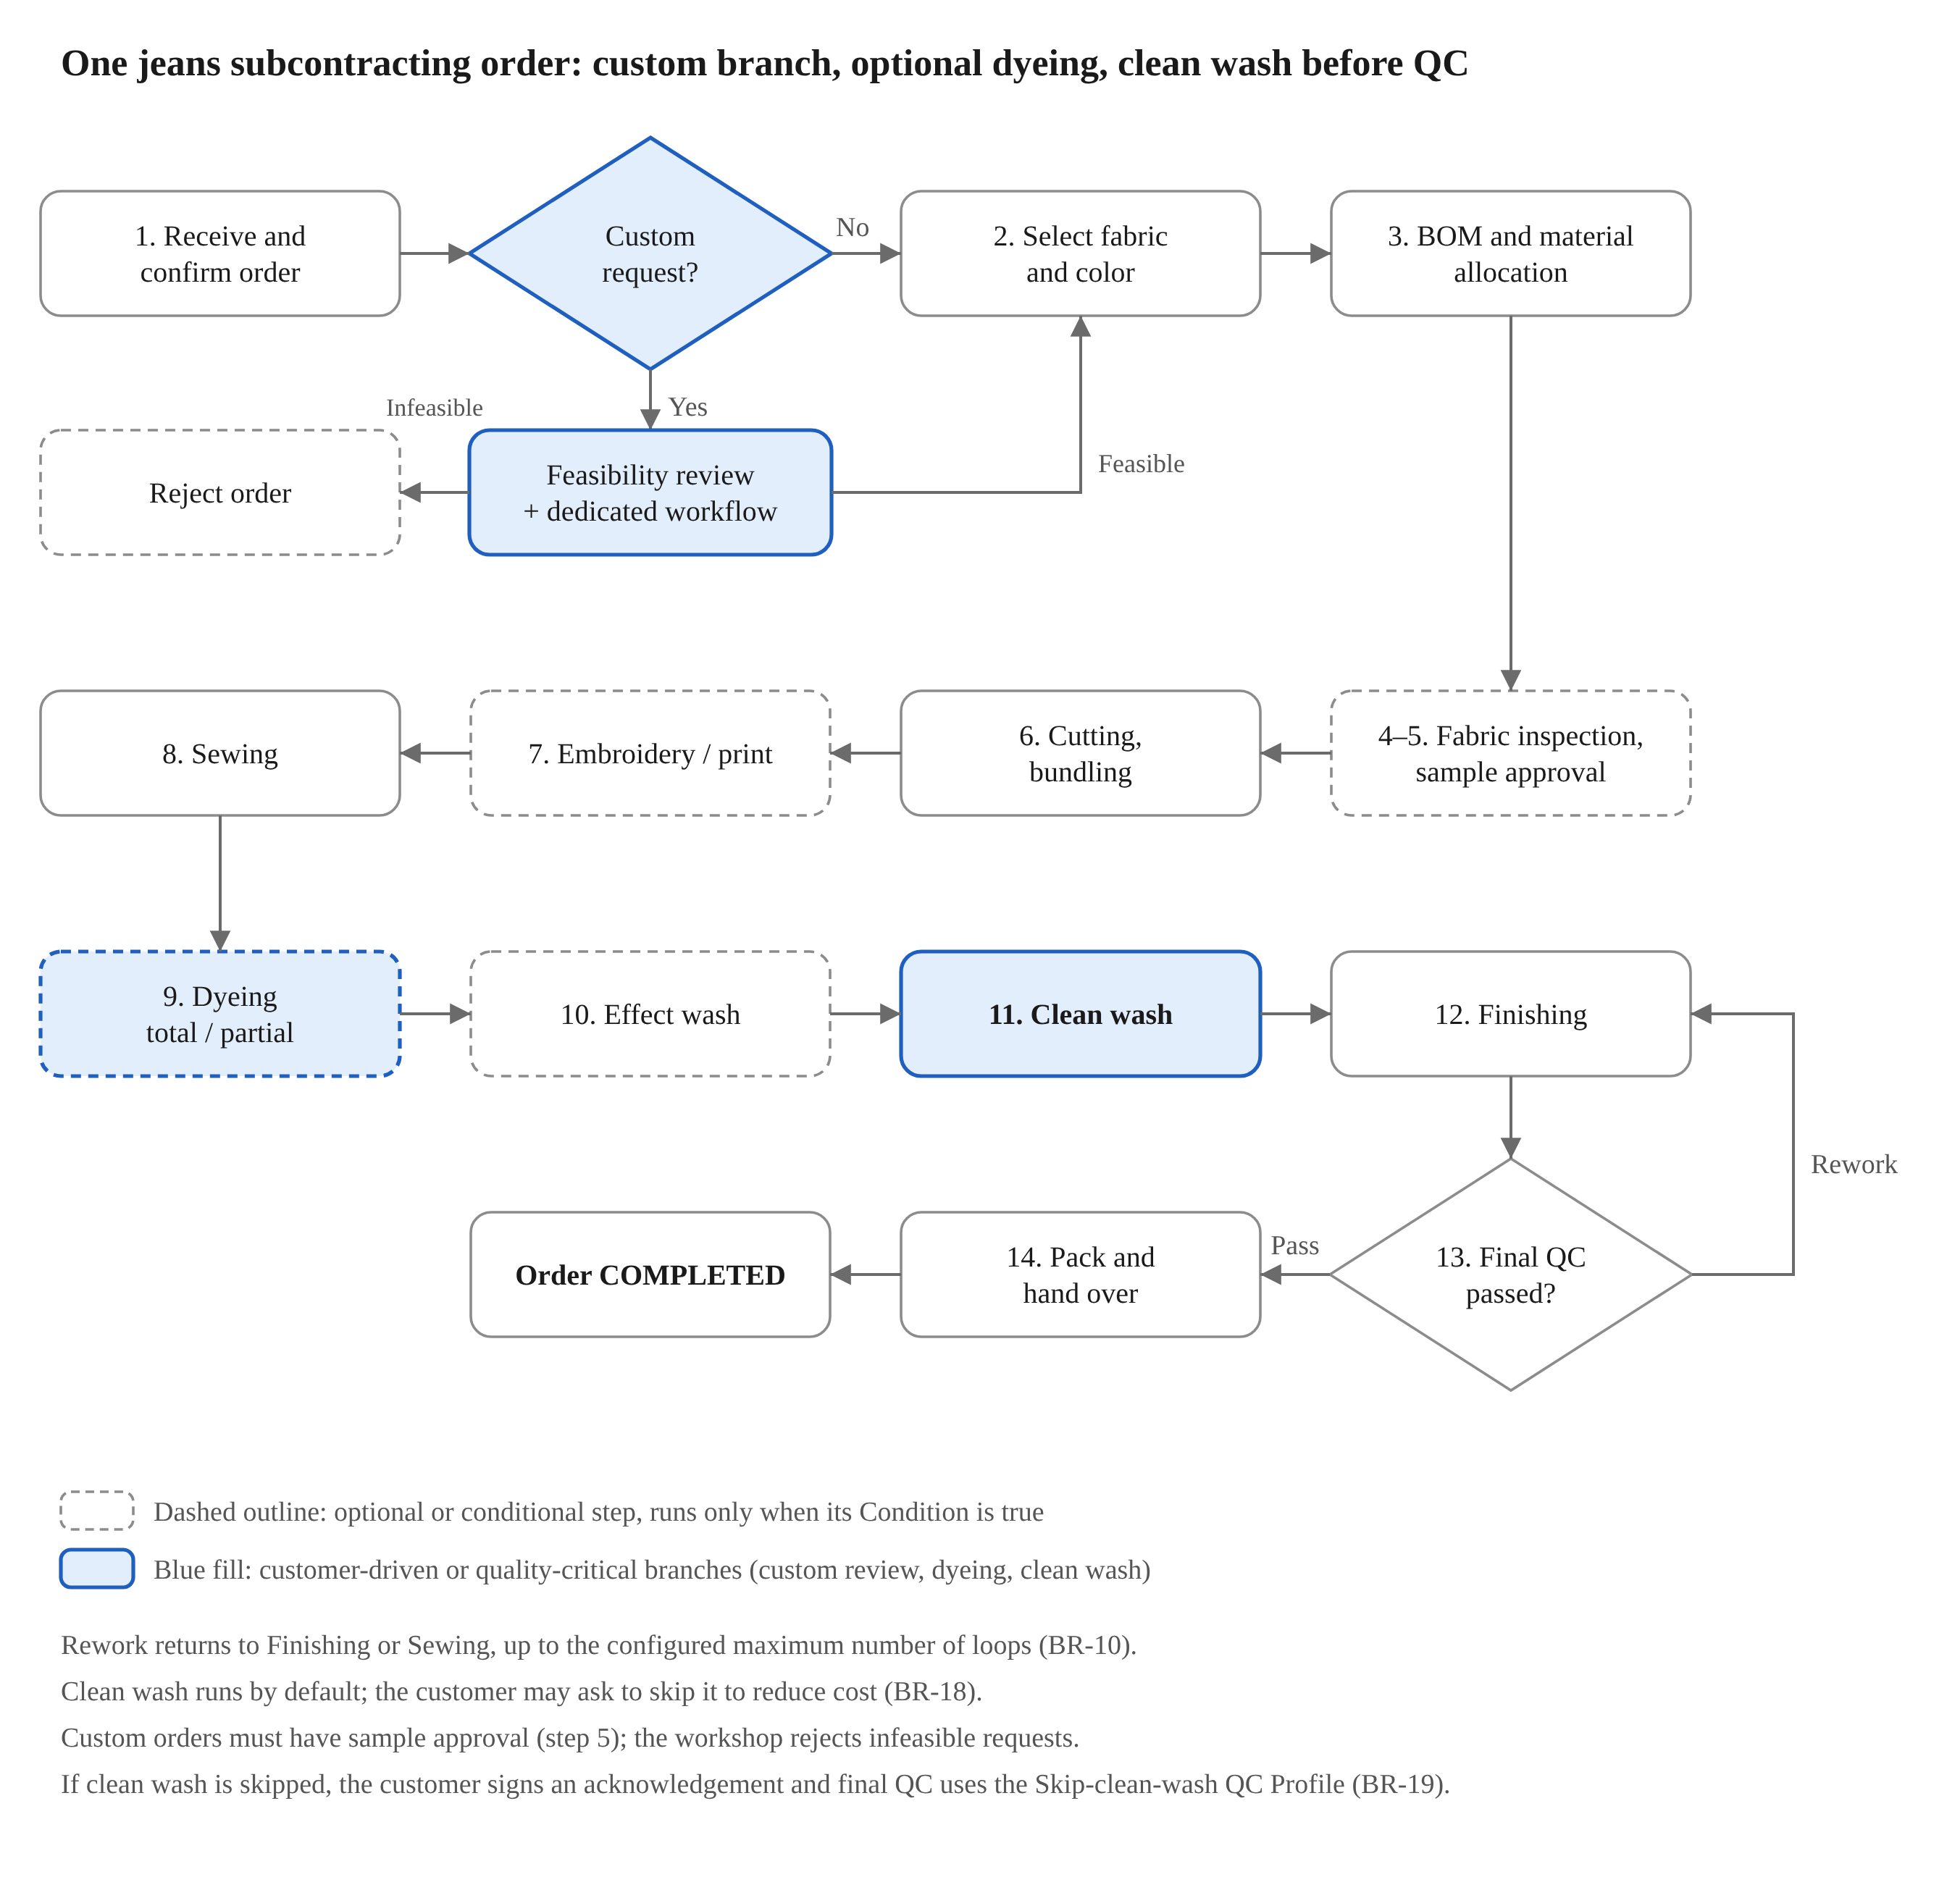
Figure 6.1 – Main flow of a jeans subcontracting order
The order moves along the solid path from top to bottom. Right after intake, if the customer requests a dedicated custom process, the order branches into the review-and-dedicated-workflow branch; if it is feasible it rejoins the main flow at fabric and color selection (custom orders must have sample approval), and if it is infeasible the workshop rejects the order. After Sewing come Dyeing (if requested) and Effect wash (if any), then Clean wash runs by default before finishing (the customer may ask to skip it, BR-18; the customer then signs an acknowledgement and final QC uses the Skip-clean-wash QC Profile, BR-19). If the final QC passes, the order is packed and completed; if not, it goes back for correction per BR-10. Dashed steps are dynamic steps that appear only when the Style or order requires them.

6.2 Detailed UML 2.0 Activity Diagram
The diagram on the following landscape pages describes the control flow of one Production Order from the moment the Planner enters the order until handover or exception handling, drawn to the UML 2.0 Activity Diagram standard. It is divided into 5 Activity Partitions (swimlanes, i.e. vertical columns naming the responsible role): Process Engineer, Production Planner, Warehouse Keeper, Station Operator and QC Inspector. Admin and Manager do not appear because Admin only configures catalogs (Fabric–Color Matrix, accounts) and Manager only views dashboards; neither performs any action in the flow of a single order.
Notation used in the diagram
UML 2.0 element | Shape | Meaning in this diagram
Initial Node | Solid circle | Start point: the Planner enters the order
Action Node | Rounded rectangle | An action or a workflow step (with a BR code to trace back to Section 9)
Decision Node | Diamond with text, several outgoing edges | Branching; each outgoing edge has a guard in the form [condition], and the guards are mutually exclusive
Merge Node | Small diamond, no text | Merges branches back into one flow, without synchronization (not a Join)
Activity Final Node | Solid circle inside a circle | Ends the whole flow; the diagram has 3 end points: order rejected, order COMPLETED, order falls into Hold or CANCELLED
Control Flow | Solid arrow | Order of execution between two nodes
Activity Partition | Vertical column with a title | The role (Actor) responsible for the nodes inside the column
Note | Folded-corner shape, connected with a dashed line | A constraint note attached to a node; it is not an executable step
How to read the flow
- Custom branch: after Confirm, if the customer requests a custom process, the Process Engineer assesses feasibility. If infeasible, the workshop rejects the order and it ends in the CANCELLED state; if feasible, the template is cloned, validated per BR-01, the dedicated workflow is approved, and the order rejoins the main flow through a Merge Node before fabric and color selection (BR-17).
- Optional steps (fabric inspection, sample approval, embroidery/print, dyeing, effect wash) are represented by a Decision and Merge pair: the [no] branch goes straight down to the Merge, and the [yes] branch passes through the step before returning to the Merge. This matches the Condition mechanism of the Dynamic Workflow in Section 4.
- Clean wash runs for every order by default: if the customer skips clean wash, the step is marked SKIPPED and written to the AuditLog (BR-18), and the Skip-clean-wash QC Profile is selected (BR-19); otherwise the step runs normally and the FULL_PROCESS profile applies. The signed acknowledgement is attached when the order is confirmed (see the Note beside the Confirm action). Both branches meet at the Merge before the Finishing step.
- Three loops in the flow: when materials are short, a Material Request is created and allocation is repeated; when the sample is not approved, the sample is remade; when QC chooses Rework, the order returns to the designated step and passes QC again, and if the rework limit is exhausted or the result is Reject, it is handed to the Planner for exception handling (BR-10).
- Deliberately simplified: the Gate (BR-14) and AuditLog (BR-16) apply to every step, so they are shown as a Note instead of separate actions; Sewing is drawn as one action, with the sub-workflow remaining optional pending a design decision (open question Q8 in the Appendix document). For custom orders, sample approval is mandatory and is stated in the text of the Decision.
A single-piece version of the diagram (not split across pages) is provided in the file DenimFlow-BO_Activity-Diagram_EN.drawio (open it with draw.io / diagrams.net; each node can be edited), together with a Mermaid version DenimFlow-BO_Activity-Diagram_EN.mmd that can be pasted into Markdown documents or GitHub. Mermaid has no dedicated activity-diagram syntax, so that version uses a flowchart and shows the partitions with background colors.

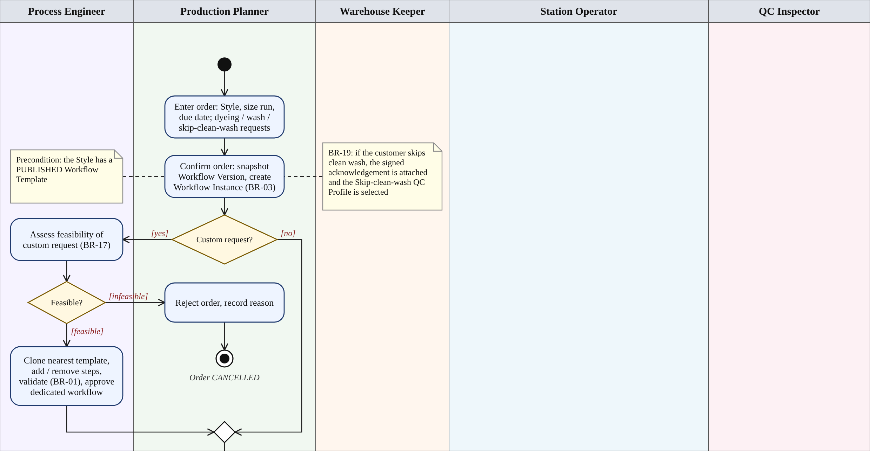
Figure 6.2 – Activity diagram, part 1/5: order intake and custom branch
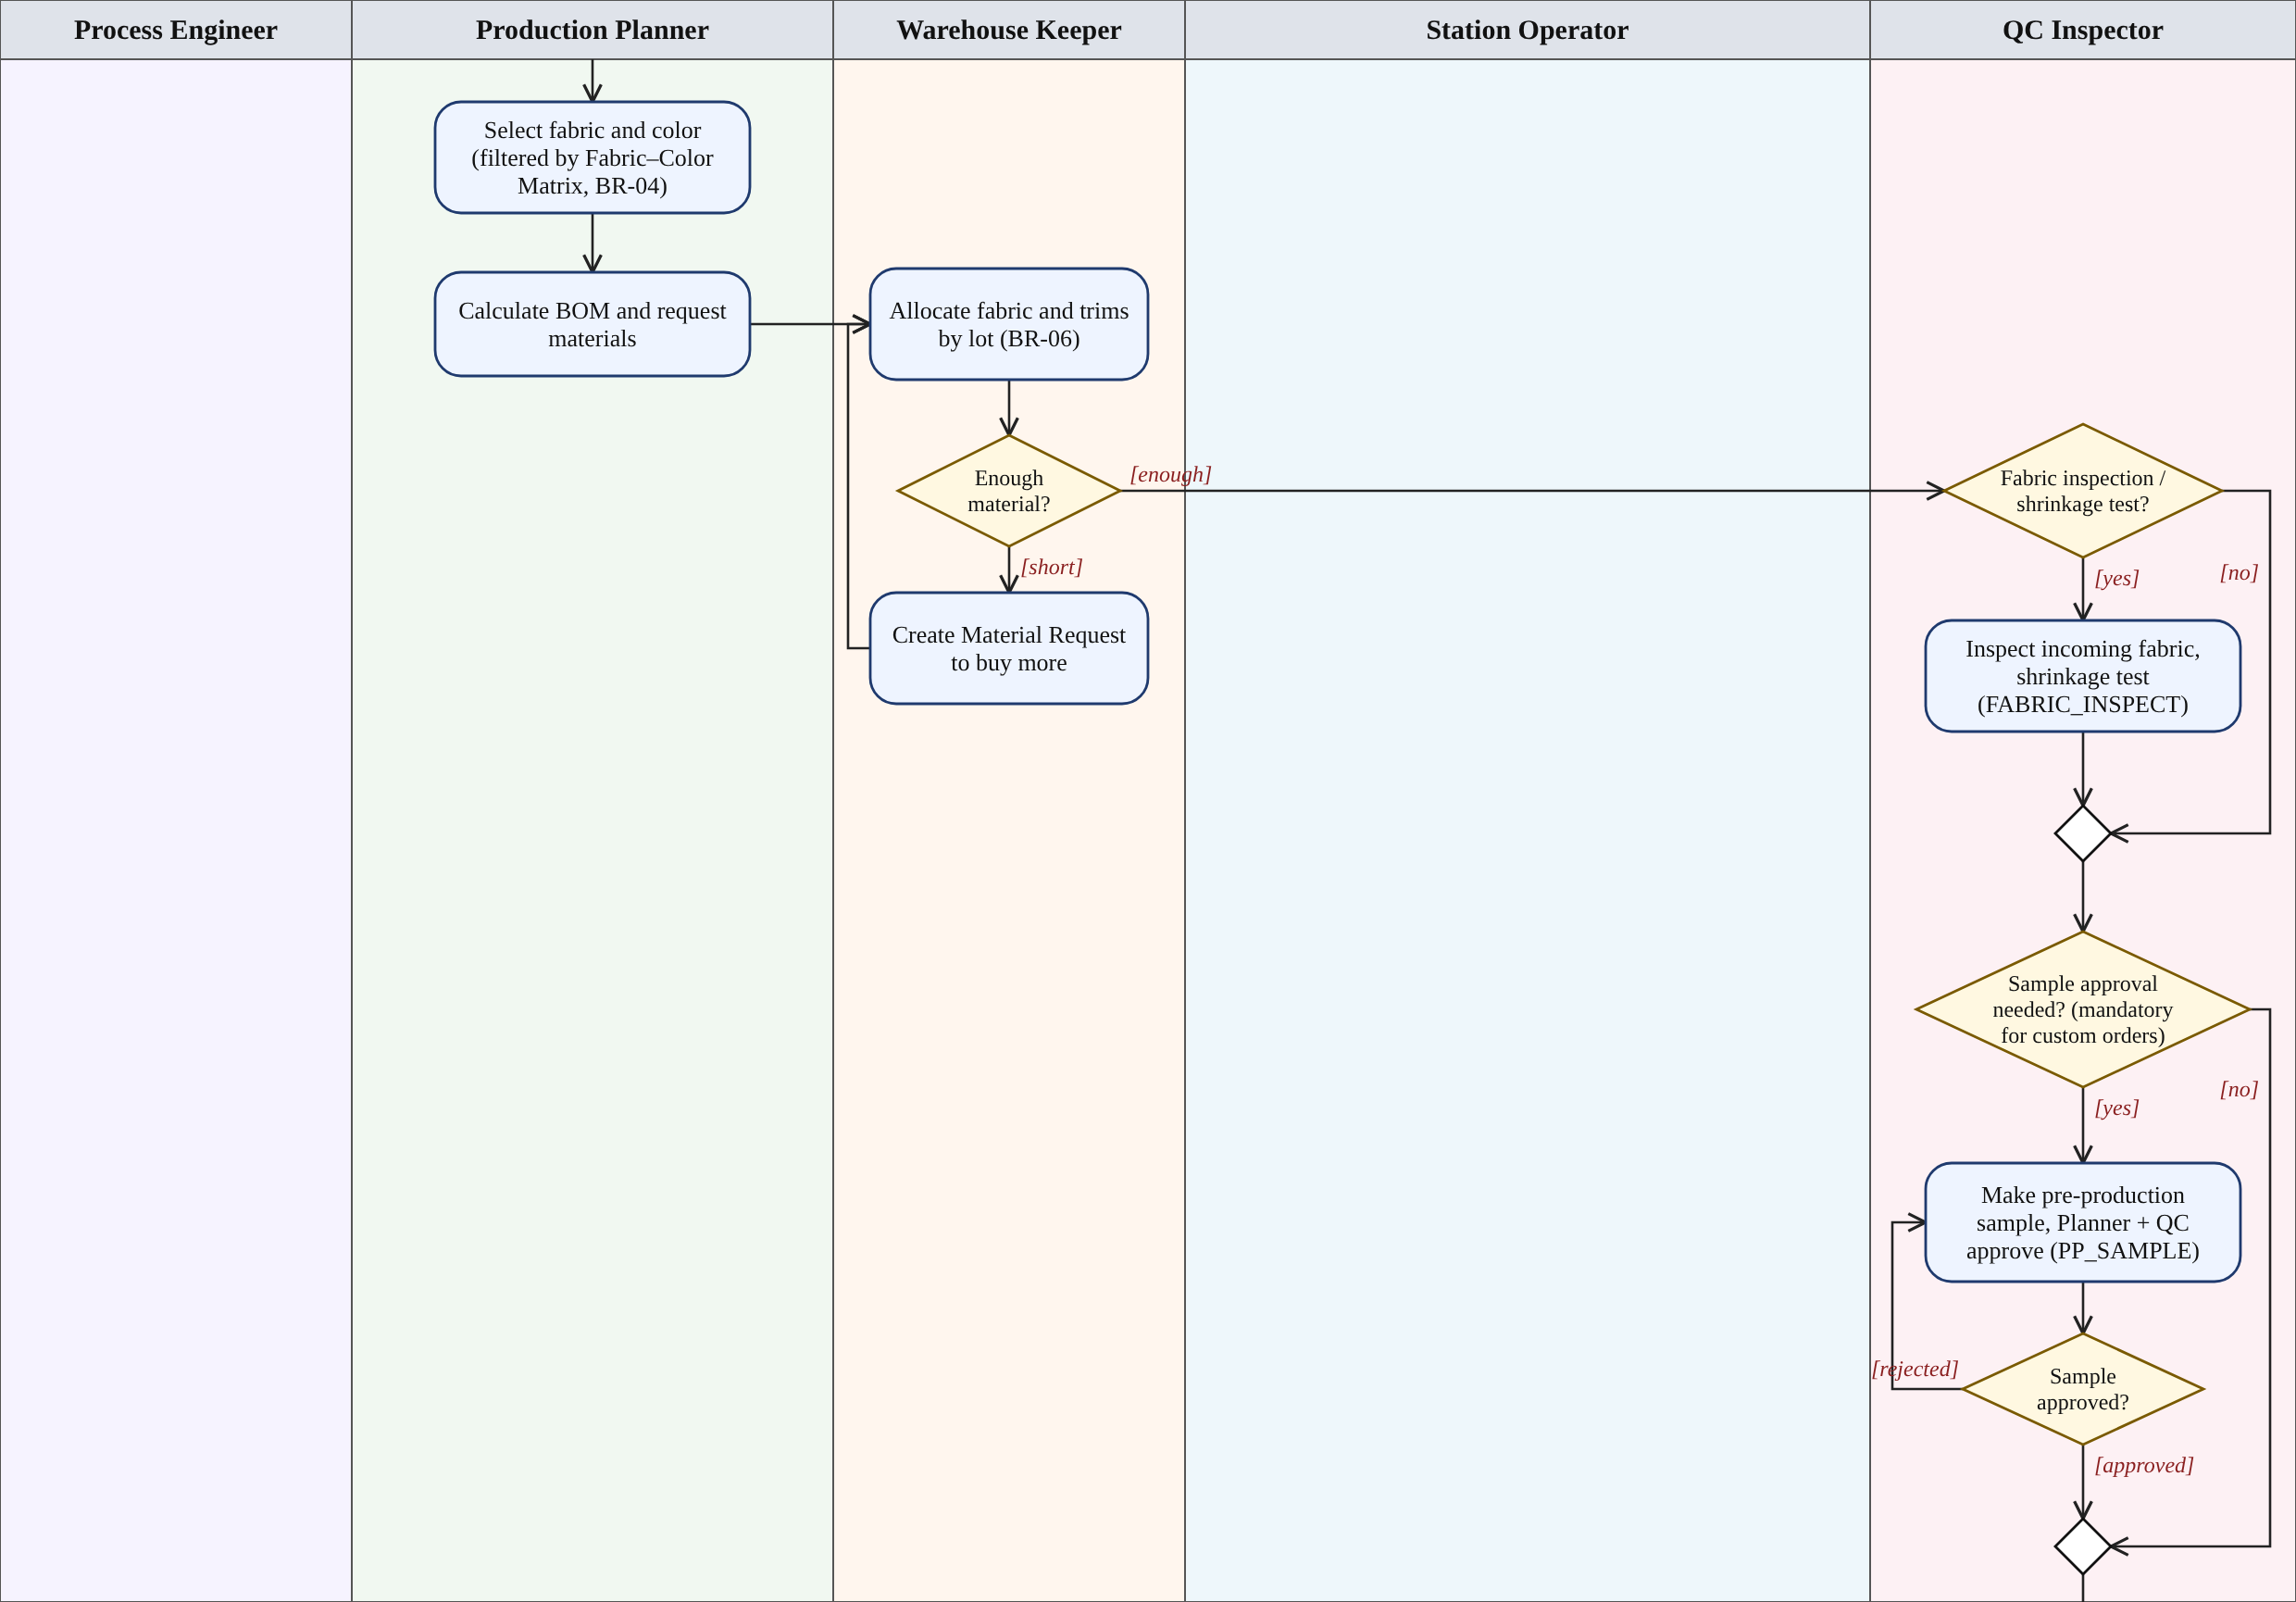
Figure 6.3 – Activity diagram, part 2/5: fabric–color selection, material allocation, fabric inspection, sample approval
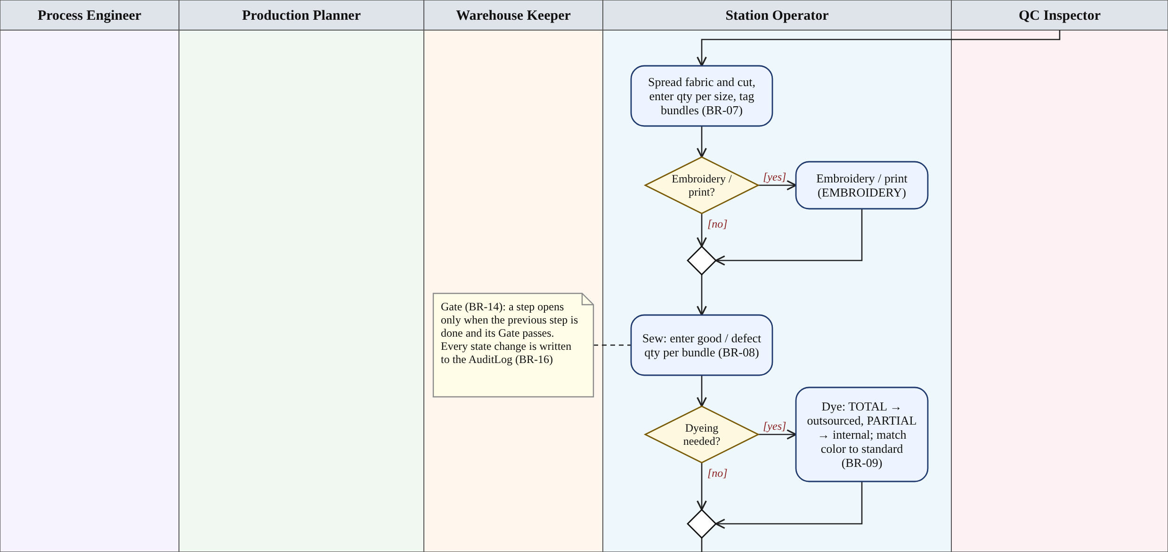
Figure 6.4 – Activity diagram, part 3/5: cutting, embroidery/print, sewing, dyeing (first part)
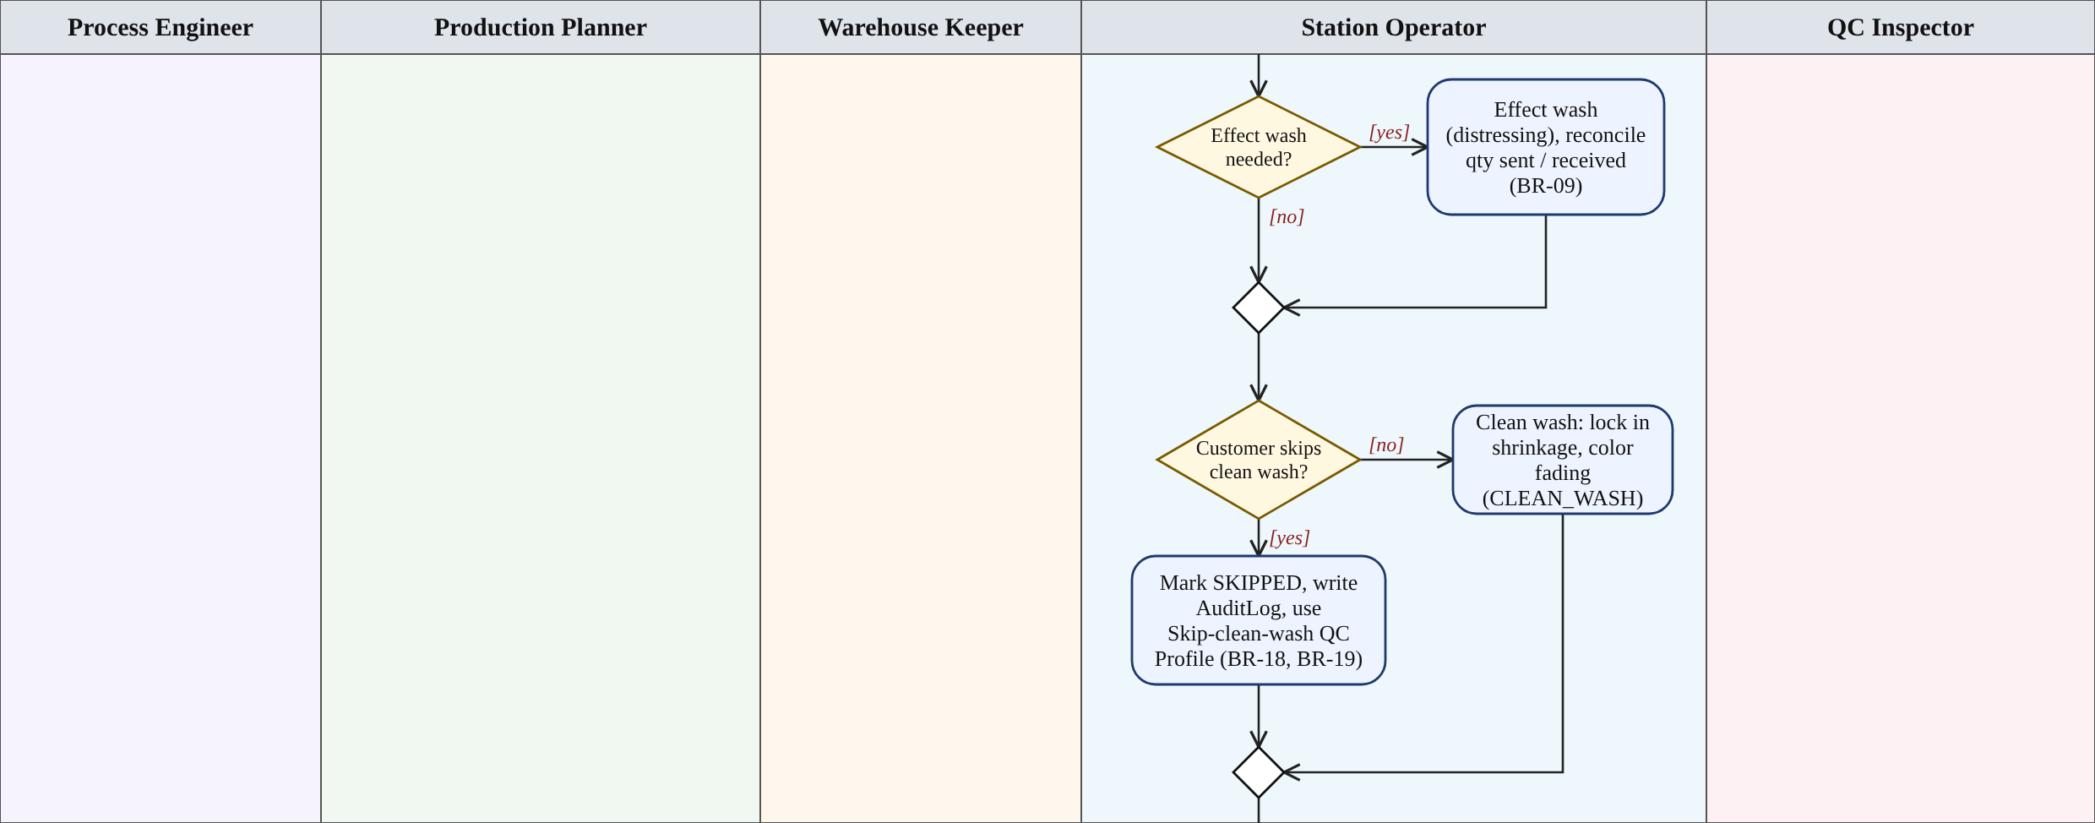
Figure 6.5 – Activity diagram, part 4/5: effect wash and clean wash
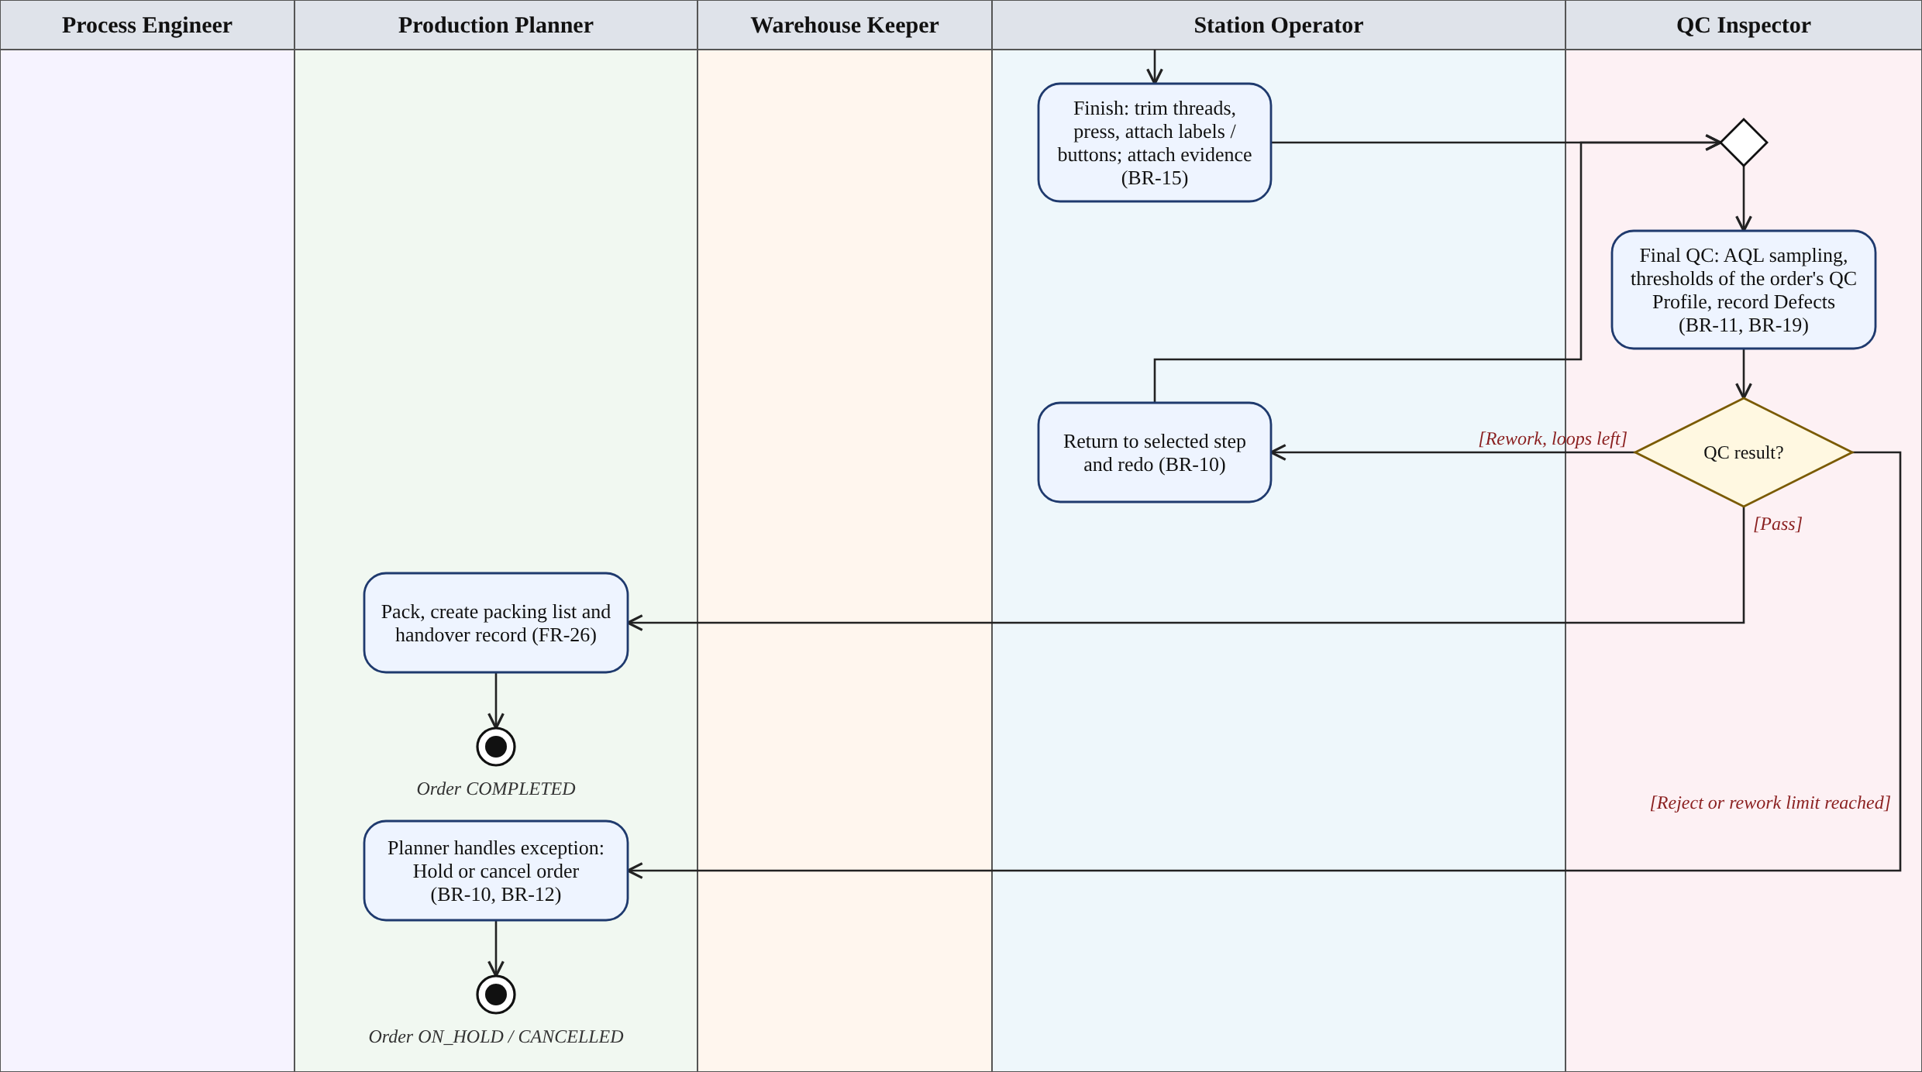
Figure 6.6 – Activity diagram, part 5/5: finishing, final QC, rework and end states

7. Detailed Specification by Stage
Each stage below corresponds to one or more steps in the default template (Section 5). BR-xx codes refer to Section 9.

Stage 0: Design and Publish the Workflow
- Actor: Process Engineer.
- Processing: pick steps from the step-type library (SELECTION, MATERIAL, PRODUCTION, QC, APPROVAL), connect them with transitions, set a Condition and Gate for each step, then run validation.
- Output: a new Workflow Version in the PUBLISHED state, assigned to one or more Styles.
- Rule: BR-01, BR-02.

Stage 1: Order Intake and Production Order Creation
- Actor: Production Planner.
- Input: Style, size run (quantity per size), due date, technical notes, customer/brand reference.
- Processing: the system proposes a workflow template by Style; the Planner previews it and presses Confirm. At Confirm, the system snapshots the version and creates the Workflow Instance, with the first step in the READY state. If the customer asks to skip clean wash, the Planner records the request and attaches the customer's signed acknowledgement; the system then selects the SKIP_CLEAN_WASH QC Profile, and Confirm is blocked until the acknowledgement is attached.
- Output: a Production Order in the CONFIRMED state together with its Workflow Instance.
- Rule: BR-03, BR-19.

Stage 1b: Custom Subcontracting Branch
- Condition: the order is flagged as having a dedicated custom request (the customer wants to customize the Style, add or remove operations, or has a special technical requirement).
- Actor: Production Planner, Process Engineer.
- Processing: the Planner records the request; the Process Engineer assesses feasibility, clones the nearest template into a dedicated workflow (adding, removing or changing steps), validates it per BR-01, then approves it. The dedicated workflow replaces the order's original snapshot. If the request is infeasible, the workshop rejects it and the order moves to CANCELLED with a reason. For custom orders, the Sample Approval step (PP_SAMPLE) is mandatory because requirements the workshop cannot meet may surface.
- Output: a dedicated Workflow Version tied to exactly one order; the order rejoins the main flow at fabric and color selection.
- Rule: BR-17.

Stage 2: Fabric and Color Selection
- Actor: Production Planner.
- Processing: choose the denim fabric type (weight in oz, composition, rigid or stretch), then choose the color. The system lists only the colors valid for the selected fabric according to the Fabric–Color Matrix configured by the Admin. If the Style has a wash, a wash type is also chosen. The system checks stock by fabric lot.
- Output: FabricType, ColorOption and (if any) WashType are locked into the order.
- Rule: BR-04, BR-05.

Stage 3: BOM and Material Allocation
- Actor: Production Planner, Warehouse Keeper.
- Processing: the system calculates the BOM (Bill of Materials, the list of material requirements) covering fabric, thread, buttons, rivets, zippers, labels and packaging, by size run and wastage. The Warehouse Keeper allocates from specific fabric lots. If materials are short, a Material Request is created to purchase more.
- Output: MaterialAllocation by lot; the order is ready for cutting.
- Rule: BR-06.

Stage 4: Cutting
- Actor: Station Operator (cutting team).
- Processing: spread the fabric, cut by pattern, enter the cut quantity per size, split into bundles (bundles of semi-finished pieces) and attach bundle codes. Record the actual fabric consumed so it can be deducted from stock.
- Output: a list of Bundles with codes and quantities per size.
- Rule: BR-07, BR-08.

Stage 5: Sewing
- Actor: Station Operator (sewing team).
- Processing: receive bundles, sew along the line, and enter the completed quantity and defect count per bundle. If the Sewing step is configured as a sub-workflow, each child step (pocket attachment, body assembly, inseam closing, waistband attachment) has its own status.
- Output: good sewn quantity per bundle.
- Rule: BR-08.

Stage 6: Embroidery, Dyeing, Wash, Clean Wash and Finishing
- Actor: Station Operator (embroidery, dyeing, wash, finishing teams).
- Processing: Embroidery, Dyeing and Effect wash appear only if the Style or the order requires them. For outsourced dyeing and wash, record the quantity sent out and received back for reconciliation; dyeing must be color-matched against the approved color standard, and partial dyeing must hit the correct dyed area. Dyeing has two modes: total (proposed outsourced) and partial (proposed internal). Clean wash runs by default for every order (the customer may ask to skip it to reduce cost, per BR-18): it washes to lock in shrinkage and color fading, ensuring the customer sees no difference after the first wash. Finishing covers thread trimming, pressing, and label and button attachment.
- Output: semi-finished goods that have been clean-washed and are ready for final QC.
- Rule: BR-08, BR-09.

Stage 7: QC and Rework
- Actor: QC Inspector.
- Processing: inspect against the Style's checklist (measurements, seams, color, wash, trims), sampling per AQL. Shrinkage and color fading are judged against the thresholds of the order's QC Profile (FULL_PROCESS or SKIP_CLEAN_WASH, BR-19). The result is Pass, Rework or Reject. For Rework, choose the step to return to (for example Sewing or Finishing); defects are recorded with the defect type and the related bundle.
- Output: a QCInspection and a list of Defects; passing bundles move on.
- Rule: BR-10, BR-11, BR-19.

Stage 8: Packing and Handover
- Actor: Production Planner or packing staff.
- Processing: pack cartons by size, create the packing list, and write the handover record, which states the QC Profile used at final QC. The order moves to COMPLETED.
- Output: the packing list and handover record.

Operational Exceptions
- Hold / Resume: the Planner pauses the order when materials are short or when waiting for the customer; all steps stop accepting new actions.
- Cancel: the Planner cancels the order; a reason is mandatory and cancellation is allowed only per BR-12.
- Workflow change while running: per BR-13.

8. State Machine
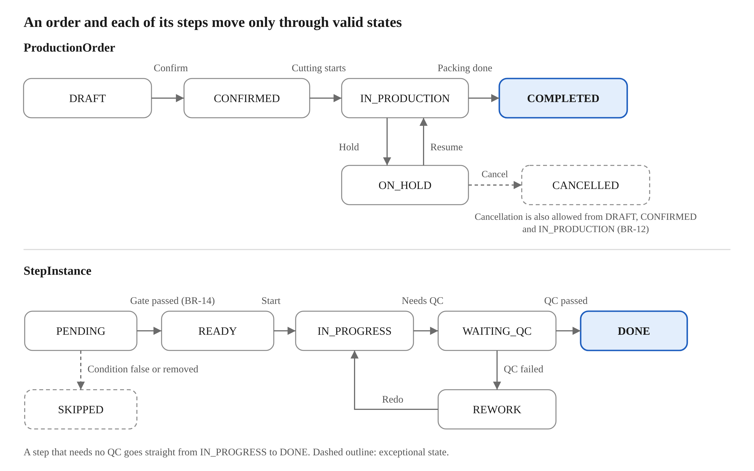
Figure 8.1 – State machines of ProductionOrder and StepInstance
Two state machines run nested: the order (ProductionOrder) and each step (StepInstance). An order can be put on Hold from CONFIRMED or IN_PRODUCTION, and Resume returns it to the previous state.
ProductionOrder
State | Meaning | Transition condition
DRAFT | The Planner is entering Style, size run and fabric–color | Confirm when data is complete and the Style has a PUBLISHED template (BR-03)
CONFIRMED | The workflow has been snapshotted; waiting to enter production | Moves to IN_PRODUCTION when the CUTTING step starts (BR-05, BR-06)
IN_PRODUCTION | Steps are running according to the Workflow Instance | Moves to COMPLETED when the last step finishes
ON_HOLD | Paused because of missing materials or waiting for the customer | Resume to the previous state; it can also be cancelled
COMPLETED | Packed and handed over | Final state
CANCELLED | Cancelled, with a reason | Final state (BR-12)
StepInstance
State | Meaning | Transition condition
PENDING | Not yet its turn | Moves to READY when all predecessor steps are done and the Gate passes (BR-14); moves to SKIPPED if the Condition is false
READY | Ready and shown on the station's worklist | Start moves it to IN_PROGRESS
IN_PROGRESS | In progress; quantities and evidence are entered | Complete moves to WAITING_QC if the step needs QC, otherwise to DONE (BR-15)
WAITING_QC | Waiting for the QC Inspector | QC pass moves to DONE; Fail or Rework moves to REWORK (BR-10)
REWORK | Being redone | Returns to IN_PROGRESS; beyond the permitted number of loops, the Planner handles it
DONE | Completed | Opens the next step
SKIPPED | Skipped | Due to a false Condition or a workflow change (BR-13); still counts as done when evaluating the Gate

9. Mandatory Business Rules
The system has 19 rules; the "Rationale" column states what each rule protects.
ID | Rule | Rationale
BR-01 | Publish only valid templates: exactly one start step, an end step exists, every step has a path to an end, no orphan steps, and every rework loop has a limit on its iterations | Prevents workflows from getting stuck or looping forever
BR-02 | Versions are immutable. Editing a template creates a new version; a template that has running orders may only be deactivated, never deleted | Protects orders in production and keeps history
BR-03 | When an order is confirmed, the system snapshots the version currently PUBLISHED for the Style; a Style without a PUBLISHED template cannot be confirmed | Every order runs on one well-defined process
BR-04 | Only colors listed in the Fabric–Color Matrix for the selected fabric type may be chosen | Prevents wrong fabric–color pairs that ruin a whole lot
BR-05 | Once the CUTTING step starts, fabric–color–wash is locked. Changing it requires BR-13 or cancelling the order | Fabric that has been cut cannot be changed back
BR-06 | CUTTING may not start unless fabric has been fully allocated per the BOM | Avoids stopping halfway through cutting because of missing fabric
BR-07 | The total cut quantity per size may not exceed the plan plus the configured tolerance | Controls wastage and over-cutting
BR-08 | Quantity conservation: the quantity entering the next step may not exceed the good quantity of the previous step; the difference must match the recorded defects or wastage | Traces every single pair of jeans and detects losses
BR-09 | Outsourced wash: the quantity received back must be reconciled against the quantity sent out, and any mismatch needs a recorded reason | Prevents goods from going missing outside the workshop
BR-10 | QC Fail or Rework must select a step to return to and record a reason. Beyond the maximum number of rework loops, the order is handed to the Planner | Prevents endless rework with nobody noticing
BR-11 | Separation of duties: the person performing a step may not approve QC for that same step | Keeps QC objective
BR-12 | Cancelling an order requires a reason. Before CUTTING, all allocations are released; from CUTTING onward, the fabric already cut and related cost must be recorded | Fabric that has been cut is a sunk cost
BR-13 | Changing the workflow while running: only steps that have not started may be inserted or skipped, mandatory steps may not be skipped, and Process Engineer approval is required | Flexible without breaking the core process
BR-14 | Gatekeeper: a step opens only when all predecessor steps are complete and their Gates pass | No skipping operations
BR-15 | A step configured as "evidence required" cannot be completed without at least 01 attachment (photo, slip) | Provides proof when a dispute arises
BR-16 | Every state transition, workflow change and quantity entry writes an AuditLog (who, when, old value, new value), which may not be edited or deleted | Traces accountability
BR-17 | An order with a dedicated custom request must pass through the CUSTOM_REVIEW branch: the workshop assesses feasibility and rejects the order if the request is infeasible; if feasible, a dedicated workflow is cloned from the nearest template, validated per BR-01 and approved by the Process Engineer, replacing the original snapshot, before the order enters fabric and color selection; custom orders must have sample approval (PP_SAMPLE) before cutting | Allows customer-specific customization while keeping the process valid and controllable
BR-18 | Clean wash runs by default for every order. It may be skipped only when the customer requests it to reduce cost; the Planner records the reason and the customer's confirmation, the step moves to SKIPPED and an AuditLog is written. Final QC then uses the SKIP_CLEAN_WASH QC Profile (BR-19) | Meets the request to lower cost while keeping evidence that the customer accepted the shrinkage and color-fading risk
BR-19 | Every Style has two QC Profiles, FULL_PROCESS and SKIP_CLEAN_WASH, each with its own shrinkage and color-fading thresholds configured by the Process Engineer. An order with skipCleanWash = true may be confirmed only with the customer's signed acknowledgement attached, and its final QC and handover record use the SKIP_CLEAN_WASH profile; otherwise FULL_PROCESS applies. Changing the skip decision after Confirm is a runtime workflow change (BR-13) and needs a new acknowledgement | Final QC judges each garment against the process it actually went through, and the customer's acceptance of the different thresholds is on record

10. Core Data Model
The entities are divided into 4 groups: catalog, workflow, production order and operation. Attribute names use camelCase so they can be used directly when drawing a Class Diagram and an ERD.
Group | Entity | Main attributes
Catalog | User | id, fullName, email, passwordHash, role, stationId
Catalog | Station | id, name, stationType (CUTTING, SEWING, EMBROIDERY, DYEING, WASH, FINISHING, QC, PACKING), isOutsourced
Catalog | Style | id, styleCode, name, fitType, defaultTemplateId
Catalog | FabricType | id, code, weightOz, composition, stretchType (RIGID, STRETCH)
Catalog | ColorOption | id, code, name, colorFamily
Catalog | FabricColorRule | id, fabricTypeId, colorId, isAllowed
Catalog | FabricLot | id, fabricTypeId, colorId, lotNo, availableMeters, shrinkagePercent
Catalog | QCProfile | id, styleId, profileType (FULL_PROCESS, SKIP_CLEAN_WASH), maxShrinkagePercent, maxColorFadingLevel, isActive
Workflow | WorkflowTemplate | id, name, status, currentVersionId
Workflow | WorkflowVersion | id, templateId, versionNo, status (DRAFT, PUBLISHED, RETIRED), publishedAt
Workflow | StepDefinition | id, versionId, code, name, stepType, stationType, isMandatory, requiresEvidence, conditionExpr, maxRework
Workflow | StepTransition | id, versionId, fromStepId, toStepId, conditionExpr, kind (NORMAL, REWORK)
Production order | ProductionOrder | id, orderNumber, styleId, fabricTypeId, colorId, washType, dyeRequired, dyeMode, dyeSource, skipCleanWash, qcProfileId, isCustom, status, dueDate, createdBy
Production order | CustomerAcknowledgement | id, orderId, ackType (SKIP_CLEAN_WASH), qcProfileId, fileUrl, acknowledgedBy, acknowledgedAt, recordedBy
Production order | OrderSizeLine | id, orderId, size, plannedQty
Production order | BomLine | id, orderId, materialType, requiredQty, unit
Production order | MaterialAllocation | id, bomLineId, fabricLotId, allocatedQty
Operation | WorkflowInstance | id, orderId, versionId, status
Operation | StepInstance | id, instanceId, stepDefinitionId, status, assignedTo, startedAt, completedAt, qtyIn, qtyGood, qtyDefect, reworkCount
Operation | Bundle | id, orderId, bundleCode, size, qty, currentStepInstanceId
Operation | Evidence | id, stepInstanceId, fileUrl, note, uploadedBy, uploadedAt
Operation | QCInspection | id, stepInstanceId, inspectorId, qcProfileId, sampleSize, result (PASS, REWORK, REJECT), notes
Operation | Defect | id, inspectionId, bundleId, defectType, qty
Operation | WorkflowChangeRequest | id, instanceId, requestedBy, payload, status, approvedBy
Operation | AuditLog | id, entityType, entityId, action, oldValue, newValue, actorId, createdAt
Main relationships: a Style has one default template; a WorkflowTemplate has many WorkflowVersions; a ProductionOrder has exactly one WorkflowInstance pointing to a fixed version; each WorkflowInstance has many StepInstances, and each StepInstance has many Evidence records. A Style has two QCProfiles; a ProductionOrder with skipCleanWash = true has one CustomerAcknowledgement and points to the SKIP_CLEAN_WASH profile.

11. Preliminary Feature List
The draft has 29 functional requirements (FR) in 8 modules, of which 14 belong to the MVP, enough for an order to run from Confirm all the way to handover on a configurable workflow. They are to be adjusted when the scope is finalized (see the Appendix document).
FR ID | Module | Function | Actor | Priority
FR-01 | Auth & Master Data | Login, RBAC authorization | All | MVP
FR-02 | Auth & Master Data | Manage Style, FabricType, ColorOption, Fabric–Color Matrix | Admin | MVP
FR-03 | Auth & Master Data | Manage fabric stock by lot (FabricLot) and trims | Warehouse Keeper | High
FR-04 | Workflow Designer | Create/edit Workflow Template (step, transition, condition, gate) | Process Engineer | MVP
FR-05 | Workflow Designer | Validate, publish a version and assign the template to a Style | Process Engineer | MVP
FR-06 | Workflow Designer | View version history, deactivate a template | Process Engineer | Medium
FR-07 | Production Order | Create and Confirm a Production Order (Style, size run, due date) | Planner | MVP
FR-08 | Production Order | Select fabric–color, with the system filtering by the Matrix | Planner | MVP
FR-09 | Production Order | Calculate BOM, allocate materials, create a Material Request when short | Planner, Warehouse Keeper | MVP
FR-10 | Production Order | Hold, Resume, Cancel an order | Planner | High
FR-11 | Execution Engine | Create a Workflow Instance from the snapshot, open steps by Gate | System | MVP
FR-12 | Execution Engine | Worklist by station: pick up work, Start/Complete a step | Station Operator | MVP
FR-13 | Execution Engine | Enter good/defect quantities per bundle, check quantity conservation | Station Operator | MVP
FR-14 | Execution Engine | Attach evidence (photos, slips) | Station Operator | High
FR-15 | Execution Engine | Generate bundles and bundle codes | Station Operator, System | High
FR-16 | QC & Rework | QC by checklist/AQL, with Pass/Rework/Reject results | QC Inspector | MVP
FR-17 | QC & Rework | Route rework back to a designated step, limit the number of loops | System | MVP
FR-18 | QC & Rework | Record Defects by bundle | QC Inspector | High
FR-19 | Runtime Change | Propose inserting/skipping a step for one order | Planner | Medium
FR-20 | Runtime Change | Approve or reject a workflow change | Process Engineer | Medium
FR-21 | Tracking & Report | WIP dashboard by order and by operation | Manager, Planner | MVP
FR-22 | Tracking & Report | Defect rate and run time reports per step | Manager | Medium
FR-23 | Tracking & Report | Traceability by fabric lot and bundle | Planner, QC Inspector | High
FR-24 | Notification & Audit | Notify when a step is READY, BLOCKED or QC fails | System | High
FR-25 | Notification & Audit | View and filter the AuditLog | Admin | High
FR-26 | Notification & Audit | Packing, packing list and handover record | Planner | MVP
FR-27 | Production Order | Create a custom request, assess feasibility (or reject) and create a dedicated workflow (cloned from a template) | Planner, Process Engineer | High
FR-28 | QC & Rework | Configure QC Profiles per Style (shrinkage and color-fading thresholds for FULL_PROCESS and SKIP_CLEAN_WASH) and apply the matching profile at final QC | Process Engineer, QC Inspector | High
FR-29 | Production Order | Record the customer's signed acknowledgement when clean wash is skipped, and block Confirm until it is attached | Planner | High

12. Applied Design Patterns
The project uses 5 main patterns, each solving exactly one problem of the workflow engine; patterns are not applied just for show.
Pattern | Where applied | Why chosen | Trade-off
State | The lifecycle of ProductionOrder and StepInstance; each state is a class that decides its own valid behavior | Blocks illegal state transitions without nested if-else chains | Many small classes, and the transition table must be kept in sync with Section 8
Chain of Responsibility | The chain of Gate checks before a step opens: predecessor done, full quantity, evidence attached, QC passed | A Gate type can be added or removed without modifying the other Gates; it fits the "gatekeeper" idea | The order of the links affects the error reported, and debugging is harder
Strategy | Evaluating a Condition (expression) calculating BOM in different ways (by size, by fixed norm), and choosing the QC thresholds by QC Profile | The evaluation or calculation method can be changed without touching the engine | Adds an abstraction layer, which may be excessive for a small project
Factory Method | Creating a StepHandler by stepType (SELECTION, MATERIAL, PRODUCTION, QC, APPROVAL) | A new step type needs only a new handler plus registration with the factory; the engine does not change | Needs a clear handler-registration convention
Observer | Emitting the events StepCompleted, StepBlocked, QcFailed to Notification, AuditLog and Dashboard | The event publisher does not need to know who listens, and adding a notification channel does not modify the engine | Execution is indirect and harder to follow than a direct call
Two optional patterns if the schedule allows: Composite for the sub-workflow (the Sewing step contains child steps, handled uniformly) and Command for WorkflowChangeRequest (each workflow change is a command that can be approved, applied and logged).
Proposed architecture: a Modular Monolith following Clean Architecture, with the modules Catalog, Workflow, Order, Execution, Quality, Inventory and Audit. A modular monolith is chosen because the project team is small, and the module boundaries stay clear so services can be split out later if needed.

