- Breadth-First Search

Environment size | #nodes explored | Solution length | Score | Is it optimal?
5x5 | 95 | 41 | 152 | NO
10x10 | 450 | 137 | 662 | NO
15x15 | 1178 | 323 | 1082 | NO
20x20 | 2005 | 511 | 2914 | NO

After test all the environment size 5 time each but none of them have the same score
These picture below will show you the result:
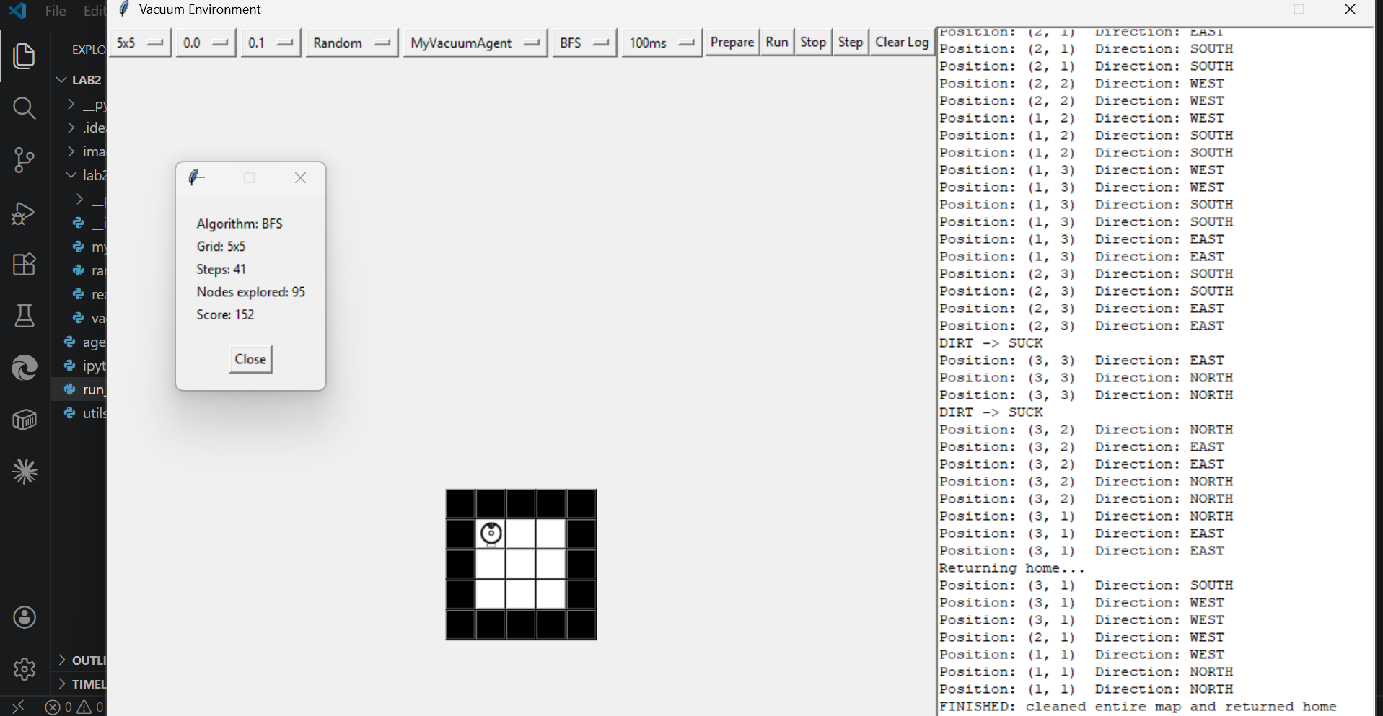
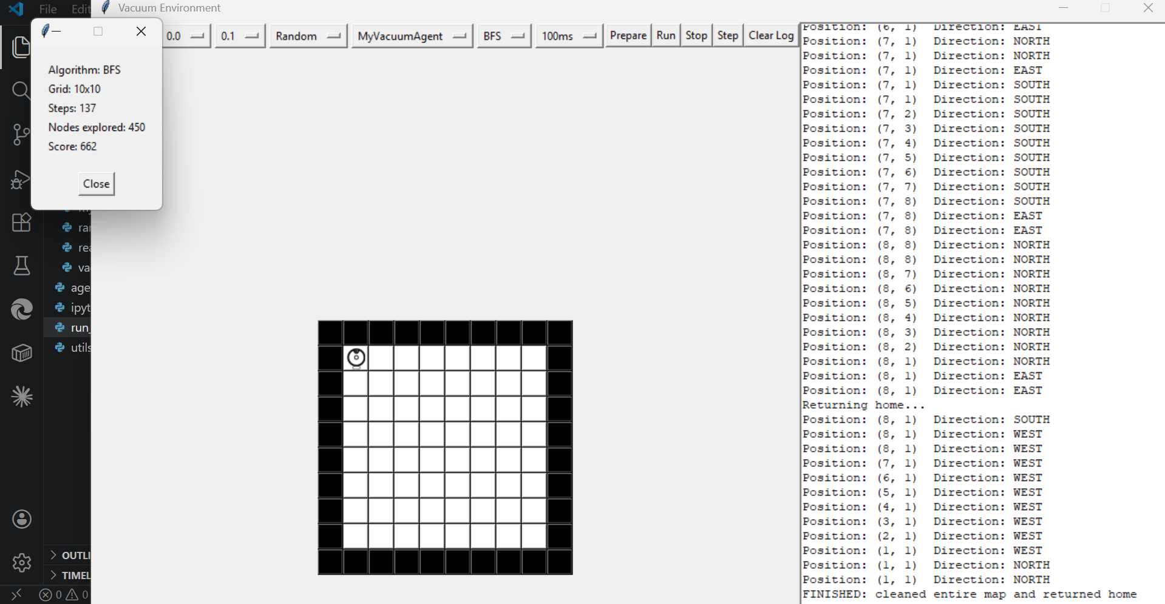
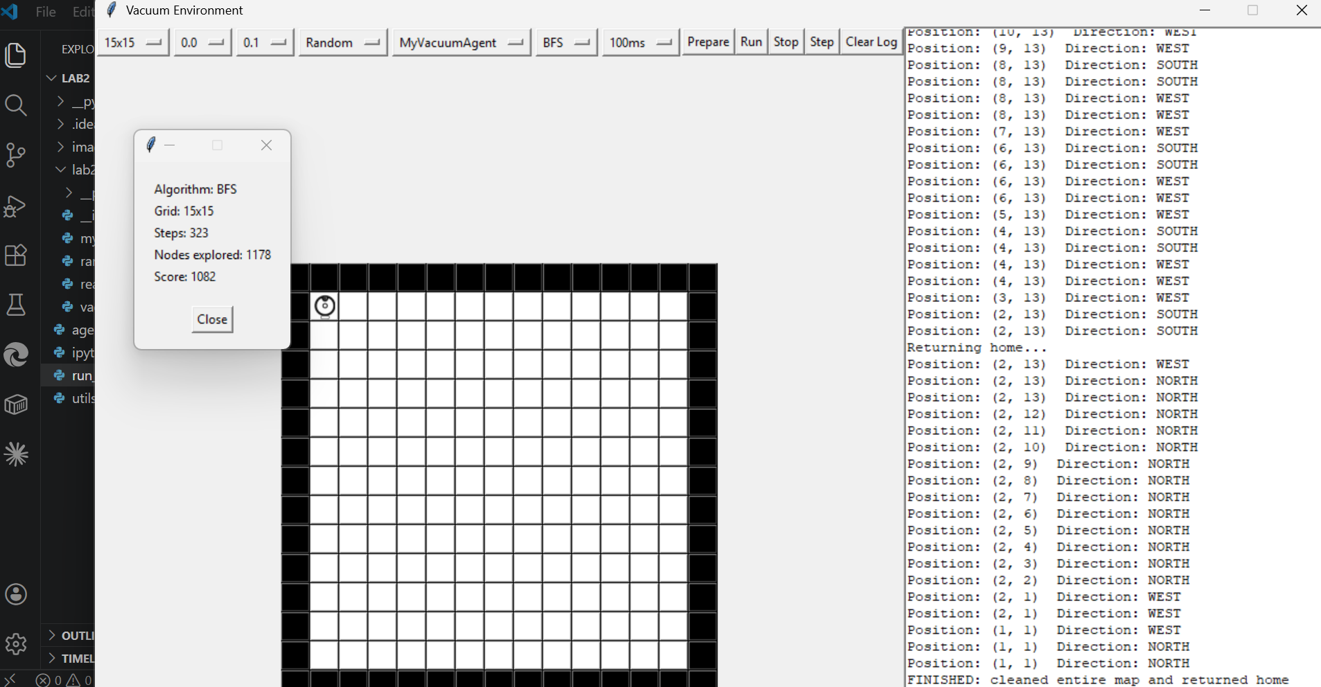
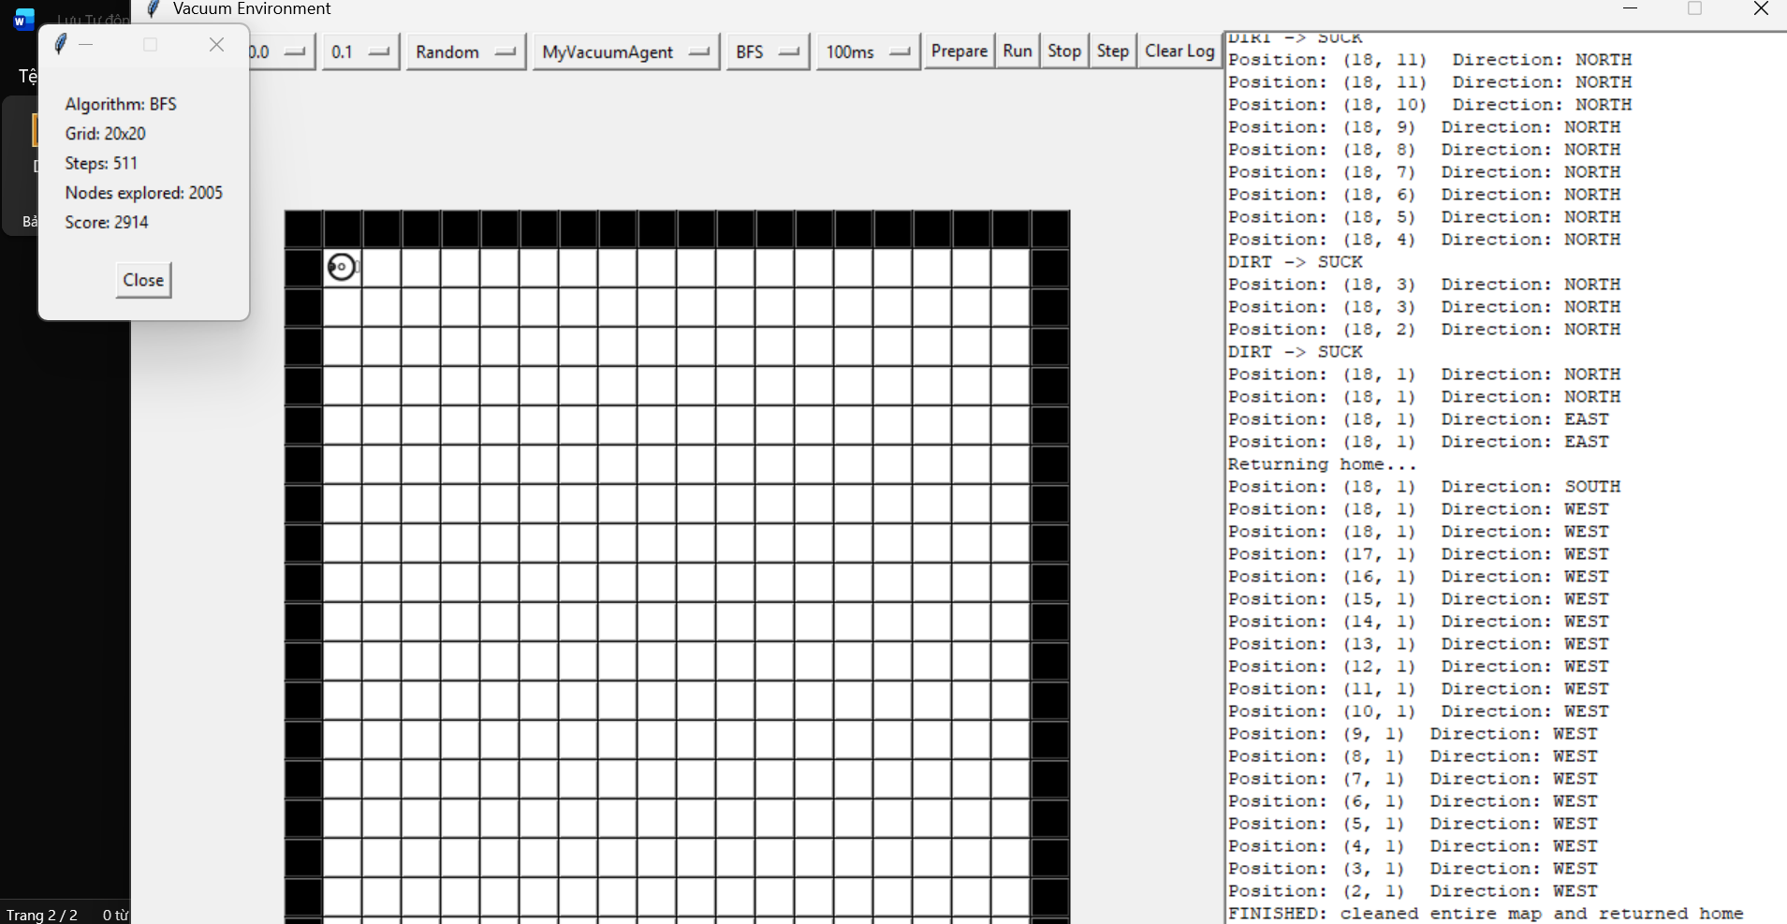

- A* Algorithm

Environment size | #nodes explored | Solution length | Score | Is it optimal?
5x5 | 65 | 40 | 135 | YES
10x10 | 344 | 157 | 1046 | YES
15x15 | 794 | 303 | 799 | YES
20x20 | 1458 | 506 | 2414 | YES

After test all the environment size 5 time each but none of them have the same score
These picture below will show you the result:
