**Bài tập 1: Sử dụng Animation**

Bước 1: Ta tạo file dimens.xlm như trong hình

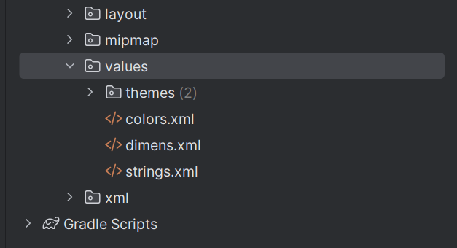

Bước 2: Ta copy code vào 2 file dimens.xml và strings.xml theo thứ tự

<resources>  
 <dimen name="margin_base">5dp</dimen>  
 <dimen name="margin_basex2">10dp</dimen>  
 <dimen name="text_medium">16sp</dimen>  
 <dimen name="image_base">100dp</dimen>  
</resources>

<resources>  
 <string name="app_name">BaiTapLyThuyetLap6</string>  
 <string name="from_xml">From XML</string>  
 <string name="from_code">From CODE</string>  
 <string name="fade_in">Fade In</string>  
 <string name="fade_out">Fade Out</string>  
 <string name="blink">Blink</string>  
 <string name="zoom_in">Zoom In</string>  
 <string name="zoom_out">Zoom Out</string>  
 <string name="rotate">Rotate</string>  
 <string name="move">Move</string>  
 <string name="slide_up">Slide Up</string>  
 <string name="bounce">Bounce</string>  
 <string name="combine">Combine</string>  
</resources>

Bước 3: Ta xây dựng giao diện trong activity_main.xml

<?xml version="1.0" encoding="utf-8"?>  
<LinearLayout  
 xmlns:android="http://schemas.android.com/apk/res/android"  
 xmlns:tools="http://schemas.android.com/tools"  
 android:layout_width="match_parent"  
 android:layout_height="match_parent"  
 android:orientation="vertical"  
 tools:context=".MainActivity">  
 <FrameLayout  
 android:layout_width="match_parent"  
 android:layout_height="0dp"  
 android:layout_weight="6">  
 <ImageView  
 android:id="@+id/iv_uit_logo"  
 android:layout_width="@dimen/image_base"  
 android:layout_height="@dimen/image_base"  
 android:layout_gravity="center"  
 android:scaleType="fitCenter"  
 android:src="@drawable/img"/>  
 </FrameLayout>  
 <LinearLayout  
 android:layout_marginTop="@dimen/margin_basex2"  
 android:layout_width="match_parent"  
 android:layout_height="wrap_content"  
 android:orientation="horizontal">  
 <TextView  
 android:layout_width="0dp"  
 android:layout_height="wrap_content"  
 android:layout_weight="1"  
 android:text="@string/from_xml"  
 android:gravity="center"  
 android:textStyle="bold"  
 android:layout_marginRight="@dimen/margin_base"/>  
 <TextView  
 android:layout_width="0dp"  
 android:layout_height="wrap_content"  
 android:layout_weight="1"  
 android:text="@string/from_code"  
 android:textStyle="bold"  
 android:gravity="center"  
 android:layout_marginRight="@dimen/margin_base"/>  
 </LinearLayout>  
 <ScrollView  
 android:layout_width="match_parent"  
 android:layout_height="0dp"  
 android:layout_weight="5">  
 <LinearLayout  
 android:layout_width="match_parent"  
 android:layout_height="wrap_content"  
 android:orientation="vertical">  
 <LinearLayout  
 android:layout_marginTop="@dimen/margin_base"  
 android:layout_width="match_parent"  
 android:layout_height="wrap_content"  
 android:orientation="horizontal">  
 <Button  
 android:id="@+id/btn_fade_in_xml"  
 android:layout_width="0dp"  
 android:layout_height="wrap_content"  
 android:layout_weight="1"  
 android:text="@string/fade_in"  
 android:gravity="center"  
 android:layout_marginRight="@dimen/margin_base"/>  
 <Button  
 android:id="@+id/btn_fade_in_code"  
 android:layout_width="0dp"  
 android:layout_height="wrap_content"  
 android:layout_weight="1"  
 android:text="@string/fade_in"  
 android:gravity="center"  
 android:layout_marginRight="@dimen/margin_base"/>  
 </LinearLayout>  
 <LinearLayout  
 android:layout_marginTop="@dimen/margin_base"  
 android:layout_width="match_parent"  
 android:layout_height="wrap_content"  
 android:orientation="horizontal">  
 <Button  
 android:id="@+id/btn_fade_out_xml"  
 android:layout_width="0dp"  
 android:layout_height="wrap_content"  
 android:layout_weight="1"  
 android:text="@string/fade_out"  
 android:gravity="center"  
 android:layout_marginRight="@dimen/margin_base"/> <Button  
 android:id="@+id/btn_fade_out_code"  
 android:layout_width="0dp"  
 android:layout_height="wrap_content"  
 android:layout_weight="1"  
 android:text="@string/fade_out"  
 android:gravity="center"  
 android:layout_marginRight="@dimen/margin_base"/>  
 </LinearLayout>  
 <LinearLayout  
 android:layout_marginTop="@dimen/margin_base"  
 android:layout_width="match_parent"  
 android:layout_height="wrap_content"  
 android:orientation="horizontal">  
 <Button  
 android:id="@+id/btn_blink_xml"  
 android:layout_width="0dp"  
 android:layout_height="wrap_content"  
 android:layout_weight="1"  
 android:text="@string/blink"  
 android:gravity="center"  
 android:layout_marginRight="@dimen/margin_base"/>  
 <Button  
 android:id="@+id/btn_blink_code"  
 android:layout_width="0dp"  
 android:layout_height="wrap_content"  
 android:layout_weight="1"  
 android:text="@string/blink"  
 android:gravity="center"  
 android:layout_marginRight="@dimen/margin_base"/>  
 </LinearLayout>  
 <LinearLayout  
 android:layout_marginTop="@dimen/margin_base"  
 android:layout_width="match_parent"  
 android:layout_height="wrap_content"  
 android:orientation="horizontal">  
 <Button  
 android:id="@+id/btn_zoom_in_xml"  
 android:layout_width="0dp"  
 android:layout_height="wrap_content"  
 android:layout_weight="1"  
 android:text="@string/zoom_in"  
 android:gravity="center"  
 android:layout_marginRight="@dimen/margin_base"/>  
 <Button  
 android:id="@+id/btn_zoom_in_code"  
 android:layout_width="0dp"  
 android:layout_height="wrap_content"  
 android:layout_weight="1"  
 android:text="@string/zoom_in"  
 android:gravity="center"  
 android:layout_marginRight="@dimen/margin_base"/>  
 </LinearLayout>  
 <LinearLayout  
 android:layout_marginTop="@dimen/margin_base"  
 android:layout_width="match_parent"  
 android:layout_height="wrap_content"  
 android:orientation="horizontal">  
 <Button  
 android:id="@+id/btn_zoom_out_xml"  
 android:layout_width="0dp"  
 android:layout_height="wrap_content"  
 android:layout_weight="1"  
 android:text="@string/zoom_out"  
 android:gravity="center"  
 android:layout_marginRight="@dimen/margin_base"/>  
 <Button  
 android:id="@+id/btn_zoom_out_code"  
 android:layout_width="0dp"  
 android:layout_height="wrap_content"  
 android:layout_weight="1"  
 android:text="@string/zoom_out"  
 android:gravity="center"  
 android:layout_marginRight="@dimen/margin_base"/> </LinearLayout>  
 <LinearLayout  
 android:layout_marginTop="@dimen/margin_base"  
 android:layout_width="match_parent"  
 android:layout_height="wrap_content"  
 android:orientation="horizontal">  
 <Button  
 android:id="@+id/btn_rotate_xml"  
 android:layout_width="0dp"  
 android:layout_height="wrap_content"  
 android:layout_weight="1"  
 android:text="@string/rotate"  
 android:gravity="center"  
 android:layout_marginRight="@dimen/margin_base"/>  
 <Button  
 android:id="@+id/btn_rotate_code"  
 android:layout_width="0dp"  
 android:layout_height="wrap_content"  
 android:layout_weight="1"  
 android:text="@string/rotate"  
 android:gravity="center"  
 android:layout_marginRight="@dimen/margin_base"/>  
 </LinearLayout>  
 <LinearLayout  
 android:layout_marginTop="@dimen/margin_base"  
 android:layout_width="match_parent"  
 android:layout_height="wrap_content"  
 android:orientation="horizontal">  
 <Button  
 android:id="@+id/btn_move_xml"  
 android:layout_width="0dp"  
 android:layout_height="wrap_content"  
 android:layout_weight="1"  
 android:text="@string/move"  
 android:gravity="center"  
 android:layout_marginRight="@dimen/margin_base"/>  
 <Button  
 android:id="@+id/btn_move_code"  
 android:layout_width="0dp"  
 android:layout_height="wrap_content"  
 android:layout_weight="1"  
 android:text="@string/move"  
 android:gravity="center"  
 android:layout_marginRight="@dimen/margin_base"/>  
 </LinearLayout>  
 <LinearLayout  
 android:layout_marginTop="@dimen/margin_base"  
 android:layout_width="match_parent"  
 android:layout_height="wrap_content"  
 android:orientation="horizontal">  
 <Button  
 android:id="@+id/btn_slide_up_xml"  
 android:layout_width="0dp"  
 android:layout_height="wrap_content"  
 android:layout_weight="1"  
 android:text="@string/slide_up"  
 android:gravity="center"  
 android:layout_marginRight="@dimen/margin_base"/> <Button  
 android:id="@+id/btn_slide_up_code"  
 android:layout_width="0dp"  
 android:layout_height="wrap_content"  
 android:layout_weight="1"  
 android:text="@string/slide_up"  
 android:gravity="center"  
 android:layout_marginRight="@dimen/margin_base"/>  
 </LinearLayout>  
 <LinearLayout  
 android:layout_marginTop="@dimen/margin_base"  
 android:layout_width="match_parent"  
 android:layout_height="wrap_content"  
 android:orientation="horizontal">  
 <Button  
 android:id="@+id/btn_bounce_xml"  
 android:layout_width="0dp"  
 android:layout_height="wrap_content"  
 android:layout_weight="1"  
 android:text="@string/bounce"  
 android:gravity="center"  
 android:layout_marginRight="@dimen/margin_base"/>  
 <Button  
 android:id="@+id/btn_bounce_code"  
 android:layout_width="0dp"  
 android:layout_height="wrap_content"  
 android:layout_weight="1"  
 android:text="@string/bounce"  
 android:gravity="center"  
 android:layout_marginRight="@dimen/margin_base"/> </LinearLayout>  
 <LinearLayout  
 android:layout_marginTop="@dimen/margin_base"  
 android:layout_width="match_parent"  
 android:layout_height="wrap_content"  
 android:orientation="horizontal">  
 <Button  
 android:id="@+id/btn_combine_xml"  
 android:layout_width="0dp"  
 android:layout_height="wrap_content"  
 android:layout_weight="1"  
 android:text="@string/combine"  
 android:gravity="center"  
 android:layout_marginRight="@dimen/margin_base"/>  
 <Button  
 android:id="@+id/btn_combine_code"  
 android:layout_width="0dp"  
 android:layout_height="wrap_content"  
 android:layout_weight="1"  
 android:text="@string/combine"  
 android:gravity="center"  
 android:layout_marginRight="@dimen/margin_base"/> </LinearLayout>  
 </LinearLayout>  
 </ScrollView>  
</LinearLayout>

Bước 4: Từ thư mục res, ta tạo thư mục anim để chứa các hiệu ứng

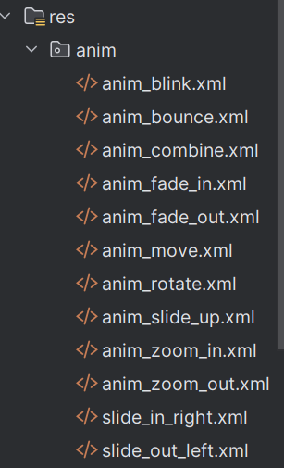

Bước 5: Tạo file anim_fade_in.xml và dán code thầy đã cho vào

<?xml version="1.0" encoding="utf-8"?>  
<set xmlns:android="http://schemas.android.com/apk/res/android" android:fillAfter="true" >  
 <alpha  
 android:duration="1000"  
 android:fromAlpha="0.0"  
 android:toAlpha="1.0" />  
</set>

Bước 6: Tương tự tạo các file: anim_fade_out.xml, anim_blink.xml, anim_zoom_in.xml, anim_zoom_out.xml, anim_rotate.xml, anim_move.xml, anim_slide_up.xml, anim_bounce.xml, anim_combine.xml và dán code vào từng file đó.

Bước 7: Ta vào MainActivity để khai báo

import androidx.appcompat.app.AppCompatActivity;  
  
public class MainActivity extends AppCompatActivity {  
 private ImageView ivUitLogo;  
  
 // Button khai báo  
 private Button btnFadeInXml, btnFadeOutXml, btnBlinkXml, btnZoomInXml, btnZoomOutXml,  
 btnRotateXml, btnMoveXml, btnSlideUpXml, btnBounceXml, btnCombineXml;  
  
 @Override  
 protected void onCreate(Bundle savedInstanceState) {  
 super.onCreate(savedInstanceState);  
 setContentView(R.layout.*activity_main*);  
  
 findViewsByIds();  
  
 // Gọi lần lượt  
 handleClickAnimationXml(btnFadeInXml, R.anim.*anim_fade_in*);  
 handleClickAnimationXml(btnFadeOutXml, R.anim.*anim_fade_out*);  
 handleClickAnimationXml(btnBlinkXml, R.anim.*anim_blink*);  
 handleClickAnimationXml(btnZoomInXml, R.anim.*anim_zoom_in*);  
 handleClickAnimationXml(btnZoomOutXml, R.anim.*anim_zoom_out*);  
 handleClickAnimationXml(btnRotateXml, R.anim.*anim_rotate*);  
 handleClickAnimationXml(btnMoveXml, R.anim.*anim_move*);  
 handleClickAnimationXml(btnSlideUpXml, R.anim.*anim_slide_up*);  
 handleClickAnimationXml(btnBounceXml, R.anim.*anim_bounce*);  
 handleClickAnimationXml(btnCombineXml, R.anim.*anim_combine*);  
 }  
  
 private void findViewsByIds() {  
 ivUitLogo = findViewById(R.id.*iv_uit_logo*);  
 btnFadeInXml = findViewById(R.id.*btn_fade_in_xml*);  
 btnFadeOutXml = findViewById(R.id.*btn_fade_out_xml*);  
 btnBlinkXml = findViewById(R.id.*btn_blink_xml*);  
 btnZoomInXml = findViewById(R.id.*btn_zoom_in_xml*);  
 btnZoomOutXml = findViewById(R.id.*btn_zoom_out_xml*);  
 btnRotateXml = findViewById(R.id.*btn_rotate_xml*);  
 btnMoveXml = findViewById(R.id.*btn_move_xml*);  
 btnSlideUpXml = findViewById(R.id.*btn_slide_up_xml*);  
 btnBounceXml = findViewById(R.id.*btn_bounce_xml*);  
 btnCombineXml = findViewById(R.id.*btn_combine_xml*);  
 }  
  
 private void handleClickAnimationXml(Button btn, int animId) {  
 btn.setOnClickListener(v -> {  
 Animation animation = AnimationUtils.*loadAnimation*(getApplicationContext(), animId);  
 ivUitLogo.startAnimation(animation);  
 });  
 }  
}

Bước 8: Kết quả khi chạy

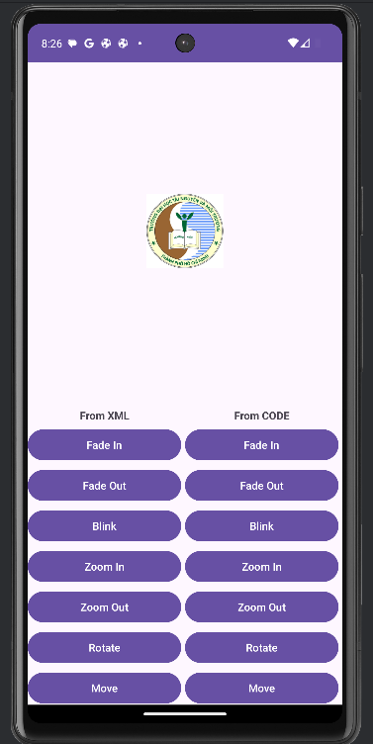

**Bài tập 2: Animation từ Code**

Bước 1: Thêm hàm dưới đây vào MainActivity

private void handleClickAnimationCode(Button btn, final Animation animation) {  
 btn.setOnClickListener(v -> ivUitLogo.startAnimation(animation));  
}  
  
// Các hàm tạo animation bằng code  
private Animation createFadeInAnim() {  
 AlphaAnimation anim = new AlphaAnimation(0.0f, 1.0f);  
 anim.setDuration(1000);  
 anim.setFillAfter(true);  
 return anim;  
}

Bước 2: Trong hàm onCreate(), thêm các đoạn sau

handleClickAnimationCode(findViewById(R.id.*btn_fade_in_code*), createFadeInAnim());  
handleClickAnimationCode(findViewById(R.id.*btn_zoom_in_code*), createZoomInAnim());  
handleClickAnimationCode(findViewById(R.id.*btn_rotate_code*), createRotateAnim());

Bước 3: Ta tạo thêm các createZoomOutAnim(), createRotateAnim()

private Animation createZoomInAnim() {  
 ScaleAnimation anim = new ScaleAnimation(  
 1, 3, 1, 3,  
 Animation.*RELATIVE_TO_SELF*, 0.5f,  
 Animation.*RELATIVE_TO_SELF*, 0.5f);  
 anim.setDuration(1000);  
 return anim;  
}  
  
private Animation createRotateAnim() {  
 RotateAnimation anim = new RotateAnimation(  
 0, 360,  
 Animation.*RELATIVE_TO_SELF*, 0.5f,  
 Animation.*RELATIVE_TO_SELF*, 0.5f);  
 anim.setDuration(600);  
 return anim;  
}

Bước 4: Kết quả như hình

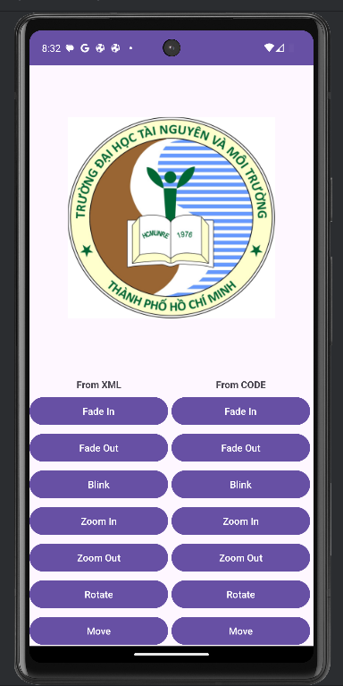

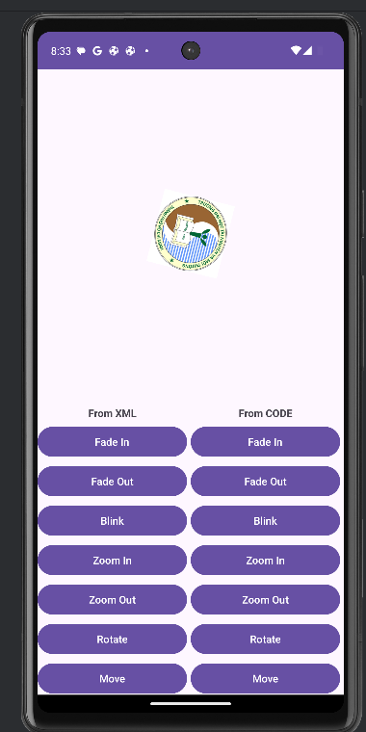

**Bài tập 3: Animation khi mở Activity mới**

Bước 1: Tạo SecondActivity.java + activity_second.xml

Bước 2: Trong MainActivity, bắt sự kiện click vào logo

ivUitLogo.setOnClickListener(new View.OnClickListener() {  
 @Override  
 public void onClick(View v) {  
 Intent intent = new Intent(MainActivity.this, SecondActivity.class);  
 startActivity(intent);  
  
 // Animation chuyển màn hình  
 overridePendingTransition(R.anim.*slide_in_right*, R.anim.*slide_out_left*);  
 }  
});

Bước 3: Tạo thêm 2 file anim slide_in_right.xml và slide_out_left.xml và gõ đoạn code dưới đây

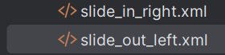

<?xml version="1.0" encoding="utf-8"?>  
<set xmlns:android="http://schemas.android.com/apk/res/android">  
 <translate xmlns:android="http://schemas.android.com/apk/res/android"  
 android:duration="500"  
 android:fromXDelta="100%p"  
 android:toXDelta="0"/>  
</set>

Bước 4: Trong file activity_second.xml, copy đoạn code giao diện dưới đây

<LinearLayout xmlns:android="http://schemas.android.com/apk/res/android"  
 android:layout_width="match_parent"  
 android:layout_height="match_parent"  
 android:orientation="vertical"  
 android:gravity="center"  
 android:background="#E3F2FD">  
  
 <TextView  
 android:text="Đây là SecondActivity"  
 android:textSize="22sp"  
 android:textStyle="bold"  
 android:layout_width="wrap_content"  
 android:layout_height="wrap_content"/>  
</LinearLayout>

Bước 5: Kết quả

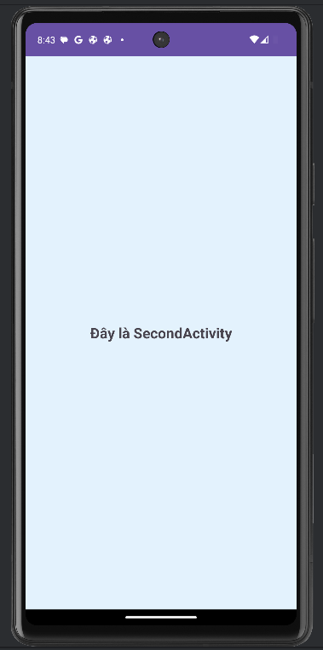

Bài 4: ViewPager2

Bước 1: Tạo một Activity mới tên **ViewPagerActivity và giao diện** activity_viewpager.xml cùng đoạn code sau

<?xml version="1.0" encoding="utf-8"?>  
<androidx.constraintlayout.widget.ConstraintLayout  
 xmlns:android="http://schemas.android.com/apk/res/android"  
 xmlns:app="http://schemas.android.com/apk/res-auto"  
 android:layout_width="match_parent"  
 android:layout_height="match_parent">  
  
 <androidx.viewpager2.widget.ViewPager2  
 android:id="@+id/viewPager"  
 android:layout_width="0dp"  
 android:layout_height="0dp"  
 app:layout_constraintTop_toTopOf="parent"  
 app:layout_constraintBottom_toBottomOf="parent"  
 app:layout_constraintStart_toStartOf="parent"  
 app:layout_constraintEnd_toEndOf="parent"/>  
  
</androidx.constraintlayout.widget.ConstraintLayout>

Bước 2: Tạo FragmentOne.java và FragmentTwo.java với copy lần lượt code theo thứ tự

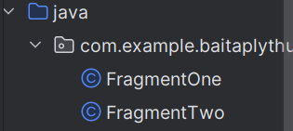

package com.example.baitaplythuyetlap6;  
  
import android.os.Bundle;  
import android.view.LayoutInflater;  
import android.view.View;  
import android.view.ViewGroup;  
  
import androidx.annotation.NonNull;  
import androidx.annotation.Nullable;  
import androidx.fragment.app.Fragment;  
  
public class FragmentOne extends Fragment {  
 @Nullable  
 @Override  
 public View onCreateView(@NonNull LayoutInflater inflater,  
 @Nullable ViewGroup container,  
 @Nullable Bundle savedInstanceState) {  
 return inflater.inflate(R.layout.fragment_one, container, false);  
 }  
}

package com.example.baitaplythuyetlap6;  
  
import android.os.Bundle;  
import android.view.LayoutInflater;  
import android.view.View;  
import android.view.ViewGroup;  
  
import androidx.annotation.NonNull;  
import androidx.annotation.Nullable;  
import androidx.fragment.app.Fragment;  
  
public class FragmentTwo extends Fragment {  
 @Nullable  
 @Override  
 public View onCreateView(@NonNull LayoutInflater inflater,  
 @Nullable ViewGroup container,  
 @Nullable Bundle savedInstanceState) {  
 return inflater.inflate(R.layout.*fragment_two*, container, false);  
 }  
}

Bước 3: Tạo 2 giao diện fragment_one.xml và fragment_two.xml copy lần lượt code theo thứ tự

<?xml version="1.0" encoding="utf-8"?>  
<LinearLayout xmlns:android="http://schemas.android.com/apk/res/android"  
 android:gravity="center"  
 android:orientation="vertical"  
 android:background="#FFCDD2"  
 android:layout_width="match_parent"  
 android:layout_height="match_parent">  
  
 <TextView  
 android:text="Fragment One"  
 android:textSize="24sp"  
 android:textStyle="bold"  
 android:layout_width="wrap_content"  
 android:layout_height="wrap_content"/>  
</LinearLayout>

<?xml version="1.0" encoding="utf-8"?>  
<LinearLayout xmlns:android="http://schemas.android.com/apk/res/android"  
 android:gravity="center"  
 android:orientation="vertical"  
 android:background="#C8E6C9"  
 android:layout_width="match_parent"  
 android:layout_height="match_parent">  
  
 <TextView  
 android:text="Fragment Two"  
 android:textSize="24sp"  
 android:textStyle="bold"  
 android:layout_width="wrap_content"  
 android:layout_height="wrap_content"/>  
</LinearLayout>

Bước 4: Tạo ViewPagerAdapter.java và dán code sau vào

package com.example.baitaplythuyetlap6;  
  
import androidx.annotation.NonNull;  
import androidx.fragment.app.Fragment;  
import androidx.fragment.app.FragmentActivity;  
import androidx.viewpager2.adapter.FragmentStateAdapter;  
  
public class ViewPagerAdapter extends FragmentStateAdapter {  
 public ViewPagerAdapter(@NonNull FragmentActivity fragmentActivity) {  
 super(fragmentActivity);  
 }  
  
 @NonNull  
 @Override  
 public Fragment createFragment(int position) {  
 if (position == 0) {  
 return new FragmentOne(); // Trang 1  
 } else {  
 return new FragmentTwo(); // Trang 2  
 }  
 }  
  
 @Override  
 public int getItemCount() {  
 return 2; // phải >= 2  
 }  
}

Bước 5: Code trong ViewPagerActivity

package com.example.baitaplythuyetlap6;  
  
import android.os.Bundle;  
import androidx.appcompat.app.AppCompatActivity;  
import androidx.viewpager2.widget.ViewPager2;  
  
public class ViewPagerActivity extends AppCompatActivity {  
 @Override  
 protected void onCreate(Bundle savedInstanceState) {  
 super.onCreate(savedInstanceState);  
 setContentView(R.layout.*activity_viewpager*);  
  
 ViewPager2 viewPager = findViewById(R.id.*viewPager*);  
 ViewPagerAdapter adapter = new ViewPagerAdapter(this);  
 viewPager.setAdapter(adapter);  
 }  
}

Bước 6: Kết quả

