Give the following XML about books collection. Write java program with the UI look like figure 1. User can be search by book name, book ID or a list of books with category.

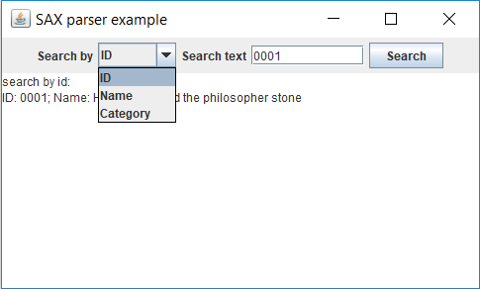

Figure 1

<?xml version=**"1.0"**?>

<Books>

<Book id=**"0001"** Category=**"novel"**>

<Name>**Harry Potter and the philosopher stone**</Name>

<Author>**J.K Rowling**</Author>

<ISBN>**978-3-16-148410-0**</ISBN>

<Price>**18.5**</Price>

<Sold>**21**</Sold>

<Stock>**17**</Stock>

</Book>

<Book id=**"0002"** Category=**"Programming"**>

<Name>**XML in a Nutshell, Third Edition**</Name>

<Author>**W. Scott Means**</Author>

<ISBN>**978-0-59-600764-5**</ISBN>

<Price>**31.8**</Price>

<Sold>**84**</Sold>

<Stock>**147**</Stock>

</Book>

<Book id=**"0003"** Category=**"Programming"**>

<Name>**Core Java Volume I-Fundamentals**</Name>

<Author>**Cay S. Horstmann**</Author>

<ISBN>**978-0137081899**</ISBN>

<Price>**11.96**</Price>

<Sold>**37**</Sold>

<Stock>**15**</Stock>

</Book>

<Book id=**"0004"** Category=**"Science"**>

<Name>**A Brief History of Time**</Name>

<Author>**Stephen Hawking**</Author>

<ISBN>**978-0-55-338016-3**</ISBN>

<Price>**16.25**</Price>

<Sold>**126**</Sold>

<Stock>**49**</Stock>

</Book>

</Books>