PROGRESS TEST 1
SWT301 – Software Testing | Topic: Static Testing

Duration: 50 minutes  Total Marks: 10 points | Permitted Materials: All  Instructor: traltb@fe.edu.vn

STUDENT INFORMATION

Full Name: Nguyen Truong Phuc | Student ID: DE200133 | Class: SE20A01
Date: _________________________ | Duration: _________________________ | Score: _________________________

GENERAL INSTRUCTIONS

- Read all questions carefully before answering.
- Write your answers clearly in the designated answer templates below each question.
- All answers must be written in English.
- Justify each identified defect with a clear description and a suggested fix.
- Partial credit may be awarded for partially correct answers.

PART 1 – CODE REVIEW & BUG IDENTIFICATION (6 points)

Question 1 (4 points)
This question consists of TWO code review exercises. Read the code carefully, then complete the answer template below each exercise.

Exercise 1A – Insurance Claim Processing System (2 points)
The Java method below is taken from an insurance claim processing system. Identify exactly 6 errors related to:
- Coding conventions and naming standards
- Coding style and formatting
- Logic errors or incorrect behaviour

Code under review:

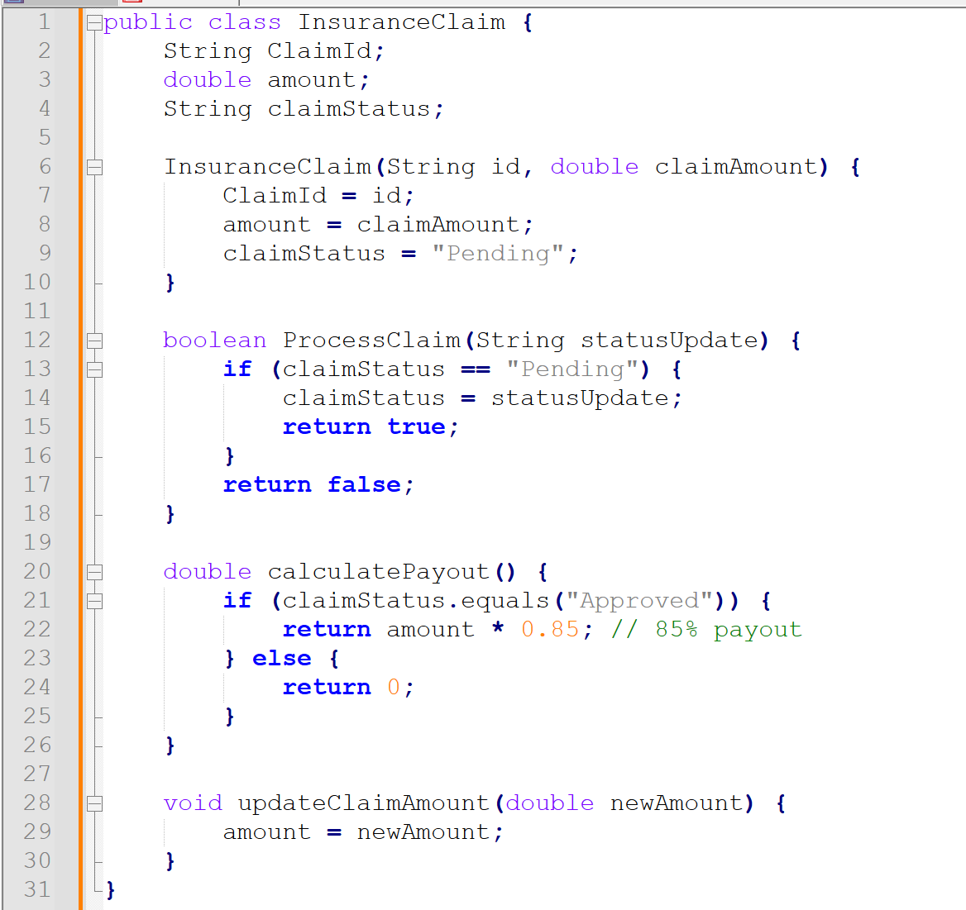

Answer Template – Exercise 1A
Identify 6 errors and explain each one. For every error, specify the location (line number or code element), describe the problem, and suggest a correction.
Error # | Location / Line | Description of Defect | Suggested Fix
1 | 2 | Variable ClaimId. Start with uppercase. Break camelCase rule. | Use claimId.
2 | 12 | Method ProcessClaim. Start with uppercase. Break camelCase rule. | Use processClaim.
3 | 2, 3, 4 | Class fields. Lack access modifiers. Break encapsulation. | Add private to lines 2-4.
4 | 13 | Line 13 check. Use == for String. Compare memory reference instead of string value. | Use claimStatus.equals("Pending").
5 | 13-16 | Method ProcessClaim. Accept any string. Allow invalid status state. | Validate statusUpdate input.
6 | 28-30 | Method updateClaimAmount. Accept negative numbers. Corrupt amount data. | Add positive value check before assign.

Exercise 1B – E-Commerce Membership Categorisation Module (2 points)
You are performing a code review for a membership categorisation module in an e-commerce system. The module categorises customers based on their Total Spending to apply loyalty discounts. The business rules are:

Condition | Category
Total Spending < 10,000,000 | BRONZE
10,000,000 ≤ Total Spending < 50,000,000 | SILVER
Total Spending ≥ 50,000,000 | GOLD
Total Spending = exactly 100,000,000 (VIP Special Case) | DIAMOND_VIP
Total Spending < 0 (Invalid Case) | Throw error / handle as invalid input

Code under review:

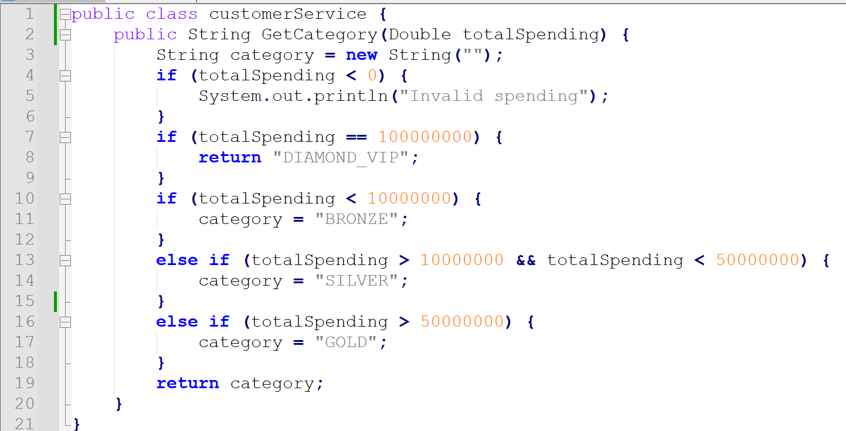

Answer Template – Exercise 1B
Identify at least 6 defects related to coding conventions, naming standards, logic, maintainability, reliability, or performance. Explain each defect and suggest a fix.
Error # | Location / Line | Description of Defect | Suggested Fix
1 | 1 | Class name customerService starts with lowercase letter. Violates Java naming standards (PascalCase). | Change to CustomerService.
2 | 2 | Method name GetCategory starts with uppercase letter. Violates Java naming standards (camelCase). | Change to getCategory.
3 | 3 | new String("") creates redundant object in heap memory. | Change to empty literal "".
4 | 10, 13, 16 | Values exactly equal to 10000000 or 50000000 skip all blocks. Result returns empty string "" instead of matching business rules (<= and >=). | Change Line 13 condition to >= 10000000. Change Line 16 condition to >= 50000000.
5 | 7, 16 | If spending is 100000000, Line 7 blocks are skipped because code continues execution instead of immediate stop if return is omitted in later chains. Here, Line 16 condition (> 50000000) also catches 100000000 and overwrites category = "GOLD" because Line 10 block uses separate if instead of linked else if. | Structure entire block into single unified if-else if-else chain, checking specific cases (like VIP) first or handling it as early exit.
6 | 4-6 | If spending , system prints text but continues execution. Returns "BRONZE" because is also . | Throw IllegalArgumentException or return error indicator immediately inside block.

PART 2 – SRS WALKTHROUGH (4 points)

Question 2 (4 points)
Read the Software Requirements Specification (SRS) excerpt below. Perform a walkthrough review to identify ALL defects. Classify each defect by type using the categories in the legend.

Type | Type | Type | Type
Ambiguous  Unclear or multiple interpretations | Contradictory  Conflicting requirements | Missing  Needed information absent | Incorrect  Technically wrong or unrealistic

SRS – FR-01: User Account Registration
Req. ID | Requirement Statement
1.1 | The user must enter full name, email, password, and phone number to register.
1.2 | The system must validate the email format before allowing registration.
1.3 | The password must have a minimum length.
1.4 | After successful registration, the system sends a confirmation email to the user's email address.
1.5 | If the email already exists in the system, the system rejects registration and displays an error message.
1.6 | Users may register using a Google or Facebook account.
1.7 | Phone number is mandatory when registering via Google or Facebook.
1.8 | The system accepts all phone number formats.
1.9 | After successful registration, the user is redirected to the home page.
1.10 | The confirmation email must be sent within 5 seconds.

Answer Template – Question 2
REVIEW LOG | FR-01: User Account Registration Reviewer: ________________________ Date: _______________

Defect ID | Section | Defect Type | Description | Suggested Fix
D01 | 1.3 | Ambiguous | "Minimum length" not defined. Developers cannot know criteria for valid password. | Change to: "The password must be a minimum of 8 characters long."
D02 | 1.5 | Missing | Error message content not defined. Technical details or user-friendly message omitted. | Change to: "...displays an error message: 'This email address is already registered.'"
D03 | 1.6 & 1.1 | Contradictory | 1.1 states user must enter full name, email, password, phone. 1.6 allows social login where password/phone may not come from provider. | Add exception to 1.1: "Except when registering via social accounts as specified in 1.6."
D04 | 1.7 & 1.6 | Missing | Doesn't state how phone number is collected during social registration since Google/Facebook API payload typically excludes phone numbers. | Add: "If social provider does not return phone number, prompt user to enter it before completing registration."
D05 | 1.8 | Incorrect | "Accepts all phone number formats" allows letters, symbols, or invalid lengths. Destroys database integrity. | Change to: "The system validates phone numbers against standard international formats (E.164)."
D06 | 1.9 & 1.4 | Unclear Sequence | Redirect to home page happens "after successful registration", but email confirmation also happens "after successful registration". User flow sequence vague. | Clarify if redirection happens immediately while email sends asynchronously in background.
D07 | 1.10 | Incorrect | 5-second email delivery window is unrealistic. Depends on external SMTP server performance and networks. | Change to performance requirement: "The system must queue the confirmation email to the mail gateway within 2 seconds."

Total defects found: | _____7___
Overall quality comment (2–3 sentences): | The requirement specification possesses severe gaps in data validation and functional clarity, especially regarding registration flows and security configurations. Contradictions between standard form data entry and social login mechanisms will block implementation. Significant refinement is needed to define clear validation boundaries, exact error messages, and explicit operational flows before development begins.

——— END OF TEST ———

