University of South Florida

CDA 4205L Computer Architecture Lab

Lab Report

Semester: Fall 2026
Experiment | Number: | 10
Experiment | Date: | 11/05/2026
Lab | Section: | 003
Lab | Lab TA: | Youjian Tang
Report | Due Date: | 11/12/2026
Group  (Lab3 onwards) | Member #1 name: | Felix Hoang
Group  (Lab3 onwards) | Member #2 name: | Jordan Martin

ABSTRACT
This lab examines read-after-write hazards in the five-stage WebRISC-V pipeline. The same five arithmetic instructions took 9 cycles with forwarding enabled and 13 cycles with forwarding disabled. The four-cycle difference is consistent with the stalls needed to wait for register writeback.
1. INTRODUCTION
A pipelined processor overlaps instruction fetch, decode, execute, memory access, and writeback. A read-after-write (RAW) hazard occurs when an instruction needs an earlier result that is still in the pipeline. Forwarding supplies an available result directly to a dependent instruction, allowing the pipeline to continue before register writeback [1].
2. METHODOLOGY
In WebRISC-V, select Load Program, choose the Data Hazard example (hazard.s), and click Load into Memory with forwarding activated. Use Step Forward until execution completes, then record the cycle count and open the Execution Table. Reload the same program and deactivate forwarding before loading it into memory. Repeat the run and compare the timing [1], [2].
3. RESULTS
T1 Identify data hazards
1 addi t0, x0, 1
2 addi t1, x0, 2
3 add t2, t0, t1
4 add t3, t0, t2
5 add t4, t0, t2
Instruction 3 reads t0 from instruction 1 and t1 from instruction 2. Instructions 4 and 5 both read t2 from instruction 3. They also depend on instruction 1 for t0, which is available by the time they need it. For the first hazard, instruction 1 has RegWrite = 1 and rd = t0 (x5), a nonzero destination that matches rs1 of instruction 3. At the same time, instruction 2 writes t1 (x6), which matches rs2 of instruction 3. When instruction 3 reaches EX, forwarding supplies t0 from MEM/WB and t1 from EX/MEM. Both values are ALU results, so the load-use stall condition is false.

T2 Cycle count with forwarding
WebRISC-V reported 9 cycles with forwarding enabled (Figure 1). This matches the theoretical total of five instructions plus four cycles to fill and drain the pipeline.
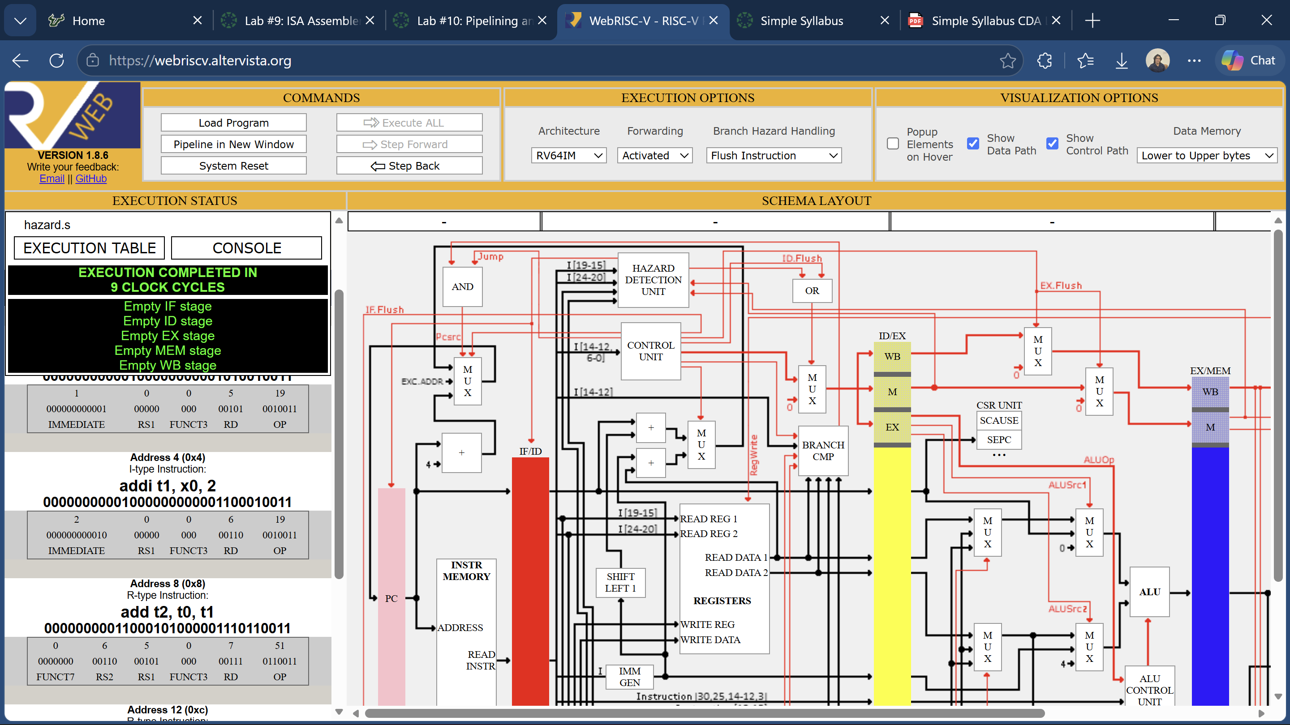
Figure 1. Execution Status showing 9 cycles with forwarding enabled.
[Insert the forwarding-enabled Execution Table screenshot here.]
T3 Pipeline behavior without forwarding
The pipeline holds a dependent instruction in decode and pauses fetch until the required value is available in the register file. A bubble enters execute while older instructions continue toward writeback. In this program, instruction 3 waits for t1 from instruction 2, and instruction 4 waits for t2 from instruction 3.
T4 Cycle count without forwarding
WebRISC-V reported 13 clock cycles with forwarding deactivated (Figure 2).
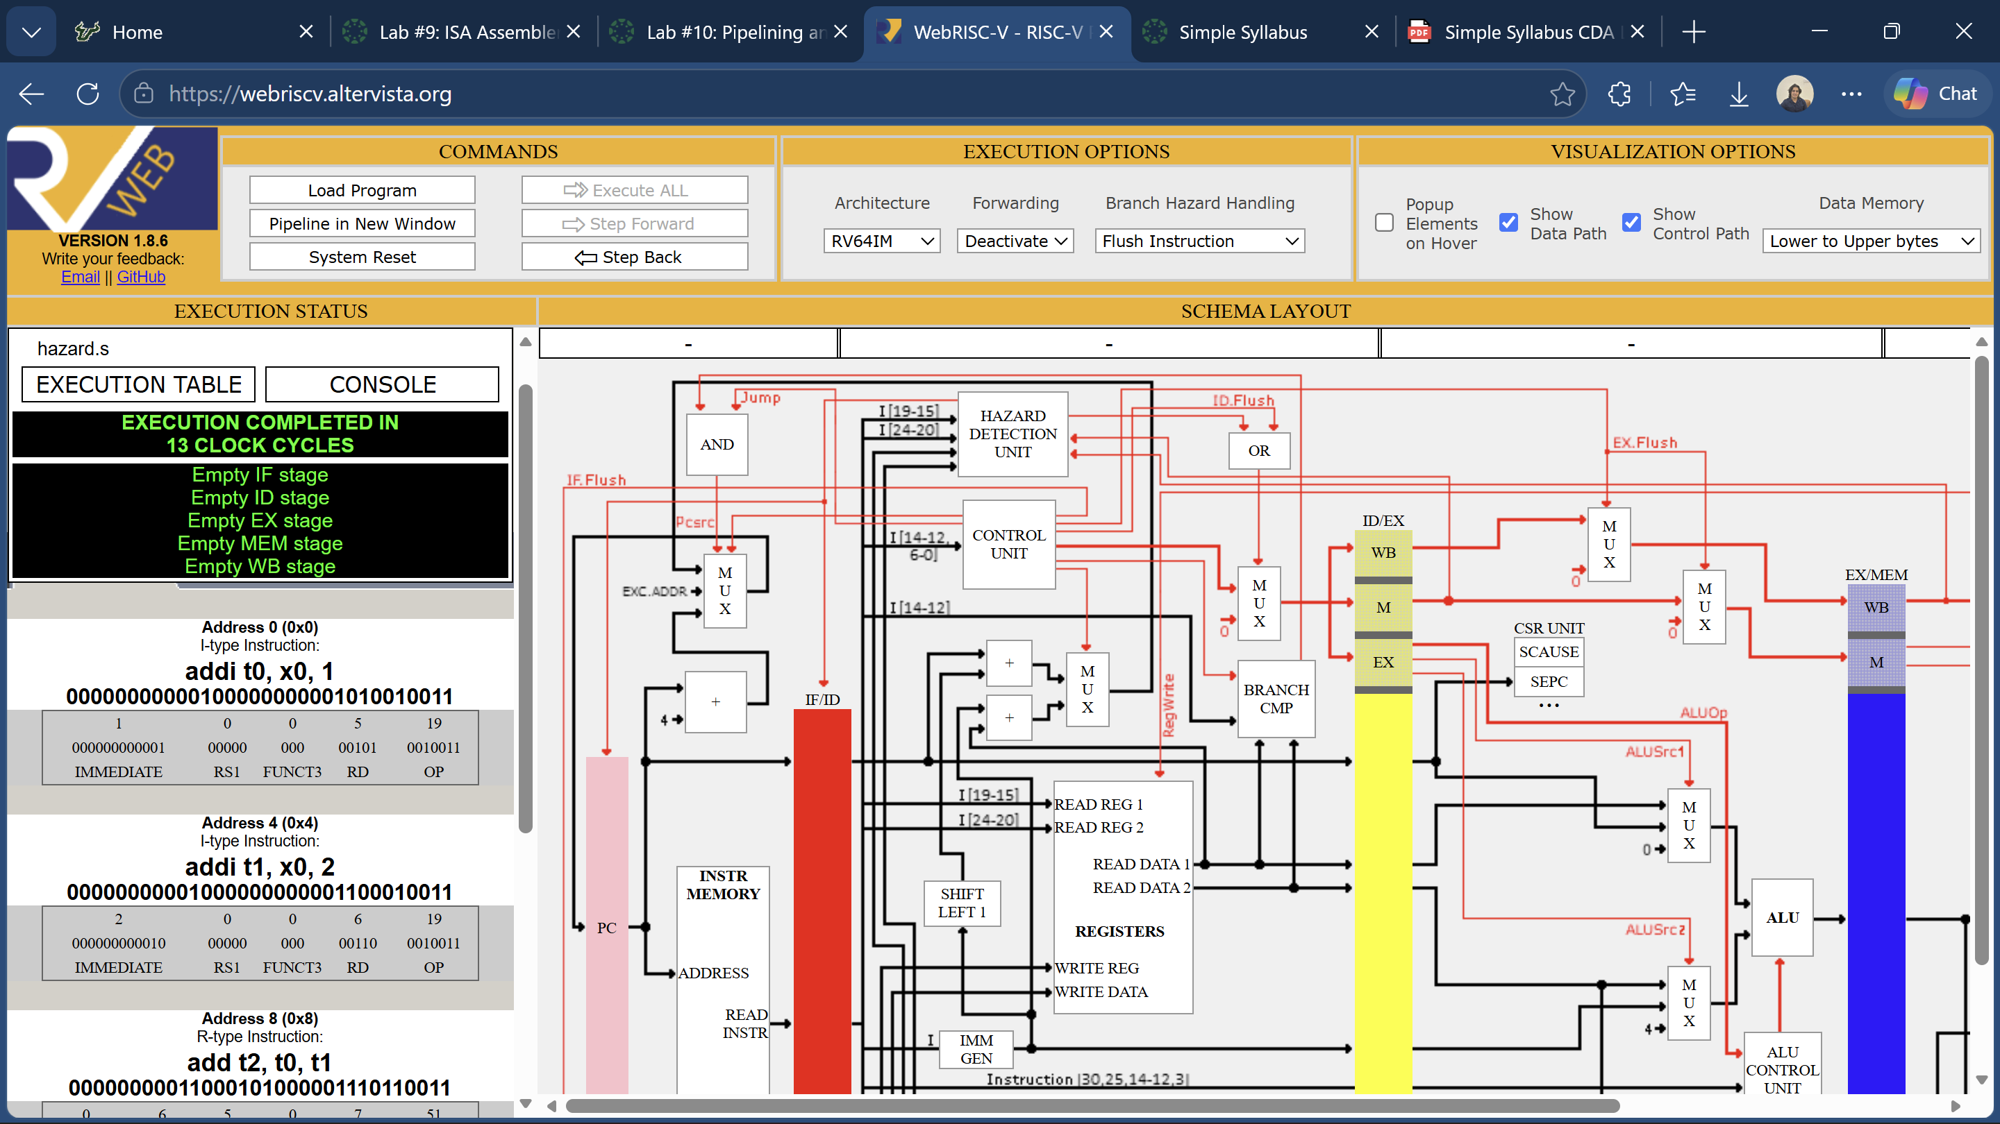
Figure 2. Execution Status showing 13 cycles with forwarding deactivated.
[Insert the forwarding-disabled Execution Table screenshot here.]
4. DISCUSSION AND CONCLUSION
Forwarding reduced the measured total from 13 to 9 cycles. The four-cycle difference is consistent with two stalls before instruction 3 and two before instruction 4. Forwarding lets each dependent instruction use the ALU result before register writeback.
REFERENCES
[1] University of South Florida, “CDA 4205L Lab #10: Pipelining and Hazards,” course handout, Fall 2026.
[2] WebRISC-V, “RISC-V Pipelined Datapath Simulation Online,” ver. 1.8.6. https://webriscv.altervista.org/

