University of South Florida

CDA 4205L Computer Architecture Lab

Lab Report

Semester: Fall 2026
Experiment | Number: | 9 - ISA Assembler Design (Part 3)
Experiment | Date: | 10/29/2026
Lab | Section: | 003
Lab | Lab TA: | Youjian Tang
Report | Due Date: | 11/05/2026
Group  (Lab3 onwards) | Member #1 name: | Felix Hoang
Group  (Lab3 onwards) | Member #2 name: | Jordan Martin

ABSTRACT:
This lab focuses on recognizing data dependencies and rearranging assembly instructions in a Python notebook. We completed the functions that divide the code into subsets, identify source and destination registers, search for independent instructions, and reorder each subset. The completed notebook was executed locally with example.asm. All six task outputs matched the supplied expected results. However, the expected schedules still contain a load-use hazard and an incompletely separated load-to-branch dependency. The results show how instruction scheduling can reduce stalls while also showing the limits of the provided algorithm.
I. INTRODUCTION:
A pipelined processor overlaps the stages of several instructions to improve instruction throughput. This overlap creates problems when an instruction needs a result that an earlier instruction has not made available yet. A data dependency describes the relationship between those instructions, while a data hazard occurs when their timing prevents normal execution. The Lab 9 pipeline includes forwarding, but some dependent instructions still need stall cycles [1].
A compiler can reduce these stalls by moving useful, independent work between a producer and its consumer. The order cannot be changed arbitrarily because register values, memory effects, and control flow must remain correct. This lab adds an instruction-reordering stage to the assembler work from earlier labs. The supplied notebook calls this Lab 10, but its title, example file, and six tasks match the Lab 9 assignment [1], [2].
II. METHODOLOGY:
Setup and Resources:
The implementation uses Python 3, the course notebook Lab10.ipynb, and the supplied example.asm input. The notebook can run in Google Colab; the results in this report were obtained by executing its code cells locally in order and saving the outputs. Figures 2 through 7 reproduce those saved outputs as text excerpts, rather than browser screenshots.
CDA4205L_Lab9_Completed.ipynb is the modified notebook containing the completed functions and executed test cells. The example.asm file remains unchanged and provides seven labeled groups of assembly-like instructions. No processor simulation or cycle-count measurement was performed.

II. METHODOLOGY (continued)
Development Process:
We first separated the instructions into subsets so that the reordering would remain inside the boundaries created by labels, branches, and jumps. Each label becomes its own subset. The operand functions then identify which registers each instruction reads and writes. Loads and immediate instructions have one register source, register arithmetic has two, and stores and branches have no register destination.
Next, we implemented the upward search. A candidate must not supply a register read by the current instruction, and it must pass dependency checks in both directions against every instruction it crosses. The search returns an index or False. We used “is not False” because index 0 is a valid result and would otherwise be confused with failure.
The reordering pass works from bottom to top, first searching above a dependent pair and then searching below if necessary. During validation, the initial lower-search boundary allowed an instruction to be moved away from a previously arranged pair in fix_no_steal. Setting the boundary to current_index - 1 produced the supplied expected ordering. We also corrected the Task 4 test printer so that it displays the returned list instead of printing the expected list twice. The final execution matched the supplied outputs for Tasks 1 through 6.
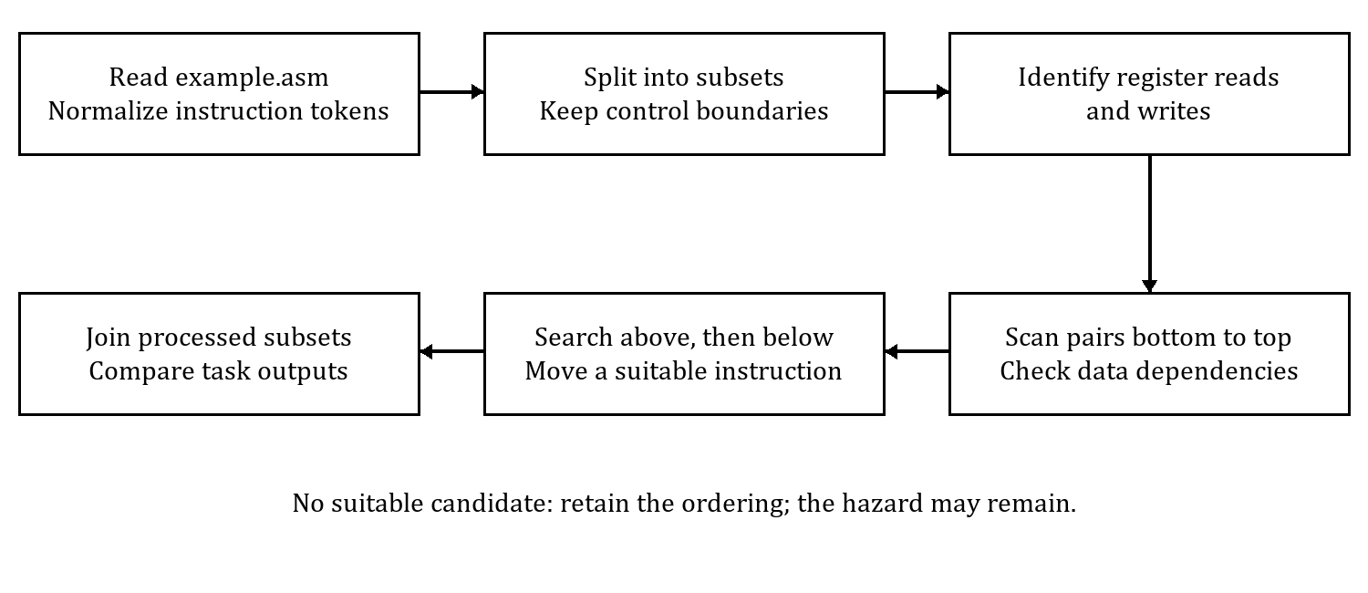
Figure 1. Instruction-reordering process used by the notebook.

III. RESULTS:
T1: Split the assembly into subsets
The splitAssemblyIntoSubsets() test returned six subsets, matching the expected answer. The main and loop labels were kept alone, and the branch and jump ended their respective instruction groups. This prevents the scheduler from moving instructions across those control-flow boundaries. Figure 2 shows the returned groups.
1. ['main:']
2. ['lw', 'x4', 'x0', '16']
['add', 'x5', 'x2', 'x4']
['sub', 'x7', 'x3', 'x6']
3. ['loop:']
4. ['sw', 'x5', 'x0', '32']
['lw', 'x4', 'x0', '16']
['addi', 'x9', 'x1', 'x4']
['bne', 'x9', 'x1', 'x4']
5. ['lw', 'x4', 'x0', '16']
['add', 'x5', 'x1', 'x4']
['j', 'x5']
6. ['sw', 'x5', 'x0', '32']
Figure 2. Task 1 returned output from local Python execution.
T2: Identify operands and data dependencies
For the sample load, get_operands() returned (x4, x0), get_rd() returned x4, and get_rs() returned x0. The dependency check returned True because the following add reads x4. All four results matched the expected values. Register aliases are compared as complete identities, and writes to x0 are ignored.
get_operands: ('x4', 'x0')
get_rd: x4
get_rs: x0
are_data_dependent: True
Figure 3. Task 2 returned values, extracted from saved output.

III. RESULTS (continued)
T3: Find an instruction above the dependent pair
The four tests returned 0, 0, False, and 1, matching the expected answers. The first two found the independent load at index 0. The third had no earlier candidate, and the fourth selected the add at index 1. The function checks whether moving a candidate changes the register dependencies of the instructions it crosses. These checks follow the notebook’s model; they are not a complete proof that arbitrary instruction motion is safe.
Test 1: 0 (['lw', 'x2', 'x0', '16'])
Test 2: 0 (['lw', 'x2', 'x0', '16'])
Test 3: False
Test 4: 1 (['add', 'x7', 'x7', 'x9'])
Figure 4. Task 3 returned values, extracted from saved output.
T4: Move an instruction above an index
The move function removed the instruction at source index 3 and inserted it before target index 1. Figure 5 shows that the returned list matches the expected list. The helper adjusts the target when the source is above it, since removing an earlier element changes the later indices.
['lw', 'x4', 'x0', '16']
['sw', 'x5', 'x0', '32']
['add', 'x5', 'x1', 'x4']
['add', 'x5', 'x1', 'x4']
Figure 5. Task 4 returned output from local Python execution.
This test checks the list operation itself, not dependency safety. Its store is moved before the add that writes x5, so this example movement is not generally equivalent assembly execution. The scheduler must establish that a move is safe before calling the helper.

III. RESULTS (continued)
T5: Reorder a subset
The reordered seven-instruction list matched the expected answer. The load into x4 moved between the load into x2 and the add that reads x2. The add into x3 also separates the x4 load from its consumer. The two stores remain after the arithmetic instructions whose results they use. Figure 6 shows the returned order.
['lw', 'x1', 'x0', '0']
['lw', 'x2', 'x0', '8']
['lw', 'x4', 'x0', '16']
['add', 'x3', 'x1', 'x2']
['add', 'x5', 'x1', 'x4']
['sw', 'x3', 'x0', '24']
['sw', 'x5', 'x0', '32']
Figure 6. Task 5 returned output from local Python execution.
T6: Process the complete example file
The full-file test processed seven labeled groups and returned 37 entries, including labels. Every entry matched the notebook’s expected list. Figure 7 on the following page reproduces the complete reordered column from the saved output. Table 1 summarizes what changed.
Group | Result
load_use1 | Independent sub placed between load and add.
load_use2 | Independent or used; later write to t1 stays after its reader.
no_dep | Original ordering retained.
alu_then_branch | One independent instruction separates add and branch.
load_then_branch | One instruction separates load and branch; one stall remains under the lab model.
fix_no_steal | Expected ordering matched, but the first load-use pair remains adjacent.
handshake | Two independent operations separate the load from its add.

Table 1. Full-file scheduling results and remaining hazards.

III. RESULTS (continued)
T6: Complete reordered output
['load_use1:']
['lw', 't1', 't1', '12']
['sub', 't8', 't6', 't7']
['add', 't5', 't1', 't7']
['or', 't9', 't6', 't7']
['load_use2:']
['lw', 't1', 't1', '12']
['or', 't9', 't6', 't7']
['add', 't5', 't1', 't7']
['sub', 't1', 't6', 't7']
['no_dep:']
['lw', 't0', 't1', '12']
['add', 't5', 't6', 't7']
['sub', 't2', 't0', 's1']
['or', 's5', 's6', 't6']
['alu_then_branch:']
['sub', 's3', 's3', 't0']
['add', 't0', 't1', 't2']
['sub', 't3', 't4', 't5']
['beq', 't0', 't5', 'loop']
['load_then_branch:']
['add', 't4', 't6', 't7']
['lw', 't0', 't1', '0']
['sub', 't2', 't3', 's1']
['beq', 't0', 't5', 'loop']
['fix_no_steal:']
['lw', 't0', 't1', '12']
['add', 't5', 't0', 't7']
['or', 's5', 't0', 't6']
['sub', 't2', 't4', 't6']
['add', 's3', 's5', 's6']
['handshake:']
['lw', 't0', 't1', '12']
['sub', 's5', 't4', 't6']
['or', 's5', 't7', 't6']
['add', 't5', 't0', 't7']
['add', 's3', 's5', 's6']
Figure 7. Full reordered column from Task 6 local Python output.
The list uses normalized operands from the notebook. A load appears as [opcode, destination, base, offset], rather than conventional offset(base) assembly syntax. The supplied names t7, t8, and t9 are retained as symbolic tokens; they are not standard RISC-V ABI register names. The undefined loop target is also retained because this task processes text rather than executing the sample as a program [2], [3].

III. RESULTS (continued)
T7: What are pipeline hazards? Give an example and sample assembly code.
A pipeline hazard is a condition that prevents an instruction from proceeding normally in its scheduled cycle. A structural hazard occurs when instructions need the same hardware resource at the same time. A data hazard occurs when an instruction needs a value that is not available yet. A control hazard occurs when a branch or jump changes which instruction should execute next [1].
lw t0, 0(t1)
add t2, t0, t3
Example 1. A load-use data hazard.
In this example, add reads the value that lw produces in t0. For the five-stage pipeline in the assignment, the load produces its data in MEM while the following add needs it at the start of EX. Forwarding cannot make the value arrive earlier than it is produced, so the adjacent pair needs one stall cycle [1].
T8: How can CPU hardware deal with hazards? How can a compiler help?
Hardware can forward results to dependent instructions without waiting for register write-back. A hazard-detection unit can stall the pipeline when forwarding is not sufficient. Separate or additional hardware resources can reduce structural conflicts. Branch prediction and flushing incorrect-path instructions help manage control hazards. These methods address different causes, so no single technique removes every hazard.
A compiler can move an independent instruction into a required delay slot while preserving the program’s register and memory behavior. For the load-use example, an independent sub can provide the required separation. If no safe instruction is available, the delay still needs to be handled by a stall or an inserted nop. Under the assignment’s branch-in-ID model, an adjacent ALU-to-branch dependency needs one stall, and an adjacent load-to-branch dependency needs two. These counts depend on the stated pipeline and forwarding paths, rather than the ISA alone [1].
lw t0, 0(t1)
sub t4, t5, t6
add t2, t0, t3
Example 2. Independent work placed between the load and its consumer.

IV. DISCUSSION:
The results show how a small scheduling pass can recognize register dependencies and create useful separation between instructions. The six task outputs matched the supplied answers, but that comparison only validates the expected list transformations. It does not prove that every dependency is safe or that every stall is removed. In particular, fix_no_steal keeps an adjacent load-use pair, while load_then_branch provides only one intervening instruction when the assignment requires two stall cycles for an adjacent load and branch.
A more complete implementation would track instruction latency, write-after-write conflicts, memory aliases, and control-flow effects before allowing a move. It would also handle unresolved hazards explicitly instead of leaving them unchanged. Future tests should check final register and memory values, not only compare instruction lists. The lab could make the limits of the supplied expected outputs clearer, especially the remaining hazards and the Task 4 example that demonstrates list movement without demonstrating a safe schedule.
V. CONCLUSION
This lab added dependency analysis and instruction reordering to the assembler workflow. We completed the required functions and executed the notebook with the provided input. Tasks 1 through 6 matched the expected outputs, and the full-file test returned the expected 37 entries. The main implementation issue was keeping the lower search from reusing an instruction already placed to separate a dependent pair. The final results illustrate how scheduling can reduce pipeline stalls, while the remaining hazards show why additional safety checks and latency handling are needed for a general compiler.
REFERENCES:
[1] University of South Florida, “CDA 4205L Lab #9: ISA Assembler Design (Part 3),” course assignment, provided PDF, Fall 2026.
[2] University of South Florida, “Lab 10 - ISA Assembler Design (Part 3),” Lab10.ipynb, course-provided Python notebook, Fall 2026.
[3] University of South Florida, “example.asm,” course-provided instruction-reordering input, Fall 2026.

