Report lab1

Subject

Trnag giới thiệu

Table of Contents

**TEACHER’S COMMMENTS** 4

**WORK DISTRIBUTION** 4

**MEANING OF VALUES** 4

**A. GDP OF VIETNAM** 4

**1.USING MS EXCEL, R AND PYTHON PROGRAMMING LANGUAGE:** 4

**1.1 Analyzing by using Excel** 4

**1.2 Analyzing by using R** 4

**1.3 Analyzing by using Python** 4

**2. DATA VISUALIZATION** 4

**2.1 Using Excel** 4

**2.2 Using R** 4

**2.3 Using Python** 4

**B. COMPUTER REPAIR TIMES** 4

**1.USING MS EXCEL, R AND PYTHON PROGRAMMING LANGUAGE:** 4

**1.1 Analyzing by using Excel** 4

**1.2 Analyzing by using R** 4

**1.3 Analyzing by using Python** 4

**2. DATA VISUALIZATION** 4

**2.1 Using Excel** 4

**2.2 Using R** 4

**2.3 Using Python** 4

**C. COLLEGES AND UNIVERSITIES** 4

**1.USING MS EXCEL, R AND PYTHON PROGRAMMING LANGUAGE IN EXAMPLE 4.21** 4

**1.1 Analyzing by using Excel** 4

**1.2 Analyzing by using R** 5

**1.3 Analyzing by using Python** 5

**2. MEANING OF CORRELATION AND COVARIANCE COEFFICIENTS IN EXAMPLE 4.22** 5

**2.1 Analyzing by using Excel** 5

**2.2 Analyzing by using R** 5

**2.3 Analyzing by using Python** 5

**D. HOME MARKET VALUE** 5

**USING MS EXCEL, R AND PYTHON PROGRAMMING LANGUAGE IN EXAMPLE 4.23** 5

**1.1 Analyzing by using Excel** 5

**1.2 Analyzing by using R** 5

**1.3 Analyzing by using Python** 5

**E. STATISTICAL THINKING IN BUSINESS DECISIONS:** 5

**1. DEFINITION: WHAT IS STATISTICAL THINKING IN BUSINESS DECISIONS?** 5

**2. ILLUSTRATION EXAMPLE OF STATISTICAL THINKING IN BUSINESS DECISIONS** 5

**F. REFERENCES** 5

# **TEACHER’S COMMMENTS**

…………………………………………………………………………………………………………………………………………

…………………………………………………………………………………………………………………………………………

…………………………………………………………………………………………………………………………………………

…………………………………………………………………………………………………………………………………………

…………………………………………………………………………………………………………………………………………

…………………………………………………………………………………………………………………………………………

…………………………………………………………………………………………………………………………………………

…………………………………………………………………………………………………………………………………………

…………………………………………………………………………………………………………………………………………

…………………………………………………………………………………………………………………………………………

…………………………………………………………………………………………………………………………………………

…………………………………………………………………………………………………………………………………………

…………………………………………………………………………………………………………………………………………

…………………………………………………………………………………………………………………………………………

…………………………………………………………………………………………………………………………………………

…………………………………………………………………………………………………………………………………………

…………………………………………………………………………………………………………………………………………

…………………………………………………………………………………………………………………………………………

…………………………………………………………………………………………………………………………………………

…………………………………………………………………………………………………………………………………………

…………………………………………………………………………………………………………………………………………

…………………………………………………………………………………………………………………………………………

…………………………………………………………………………………………………………………………………………

…………………………………………………………………………………………………………………………………………

…………………………………………………………………………………………………………………………………………

…………………………………………………………………………………………………………………………………………

…………………………………………………………………………………………………………………………………………

…………………………………………………………………………………………………………………………………………

# **WORK DISTRIBUTION**

|  |  |  |  |  |  |
| --- | --- | --- | --- | --- | --- |
|  | Tran Hoang Phuc  (Leader) | Le Ba Nhat Long | Nguyen Viet Hoang | Le Anh Duy | Nguyen Hung Tuan |
| Problem statement |  |  |  |  |  |
| Build the report template |  |  |  |  |  |
| Do all exercise with Excel |  |  |  |  |  |
| Do all exercise with R |  |  |  |  |  |
| Do all exercise with Python |  |  |  |  |  |
| Summarize and edit reports |  |  |  |  |  |
| Completion(%) | 100% | 100% | 100% | 100% | 100% |

# **MEANING OF VALUES**

# **A. GDP OF VIETNAM**

## **1.USING MS EXCEL, R AND PYTHON PROGRAMMING LANGUAGE:**

### **1.1 Analyzing by using Excel**

Data:

If Excel doesn't have the Data Analysis function, add it by following these steps:

File -> Options -> Adds-in -> Go -> Analysis ToolPak -> OK.

Perform Descriptive Statistics by following these steps:

**Step 1:** Select Data -> Data Analysis.

**Step 2:** Select Descriptive Statistics -> OK

**Step 3:** The Descriptive Statistics dialog box appears:

3.1: **Input Range**: Select the cells that you want to analyze.

3.2: **Output Range**: Select the cell where you want the results to appear.

3.3: Select **Summary Statistics** to perform the calculations.

3.4: Click OK.

Result:

### **1.2 Analyzing by using R**

Import data:

To calculate the Skewness and Kurtosis values, you need to add the **‘e1071’** library.

To add the library, use the **require(<Library name>)** function.

### **1.3 Analyzing by using Python**

**Step 1:** Import the necessary library

**Step 2:** Import data and show data

**Step 3:** To calculate values like mean, median, mode, variance, and standard deviation, we use the **statistics** library.

**Step 4:** To calculate quantile we use the **numpy** library.

**Step 5:** To calculate values like skewness and kurtosis, we use the **scipy.stats** package of the **scipy** library.

## **2. DATA VISUALIZATION**

### **2.1 Using Excel**

Box Plot

**Step 1:** Select the values to plot in the boxplot.

**Step 2:** Choose Insert -> Charts -> All Charts -> Box and Whisker -> OK.

Result:

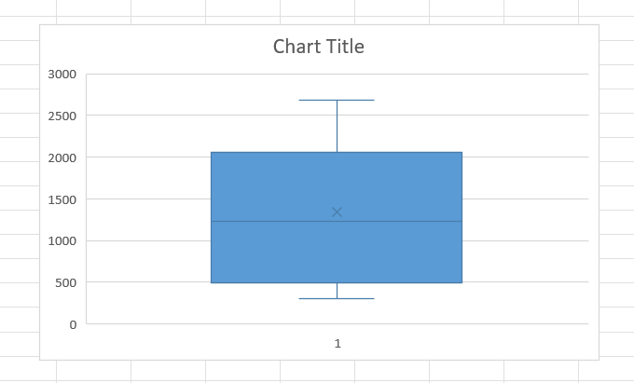

Histogram

**Step 1:** Choose Data -> Data Analysis -> Histogram.

**Step 2:** Select the values to plot in the Input Range.

**Step 3:** Select the cell where you want the results to appear.

**Step 4:** Select Chart Output to display the chart.

**Step 5:** Click OK. The chart appears:

### **2.2 Using R**

Command to draw Box Plot and Histogram.

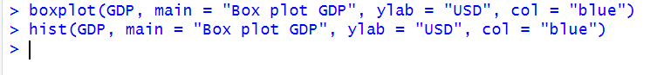

Box Plot

Histogram

### **2.3 Using Python**

Import **matplotlib.pyplot** library.

Histogram

Box Plot

# **B. COMPUTER REPAIR TIMES**

## **1.USING MS EXCEL, R AND PYTHON PROGRAMMING LANGUAGE:**

### **1.1 Analyzing by using Excel**

### **1.2 Analyzing by using R**

### **1.3 Analyzing by using Python**

## **2. DATA VISUALIZATION**

### **2.1 Using Excel**

### **2.2 Using R**

### **2.3 Using Python**

# **C. COLLEGES AND UNIVERSITIES**

## **1.USING MS EXCEL, R AND PYTHON PROGRAMMING LANGUAGE IN EXAMPLE 4.21**

### **1.1 Analyzing by using Excel**

### **1.2 Analyzing by using R**

### **1.3 Analyzing by using Python**

## **2. MEANING OF CORRELATION AND COVARIANCE COEFFICIENTS IN EXAMPLE 4.22**

### **2.1 Analyzing by using Excel**

### **2.2 Analyzing by using R**

### **2.3 Analyzing by using Python**

# **D. HOME MARKET VALUE**

## **USING MS EXCEL, R AND PYTHON PROGRAMMING LANGUAGE IN EXAMPLE 4.23**

### **1.1 Analyzing by using Excel**

### **1.2 Analyzing by using R**

### **1.3 Analyzing by using Python**

# **E. STATISTICAL THINKING IN BUSINESS DECISIONS:**

## **1. DEFINITION: WHAT IS STATISTICAL THINKING IN BUSINESS DECISIONS?**

## **2. ILLUSTRATION EXAMPLE OF STATISTICAL THINKING IN BUSINESS DECISIONS**

# **F. REFERENCES**