**Meaning of Correlation and Covariance using Excel – Example 4.21 and 4.22:**

***Example 4.21:***

Data:

Calculate Correlation:

Calculate Covariance:

The Result:

***Example 4.22:***

Data:

The result:

**Meaning of Ouliers using Excel – Example 4.23:**

Data:

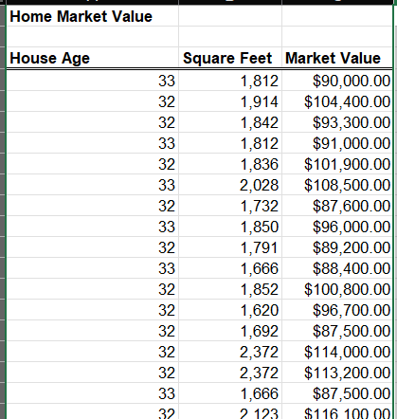

Calculate Standard Deviation and Mean:

The result:

None of the z-scores for Square Feet or Market Value exceed 3

***Get Meaning of Outliers using Python – Example 4.23***

Read data:

c:

Calculate Q1, Q3, lower limit, upper limit:

The result:

There are no ouliers:

***Get Meaning of Correlation and Covariance using Python – Example 4.21 and 4.22:***

Read file 421.csv:

Calculate Covariance using cov() function and Correlation using corr() function:

Read file 421.csv:

Calculate Covariance using cov() function and Correlation using corr() function:

