

**REPORT CARD - END OF SCHOOL YEAR**

**BILINGUAL PROGRAMME**

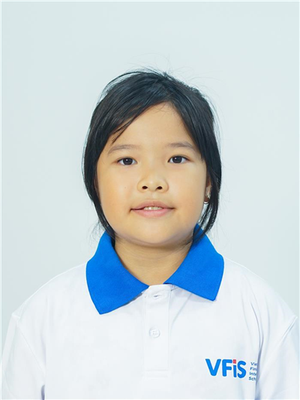

Student Name Hà Vân Anh

Grade 7 - 7B

Date of Birth 23/07/2010

Student ID 1211900039

Date of Enrolment 19/08/2019

School Year 2022-2023

**SUBJECTS**

|  |  |  |
| --- | --- | --- |
| **Mathematics**   |  |  | | --- | --- | | You became much more confident in completing tasks as the term progressed. You are beginning to be able to do simple to complex Math problems with minor support. You just need to consistently listen and follow class rules to further improve. | Term 2: 5.7  **End-of-Year: 5.5** | |
| **Vietnamese Literature**   |  |  | | --- | --- | | You have your potential to study Vietnamese literature. However, I would like to offer some constructive feedback regarding your concentration, note-taking, and respect towards others including teachers and classmates. Wish you all the best in next year! | Term 2: 5.8  **End-of-Year: 5.7** | |
| **History and Geography**   |  |  | | --- | --- | | You are a confident student in the class. Putting more effort and concentration into the lessons will help you get better results. | Term 2: 6.9 | |
| **Crafts**   |  |  | | --- | --- | | You have made good progress in crafts and learnt some of the techniques involved in woodworking. You also have the ability to learn more and go further in this subject. Keep up the good work. | Term 2: 8  **End-of-Year: 8** | |
| **English**   |  |  | | --- | --- | | You are a capable student, however, you get easily distracted, or you simply refuse to do certain assignments. You clearly have the capacities, with a better attitude, you'll get a lot further. | Term 2: 4.6  **End-of-Year: 5.3** | |
| **Values Education**   |  |  | | --- | --- | | You are hard-working student. For better results, you need to be more active. | Term 2: 8.1  **End-of-Year: 8** | |
| **Physical Education**   |  |  | | --- | --- | | Anh, You are always on time and participate in class. | Term 2: 8.4  **End-of-Year: 8.3** | |
| **Music**   |  |  | | --- | --- | | You try to practice music hard and stay focused. That helps you make a lot of progress. | Term 2: 7.6  **End-of-Year: 7.6** | |
| **French Intermediate**   |  |  | | --- | --- | | You did quite a fair job this time. However, you need to overcome your temperament and stay more focused in class. Plenty of areas for improvement : you can for example begin with memorizing key rules in grammar and build simple sentences with vocabulary learnt. | Term 2: 3.1  **End-of-Year: 4.8** | |
| **Visual arts**   |  |  | | --- | --- | | You should continue to actively engage in class discussions and activities to gain a deeper understanding of the subject matter. By increasing participation and engagement in the course, you have the potential to improve your grades and achieve outcomes. | Term 2: 7.1  **End-of-Year: 7.3** | |
| **ICT**   |  |  | | --- | --- | | You are a friendly student. You need to increase your focus in lessons. If You can work on your self-motivation more, I am sure you will improve your ability to work independently. Please remember to seek help from your teacher when you have a question. | Term 2: 7.1  **End-of-Year: 7.3** | |
| **Science**   |  |  | | --- | --- | | Annie, your lesson activity is good. The notebook work needs a bit more consistency. It's been a joy to have you in the class!  Physics: We learned about light and magnetism this semester. You can do well in tests but might be distracted in class at times and needs reminders to be on task. Try your best.  Chemistry: Your efforts and interest in learning Chemistry are praiseworthy. With the right support, I have no doubt you will continue to excel in the subject. Keep up the great work! | Term 2: 6.3  **End-of-Year: 6.3** | |
| **Experiential Learning**   |  |  | | --- | --- | | In this term, you have been training your presentation skill. You also learn about street food in HCM city and some about traffic safety. You have a well-improved in this semester. You are more concentrated in your task. | Term 2: 8 | |
| **Conduct: Fair** |
| **Homeroom**   |  | | --- | | Even though you've made some progress this semester, the results have been different from what you expected. You should work on getting along with your classmates, make an effort to maintain your composure. I do believe that you could become a better version of yourself in the future. | |

**Huynh Ngoc Bao Tran** **Tuomo Jaakkonen Viljami**

**Homeroom teacher** **Acting Head of School**