Daily Extract Console: Hosting Brief
For the internal application hosting team · 21 October 2026
Summary
The Daily Extract Console is a small internal web application that monitors and operates the nightly CLARITY to STRATAJAZZ data extract: SQL Agent jobs, SSIS packages, output files and reconciliation. Today each team member runs a private copy on their own PC. We would like to make it available to a broader group as one hosted instance, and we are asking which hosting platform fits.
Short answer, from the code: it needs a domain-joined Windows host with the ASP.NET Core 10 runtime, Windows-authenticated access to four on-premises SQL Server instances and three SMB file shares, and no internet access. An on-premises, IIS-based shared .NET environment looks like the right fit, provided it can give the app its own service account, the network paths in section 4, and an answer to the identity question in section 5. Resource needs are small: about 180 MB of memory, and negligible CPU.
1. What the application does
- Shows the state of the daily extract's SQL Agent job and its steps, run history, and the SSIS packages each run executed, with their errors.
- Starts the job, restarts it from a failed step, or stops it. These are the only operations that change state in SQL Server, apart from the app's own tables.
- Reconciles database table counts against the files the extract wrote, reading those files on an SMB share.
- Lets the team add or remove entries in ten small list files on an SMB share that the next extract reads ("AdHoc lists").
- Charts data volumes and logs from three databases, and keeps a shared catalogue of known failures and fixes in its own SQL tables.
Users: the data engineering team today; the broader group would be about [number] people. It is a business-hours tool. The extract itself runs independently, and an outage of the console does not affect it.
2. Architecture
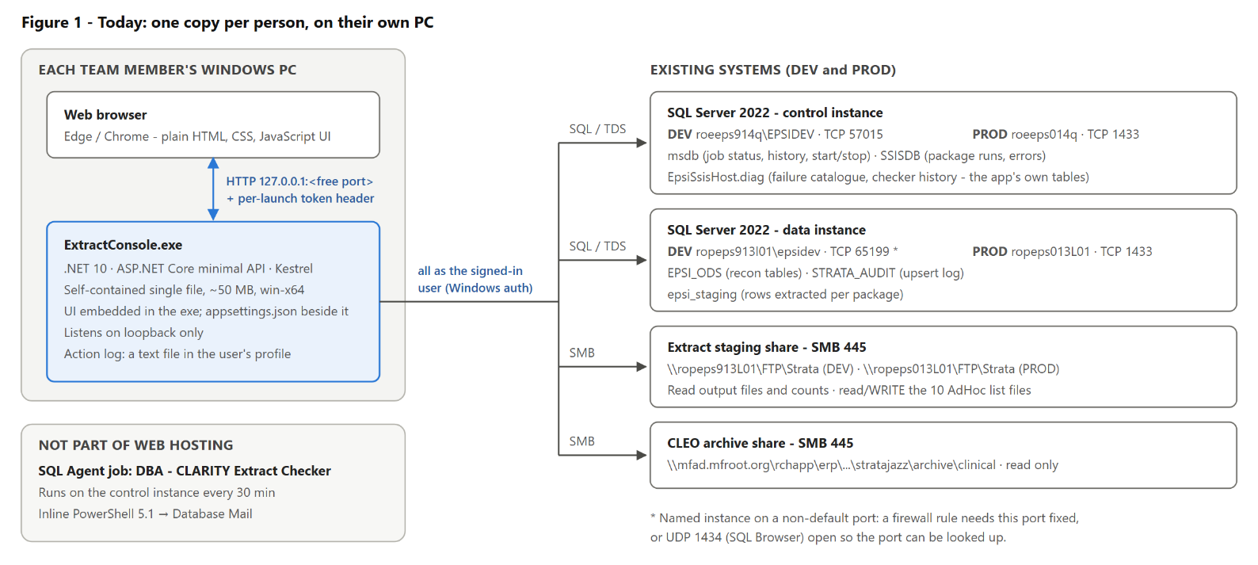
Figure 1. Current deployment. Every connection is made as the signed-in user, so SQL Server and NTFS permissions are the access control today.
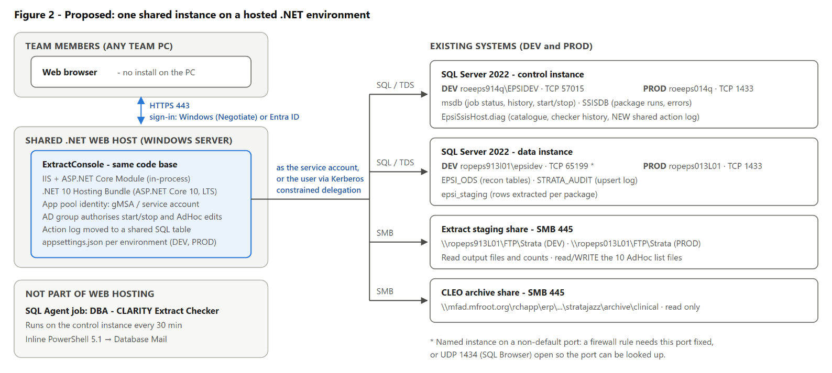
Figure 2. Proposed hosted deployment. The code and downstream systems are unchanged; what changes is how users sign in and which identity reaches SQL Server and the shares (section 5).
3. Technology stack
Layer | Technology | Notes
Runtime | .NET 10 (LTS), ASP.NET Core 10 | Built with SDK 10.0.401. Minimal APIs; no MVC, no Razor.
Language | C# | About 4,100 lines across 15 source files.
Web server | Kestrel (today) | Proposed: IIS with the ASP.NET Core Module, in-process.
Data access | Microsoft.Data.SqlClient 7.1.1 | Parameterised SQL, no ORM. Integrated security, Encrypt=true, connection pooling on. TrustServerCertificate is currently true in both environments' config; it can be turned off where the SQL servers present trusted certificates.
Other packages | Microsoft.Extensions.FileProviders. Embedded 10.0.0 | The only other dependency. No third-party packages.
Front end | HTML, CSS and plain JavaScript | About 3,200 lines; no framework, no build step, no CDN, no external calls. Embedded in the assembly as static files.
Configuration | appsettings.json | Server names, database names, share paths per environment. Holds no secrets: all authentication is integrated.
Sign-in (today) | None | Bound to 127.0.0.1 with a random per-launch token. To be replaced; see the last section.
Own data | EpsiSsisHost.diag tables | Failure catalogue and checker history, on the control SQL instance. EpsiSsisHost is due for decommission in early 2027; the location is a configuration setting.
Packaging (today) | Self-contained single-file exe | win-x64, ~50 MB. For IIS it would be published as a framework-dependent folder instead.
Tests | PowerShell integration suite | 47 tests against a disposable SQL Agent job and temporary file copies.
Related, not hosted | SQL Agent job + PowerShell 5.1 | The unattended checker runs inside SQL Agent and sends mail through Database Mail. It needs nothing from web hosting.
4. Connectivity the host would need
Measured from the code and the servers on 21 Oct 2026. The application makes no outbound internet calls and sends no mail.
From the web host to | Protocol / port | Access | Used for
Inbound
Users' browsers → web host | HTTPS 443 | Signed-in team members | The whole UI and API (20 endpoints)
SQL Server 2022
roeeps914q\EPSIDEV (DEV control) | TCP 57015 | Read; execute job procs; read/write diag | msdb, SSISDB, EpsiSsisHost
roeeps014q (PROD control) | TCP 1433 | Same | Same
ropeps913l01\epsidev (DEV data) | TCP 65199 * | Read only | EPSI_ODS, STRATA_AUDIT, epsi_staging
ropeps013L01 (PROD data) | TCP 1433 | Read only | Same
File shares (SMB)
\\ropeps913L01\FTP\Strata, \\ropeps013L01\FTP\Strata | SMB 445 | Read; Modify on 10 list files | Output files, record counts, AdHoc lists
\\mfad.mfroot.org\rchapp\erp\...\archive\clinical (DFS) | SMB 445 | Read only | What CLEO sent to the vendor
* A named instance on what looks like a dynamic port. A firewall rule needs either the port fixed by the DBAs, or UDP 1434 (SQL Browser) open so clients can look it up. One deployment talks to both DEV and PROD back ends today; whether a hosted PROD instance may reach DEV servers is a question for you (section 8).
5. Identity: the decision that shapes the hosting
Today every query, job start and file write is made as the person using the app, so SQL Server and NTFS permissions do all the access control, and SQL Agent records who restarted a job. A shared host breaks that model. There are two ways to restore it:
 | A. Service account | B. Kerberos constrained delegation
How | App pool runs as a gMSA that holds the grants. The app signs users in, checks an AD group before any action, and records who did what in a SQL table. | Users sign in with Windows authentication; the app passes their identity through to SQL Server and the shares.
AD work | One gMSA; grants on 4 SQL instances and 3 shares. | Delegation configured to MSSQLSvc SPNs on 4 instances and CIFS SPNs on 3 file servers.
Audit | SQL Agent shows the service account; the app's own log shows the person. | SQL Agent and NTFS show the actual person.
Sign-in | Windows (Negotiate) or Entra ID. | Windows (Negotiate) only.
Our view | Simpler and portable. Our default unless policy requires B. | Preserves today's model exactly, if your environment supports it.
6. Hosting requirements
Area | Requirement
Operating system | Windows Server, domain-joined. Integrated authentication to SQL Server and UNC file paths make Windows the natural host.
Runtime | ASP.NET Core 10 Hosting Bundle (x64). .NET 10 is the current LTS release.
Identity | Its own app pool identity (gMSA) and grants, per section 5. Our grants script lists every permission the app uses.
Sign-in | Windows authentication (Negotiate) or Entra ID, whichever is your standard.
TLS and DNS | A certificate and DNS name per environment.
Memory and CPU | Measured: ~180 MB working set, and ~3 s of CPU in total across a load test of every tab plus 20 status refreshes. Each open browser polls one status endpoint every 15 s (~100 ms per call), about 4 requests a minute, so even 50 users is under 4 requests a second.
Long requests | One on-demand action, "Count records in files", streams the day's output files over SMB: up to ~5 GB when the largest file is split. We have not yet timed it at that size, so it needs either a request timeout of several minutes or to become a background task. In-process IIS has no module timeout of its own; any load balancer idle timeout would apply.
State | No session state, no server affinity. Once the action log moves to SQL, it can run as more than one instance. Concurrent edits to the list files are serialised with an exclusive file lock.
Configuration | One appsettings.json per environment. No secrets, so no secret store is needed.
Logging and health | Console/stdout today. A health-check endpoint and your standard logging sink can be added.
Data sensitivity | Displays patient account numbers (HSP_ACCOUNT_ID) and job error text. Internal users only; PHI handling applies.
Availability | Business hours. Not on the extract's critical path.
7. Platform fit
Platform | Fit | Why
Shared on-prem Windows / IIS .NET environment | Good | Meets everything above if it offers ASP.NET Core 10, a per-app identity, and the network paths. Cheapest to run. Our preferred option.
Dedicated Windows VM (IIS or a Windows service) | Good | Same technical fit with more overhead. The fallback if the shared environment cannot offer .NET 10 or per-app identity.
Linux containers / on-prem Kubernetes | Poor | Windows-integrated SQL access and UNC shares would need Kerberos keytabs and SMB mounts in the container. Possible, but significant rework for no gain here.
Azure App Service or other cloud PaaS | Poor | Needs private connectivity to on-prem SQL and SMB, and loses Windows-integrated access to them. PHI adds review. Not a fit while the extract stays on-prem.
The requirements in section 6 are typical of internal tools built on on-prem SQL Server and file shares. A shared environment that meets them would likely serve other team tools as well.
8. Questions for the hosting team
- Does the shared .NET environment offer ASP.NET Core 10, and how quickly do runtime updates follow Microsoft's releases?
- Can each application run under its own gMSA app pool identity?
- Is Kerberos constrained delegation (option B) supported and permitted, or should we plan for option A?
- Which sign-in standard applies to internal apps: Windows authentication or Entra ID?
- Can the environment reach the four SQL instances and three shares in section 4, including the DEV named instance's port? Which network zone would it sit in?
- Are DEV and PROD hosted separately? Today one deployment can switch between DEV and PROD back ends; we can split it per environment if required.
- What request timeout applies at any load balancer in front of the environment?
- What are the requirements for an application that displays PHI, and the process for certificates, DNS and logging?
Changes on our side before hosting
None of this needs the hosting team, but it has to be done before go-live: sign-in and AD-group authorisation; anti-forgery protection on the action endpoints; the action log moved to a shared SQL table; removal of the loopback binding and per-launch token; an IIS publish profile; a health endpoint; and a decision on the long-running record count. The application code and its downstream systems otherwise stay as they are.

