**Object-oriented programming Lab 02 Report**

**Name: Nguyễn Đình Phúc**

**Student ID: 20226062**

**1, Use case diagram**

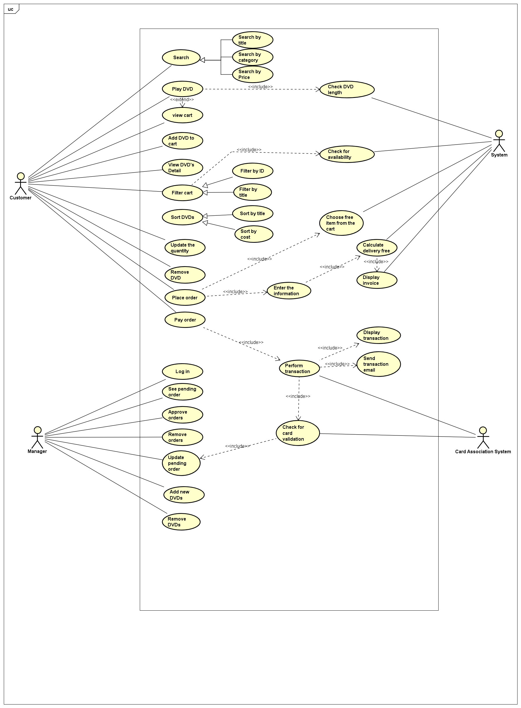

**2, Class Diagram**

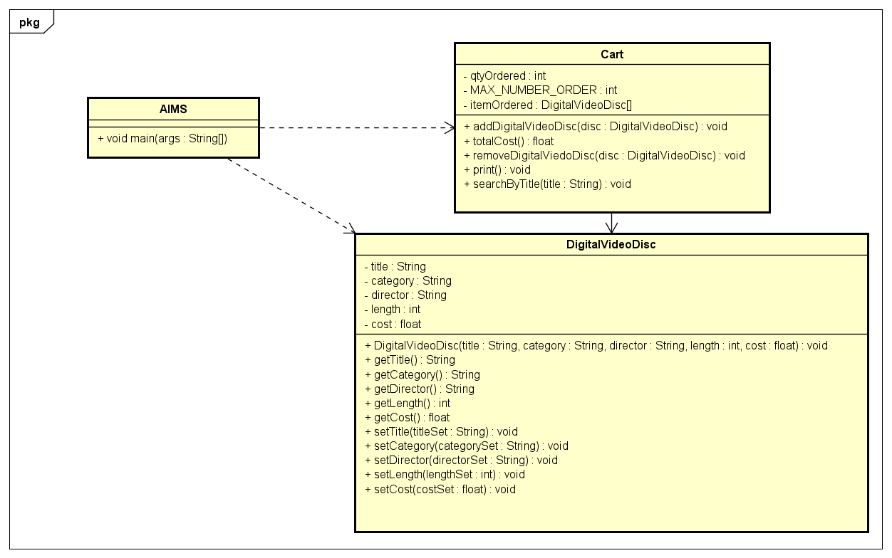

**3, Reading Assignment and Question**

**3.1, Reading Assignment:** When should accessor methods be used?

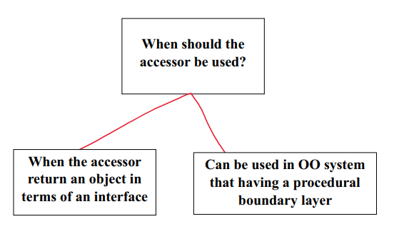

**3.2, Question:** If you create a constructor method to build a DVD by title then create a constructor method to build a DVD by category. Does JAVA allow you to do this?

**Answer:** Yes, Java allows you to create multiple constructors in a class through a concept called *constructor overloading*. Constructor overloading is when a class has multiple constructors with different parameter lists. Each constructor can initialize an object with different sets of initial values based on the parameters it receives.

**4. Source code**

**4.1, Aims.java**

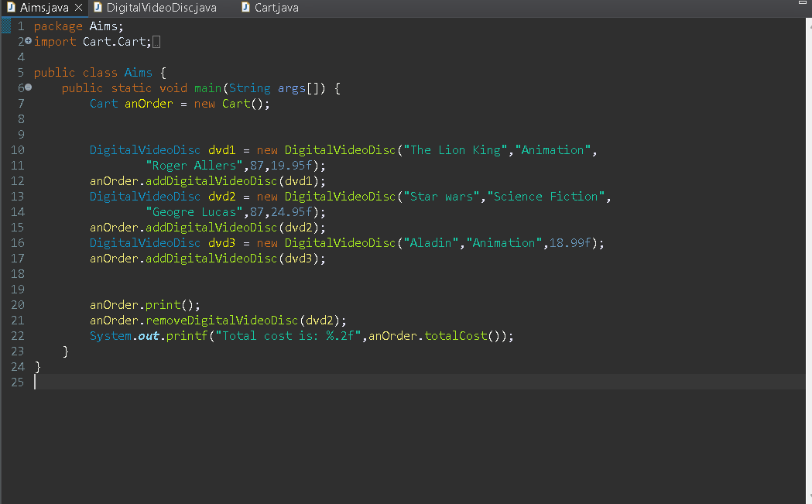

**4.2, DigitalVideoDisc.java**

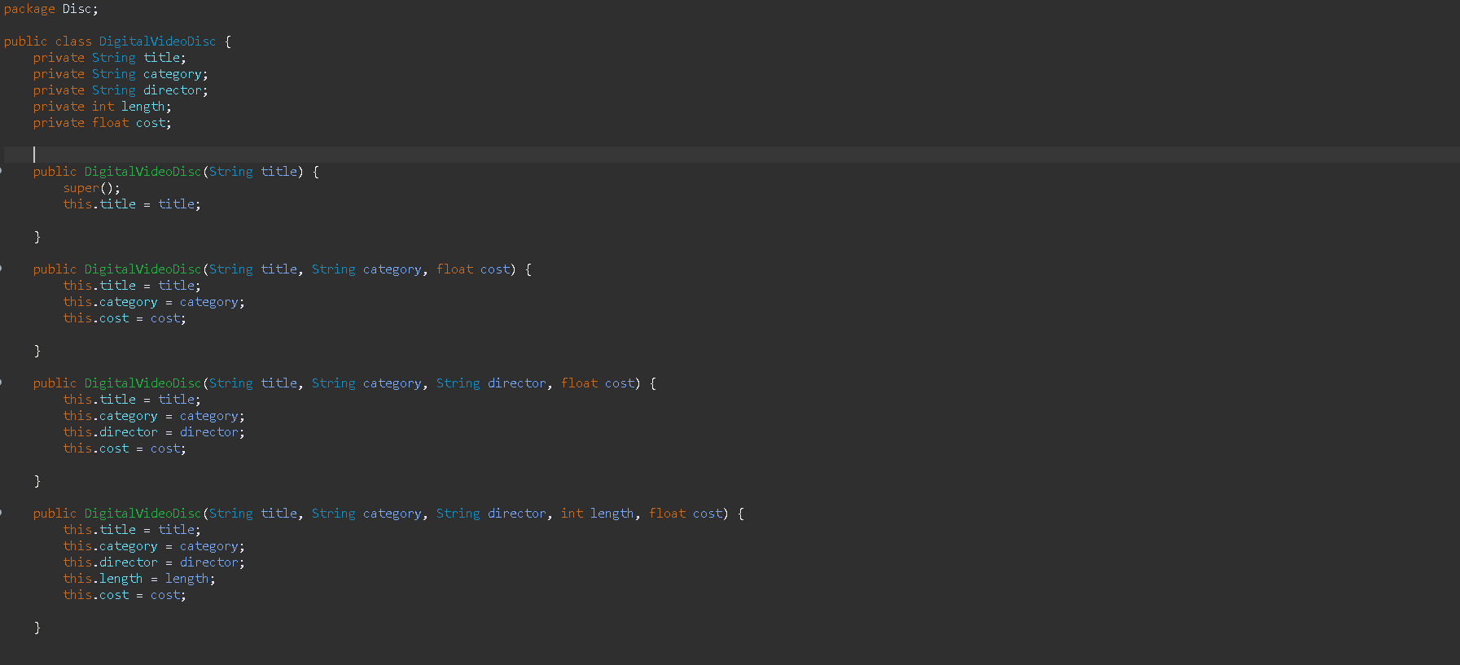

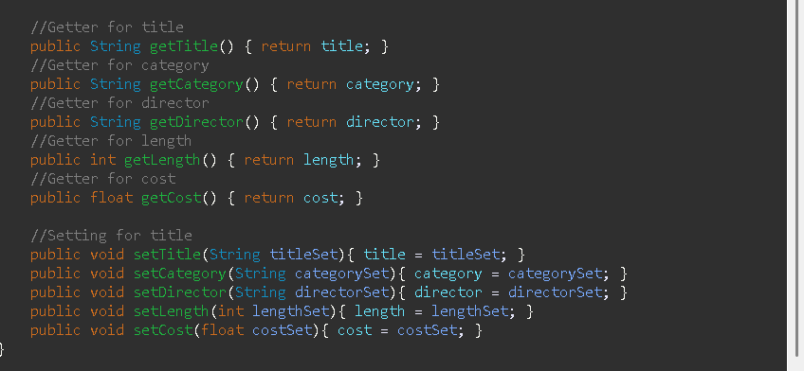

**4.3, Cart.java**



