Lab1 Session

1. **Lab Set-up**

Based on the requirements, I have successfully set up VM and SSH to use it in the Windows teriminal.

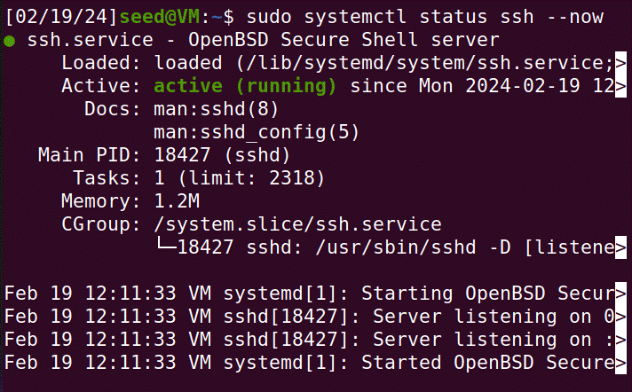

**Figure 1.1. the systemctl status**

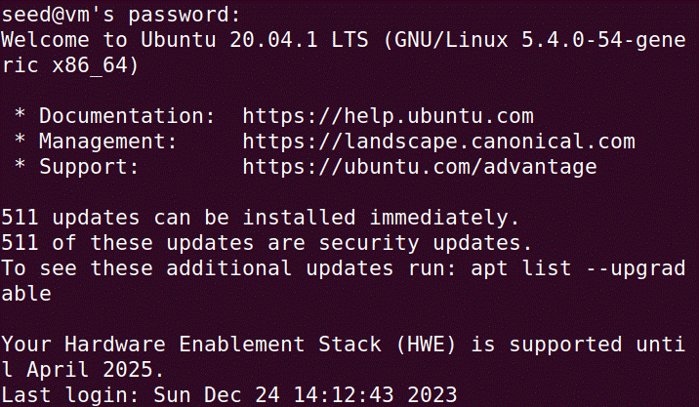

**Figure 1.2. The user interface of SSH into the VM**

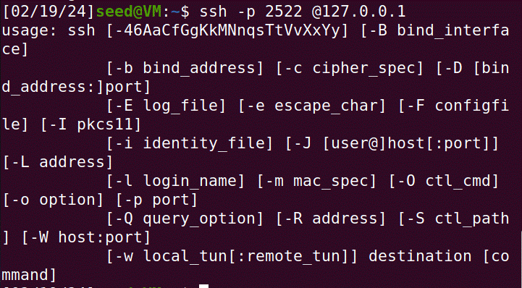

**Figure 1.3. The user interface of SSH NAT access to VM**

1. **Update and Install Software**

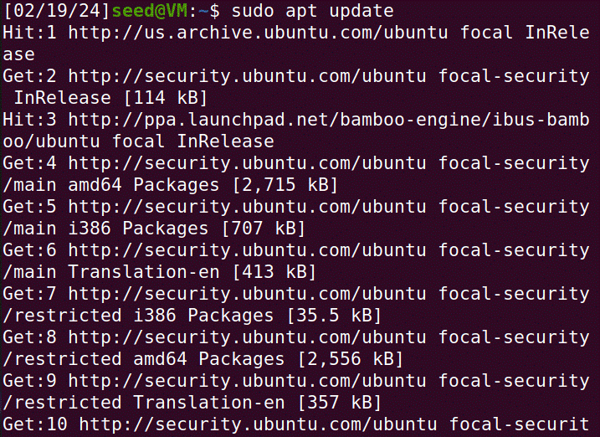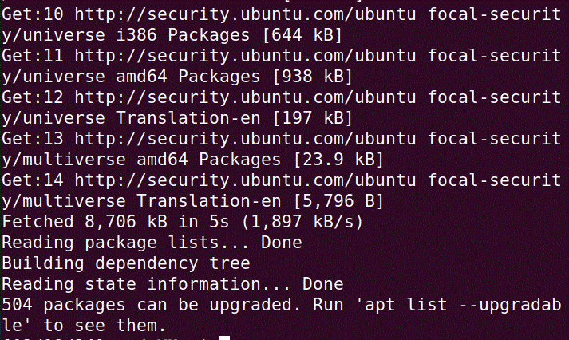

**Figure 2.1. Sudo apt update**

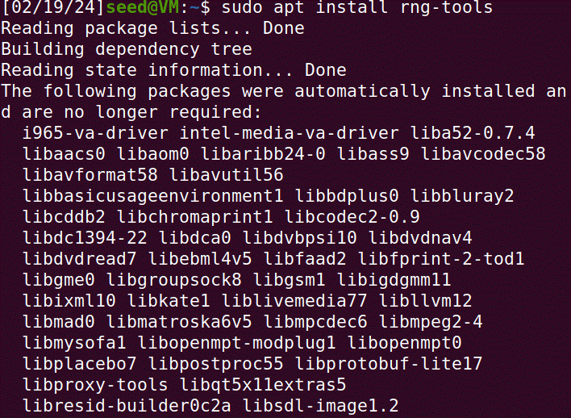

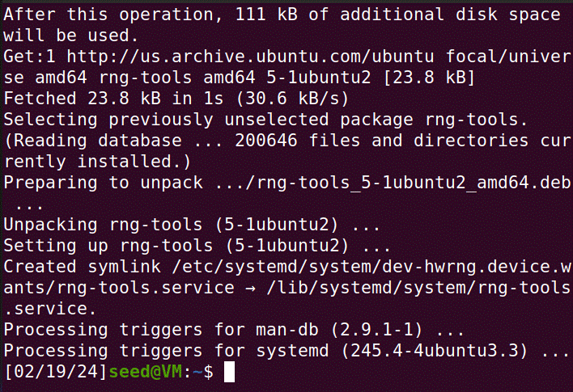

**Figure 2.2. Sudo apt install rng-tools**

1. **Create user account**

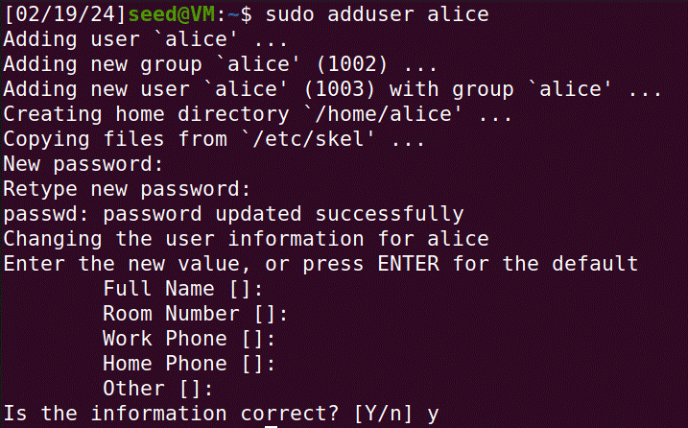

**Figure 3.1. Creating Alice account on the VM**

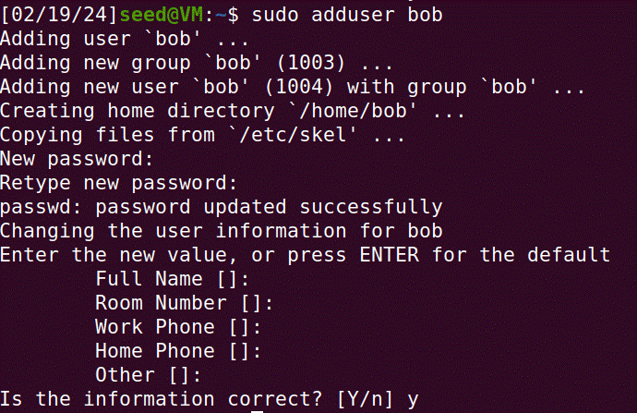

**Figure 3.2. Creating Bob account on the VM**

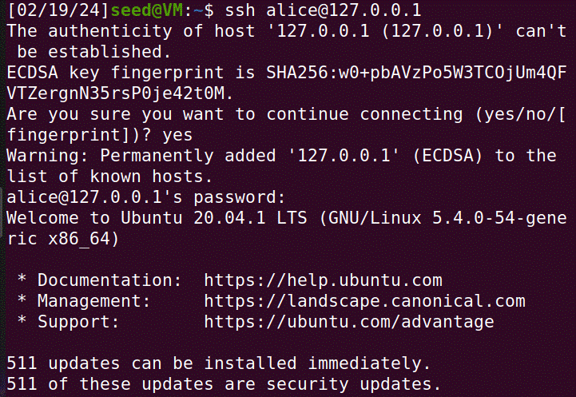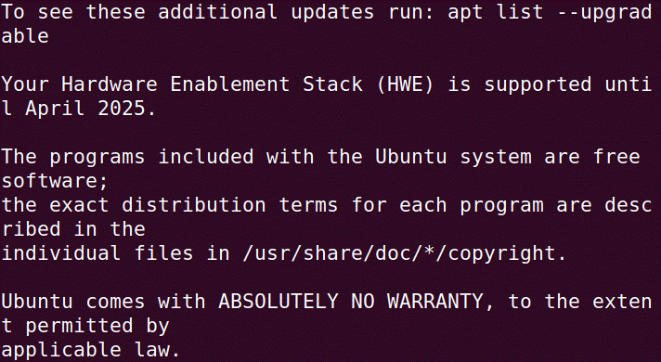

**Figure 3.3. switch to alice account on the VM**

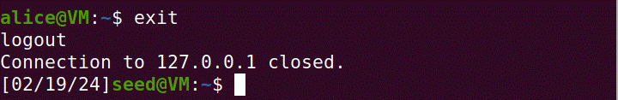

**Figure 3.3. log out alice account on the VM**