**Lab4**

1. **Labsetup**

**Figure 1. Download and unzip set-up files**

**Figure 2. Running docker server**

Open a new terminal  
**Figure 3. Interacting with the docker**

**Figure 4. Host file modification**

1. **Send a request to list files**

**Figure 1. Viewing the critical file and calculating the sum for the request**

**Figure 2. Access the page using the MAC calculated**

1. **Create padding**

**Figure 1. Find the size of the original command**

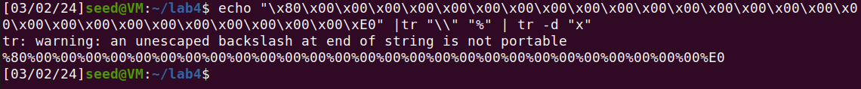**Figure 2. Replace character to create padding string**

1. **The length extension attack**

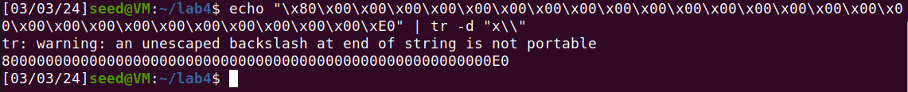**Figure 1. Modify the string for our need**

**Figure 2. Creating the file for padding purposes**

**Figure 3. Concatenate and view the file**

**Figure 4. New MAC value from padding the extension command**

**Figure 5. Access the page with the new MAC calculated**

1. **Attack Mitigation using HMAC**

**Figure 1. List the file in the server folder**

**Figure 2. Alter the HMAC algorithm**

**Figure 3. Rebuild the machine**

**Figure 4. Retart the machine**

**Figure 5. Program to calculate HMAC**

**Figure 6. Recalculating HMAC**

**Figure 7. Access the page with HMAC**