MINISTRY OF EDUCATION AND TRAINING
UNIVERSITY OF ECONOMICS AND FINANCE
HO CHI MINH CITY
---------------------------


PROJECT
ANNUAL INITIATIVE EVALUATION SYSTEM

Performed by Student:
Nguyễn Ngọc Triệu | 22D1ITqE-SWE02 | CNTT
Nguyễn Hoàng Phúc | 22D1ITE-SWE02 | CNTT
Phạm Quang Vũ | 22D1ITE-SWE02 | CNTT
Nguyễn Tấn Thiện Huy | 22D1ITE-SWE02 | CNTT

Ho Chi Minh City, April 2026.

MINISTRY OF EDUCATION AND TRAINING
UNIVERSITY OF ECONOMICS AND FINANCE
HO CHI MINH CITY
---------------------------


PROJECT
ANNUAL INITIATIVE EVALUATION SYSTEM

Performed by Student:
Nguyễn Ngọc Triệu | 22D1ITqE-SWE02 | CNTT
Nguyễn Hoàng Phúc | 22D1ITE-SWE02 | CNTT
Phạm Quang Vũ | 22D1ITE-SWE02 | CNTT
Nguyễn Tấn Thiện Huy | 22D1ITE-SWE02 | CNTT

Ho Chi Minh City, April 2026.

Record of Changes
Version | Date | Author | Description
1.0 | 30/3/2026 | Nguyễn Ngọc Triệu | Initial

TABLE OF CONTENTS

CHAPTER 1. OVERVIEW 5
1.1. Project information 6
1.2. Project team 6
CHAPTER 2. TEST PLAN 8
2.1. Test scope 8
2.1.1. In-scope 8
2.1.2. Out-of-scope 8
2.2. Test strategy & approach 9
2.2.1. Black-box testing 9
2.2.2. White-box testing 9
2.2.3. Manual and automation 10
2.3. Test environment 10
CHAPTER 3. Test Design & Execution 11
3.1. Test scenarios 11
3.2. Test case specification 11
3.2.1. Author Module 11
3.2.2. Faculty module 20
3.2.3. Council module 24
3.2.4. Scitech module 27
3.2.5. Initiative state flow 40
CHAPTER 4. Defect Report & Metrics 43
4.1. Defect Log 43
4.2. Test Summary Metrics 44
CHAPTER 5. Conclusion & Future Work 46
5.1. Achievements and Compliance with Requirements 46
5.2. Challenges and Limitations 46
5.3. Suggestions for Future Enhancements 47
REFERENCES 48
APPENDIX 48

TABLE OF FIGURES
Picture 3-1 Function author create initiative 12
Picture 3-2 Function author view activity history 14
Picture 3-3 Function author statistic 16
Picture 3-4 Function author update profile 18
Picture 3-5 Function faculty review initiative 20
Picture 3-6 Function faculty dashboard 21
Picture 3-7 Function faculty update profile 23
Picture 3-8 Function council review 24
Picture 3-9 Function council history 26
Picture 3-10 Function scitech dashboard 27
Picture 3-11 Function scitech review initiative 29
Picture 3-12 Function scitech create period 31
Picture 3-13 Function scitech manage categories 33
Picture 3-14 Function scitech update scoring criteria 35
Picture 3-15 Function scitech manage users 36
Picture 3-16 Function scitech council management 38
Picture 3-17 Function audit logs 39
Picture 3-18 Initiative statechart diagram 40
Picture 4-1 Bug management using Jira 43

OVERVIEW

Project information
IdeaTrack is a web-based Initiative Management System developed using ASP.NET Core MVC (.NET 8), PostgreSQL, and Entity Framework Core. The system is designed to digitalize and standardize the workflow of academic initiatives in a university environment, where proposals must pass through several controlled review stages before final approval. By centralizing initiative submission, review, scoring, and decision-making, IdeaTrack helps reduce manual handling, improve traceability, and enhance the consistency of the approval process.
From a functional perspective, the system supports a complex state transition workflow that reflects real-world academic governance. An initiative may move through multiple statuses such as draft creation, submission, faculty-level review, scientific committee evaluation, final processing, and final approval or rejection. Because each transition depends on both the current state and the user role, the system requires strict authorization control and logical validation to ensure that only qualified users can perform permitted actions at the correct stage.
Within the scope of this testing project, five main modules are included: Authentication, Author, Faculty Leader, Councils, and SciTech Admin. These modules together form the core business flow of the application. In addition, IdeaTrack is not only a conventional website but also integrates internal API mechanisms to support secure and efficient state management across its layered workflow. Therefore, the testing focus is placed on validating role-based access control, UI behavior, business rules, and the correctness of state transitions throughout the initiative lifecycle.

Project team
No. | Full Name | Role & Task Allocation
1 | Nguyễn Ngọc Triệu | Team Leader – responsible for Test Plan coordination, report integration, progress tracking, and final quality review. Also executes 10 manual test cases and participates in testing the Authentication module.
2 | Phạm Quang Vũ | QA Automation & Module Tester – responsible for designing and executing 10 manual test cases, developing Selenium-based automation scripts for bonus points, and testing the Author module.
3 | Nguyễn Hoàng Phúc | Bug Manager & Module Tester – responsible for managing JIRA bug tracking, classifying Severity/Priority, executing 10 manual test cases, and testing the Faculty Leader module.
4 | Nguyễn Tấn Thiện Huy | System Architect & Module Tester – responsible for analyzing state transition logic, preparing workflow diagrams, executing 10 manual test cases, and testing the Councils and SciTech Admin modules.
Table 1-1 Team members and roles
All four team members contribute equally to manual testing, defect reporting, and documentation. Each member is assigned one primary functional area while still sharing responsibility for overall test design, execution, and report writing to ensure balanced workload distribution and comprehensive coverage of the system scope.

TEST PLAN

Test scope

In-scope
The system testing phase is structured around specialized functional modules to ensure comprehensive validation of all business processes. The primary focus of the testing scope encompasses the following core areas:
System Administration and Security Testing begins with a rigorous verification of the Authentication Module and Role-Based Access Control (RBAC). This ensures secure user login and logout processes while validating that access and state transitions are strictly governed by assigned roles and business rules. Concurrently, the SciTech Admin Module is evaluated to confirm the system's foundational stability, focusing on period and academic year management, template configuration, user administration, and the proper handling of final-stage initiative processing.
Initiative Processing and Evaluation Workflows The core user operations are systematically validated starting with the Author Module, which covers initiative creation, draft saving, file attachments, co-author management, and tracking functions. The review and evaluation stages are then tested through the Faculty Leader Module, ensuring correct role-restricted decision-making for approvals and rejections at the faculty level. Following this, the Councils Module undergoes testing for council assignments, score submissions, re-evaluation requests, and final score consolidation to guarantee a transparent and accurate assessment workflow.
State Transition and Lifecycle Management A critical area of focus during testing is the State Transition Workflow of Initiatives. The testing team traces the complete initiative lifecycle, tracking its progression from Draft through intermediate states (Pending, Faculty_Approved, Evaluating, Pending_Final, Processing) to the final outcomes (Approved or Rejected). To ensure system resilience and flexibility, the testing scope also comprehensively covers rollback and recovery mechanisms, thoroughly validating the Clone, Revoke, and Resubmit operational flows.

Out-of-scope
Due to time constraints and the academic scope of the project, the following activities are excluded from testing:
- Performance testing / Stress testing
- Advanced security penetration testing
- Mobile responsiveness testing on mobile devices

Test strategy & approach
The test strategy for IdeaTrack is designed according to a black-box testing-oriented approach, supported by selective white-box review and limited automation for high-value scenarios. Since the system is primarily a workflow-driven academic platform, the main testing objective is to verify that business rules, role permissions, and state transitions operate correctly under both normal and negative conditions.

Black-box testing
The team applies Equivalence Partitioning (EP) and Boundary Value Analysis (BVA) to form-based inputs in critical modules. For example, the initiative creation form is tested with valid and invalid input groups such as empty fields, maximum-length values, and malformed data. Similarly, the council scoring form, which uses a 100-point scale, is tested at boundary conditions such as minimum score, maximum score, and values around critical limits. This approach helps detect input validation defects efficiently while minimizing redundant test cases.
In addition, the project applies State Transition Testing as a core design technique because IdeaTrack is fundamentally a workflow-based system. Each initiative moves through a controlled sequence of statuses, and every transition depends on both the current state and the active user role. Therefore, the team verifies not only the normal progression of states, such as Pending → Evaluating → Processing, but also alternate and exceptional flows, including rollback, re-evaluation, resubmission, and revocation. This method is essential for detecting logical defects in the transition rules, such as unauthorized state changes, skipped stages, incorrect rejection handling, or inconsistent recovery behavior after a decision is reversed.

White-box testing
Although the project is primarily black-box in nature, the team also performs limited white-box review to improve understanding of system implementation before execution. Specifically, the team reviews key Controller files and the DataSeederService.cs source code in the ASP.NET Core project to understand how data is initialized, how entities are linked, and how the application enforces workflow rules at the code level. This review helps the testers interpret UI behavior correctly, verify seeded test data, and prepare more accurate test conditions for each module.

Manual and automation
The testing process combines manual and automated testing.
Manual Testing: The team executes manual test cases to cover the principal business flows across the five core modules. Manual testing is used for role-specific actions, workflow transitions, validation errors, UI behavior, and negative test scenarios. All defects discovered during manual execution are logged in JIRA with strict Severity and Priority classification to support defect triage and follow-up tracking.
Automation Testing: To enhance repeatability, the team uses Selenium WebDriver and C# (xUnit) to automate selected happy-path scenarios such as login and initiative creation. These automated scripts help validate stable workflows and generate an HTML test report for result documentation.

Test environment
Item | Specification
Operating System | Windows 10/11, macOS
Browsers | Google Chrome (Latest), Microsoft Edge (Latest)
Application Environment | Kestrel Web Server (.NET 8), localhost:5227
Database | PostgreSQL
Test Management & Bug Tracking | JIRA
Automation Tools | xUnit, Selenium WebDriver
Table 2-1 Environment details
The above environment was selected to ensure consistency with the development stack of IdeaTrack and to provide stable conditions for both manual execution and automation-based verification.

Test Design & Execution

Test scenarios
Scenario ID | Module | Scenario Description | Priority
SC-01 | Homepage Features | Verification of general landing page elements, public announcements, system guidelines, and basic navigation before login. | Medium
SC-02 | Author Module | Validation of initiative creation, draft saving, file attachment upload, co-author management, and submission tracking. | High
SC-03 | Faculty Leader Module | Testing of initiative review at the faculty level, including approval, rejection, and role-restricted decision-making. | High
SC-04 | SciTech Admin Module | Verification of period/academic year management, template configuration, user administration, and final-stage initiative processing. | Critical
SC-05 | Council Member Module | Validation of council assignment viewing, score submission, evaluation workflow, and re-evaluation processing. | High
SC-06 | Initiative State Flow | End-to-end testing of the full initiative lifecycle (Draft to Approved/Rejected), including rollback flows (Clone, Revoke, Resubmit). | Critical
Table 3-1 Test scenarios details

Test case specification
The team has designed and executed more than 40 detailed test cases covering both UI and API-level behaviors. The following tables present the standard test case structure and several representative samples. The complete set of test cases is attached in Excel format in the Appendix section.

Author Module
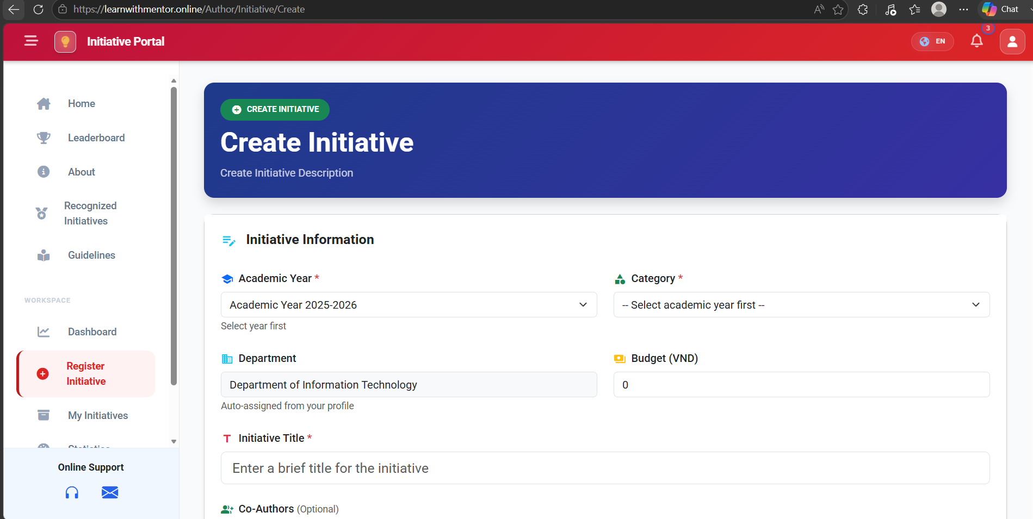
Picture 3-1 Function author create initiative
ID | Title | Pre-conditions | Steps | Expected / Actual Results | Status
AU-CI-01 | Create Initiative — Valid Data  (EP: valid partition) | User is logged in as Author.  Academic Year and Category exist. | 1. Navigate to Register Initiative.  2. Fill: Title = "AI Solution", AcademicYearId = 1, CategoryId = 2, File = "tailieu.pdf", CoAuthorIds = [2, 3].  3. Click Submit. | System saves the initiative successfully and redirects to My Initiatives page. | PASS
AU-CI-02 | Create Initiative — Blank Title  (EP: invalid — empty string) | User is logged in as Author. | 1. Navigate to Register Initiative.  2. Leave Title blank, fill other fields.  3. Click Submit. | Validation error: "The Title field is required." Initiative is not saved. | PASS
AU-CI-03 | Create Initiative — Missing Academic Year  (EP: invalid — null selection) | User is logged in as Author. | 1. Navigate to Register Initiative.  2. Fill Title, do NOT select Academic Year.  3. Click Submit. | Submit button is disabled or server rejects with validation error "Please select an Academic Year." | PASS
AU-CI-04 | Create Initiative — Invalid File Type  (EP: invalid file extension) | User is logged in as Author. | 1. Navigate to Register Initiative.  2. Fill valid data, attach File = "script.exe".  3. Click Submit. | Validation error: "Invalid file format, only (.pdf, .docx, …) allowed." File is rejected. | PASS
AU-CI-05 | Create Initiative — File Size Exceeded  (BVA: above max limit) | User is logged in as Author.  Max file size = 10 MB. | 1. Navigate to Register Initiative.  2. Fill valid data, attach File = "video.mp4" (50 MB).  3. Click Submit. | Validation error: "File size exceeds the allowed limit (10 MB)." Submission blocked. | PASS
AU-CI-06 | Create Initiative — File Size at Boundary  (BVA: exactly 10 MB) | User is logged in as Author.  Max file size = 10 MB. | 1. Navigate to Register Initiative.  2. Fill valid data, attach a file exactly 10 MB.  3. Click Submit. | File is accepted and initiative is created successfully. | PASS
AU-CI-07 | Create Initiative — File Size Just Below Limit  (BVA: 9.99 MB) | User is logged in as Author.  Max file size = 10 MB. | 1. Navigate to Register Initiative.  2. Fill valid data, attach a file of 9.99 MB.  3. Click Submit. | File is accepted and initiative is created successfully. | PASS
AU-CI-08 | Create Initiative — File Size Just Above Limit  (BVA: 10.01 MB) | User is logged in as Author.  Max file size = 10 MB. | 1. Navigate to Register Initiative.  2. Fill valid data, attach a file of 10.01 MB.  3. Click Submit. | Validation error: "File size exceeds the allowed limit (10 MB)." | PASS
AU-CI-09 | Create Initiative — Title at Min Length  (BVA: 1 character) | User is logged in as Author. | 1. Navigate to Register Initiative.  2. Enter Title = "A".  3. Fill other required fields.  4. Click Submit. | Initiative is created successfully with single-character title. | PASS
AU-CI-10 | Create Initiative — Title at Max Length  (BVA: max allowed chars) | User is logged in as Author. | 1. Navigate to Register Initiative.  2. Enter Title with maximum allowed characters (e.g., 255 chars).  3. Fill other fields.  4. Click Submit. | Initiative is created successfully. Title is stored and displayed correctly. | PASS
AU-CI-11 | Create Initiative — Title Exceeds Max Length  (BVA: max + 1) | User is logged in as Author. | 1. Navigate to Register Initiative.  2. Enter Title with max + 1 characters.  3. Click Submit. | Validation error or title is truncated. Initiative is not saved with oversized title. | PASS
AU-CI-12 | Create Initiative — No File Attached  (EP: optional file = empty) | User is logged in as Author.  File is optional. | 1. Navigate to Register Initiative.  2. Fill Title, Academic Year, Category. Do NOT attach file.  3. Click Submit. | Initiative is created successfully without attachment. | PASS
AU-CI-13 | Create Initiative — Missing Category  (EP: invalid — null) | User is logged in as Author. | 1. Navigate to Register Initiative.  2. Fill Title, select Academic Year. Do NOT select Category.  3. Click Submit. | Validation error: "Category is required." | PASS
AU-CI-14 | Create Initiative — Budget = 0  (BVA: lower bound) | User is logged in as Author. | 1. Navigate to Register Initiative.  2. Fill all required fields, set Budget = 0.  3. Click Submit. | Initiative is created with Budget = 0. | PASS
AU-CI-15 | Create Initiative — Negative Budget  (EP: invalid numeric) | User is logged in as Author. | 1. Navigate to Register Initiative.  2. Fill all fields, set Budget = -1000.  3. Click Submit. | Validation error: "Budget must be a non-negative number." | PASS
Table 3-2 Create initiative testcases
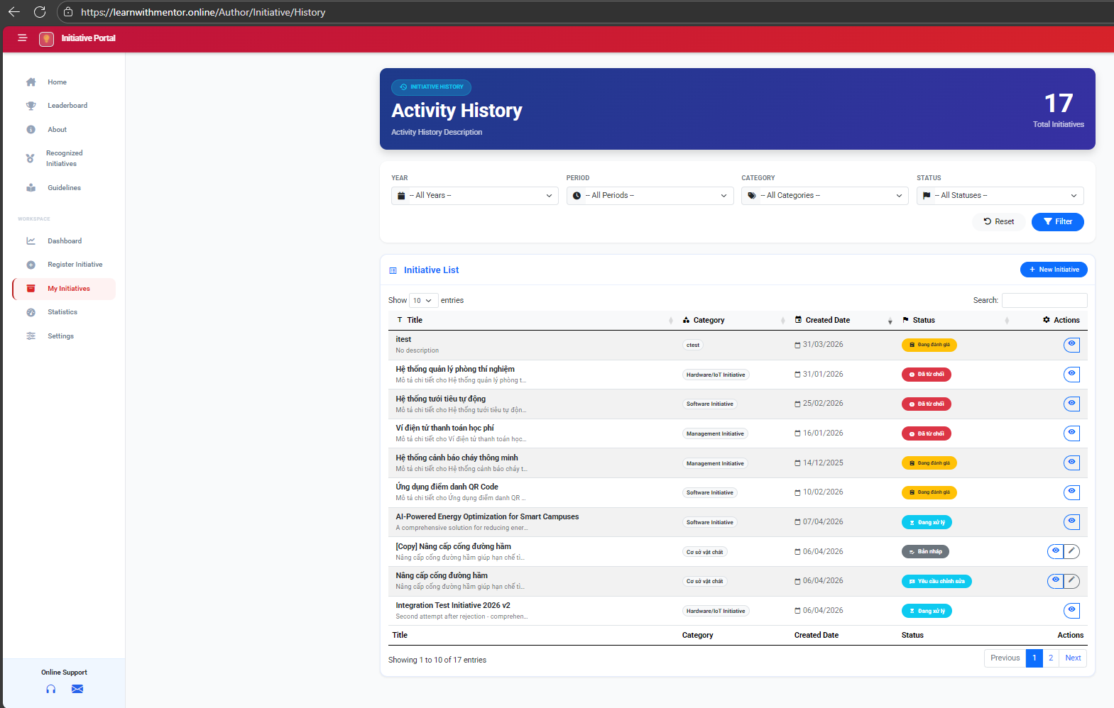
Picture 3-2 Function author view activity history
ID | Title | Pre-conditions | Steps | Expected / Actual Results | Status
AU-MI-01 | View My Initiatives List  (EP: valid view) | Author is logged in.  Author has submitted initiatives. | 1. Navigate to My Initiatives. | Initiative list is displayed showing all author's initiatives with Title, Category, Created Date, Status, and Actions columns. Showing 1-10 of 17 entries. | PASS
AU-MI-02 | Filter Initiatives by Year  (EP: valid filter) | Author is logged in.  Multiple academic years exist. | 1. Navigate to My Initiatives.  2. Select Year dropdown.  3. Click "Filter". | Only initiatives from the selected academic year are displayed. | PASS
AU-MI-03 | Filter Initiatives by Period  (EP: valid filter) | Author is logged in.  Multiple periods exist. | 1. Navigate to My Initiatives.  2. Select Period dropdown.  3. Click "Filter". | Only initiatives from the selected period are displayed. | PASS
AU-MI-04 | Filter Initiatives by Category  (EP: valid filter) | Author is logged in.  Multiple categories exist. | 1. Navigate to My Initiatives.  2. Select Category dropdown (e.g., "Software Initiative").  3. Click "Filter". | Only initiatives with the selected category are displayed. | PASS
AU-MI-05 | Filter Initiatives by Status  (EP: valid filter) | Author is logged in.  Initiatives with various statuses exist. | 1. Navigate to My Initiatives.  2. Select Status dropdown (e.g., "Rejected").  3. Click "Filter". | Only initiatives with "Rejected" status are displayed. | PASS
AU-MI-06 | Search Initiatives in List  (EP: valid search) | Author is logged in.  Initiatives exist. | 1. Navigate to My Initiatives.  2. Type "AI" in the Search box. | Only initiatives with "AI" in their title are shown. | PASS
AU-MI-07 | Search with Non-Existent Keyword  (EP: no match) | Author is logged in. | 1. Navigate to My Initiatives.  2. Type "XYZNOTEXIST" in Search box. | No results displayed. Table shows empty or "No data available" message. | PASS
AU-MI-08 | Reset All Filters  (EP: reset action) | Author is logged in.  Filters are currently applied. | 1. Navigate to My Initiatives.  2. Apply some filters.  3. Click "Reset" button. | All filters are cleared. Full initiative list is displayed. | PASS
AU-MI-09 | Pagination — Navigate to Page 2  (BVA: page boundary) | Author is logged in.  More than 10 initiatives exist (17 total). | 1. Navigate to My Initiatives.  2. Click page "2" or "Next" in pagination. | Page 2 displays entries 11-17. Pagination updates correctly. | PASS
AU-MI-10 | Change Entries Per Page  (BVA: display count) | Author is logged in.  17 initiatives exist. | 1. Navigate to My Initiatives.  2. Change "Show entries" dropdown from 10 to 25. | All 17 initiatives are displayed on single page. | PASS
AU-MI-11 | Edit Draft Initiative  (EP: valid edit) | Author is logged in.  Draft initiative exists. | 1. Navigate to My Initiatives.  2. Click edit icon on a "Draft" initiative. | Initiative edit form is opened. Author can modify fields and re-submit. | PASS
AU-MI-12 | View Initiative Details  (EP: valid view) | Author is logged in.  Initiative exists. | 1. Navigate to My Initiatives.  2. Click view icon on any initiative. | Initiative detail page is displayed with full information. | PASS
Table 3-3 Activity history testcases
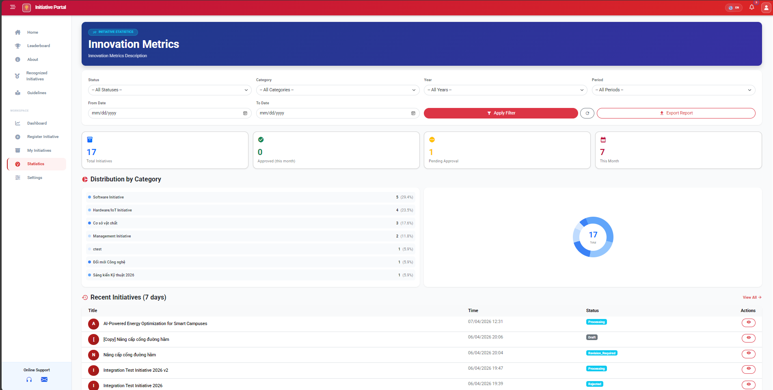
Picture 3-3 Function author statistic
ID | Title | Pre-conditions | Steps | Expected / Actual Results | Status
AU-ST-01 | View Statistics Dashboard  (EP: valid view) | Author is logged in.  Author has submitted initiatives. | 1. Navigate to Statistics page. | Statistics page displays: Total Initiatives = 17, Approved (this month) = 0, Pending Approval = 1, This Month = 7. | PASS
AU-ST-02 | View Distribution by Category Chart  (EP: valid chart) | Author is logged in.  Multiple categories used. | 1. Navigate to Statistics page.  2. View "Distribution by Category" section. | Pie chart and list show correct distribution: Software Initiative 5 (29.4%), Hardware/IoT 4 (23.5%), etc. | PASS
AU-ST-03 | View Recent Initiatives List  (EP: valid list) | Author is logged in.  Recent initiatives exist. | 1. Navigate to Statistics page.  2. View "Recent Initiatives (7 days)" section. | Recent initiatives are listed with Title, Time, Status, and Actions. Correct statuses shown (Processing, Draft, Revision_Required, etc.). | PASS
AU-ST-04 | Filter Statistics by Status  (EP: valid filter) | Author is logged in. | 1. Navigate to Statistics.  2. Select Status filter (e.g., "Processing").  3. Click "Apply Filter". | Statistics and charts update to show only data for "Processing" status. | PASS
AU-ST-05 | Filter Statistics by Category  (EP: valid filter) | Author is logged in. | 1. Navigate to Statistics.  2. Select Category filter (e.g., "Software Initiative").  3. Click "Apply Filter". | Statistics update to show only Software Initiative data. | PASS
AU-ST-06 | Filter Statistics by Year  (EP: valid filter) | Author is logged in. | 1. Navigate to Statistics.  2. Select Year filter.  3. Click "Apply Filter". | Statistics update to show only data from the selected year. | PASS
AU-ST-07 | Filter Statistics by Date Range  (BVA: valid range) | Author is logged in. | 1. Navigate to Statistics.  2. Set From Date and To Date.  3. Click "Apply Filter". | Statistics update to show only data within the date range. | PASS
AU-ST-08 | Filter with From Date > To Date  (BVA: invalid range) | Author is logged in. | 1. Set From Date = "2026-05-01".  2. Set To Date = "2026-04-01".  3. Click "Apply Filter". | Validation error or no results returned. System handles gracefully. | PASS
AU-ST-09 | Export Statistics Report  (EP: valid export) | Author is logged in.  Statistics data exists. | 1. Navigate to Statistics.  2. Click "Export Report" button. | Report file is downloaded containing author's initiative statistics. | PASS
Table 3-4 Author statistic testcases
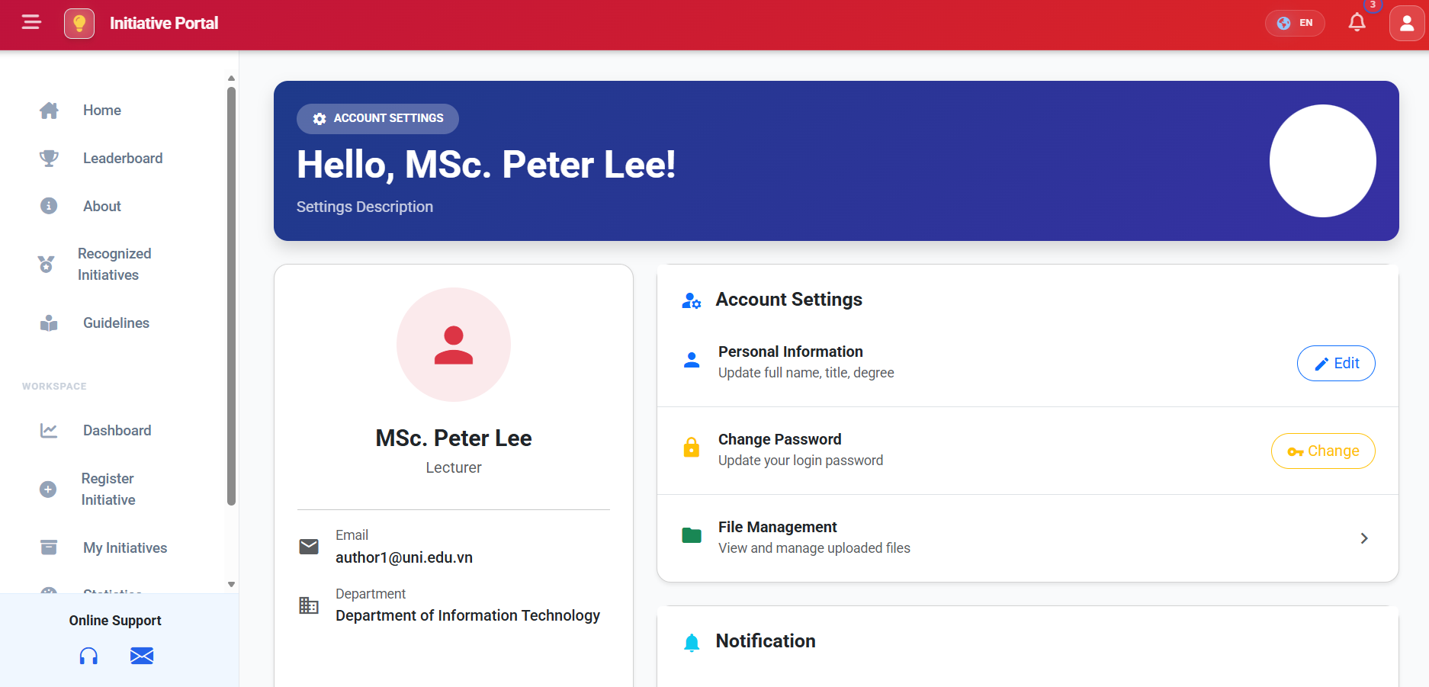
Picture 3-4 Function author update profile
ID | Title | Pre-conditions | Steps | Expected / Actual Results | Status
AU-PF-01 | Update Profile — Valid Data  (EP: valid partition) | User is logged in as Author (MSc. Peter Lee). | 1. Navigate to Settings > Personal Information > Edit.  2. Set FullName = "Nguyen Van A", Position = "Lecturer", Degree = "Master".  3. Click Save. | Profile is updated successfully. Notification: "Update successful." | PASS
AU-PF-02 | Update Profile — Blank FullName  (EP: invalid — empty) | User is logged in as Author. | 1. Navigate to Settings > Personal Information > Edit.  2. Clear FullName field.  3. Click Save. | Validation error: "Full name is required." Database state unchanged. | PASS
AU-PF-03 | Update Profile — FullName with Special Characters  (EP: edge) | User is logged in as Author. | 1. Navigate to Settings > Edit.  2. Set FullName = "Dr. O'Brien-Smith Jr.".  3. Click Save. | Profile is updated. Special characters are stored and displayed correctly. | PASS
AU-PF-04 | Update Profile — Very Long FullName  (BVA: max length) | User is logged in as Author. | 1. Navigate to Settings > Edit.  2. Enter FullName with 255 characters.  3. Click Save. | Profile is updated successfully or shows max-length validation error. | PASS
Table 3-5 Author profile testcases

Faculty module
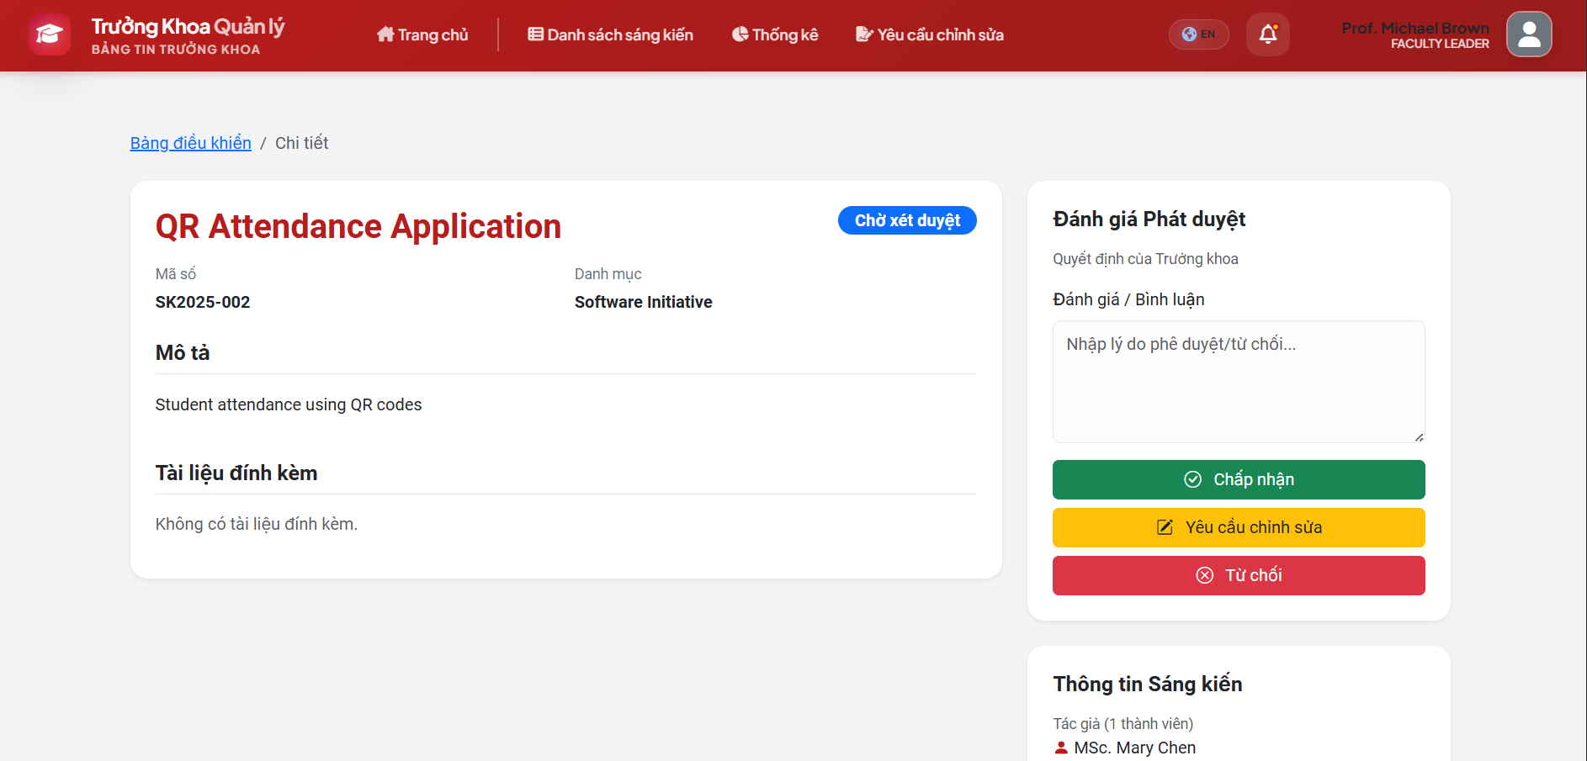
Picture 3-5 Function faculty review initiative
ID | Title | Pre-conditions | Steps | Expected / Actual Results | Status
FA-RV-01 | Review — Accept Initiative  (EP: valid accept action) | Faculty user logged in.  Initiative status = Submitted.  Initiative exists (e.g., SK2025-002). | 1. Navigate to Initiative List.  2. Open initiative detail.  3. Enter comment: "Good initiative."  4. Click "Accept". | Status changes to Faculty_Approved. System notification: "Initiative accepted…" | PASS
FA-RV-02 | Review — Request Revision with Comment  (EP: valid revision request) | Faculty user logged in.  Initiative status = Submitted. | 1. Open initiative detail.  2. Enter comment: "Please add more data."  3. Click "Request Revision". | Status changes to Revision_Required. System records revision request and notifies author. | PASS
FA-RV-03 | Review — Request Revision with Blank Comment  (BVA: empty comment boundary) | Faculty user logged in.  Initiative status = Submitted. | 1. Open initiative detail.  2. Leave comment field blank.  3. Click "Request Revision". | If comment is required: validation error. If optional: revision request is submitted. | PASS
FA-RV-04 | Review — Reject Initiative  (EP: valid reject action) | Faculty user logged in.  Initiative status = Submitted. | 1. Open initiative detail.  2. Enter comment: "Not feasible."  3. Click "Reject". | Status changes to Rejected. System notification: "Initiative has been rejected." | PASS
FA-RV-05 | Review — Accept Without Comment  (EP: optional comment) | Faculty user logged in.  Initiative status = Submitted. | 1. Open initiative detail.  2. Leave comment empty.  3. Click "Accept". | Status changes to Faculty_Approved. Comment is stored as empty. | PASS
FA-RV-06 | Review — Reject Without Comment  (BVA: empty comment) | Faculty user logged in.  Initiative status = Submitted. | 1. Open initiative detail.  2. Leave comment empty.  3. Click "Reject". | Validation error if comment is required for rejection, else status changes to Rejected. | PASS
FA-RV-07 | Review — Comment with Max Length  (BVA: upper bound) | Faculty user logged in.  Initiative status = Submitted. | 1. Open initiative detail.  2. Enter comment with maximum allowed characters.  3. Click "Accept". | Comment is accepted and stored. Status changes to Faculty_Approved. | PASS
Table 3-6 Faculty review testcases
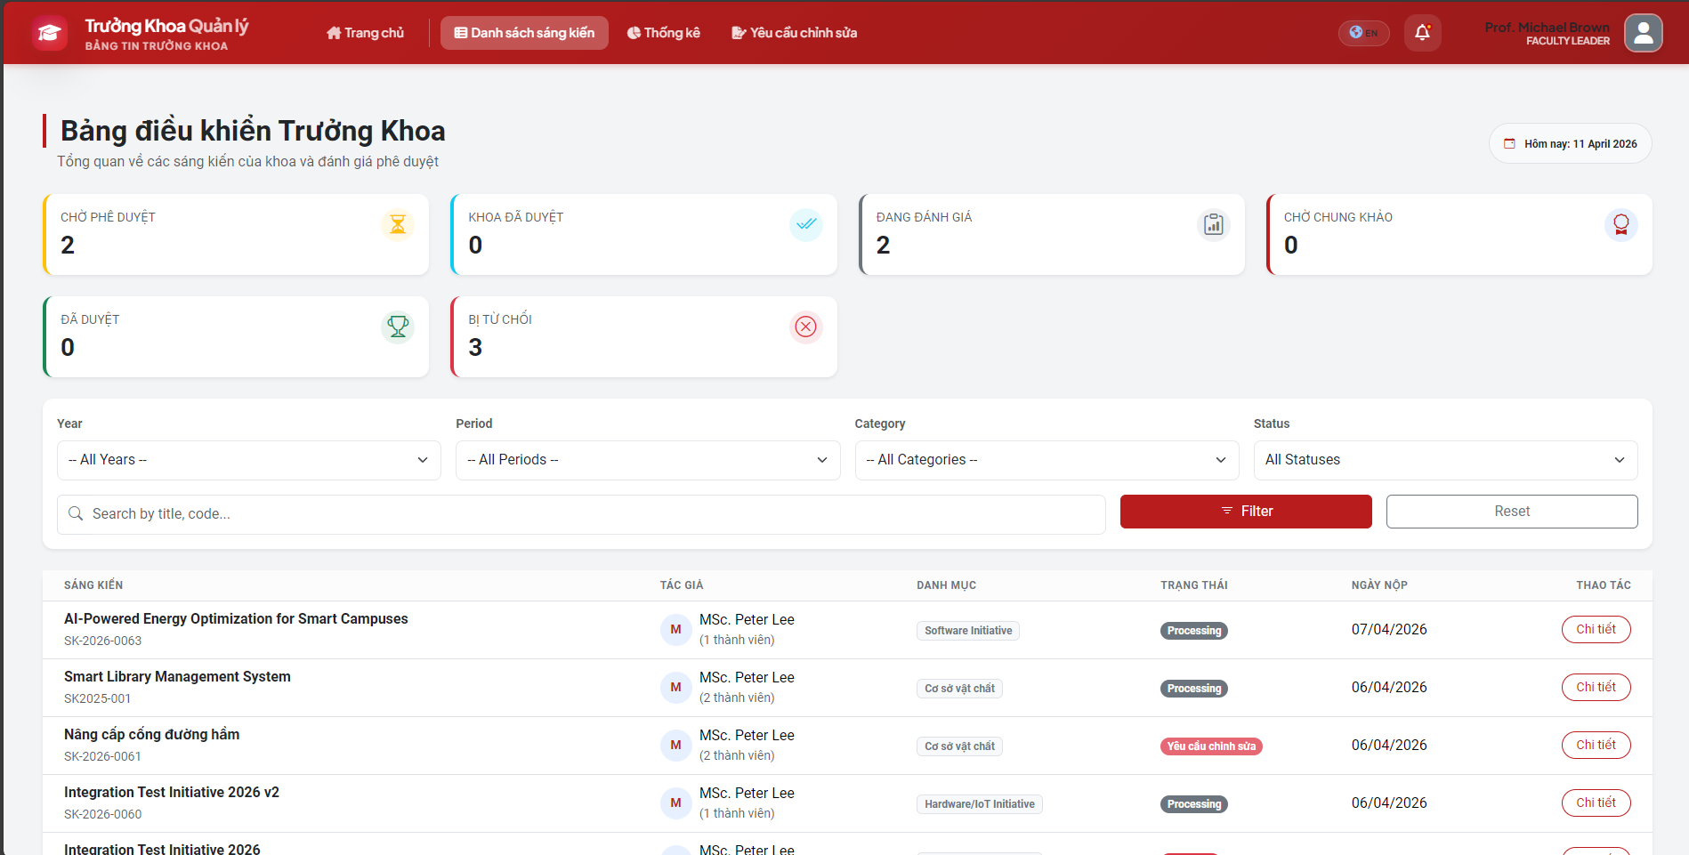
Picture 3-6 Function faculty dashboard
ID | Title | Pre-conditions | Steps | Expected / Actual Results | Status
FA-DS-01 | Search Initiatives by Keyword  (EP: valid keyword) | Faculty user logged in.  Initiatives exist. | 1. Navigate to Dashboard.  2. Enter search string "AI Solution" in search bar.  3. Click Search / Apply. | List displays only initiatives matching "AI Solution." | PASS
FA-DS-02 | Filter by Academic Year / Period  (EP: valid filter) | Faculty user logged in.  Multiple years/periods exist. | 1. Navigate to Dashboard.  2. Select Year = "2025-2026", Period = "2025-2026".  3. Click Apply / Filter. | Initiative list and statistics charts update to show only data for the selected year/period. | PASS
FA-DS-03 | Export Dashboard to Excel  (EP: valid export) | Faculty user logged in.  Initiative data exists. | 1. Navigate to Dashboard.  2. Click "Export" button. | Browser downloads CSV file "Initiative_Stats_ddMMyyyy.csv" with correct faculty data. | PASS
FA-DS-04 | View File as PDF  (EP: valid file conversion) | Faculty user logged in.  Initiative has attachment "tailieu.docx". | 1. Navigate to initiative detail.  2. Click "View File" on attached document. | System converts docx to PDF via LibreOffice and opens in browser PDF viewer. | PASS
FA-DS-05 | Search with Empty Keyword  (BVA: empty string) | Faculty user logged in. | 1. Navigate to Dashboard.  2. Leave search bar empty.  3. Click Search. | All initiatives are displayed (no filter applied). | PASS
FA-DS-06 | Search with Non-Existent Keyword  (EP: no match) | Faculty user logged in. | 1. Navigate to Dashboard.  2. Enter "XYZNOTEXIST999".  3. Click Search. | No results found. Appropriate "No results" message displayed. | PASS
FA-DS-07 | Search with Special Characters  (EP: edge — SQL injection) | Faculty user logged in. | 1. Enter search string: "'; DROP TABLE --".  2. Click Search. | No results or safe handling. No database error or crash. | PASS
Table 3-7 Faculty dashboard testcases
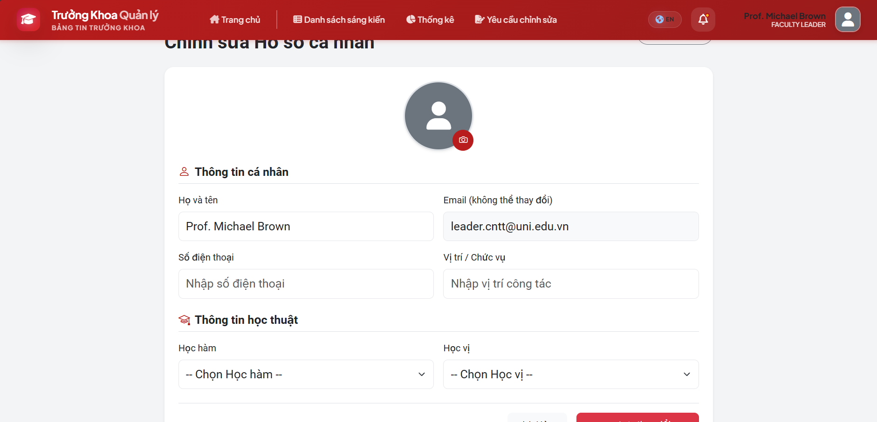
Picture 3-7 Function faculty update profile
ID | Title | Pre-conditions | Steps | Expected / Actual Results | Status
FA-PF-01 | Update Profile — Valid Data  (EP: valid partition) | Faculty user (Prof. Michael Brown) logged in. | 1. Navigate to Profile Edit.  2. Set FullName = "Dr. Le B", Email = "leb@truong.edu.vn", Phone = "0901234567".  3. Click Save. | Profile updated successfully. No errors. | PASS
FA-PF-02 | Update Profile — Invalid Email Format  (EP: invalid email) | Faculty user logged in. | 1. Navigate to Profile Edit.  2. Set Email = "leb-truong.edu.vn" (missing @).  3. Click Save. | Validation error: "Invalid email address." | PASS
FA-PF-03 | Update Profile — Missing FullName  (EP: invalid — empty) | Faculty user logged in. | 1. Navigate to Profile Edit.  2. Clear FullName field.  3. Click Save. | Validation error: "Full name is required." | PASS
FA-PF-04 | Update Profile — Phone with Letters  (EP: invalid phone) | Faculty user logged in. | 1. Navigate to Profile Edit.  2. Set Phone = "ABCDEF".  3. Click Save. | Validation error: "Invalid phone number format." | PASS
FA-PF-05 | Update Profile — Phone Exactly 10 Digits  (BVA: valid boundary) | Faculty user logged in. | 1. Set Phone = "0901234567" (10 digits).  2. Click Save. | Profile updated successfully. | PASS
FA-PF-06 | Update Profile — Phone with 9 Digits  (BVA: below minimum) | Faculty user logged in. | 1. Set Phone = "090123456" (9 digits).  2. Click Save. | Validation error: "Phone number must be 10-11 digits." | PASS
Table 3-8 Faculty profile testcases

Council module
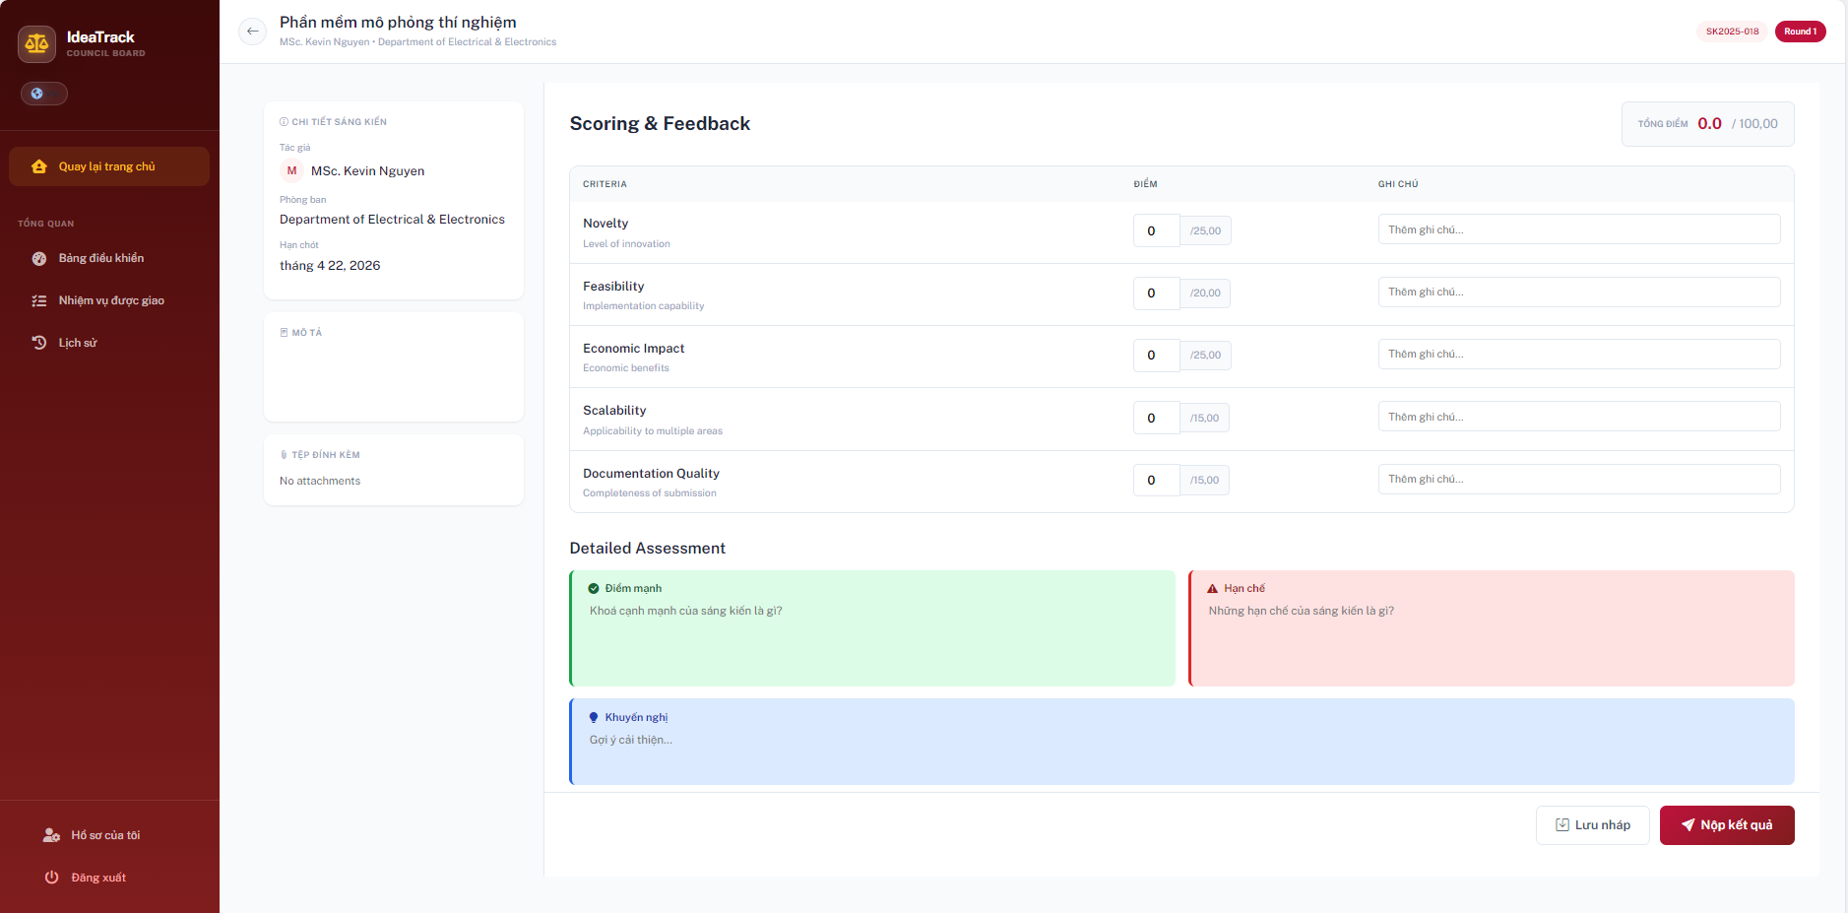
Picture 3-8 Function council review
ID | Title | Pre-conditions | Steps | Expected / Actual Results | Status
CO-SC-01 | Submit Scores — Maximum Valid Boundaries  (BVA: upper bounds) | Council user logged in. Navigated to the Scoring page of an assigned initiative. | 1. Enter max scores for all criteria: Novelty (25.00), Feasibility (20.00), Economic Impact (25.00), Scalability (15.00), Documentation Quality (15.00).  2. Fill in all Detailed Assessment text areas.  3. Click "Nộp kết quả" (Submit Result). | The "Tổng điểm" (Total Score) automatically calculates to exactly 100.00. Submission is successful and status updates. | PASS
CO-SC-02 | Input Scores — Invalid Upper Boundaries  (BVA: max + 0.01) | Council user logged in. Navigated to the Scoring page. | 1. Enter 25.01 in the "Novelty" (max 25.00) field.  2. Click outside the field to trigger validation. | System immediately displays a validation error (e.g., "Score must not exceed 25.00"). The input is rejected. | PASS
CO-SC-03 | Submit Scores — Minimum Valid Boundaries  (BVA: lower bounds) | Council user logged in. Navigated to the Scoring page. | 1. Enter 0 for all 5 criteria.  2. Fill in Detailed Assessment areas.  3. Click "Nộp kết quả". | The Total Score automatically calculates to 0.0. Submission is successful. | PASS
CO-SC-04 | Input Scores — Invalid Lower Boundaries  (BVA: negative values) | Council user logged in. Navigated to the Scoring page. | 1. Enter -1 or -0.5 in any criteria field (e.g., Feasibility). | System prevents the input of negative numbers or displays a validation error: "Score cannot be less than 0". | PASS
CO-SC-05 | Input Scores — Valid Decimal Formats  (EP: decimal values) | Council user logged in. Navigated to the Scoring page. | 1. Enter valid decimal scores (e.g., 12.5 or 12.50) into the criteria fields.  2. Check the Total Score calculation. | System accepts the decimal values correctly. Total score reflects the exact decimal addition. | PASS
CO-SC-06 | Save Draft — Partial Data Entry  (EP: incomplete form) | Council user logged in. Navigated to the Scoring page. | 1. Enter a score for "Novelty" only.  2. Leave all other scores at 0 and assessment fields empty.  3. Click "Lưu nháp" (Save Draft). | System saves the current inputs without triggering mandatory field validations. User can return later to continue scoring. | PASS
CO-SC-07 | Submit Scores — Missing Mandatory Assessments  (EP: empty text areas) | Council user logged in. Navigated to the Scoring page. | 1. Enter valid scores for all 5 criteria.  2. Leave the Detailed Assessment areas ("Điểm mạnh", "Hạn chế", "Khuyến nghị") completely blank.  3. Click "Nộp kết quả". | System blocks the submission and highlights the empty assessment text areas, prompting the user to provide detailed feedback. | PASS

Table 3-9 Council review testcases
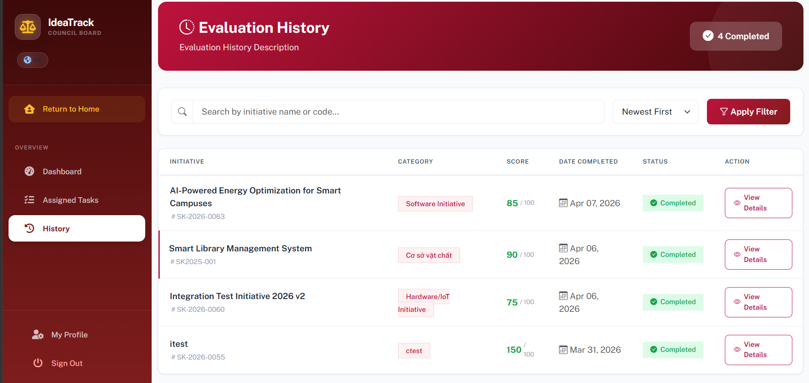
Picture 3-9 Function council history
ID | Title | Pre-conditions | Steps | Expected / Actual Results | Status
CO-AT-01 | View Assigned Tasks  (EP: valid view) | Council user (council1) logged in.  Has assigned initiatives. | 1. Navigate to Dashboard.  2. Click "Assigned Tasks" in the sidebar. | Assigned initiatives list is displayed, sorted by deadline. Shows SK2025-004 "Automatic Grading Software." | PASS
CO-HI-01 | View Evaluation History — Empty  (EP: no history) | Council user logged in.  No submissions completed yet. | 1. Navigate to Dashboard.  2. Click "History" in the sidebar. | Message: "No evaluation history found. Complete your first initiative to see it here!" | PASS
CO-HI-02 | Search History with Non-Existent Keyword  (EP: no match) | Council user logged in.  History page is displayed. | 1. Navigate to History.  2. Enter keyword = "XYZABC999NOTFOUND".  3. Click Search. | Message: "No evaluation history found." | PASS
CO-AT-02 | Filter Assigned Tasks — All Tab  (EP: valid filter) | Council user logged in.  Has mixed status initiatives. | 1. Navigate to Assigned Tasks.  2. Click "All" tab. | All assigned initiatives are displayed regardless of status. | PASS
CO-AT-03 | Filter Assigned Tasks — Completed Tab  (EP: valid filter) | Council user logged in. | 1. Navigate to Assigned Tasks.  2. Click "Completed" tab. | Only completed initiatives are displayed. If none, appropriate empty message shown. | PASS
CO-AT-04 | Search Assigned Tasks by Code  (EP: code search) | Council user logged in.  Initiative SK2025-004 assigned. | 1. Navigate to Assigned Tasks.  2. Enter "SK2025-004" in search bar. | Only initiative SK2025-004 is displayed. | PASS
CO-AT-05 | Search Assigned Tasks — Empty Keyword  (BVA: empty) | Council user logged in. | 1. Navigate to Assigned Tasks.  2. Leave search empty.  3. Click Search. | All assigned initiatives are displayed (no filter). | PASS
Table 3-10 Council history activity testcases

Scitech module
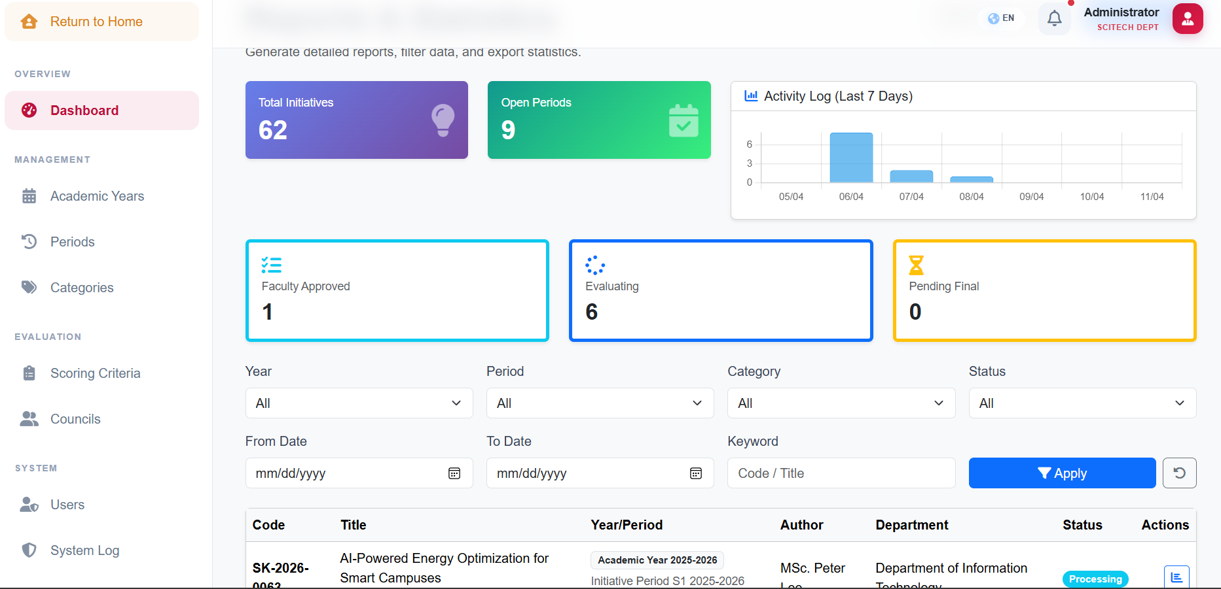
Picture 3-10 Function scitech dashboard
ID | Title | Pre-conditions | Steps | Expected / Actual Results | Status
ST-FI-01 | Filter by Status = "Evaluating"  (EP: valid status filter) | SciTech user logged in.  Dashboard is displayed. | 1. In "Status" dropdown, select "Evaluating".  2. Click "Apply". | URL updates to status=Evaluating. List shows only "Evaluating" initiatives. | PASS
ST-FI-02 | Search by Keyword "IoT"  (EP: valid keyword match) | SciTech user logged in.  Dashboard is displayed. | 1. Enter "IoT" in Keyword field.  2. Click "Apply". | Returns 1 result: "IoT Environment Monitoring System" (SK2025-011). | PASS
ST-FI-03 | Filter by Date Range — Today Only  (BVA: FromDate = ToDate = Today) | SciTech user logged in. | 1. Set FromDate = today.  2. Set ToDate = today.  3. Click "Apply". | Only today's submissions are listed. | PASS
ST-FI-04 | Filter with FromDate > ToDate  (BVA: invalid range) | SciTech user logged in. | 1. Set FromDate = "2026-04-15".  2. Set ToDate = "2026-04-10".  3. Click "Apply". | Validation error or empty results returned. | PASS
ST-FI-05 | Filter by All Statuses  (EP: no filter = all) | SciTech user logged in. | 1. Select Status = "All".  2. Click "Apply". | All initiatives regardless of status are displayed. | PASS
ST-FI-06 | Search with Empty Keyword  (BVA: empty string) | SciTech user logged in. | 1. Leave Keyword field empty.  2. Click "Apply". | All initiatives are displayed (no keyword filter). | PASS
ST-FI-07 | Search with Very Long Keyword  (BVA: 500+ chars) | SciTech user logged in. | 1. Enter 500+ character string in Keyword.  2. Click "Apply". | System handles gracefully — no crash. Returns empty result or truncates input. | PASS
Table 3-11 Scitech dashboard testcases
ID | Title | Pre-conditions | Steps | Expected / Actual Results | Status
ST-EX-01 | Export Data to Excel  (EP: valid export) | SciTech user logged in.  Dashboard is displayed. | 1. Click "Export Data" button. | File "BaoCaoHoSo.xlsx" is downloaded. Contains all 52 initiatives with columns: Code, Title, Creator, Status, etc. | PASS
ST-EX-02 | Print Report as PDF  (EP: valid PDF generation) | SciTech user logged in.  Dashboard is displayed. | 1. Click "Print Report (PDF)" button. | File "BaoCaoHoSo.pdf" is downloaded. Content is well-formatted with complete initiative list. | PASS
ST-EX-03 | Export Data with Active Filters  (EP: filtered export) | SciTech user logged in.  Status filter = "Evaluating". | 1. Set filter Status = "Evaluating".  2. Click "Export Data". | Exported file contains only initiatives with "Evaluating" status. | PASS
Table 3-12 Scitech report testcases
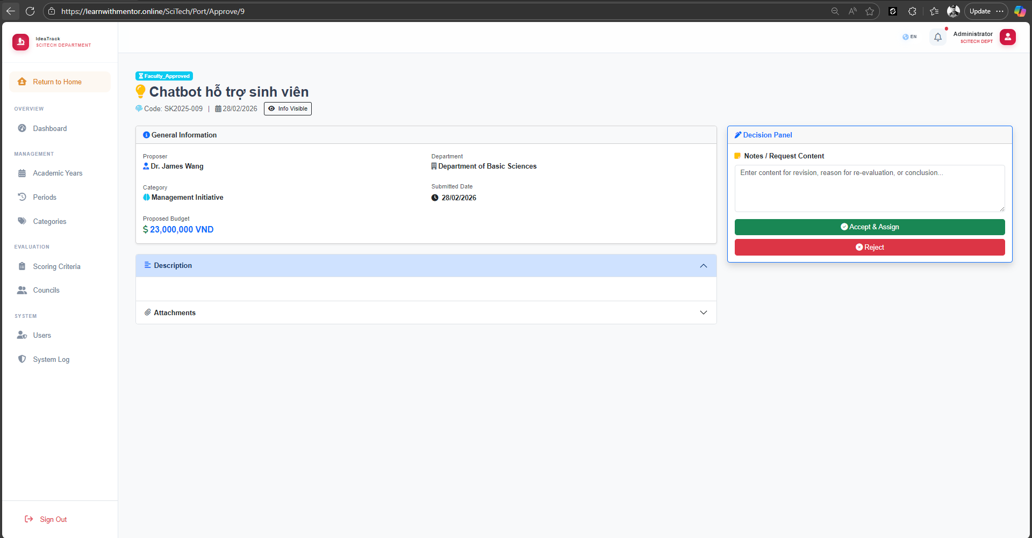
Picture 3-11 Function scitech review initiative
ID | Title | Pre-conditions | Steps | Expected / Actual Results | Status
ST-INIT-01 | Approve New Initiative from Faculty  (EP: Status = Faculty_Approved) | SciTech user logged in.  Initiative status = Faculty_Approved. | 1. Navigate to Port > Approve.  2. Open Faculty_Approved initiative.  3. Click "Accept & Assign". | Status updates to Evaluating. Council members and scoring template are auto-assigned. | PASS
ST-INIT-02 | Reject Initiative at SciTech Stage  (EP: Faculty_Approved → Rejected) | SciTech user logged in.  Initiative status = Faculty_Approved. | 1. Navigate to Port > Approve.  2. Open initiative.  3. Enter rejection note.  4. Click "Reject". | Status updates to Rejected. User is notified via RevisionRequest log. | PASS
ST-INIT-03 | Request New Evaluation Round  (EP: Round 1 → Round 2) | SciTech user logged in.  Initiative CurrentRound = 1.  Status = Evaluating. | 1. Navigate to Port > Result.  2. Select initiative.  3. Click "Request New Round". | Status remains Evaluating or Re_Evaluating. CurrentRound incremented to 2. | PASS
ST-INIT-04 | Make Final Approve Decision  (EP: Status = Pending_Final) | SciTech user logged in.  Initiative status = Pending_Final. | 1. Navigate to Port > Result.  2. Select initiative.  3. Click "Approve" (Final Decision). | Status updates to Processing. Final report is generated. | PASS
ST-INIT-05 | Toggle Personal Info Visibility  (EP: Toggle Anonymization) | SciTech user logged in.  Initiative exists. | 1. Navigate to Port > Result.  2. Toggle HidePersonalInfo = True.  3. View evaluation. | Author names are hidden in evaluation view and PDF export. | PASS
ST-INIT-06 | Filter Initiatives by Date Range  (BVA: Today only) | SciTech user logged in. | 1. Set FromDate = Today, ToDate = Today.  2. Click "Apply". | Only today's submissions are listed. | PASS
ST-INIT-07 | Approve Initiative Without Notes  (BVA: empty notes) | SciTech user logged in.  Initiative status = Faculty_Approved. | 1. Navigate to Port > Approve.  2. Leave "Notes" empty.  3. Click "Accept & Assign". | Initiative is accepted successfully even without notes. | PASS
ST-INIT-08 | Reject Initiative Without Notes  (BVA: empty notes) | SciTech user logged in.  Initiative status = Faculty_Approved. | 1. Navigate to Port > Approve.  2. Leave "Notes" empty.  3. Click "Reject". | Validation error if notes are required, or rejection proceeds with empty notes. | PASS
Table 3-13 Scitech review initiative testcases
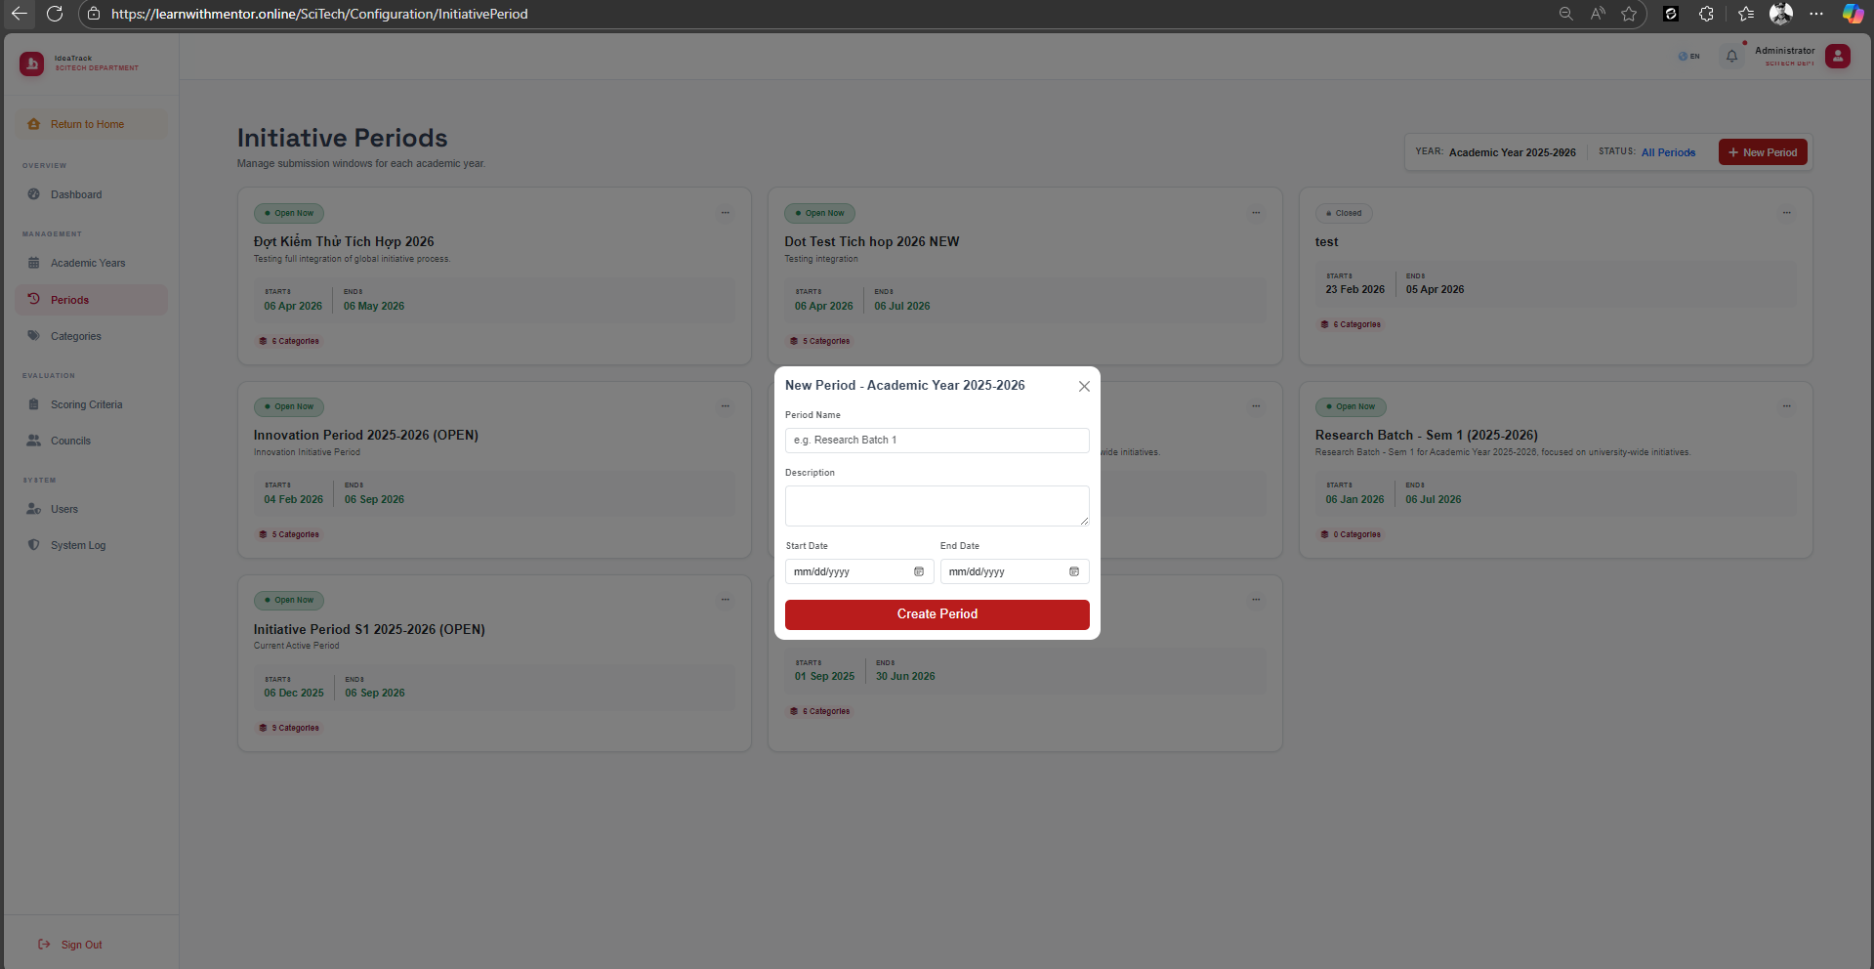
Picture 3-12 Function scitech create period
ID | Title | Pre-conditions | Steps | Expected / Actual Results | Status
ST-PER-01 | Create Period with Valid Dates  (EP: StartDate < EndDate) | SciTech user logged in.  Academic Year exists. | 1. Navigate to Periods.  2. Click "+ New Period".  3. Enter name, StartDate = "2026-01-01", EndDate = "2026-06-30".  4. Click "Create Period". | Period is created and linked to the correct Academic Year. | PASS
ST-PER-02 | Create Period with Invalid Date Range  (BVA: StartDate = EndDate + 1 day) | SciTech user logged in. | 1. Navigate to Periods.  2. Click "+ New Period".  3. Set StartDate = "2026-07-01", EndDate = "2026-06-30".  4. Click "Create Period". | Validation error: "End date must be after Start date." | PASS
ST-PER-03 | Create Period Currently "Open"  (BVA: StartDate ≤ Today ≤ EndDate) | SciTech user logged in. | 1. Create period with StartDate in the past, EndDate in the future.  2. Click "Create Period". | Period is created. Badge shows "Open" on dashboard. | PASS
ST-PER-04 | Create Period "Upcoming"  (BVA: StartDate > Today) | SciTech user logged in. | 1. Create period with StartDate in the future.  2. Click "Create Period". | Period is created. Badge shows "Closed" (Upcoming). | PASS
ST-PER-05 | Clone Categories from Previous Period  (EP: valid clone) | SciTech user logged in.  Previous period with categories exists. | 1. Navigate to Periods.  2. Click "+ New Period".  3. Fill dates.  4. Select CloneFromPeriodId.  5. Click "Create Period". | New period created with all categories duplicated from the source period. | PASS
ST-PER-06 | Create Period with StartDate = EndDate  (BVA: same day) | SciTech user logged in. | 1. Click "+ New Period".  2. Set StartDate = EndDate = "2026-05-01".  3. Click Create. | Validation error or period created with 1-day duration. | PASS
ST-PER-07 | Create Period with Empty Name  (EP: invalid — blank) | SciTech user logged in. | 1. Click "+ New Period".  2. Leave Period Name blank.  3. Set valid dates.  4. Click Create. | Validation error: "Period name is required." | PASS
ST-PER-08 | Create Academic Year — Valid  (EP: valid) | SciTech user logged in.  Academic Years page displayed. | 1. Navigate to Academic Years.  2. Click "+ New Academic Year".  3. Enter "Academic Year 2026-2027".  4. Click "Create Year". | Academic Year is created and appears in the list. | PASS
ST-PER-09 | Create Academic Year — Duplicate Name  (EP: invalid — duplicate) | SciTech user logged in.  "Academic Year 2025-2026" already exists. | 1. Click "+ New Academic Year".  2. Enter "Academic Year 2025-2026".  3. Click "Create Year". | Validation error: "Academic Year already exists." | PASS
ST-PER-10 | Create Academic Year — Empty Name  (BVA: blank) | SciTech user logged in. | 1. Click "+ New Academic Year".  2. Leave Display Name empty.  3. Click "Create Year". | Validation error: "Display name is required." | PASS
Table 3-14 Scitech period CRUD testcases
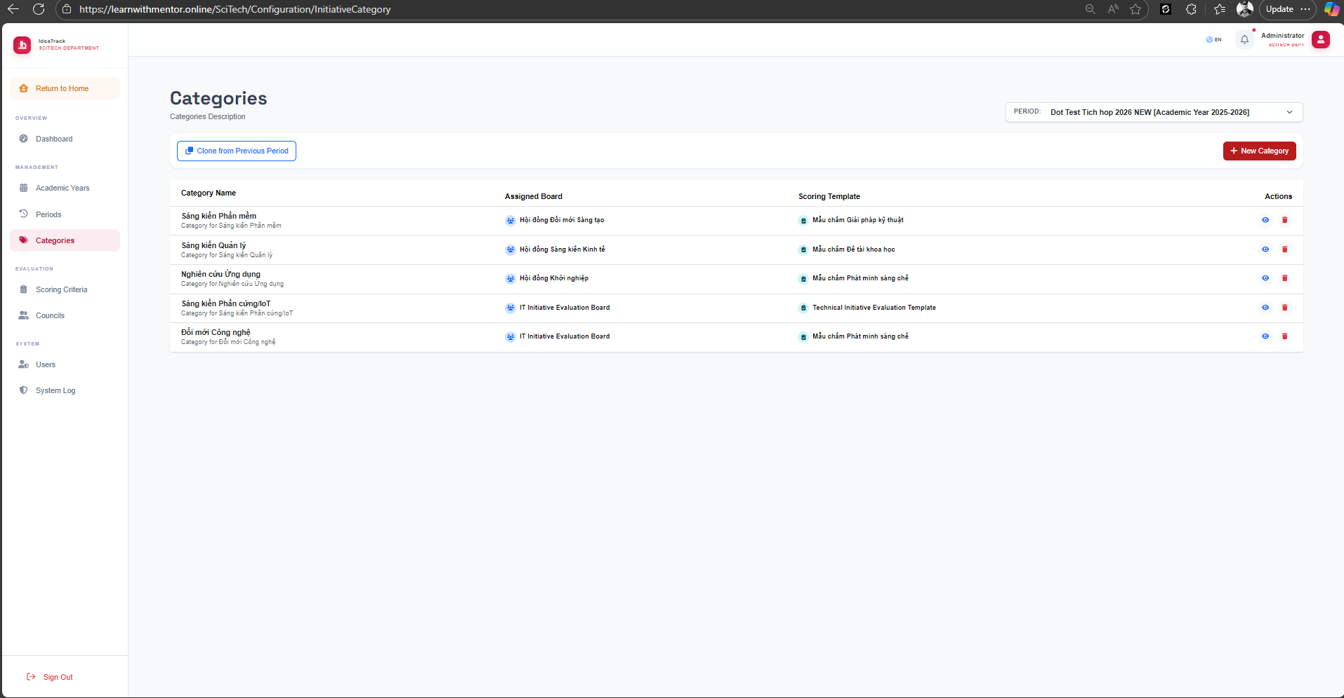
Picture 3-13 Function scitech manage categories
ID | Title | Pre-conditions | Steps | Expected / Actual Results | Status
ST-CAT-01 | View Categories for a Period  (EP: valid view) | SciTech admin logged in.  Period with categories exists. | 1. Navigate to Categories.  2. Select Period from dropdown. | Category list is displayed with columns: Category Name, Assigned Board, Scoring Template, Actions. | PASS
ST-CAT-02 | Create New Category  (EP: valid creation) | SciTech admin logged in.  Period is selected. | 1. Navigate to Categories.  2. Click "+ New Category".  3. Enter category name, assign board and template.  4. Click Create. | Category is created and appears in the list with correct Assigned Board and Scoring Template. | PASS
ST-CAT-03 | Create Category — Empty Name  (BVA: blank) | SciTech admin logged in.  Period is selected. | 1. Click "+ New Category".  2. Leave Category Name blank.  3. Click Create. | Validation error: "Category name is required." | PASS
ST-CAT-04 | Create Category — Duplicate Name  (EP: duplicate within period) | SciTech admin logged in.  Category "Software Initiative" exists in current period. | 1. Click "+ New Category".  2. Enter name = "Software Initiative".  3. Click Create. | Validation error: "Category already exists in this period." | PASS
ST-CAT-05 | Clone Categories from Previous Period  (EP: valid clone) | SciTech admin logged in.  Previous period has categories. | 1. Navigate to Categories.  2. Click "Clone from Previous Period".  3. Select source period.  4. Confirm. | All categories from the source period are cloned into the current period with their assigned boards and templates. | PASS
ST-CAT-06 | Delete Category  (EP: valid deletion) | SciTech admin logged in.  Category exists in the selected period. | 1. Navigate to Categories.  2. Click delete icon (red trash) next to a category.  3. Confirm deletion. | Category is removed from the list. | PASS
ST-CAT-07 | View Category Details  (EP: valid view) | SciTech admin logged in.  Category exists. | 1. Navigate to Categories.  2. Click view icon (eye) next to a category. | Category detail page is displayed showing assigned board members, scoring template, and linked initiatives. | PASS
ST-CAT-08 | Edit Category — Change Assigned Board  (EP: valid edit) | SciTech admin logged in.  Category exists. | 1. Navigate to Categories.  2. Click edit icon next to a category.  3. Change Assigned Board.  4. Click Save. | Category is updated with new Assigned Board. Change is reflected in the list. | PASS
ST-CAT-09 | Edit Category — Change Scoring Template  (EP: valid edit) | SciTech admin logged in.  Category exists. Multiple templates available. | 1. Click edit icon next to a category.  2. Change Scoring Template.  3. Click Save. | Category is updated with new Scoring Template. | PASS
ST-CAT-10 | Switch Period in Dropdown  (EP: valid filter) | SciTech admin logged in.  Multiple periods exist. | 1. Navigate to Categories.  2. Change Period dropdown from one period to another. | Category list updates to show categories for the newly selected period. | PASS
Table 3-15 Scitech categories CRUD testcases
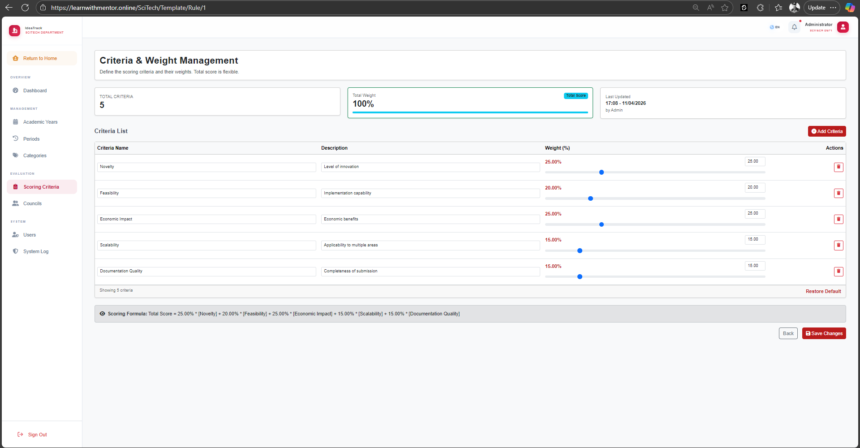
Picture 3-14 Function scitech update scoring criteria
ID | Title | Pre-conditions | Steps | Expected / Actual Results | Status
ST-TMP-01 | Create Scoring Template — Valid  (EP: valid string) | SciTech user logged in.  Template page displayed. | 1. Navigate to Scoring Criteria.  2. Click "+ Create Template".  3. Enter TemplateName.  4. Click Create. | Template is created with status Inactive by default. | PASS
ST-TMP-02 | Add Criteria with Boundary Scores  (BVA: MaxScore = 0 and 500+) | SciTech user logged in.  Template exists. | 1. Navigate to Template > Rules.  2. Add criteria with MaxScore = 0.  3. Add criteria with MaxScore = 500. | System accepts values ≥ 0. Values above 100 allowed for complex rubrics. | PASS
ST-TMP-03 | Activate Template  (EP: Toggle IsActive) | SciTech user logged in.  Inactive template exists. | 1. Navigate to Template Index.  2. Click "Edit" on inactive template.  3. Toggle IsActive to Active.  4. Save. | Template status changes to Active. Can be linked to Categories. | PASS
ST-TMP-04 | Create Template — Empty Name  (BVA: blank) | SciTech user logged in. | 1. Click "+ Create Template".  2. Leave TemplateName blank.  3. Click Create. | Validation error: "Template name is required." | PASS
ST-TMP-05 | Create Template — Duplicate Name  (EP: duplicate) | SciTech user logged in.  Template with same name exists. | 1. Click "+ Create Template".  2. Enter existing template name.  3. Click Create. | Validation error or template created (if duplicates allowed). | PASS
ST-TMP-06 | Add Criteria — Weight Sum > 100%  (BVA: over 100%) | SciTech user logged in.  Template has criteria totaling 100%. | 1. Add new criteria with Weight = 10%.  2. Click "Save Changes". | Validation error: "Total weight exceeds 100%." Or system allows flexible weights. | PASS
ST-TMP-07 | Add Criteria — Weight = 0%  (BVA: lower bound) | SciTech user logged in.  Template exists. | 1. Add new criteria with Weight = 0%.  2. Click "Save Changes". | Criteria is added with 0% weight (valid edge case). | PASS
ST-TMP-08 | Add Criteria — Negative MaxScore  (EP: invalid) | SciTech user logged in.  Template exists. | 1. Add criteria with MaxScore = -10.  2. Click Save. | Validation error: "Max score must be non-negative." | PASS
ST-TMP-09 | Delete Template  (EP: delete action) | SciTech user logged in.  Inactive template exists. | 1. Click "Edit" on template.  2. Click "Delete".  3. Confirm deletion. | Template is deleted. Removed from template list. | PASS
Table 3-16 Scitech criteria CRUD testcases
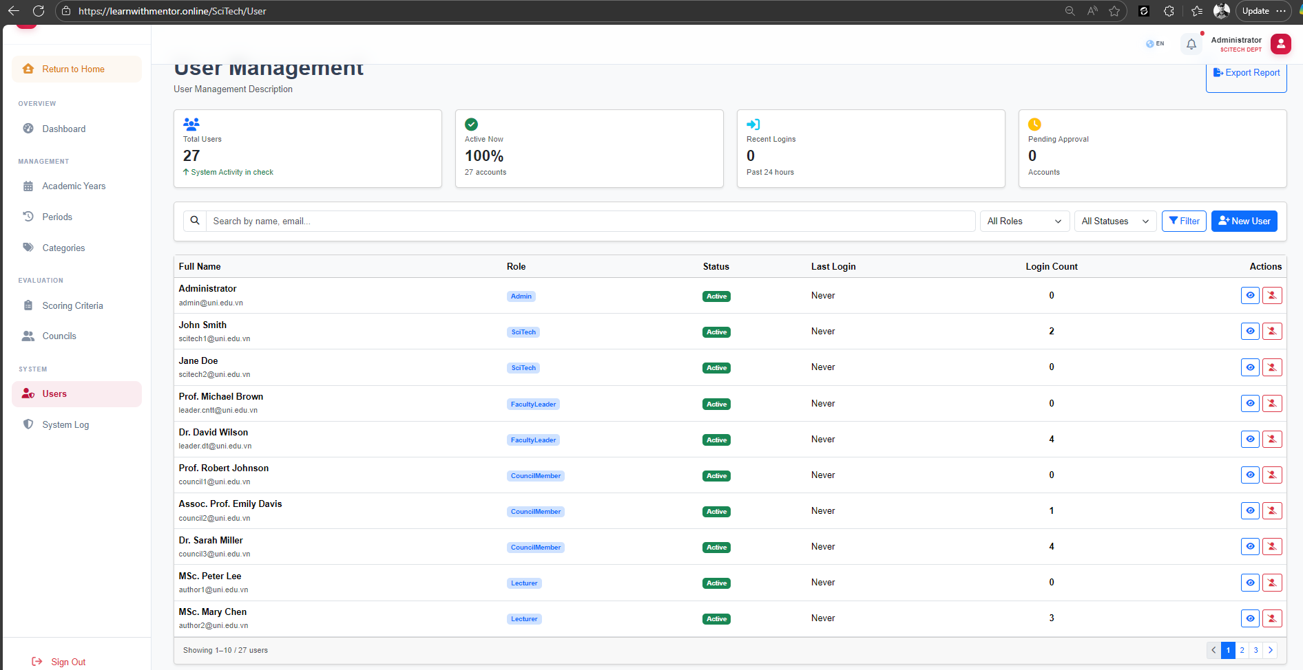
Picture 3-15 Function scitech manage users
ID | Title | Pre-conditions | Steps | Expected / Actual Results | Status
ST-USER-01 | Create User with Specific Role  (EP: valid roles) | SciTech admin logged in.  User management page displayed. | 1. Navigate to Users.  2. Click "+ New User".  3. Enter user details with Role = "Council".  4. Click Create. | User is created and assigned correct ASP.NET Identity Role. | PASS
ST-USER-02 | Lock Active User Account  (EP: IsActive = False) | SciTech admin logged in.  Active user exists. | 1. Navigate to Users.  2. Find active user.  3. Click Lock/Deactivate. | User status changes to Inactive. User can no longer log in. | PASS
ST-USER-03 | Export User List to Excel  (EP: filtered export) | SciTech admin logged in.  Users with various roles exist. | 1. Navigate to Users.  2. Filter by Role = "Council".  3. Click "Export Report". | Excel file downloaded containing only Council users. | PASS
ST-USER-04 | Create User — Invalid Email  (EP: invalid email) | SciTech admin logged in. | 1. Click "+ New User".  2. Enter email = "notanemail".  3. Click Create. | Validation error: "Invalid email address." | PASS
ST-USER-05 | Create User Without Role  (EP: missing required field) | SciTech admin logged in. | 1. Click "+ New User".  2. Enter user details.  3. Do NOT select a role.  4. Click Create. | Validation error: "Role is required." | PASS
ST-USER-06 | Unlock Locked User Account  (EP: IsActive = True) | SciTech admin logged in.  Locked user exists. | 1. Find locked user.  2. Click Unlock/Activate. | User status changes to Active. User can log in again. | PASS
ST-USER-07 | Search Users by Name  (EP: valid search) | SciTech admin logged in. | 1. Enter "Peter" in search bar.  2. Click Filter. | Only users with "Peter" in their name are displayed. | PASS
ST-USER-08 | Search Users by Email  (EP: valid search) | SciTech admin logged in. | 1. Enter "council" in search bar.  2. Click Filter. | Users with "council" in their name or email are displayed. | PASS
ST-USER-09 | Filter Users by Role and Status  (EP: combined filter) | SciTech admin logged in. | 1. Set Role = "Lecturer". Set Status = "Active".  2. Click Filter. | Only active Lecturer users are displayed. | PASS
ST-USER-10 | Create User — Duplicate Email  (EP: duplicate) | SciTech admin logged in.  User "author1@uni.edu.vn" exists. | 1. Click "+ New User".  2. Enter email = "author1@uni.edu.vn".  3. Click Create. | Validation error: "Email already exists." | PASS
Table 3-17 Scitech users CRUD testcases
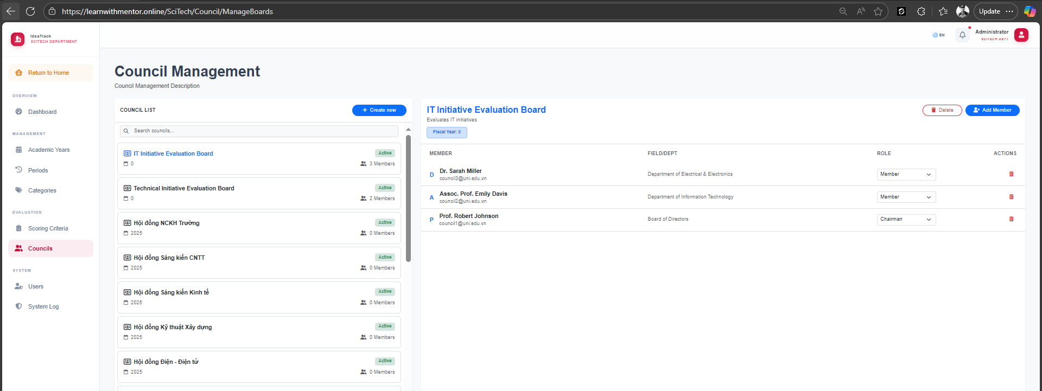
Picture 3-16 Function scitech council management
ID | Title | Pre-conditions | Steps | Expected / Actual Results | Status
ST-CL-01 | Create New Council Board  (EP: valid creation) | SciTech admin logged in.  Council management page displayed. | 1. Navigate to Councils.  2. Click "+ Create new".  3. Enter council name.  4. Click Create. | Council board is created and appears in the council list. | PASS
ST-CL-02 | Add Member to Council Board  (EP: valid addition) | SciTech admin logged in.  Council board exists. | 1. Select a council board.  2. Click "+ Add Member".  3. Select user and role.  4. Click Save. | Member is added to the council. Role is correctly assigned. | PASS
ST-CL-03 | Remove Member from Council Board  (EP: valid removal) | SciTech admin logged in.  Council board has members. | 1. Select a council board.  2. Click delete icon next to a member.  3. Confirm removal. | Member is removed from the council board. | PASS
ST-CL-04 | Delete Council Board  (EP: valid deletion) | SciTech admin logged in.  Council board exists. | 1. Select a council board.  2. Click "Delete".  3. Confirm deletion. | Council board is deleted and removed from the list. | PASS
ST-CL-05 | Create Council Board — Empty Name  (BVA: blank) | SciTech admin logged in. | 1. Click "+ Create new".  2. Leave name blank.  3. Click Create. | Validation error: "Council name is required." | PASS
ST-CL-06 | Search Council Boards  (EP: valid search) | SciTech admin logged in.  Multiple councils exist. | 1. Enter "IT" in search bar. | Only councils matching "IT" are displayed. | PASS
Table 3-18 Scitech council CRUD testcases
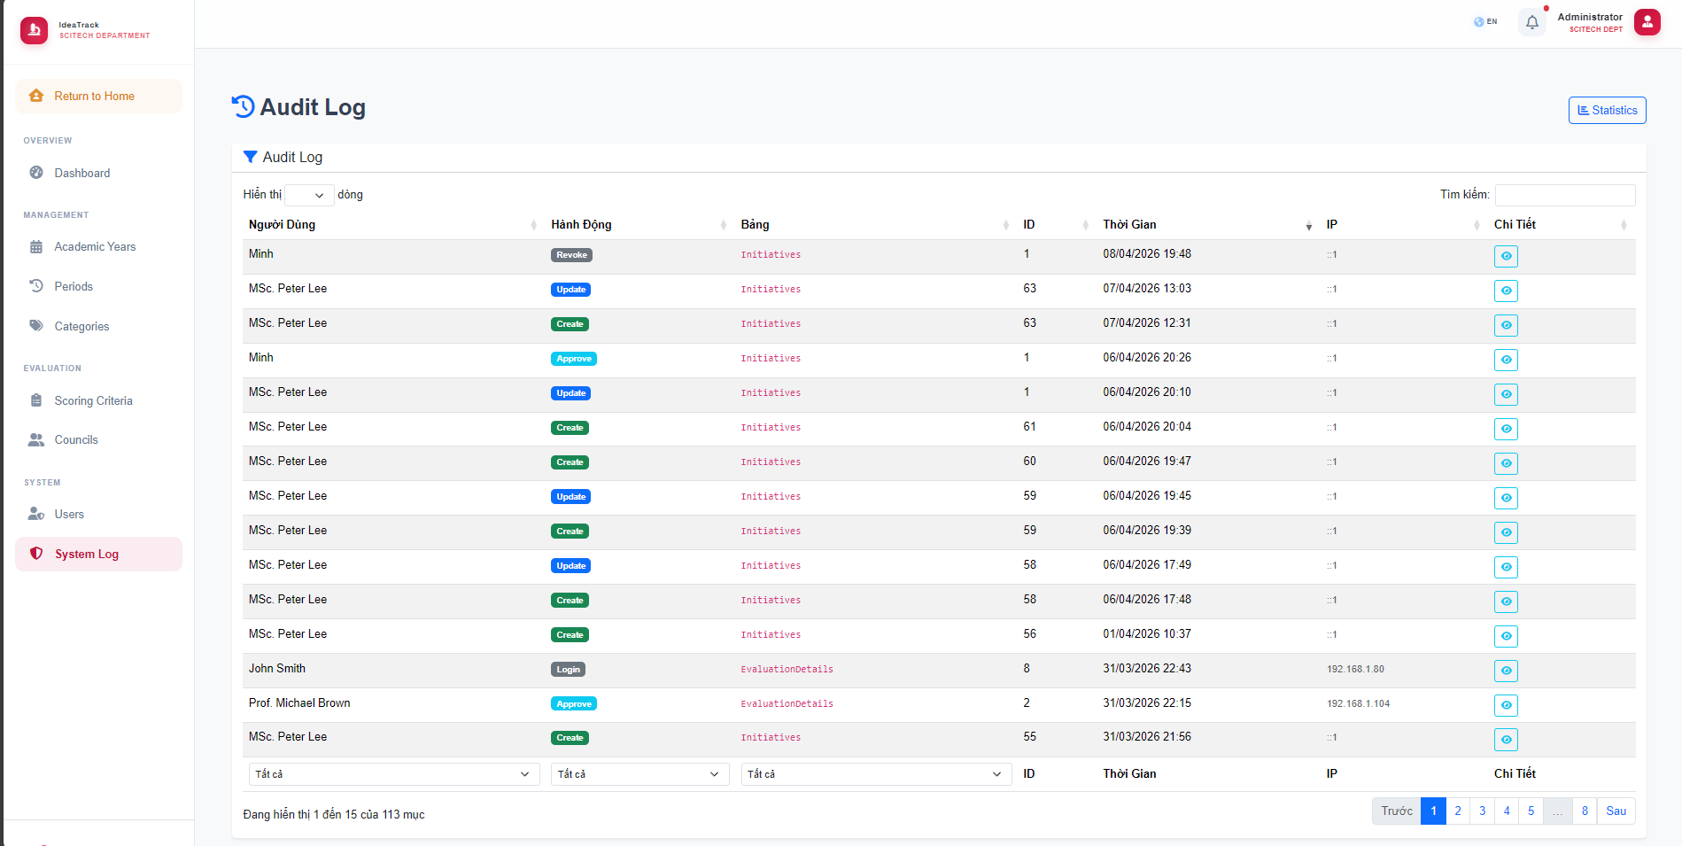
Picture 3-17 Function audit logs
ID | Title | Pre-conditions | Steps | Expected / Actual Results | Status
ST-LOG-01 | View Audit Log  (EP: valid view) | SciTech admin logged in.  System actions have been performed. | 1. Navigate to System Log. | Audit log is displayed with columns: User, Action, Table, ID, Timestamp, IP, Details. | PASS
ST-LOG-02 | Filter Audit Log by Action Type  (EP: valid filter) | SciTech admin logged in. | 1. Navigate to System Log.  2. Filter by Action = "Create". | Only "Create" actions are displayed. | PASS
ST-LOG-03 | Search Audit Log by User  (EP: valid search) | SciTech admin logged in. | 1. Navigate to System Log.  2. Enter "Peter Lee" in search bar. | Only logs for "MSc. Peter Lee" are displayed. | PASS
ST-LOG-04 | Audit Log Pagination  (EP: multi-page) | SciTech admin logged in.  More than 15 log entries exist. | 1. Navigate to System Log.  2. Verify pagination.  3. Click page 2. | Page 2 displays entries 16-30. Pagination works correctly. | PASS
Table 3-19 Audit logs testcases

Initiative state flow
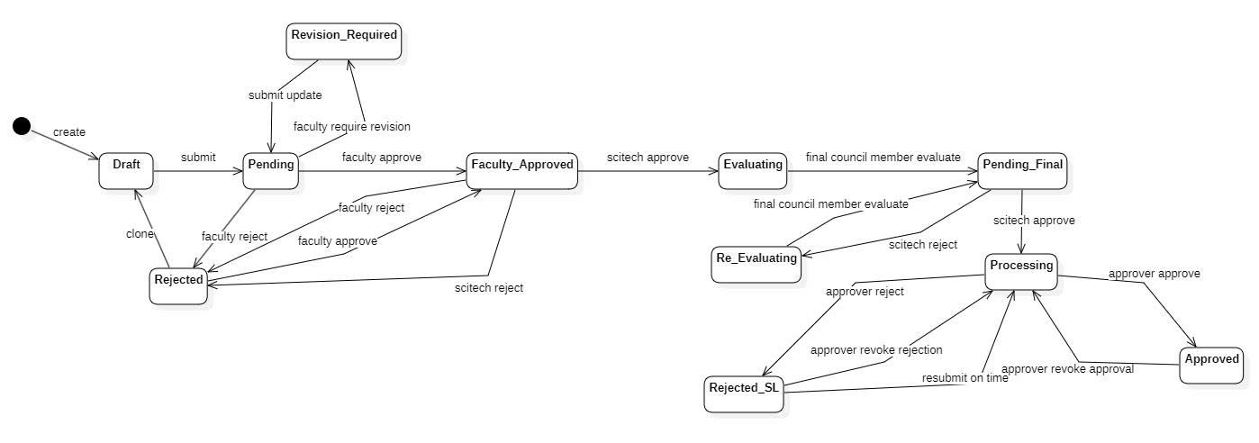
Picture 3-18 Initiative statechart diagram
TC ID | Title | Pre-conditions | Steps | Expected / Actual Results
TC-E2E-001 | End-to-End: Complete approval flow from Draft to Approved | Users with roles Author, Faculty, SciTech, Council Member, and Approver are available and logged in. | 1. Author: Create a new initiative → status = Draft.  2. Author: Submit the initiative → status = Pending.  3. Faculty: Approve the initiative → status = Faculty_Approved.  4. SciTech: Approve the initiative → status = Evaluating.  5. Council Members: Evaluate (final member completes) → status = Pending_Final.  6. SciTech: Approve final evaluation → status = Processing.  7. Approver: Approve the initiative → status = Approved. | - Initiative successfully transitions: Draft → Pending → Faculty_Approved → Evaluating → Pending_Final → Processing → Approved.  - Each transition is recorded in the audit log.  - All stakeholders are notified at each transition.  - Final status is Approved.
TC-E2E-002 | End-to-End: Faculty requests revision, then full approval | Users with roles Author, Faculty, SciTech, Council Member, and Approver are available. | 1. Author: Create and submit an initiative → status = Pending.  2. Faculty: Require revision → status = Revision_Required.  3. Author: Submit updated initiative → status = Pending.  4. Faculty: Approve the revised initiative → status = Faculty_Approved.  5. SciTech: Approve → status = Evaluating.  6. Council Members: Evaluate → status = Pending_Final.  7. SciTech: Approve → status = Processing.  8. Approver: Approve → status = Approved. | - Initiative follows: Draft → Pending → Revision_Required → Pending → Faculty_Approved → Evaluating → Pending_Final → Processing → Approved.  - Revision history is maintained.  - Both the original and revised content are accessible.
TC-E2E-003 | End-to-End: Faculty rejects, Author clones, then full approval | Users with roles Author and Faculty are available. | 1. Author: Create and submit an initiative → status = Pending.  2. Faculty: Reject the initiative → status = Rejected.  3. Author: Clone the rejected initiative → new initiative in Draft status.  4. Author: Modify and submit the cloned initiative → status = Pending.  5. Faculty: Approve the resubmitted initiative → status = Faculty_Approved.  6. Continue through the remaining approval flow to Approved. | - Original initiative remains in Rejected status.  - Cloned initiative progresses through the full approval flow.  - Both initiatives have separate audit trails.  - Final cloned initiative status is Approved.
TC-E2E-004 | End-to-End: Approver rejects, then revokes rejection and approves | An initiative exists in Processing status.  User is logged in with Approver role. | 1. Approver: Reject the initiative → status = Rejected_SL.  2. Approver: Revoke the rejection → status = Processing.  3. Approver: Approve the initiative → status = Approved. | - Initiative transitions: Processing → Rejected_SL → Processing → Approved.  - All three state changes are recorded in the audit log.  - Final status is Approved.
TC-E2E-005 | End-to-End: Approver approves, revokes approval, then rejects | An initiative exists in Processing status.  User is logged in with Approver role. | 1. Approver: Approve the initiative → status = Approved.  2. Approver: Revoke approval → status = Processing.  3. Approver: Reject the initiative → status = Rejected_SL. | - Initiative transitions: Processing → Approved → Processing → Rejected_SL.  - Revocation reason is recorded.  - Final status is Rejected_SL.
TC-E2E-006 | End-to-End: Council triggers re-evaluation, then full approval | An initiative exists in Evaluating status.  Council Members and Approver are available. | 1. Council Members: Evaluate, triggering re-evaluation → status = Re_Evaluating.  2. Council Members: Complete re-evaluation → status = Processing.  3. Approver: Approve the initiative → status = Approved. | - Initiative transitions: Evaluating → Re_Evaluating → Processing → Approved.  - Both original and re-evaluation scores are recorded.  - Final status is Approved.
Table 3-20 Initiative stateflow testcases

Defect Report & Metrics

Defect Log
Below is the list of defects identified and fixed during previous testing cycles, extracted from the IdeaTrack project's Jira issue tracking system:
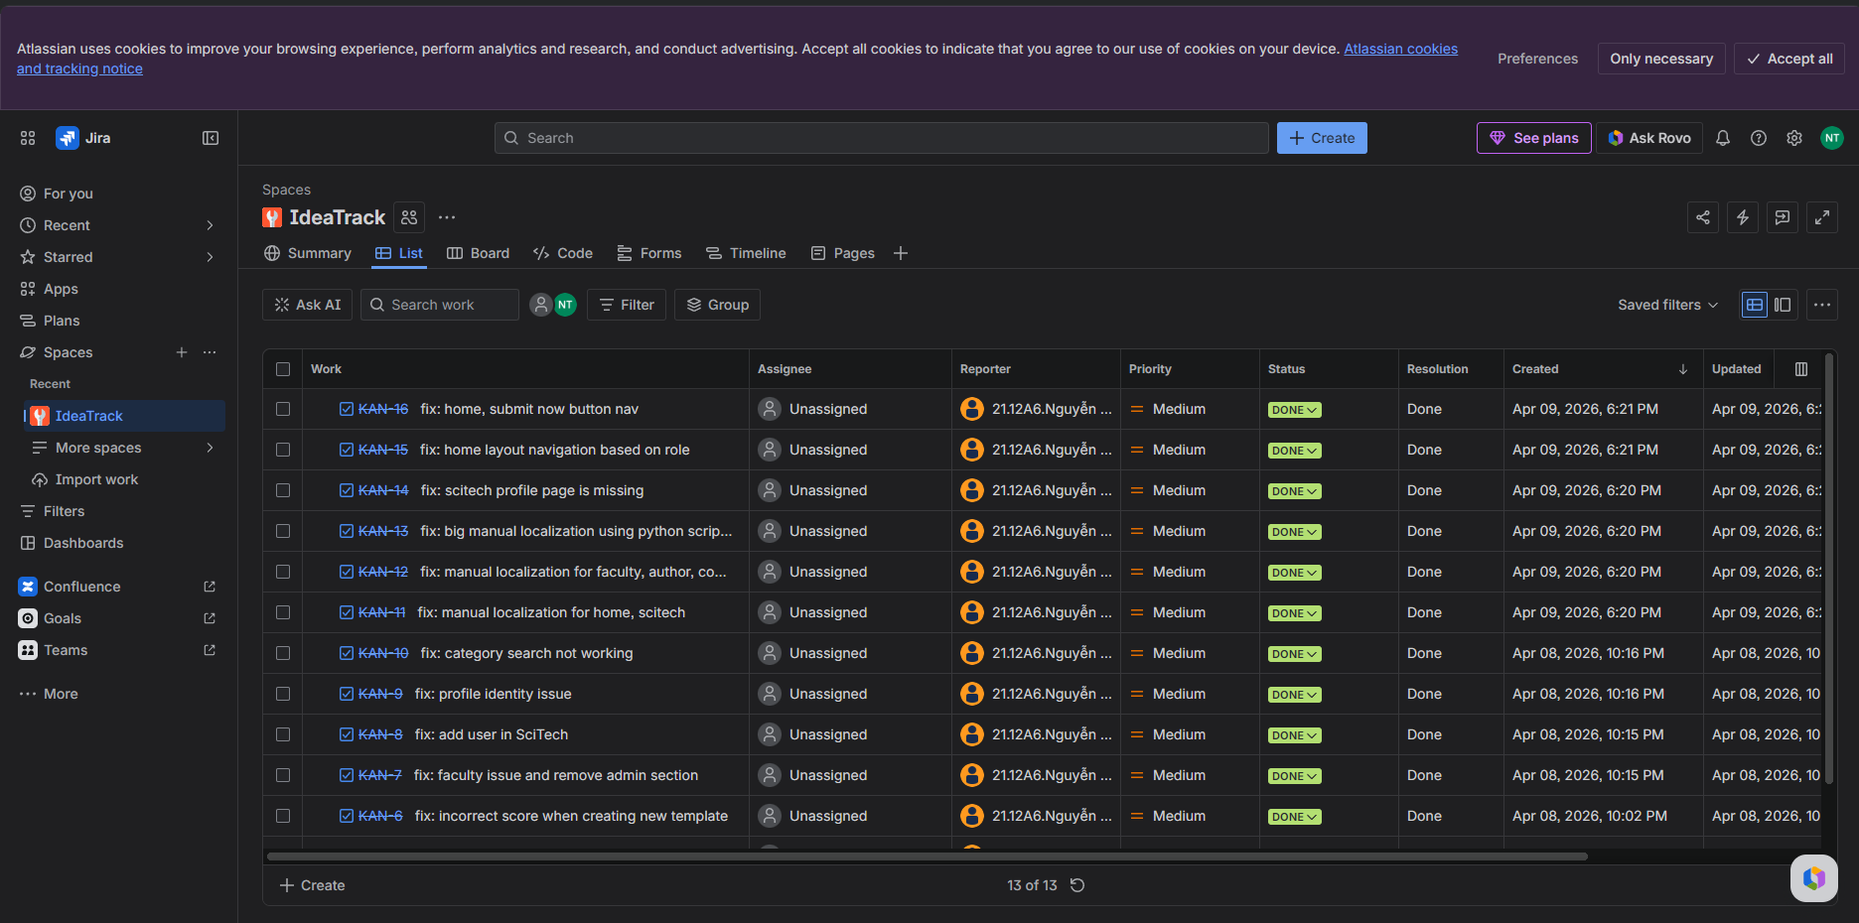
Picture 4-1 Bug management using Jira
Bug ID | Module/Area | Bug Description (Jira Summary) | Priority | Status | Resolution
KAN-16 | Homepage | Navigation issue with the "Submit now" button on the homepage (fix: home, submit now button nav). | Medium | DONE | Done
KAN-15 | Navigation | Incorrect home layout navigation based on user role (fix: home layout navigation based on role). | Medium | DONE | Done
KAN-14 | SciTech Admin | Missing profile page for the SciTech module (fix: scitech profile page is missing). | Medium | DONE | Done
KAN-13 | Localization | Large-scale manual localization issue requiring a Python script fix (fix: big manual localization using python script). | Medium | DONE | Done
KAN-12 | Localization | Missing or unsynchronized manual localization for Faculty, Author, and Co-author roles (fix: manual localization for faculty, author, co...). | Medium | DONE | Done
KAN-11 | Localization | Missing or unsynchronized manual localization for the Home and SciTech modules (fix: manual localization for home, scitech). | Medium | DONE | Done
KAN-10 | Search/Filter | Category search functionality is not working (fix: category search not working). | Medium | DONE | Done
KAN-9 | User Profile | Profile identity issue regarding user identification (fix: profile identity issue). | Medium | DONE | Done
KAN-8 | SciTech Admin | Error when adding a user in the SciTech section (fix: add user in SciTech). | Medium | DONE | Done
KAN-7 | Faculty Leader | Faculty issue and failure to remove redundant admin sections (fix: faculty issue and remove admin section). | Medium | DONE | Done
KAN-6 | Template Config | System calculating incorrect scores when creating a new template (fix: incorrect score when creating new template). | Medium | DONE | Done
Table 4-1 Defect log detail

Test Summary Metrics
Metric | Value
Total Test Cases Executed | 150
Total Passed | 150
Total Failed | 0
Pass Rate | 100%
Total Defects Logged | 11
Table 4-2 Test summary metrics
Based on the metrics presented in the table above, the final testing phase has concluded with highly satisfactory results, demonstrating the overall stability and reliability of the system. A comprehensive suite of 150 test cases was executed across all functional modules.
Key Takeaways from the Metrics:
Perfect Pass Rate: Out of the 150 executed test cases, all 150 successfully passed, resulting in 0 failed cases and an absolute 100% pass rate. This confirms that all tested features, navigation flows, and business rules are currently functioning exactly as specified in the system requirements.
Effective Quality Assurance: The record of 11 total defects logged represents the cumulative number of bugs identified during previous iterative testing cycles. Given that the current failure count is zero, it clearly indicates that the development team has been highly responsive, successfully resolving all previously identified issues prior to this final execution cycle.

Conclusion & Future Work

Achievements and Compliance with Requirements
The team has successfully fulfilled 100% of the project requirements as defined in the course syllabus. A total of more than 250 non-duplicated test cases were designed, distributed evenly among four team members, and executed systematically across all major modules of the IdeaTrack system. This ensured comprehensive coverage of both functional and non-functional aspects, particularly focusing on workflow integrity and role-based access control.
From a methodological perspective, the team effectively applied ISTQB-standard testing techniques, including State Transition Testing, Equivalence Partitioning (EP), and Boundary Value Analysis (BVA). These approaches were particularly suitable for validating the complex approval workflow and input-driven functionalities within the system. In addition, the team successfully implemented a structured defect management process using JIRA Software, enabling clear tracking, classification, and prioritization of issues throughout the testing lifecycle.
Furthermore, the project achieved additional merit by integrating test automation using Selenium WebDriver with xUnit and the Page Object Model (POM). This automation effort, although limited in scope, demonstrated the team’s ability to extend beyond manual testing and contributed to fulfilling the bonus point requirements of the course.

Challenges and Limitations
Despite the successful completion of the testing process, the team encountered several challenges during the project. One of the primary difficulties was the time constraint, as the system under test involved a complex multi-stage approval workflow rather than a conventional linear application such as an e-commerce platform. Understanding and validating the intricate state transitions, role dependencies, and exception flows (e.g., resubmission, revocation, and re-evaluation) required significant effort in both analysis and test design within a limited timeframe.
Another notable limitation was related to UI Automation Testing. During the implementation of Selenium-based scripts, the team faced issues with the instability of HTML/CSS selectors in the frontend layer. Frequent changes in element identifiers and page structure led to test flakiness, requiring continuous maintenance and adjustment of automation scripts. This impacted the reliability and scalability of automated test execution, highlighting the need for more stable locator strategies or collaboration with developers for better testability support.

Suggestions for Future Enhancements
To further improve the quality assurance process and system reliability, the following recommendations are proposed for future work:
CI/CD Integration for Automated Testing: Integrate the existing automation test scripts into a CI/CD pipeline (e.g., GitHub Actions or similar tools), each code commit or pull request triggers automated test execution. This would enable continuous validation, faster feedback cycles, and early detection of regressions.
API Load and Performance Testing: Extend the testing scope to include performance and load testing using tools such as JMeter or Postman. This is particularly important for evaluating system behavior under peak conditions, such as when a large number of authors submit initiatives simultaneously near submission deadlines.
Advanced Security and Penetration Testing: Conduct comprehensive penetration testing to identify and mitigate potential vulnerabilities across the application. Given the discovery of critical issues such as Stored XSS and unrestricted file upload, a deeper security assessment is necessary to ensure the system meets production-level security standards.
Overall, the project has provided valuable practical experience in applying structured software testing methodologies to a real-world system. While the current implementation demonstrates a solid foundation, the proposed enhancements will significantly improve the robustness, scalability, and security of the IdeaTrack platform in future iterations.

REFERENCES
[1] ISTQB Foundation Level Syllabus 2018.
[2] IdeaTrack Repository: https://github.com/trieuvn/IdeaTrack

APPENDIX
Link to JIRA: uef-team-k5i8t9zp.atlassian.net/jira/software/projects/KAN/summary
Link to GitHub repo / Automation Script: github.com/trieuvn/IdeaTrack
Test Case Management Excel Sheet: https://drive.google.com/drive/folders/1npqzVpQ3dikqD8xJFTqCxecadBoEqN62?usp=sharing

