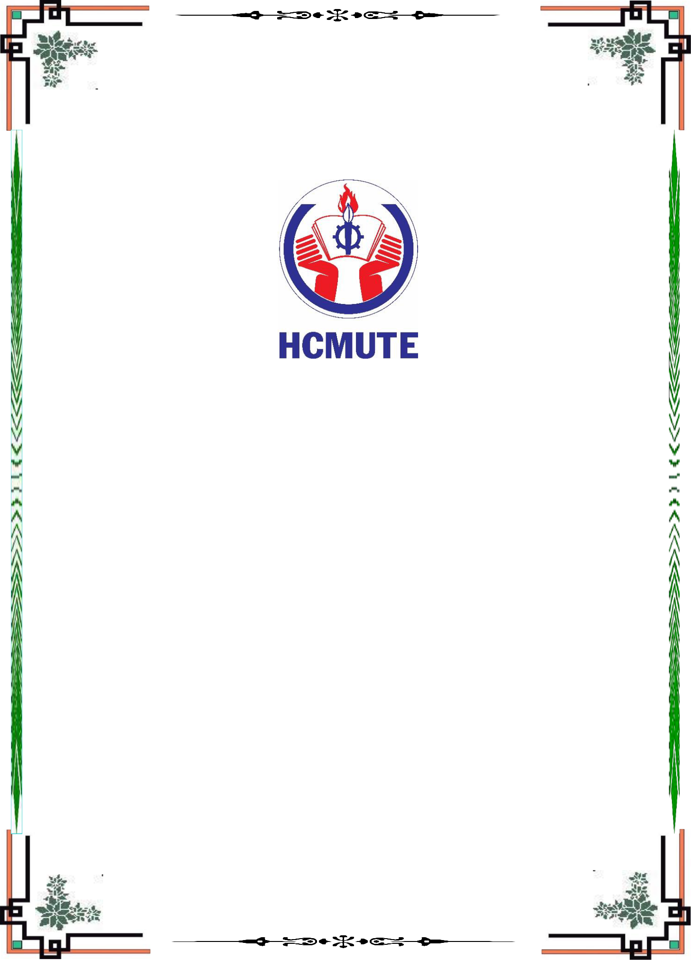

**HCMC UNIVERSITY OF TECHNOLOGY AND EDUCATION**

**FACULTY OF INFORMATION TECHNOLOGY**

**SPECIALIZED ESSAY**

**REPORT REQUIREMENTS MODELING**

**TOPIC**

**RESEARCH LEARN MONOGAME AND BUILD GAME ILLUSTRATIONS**

**Students SID**

**Nguyen Huynh Phuc 17110350**

**Pham Van Minh Tan 17110364**

**Instructors: Ph.D. Nguyen Minh Dao**

Ho Chi Minh City, September 2020

**TABLE OF CONTENTS**

I. Usecase 3

II. Business statistics and rule 3

1. Table of business statistics 3

2. Table of rule 3

3. Form of business 6

3.1. Form F-VHOS 6

3.2. Form F-GNB 7

3.3. Form F-CB 7

3.4. Form F-PLG 8

3.5. Form F-VHE 8

3.6. Form F-PAG 9

3.7. Form F-VGOS 9

**REQUIREMENTS MODELING**

# I. Usecase

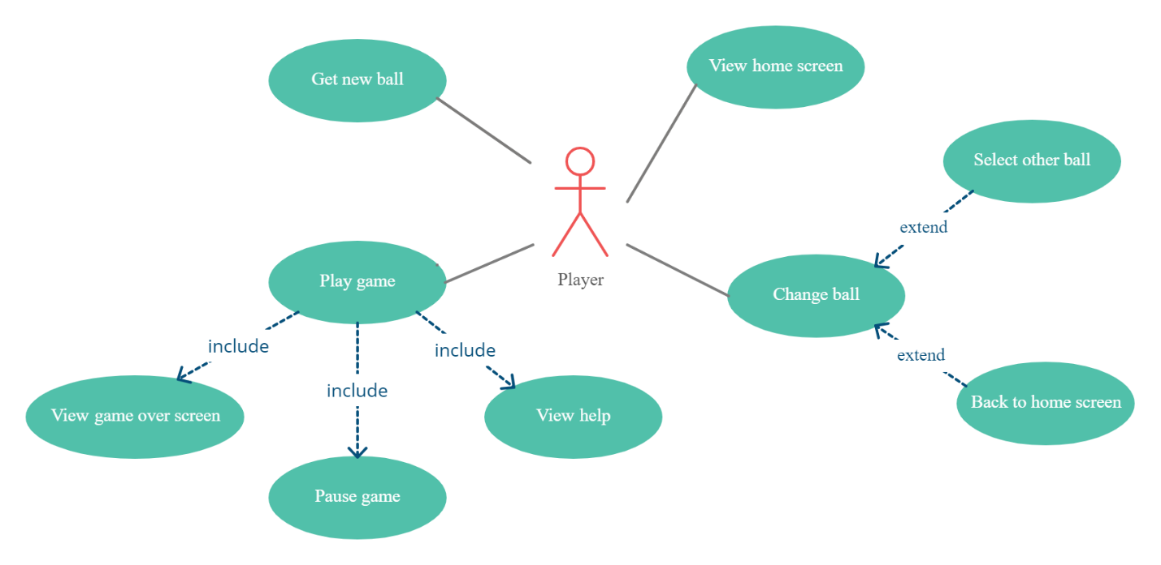

# II. Business statistics and rule

## 1. Table of business statistics

|  |  |  |  |  |
| --- | --- | --- | --- | --- |
| No. | Business name | Rule code | Form code | Note |
| 1 | View home screen | R-VHOS | F-VHOS |  |
| 2 | Get new ball | R-GNB | F-GNB |  |
| 3 | Change ball | R-CB | F-CB |  |
| 4 | Select other ball | R-SOB | F-CB |  |
| 5 | Back to home screen | R-BTHS | F-CB |  |
| 6 | Play game | R-PLG | F-PLG |  |
| 7 | View help | R-VHE | F-VHE |  |
| 8 | Pause game | R-PAG | F-PAG |  |
| 9 | View game over screen | R-VGOS | F-VGOS |  |

## 2. Table of rule

|  |  |  |  |  |
| --- | --- | --- | --- | --- |
| No. | Rule code | Rule name | Description | Note |
| 1 | R-VHOS | View home screen rule | Rule about UI is specificated in form F-VHOS. In this screen:   1. When player click get new ball, navigate to business number 2 2. When player click change ball, navigate to business number 3 3. When player click play, navigate to business number 6 |  |
| 2 | R-GNB | Get new ball rule | Rule about UI is specificated in form F-GNB. In this screen:   1. Player receive a new ball if player have enough coins 2. Otherwises, play will get a message notify that player does not have enogh coins |  |
| 3 | R-CB | Change ball rule | Rule about UI is specificated in form F-CB. In this screen player can change current ball to selected ball |  |
| 4 | R-SOB | Select other ball rule | Player can change selected ball by drag and drop screen to left or right |  |
| 5 | R-BTHS | Back to home screen rule | When player click on Back in F-CB, navigate to business number 1 |  |
| 6 | R-PLG | Play game rule | Rule about UI is specificated in form F-PLG. In this screen:   1. When player click on Pasuse, navigate to business number 8 2. When player click on View help, navigate to business number 7 3. When player play game and reach the game over game state, navigate to business number 9 |  |
| 7 | R-VHE | View help rule | Rule about UI is specificated in form F-VHE. In this screen:   1. When player click on Play, return to business number 6, 2. When player click on Volumn, toggle on/off game sound 3. When player click on Home, navigate to business number 1 |  |
| 8 | R-PAG | Pause game rule | Rule about UI is specificated in form F-PAG. In this screen:   1. When player click on Play, return to business number 6, 2. When player click on Volumn, toggle on/off game sound   When player click on Home, navigate to business number 1 |  |
| 9 | R-VGOS | View game over screen rule | Rule about UI is specificated in form F-VGOS. In this screen:   1. When player click on Get ball, navigate to business number 2 2. When player click on Play, navigate to business number 1 |  |

## 3. Form of business

### 3.1. Form F-VHOS

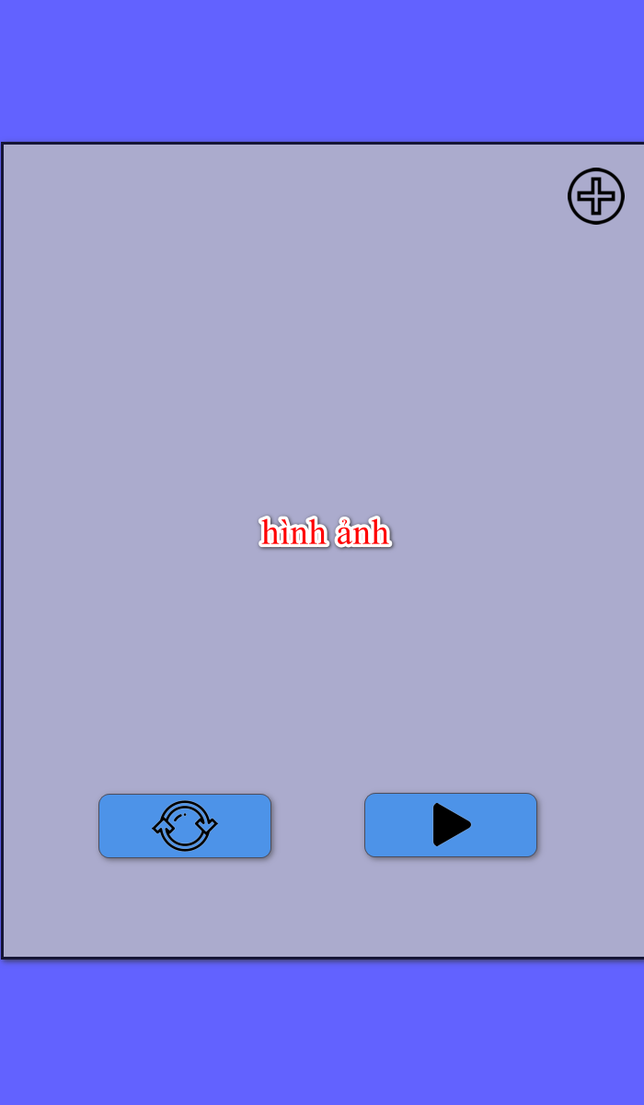

### 3.2. Form F-GNB

### 3.3. Form F-CB

### 3.4. Form F-PLG

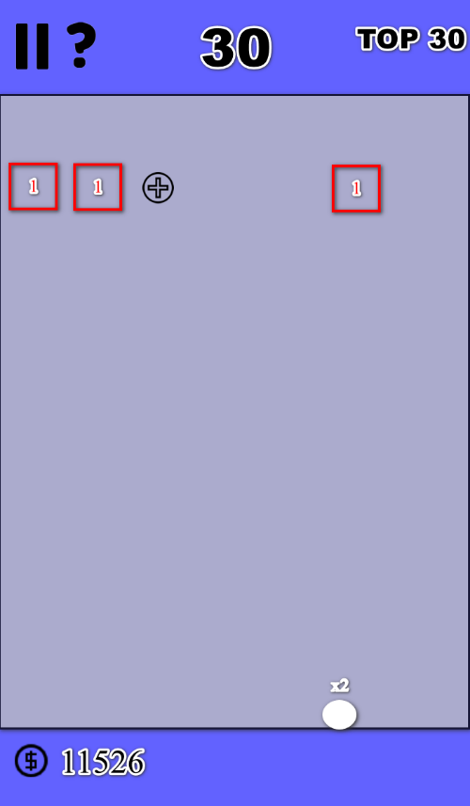

### 3.5. Form F-VHE

### 3.6. Form F-PAG

### Graphical user interface, application Description automatically generated3.7. Form F-VGOS

