Course: CSD202 - Programming Fundamentals (C/C++)

<Movie Theater Seat Booking System>

Group: 9
Group Members | Nguyễn Minh Phúc SE200061
Lecturer | Phạm Minh Trí
Class | IC2001

Ho Chi Minh, Nov – 2025

Table of Contents

Table of Contents 2
1. Introduction 3
1.1. Project Description 3
1.2. Project Team 3
2. Requirement Analysis & Decomposition 3
2.1. Data 3
2.2. Functions 3
3. Algorithm Design & Flowcharts 4
3.1. Add Product function: 4
3.2… 5
4. Implementation of Basic Functions 5
4.1. Add Product function 5
5. Object-Oriented Design (OOP)/ [struct, function pointer, module design with C] 6
6. File I/O & Testing 6
6.1. Test Cases for Update 6
7. Experimental Results 6
7.1 Update Demonstration 6
7.2 Delete Demonstration: 6
8. Appendix 6

1. Introduction

1.1. Project Description
[The project develops a Product Management System (instead of Product Management) using the C++ programming language.
The program allows managing product records, including adding, updating, searching, sorting, and deleting items.
It applies Object-Oriented Programming (OOP) principles, the Standard Template Library (STL), exception handling, and persistent File I/O.]

1.2. Project Team
# | Student ID | Full Name | Completion | Tasks Performed
1 | SE200061 | Nguyen Minh Phuc | 100% | addProduct, updateProduct, …..

2. Requirement Analysis & Decomposition

2.1. Data
# | Name | Datatype | Description
I. | Seat | class
1.1 | _seatID | string | _seatID as a string, from “A1” to “E6”.
1.2 | _seatClass | string | _seatClass include Normal, Vip, Couple as seat class..
1.3 | _status | string | _status have symbol : A is “Available” , O is “Ordered” , P is “Pending”
1.4 | _seatPrice | float | _seatPrice with three price level : 100 for normal seat, 200 for vip seat and 250 for couple seat

II | Customer | class
2.1 | _accountBalance | float | _accountBalance as a
2.2 | _nameCustomer | string | _seatPrice with three price level : 100 for normal seat, 200 for vip seat and 250 for couple seat
2.3 | _phoneNumber | string
2.4 | _seatID | string

2.2. Functions
# | Function | Description
I. | ProductManager
1.1 | addProduct(const Product& p) | Add a new product to the Store
…
II | ….

3. Algorithm Design & Flowcharts

3.1. Add Product function:
- Start.
- Input: Receive the product name, price, and quantity from the user through the ConsoleIO class.
- Duplicate Check: Iterate through the existing products list in ProductManager.
  - If the product name already exists: Throw a ProductManagerException and display an error message.
  - If it does not exist: Proceed to the next step.
- Temporary Storage: Create a new Product object and add it to the std::vector<Product>.
- Notification: Display a success message.
- End.
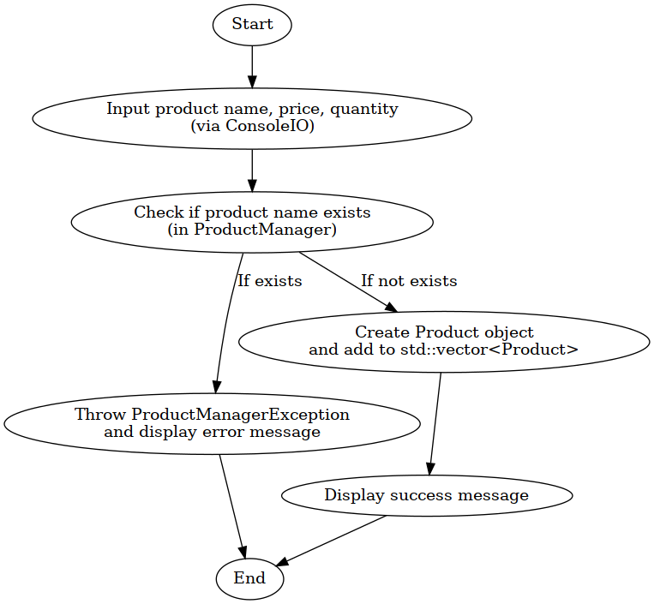

3.2…

4. Implementation of Basic Functions

4.1. Add Product function
void ProductManager::addProduct(const Product& p) {
for (const auto& product : products) {
if (product.getName() == p.getName()) {
throw ProductManagerException("Product already exists: " + p.getName());
}
}
products.push_back(p);
}
…..

5. Object-Oriented Design (OOP)
The program utilizes four primary classes to ensure separation of concerns:
- Product: A Data Transfer Object (DTO) for product information.
- ProductManager: The Controller class handling business logic and list management.
- FileHelper: A Utility class for data persistence.
- ConsoleIO: A View class for user interaction.
UML class relationships (C++)

6. File I/O & Testing

6.1. Test Cases for Update
Function | Test Scenario | Expected Result
Update | Update an existing product | Message: "Product updated successfully."
Update | Update a non-existent product | Message: "Update failed: Product not found."

7. Experimental Results

7.1 Update Demonstration
[Screenshots showing the input of an old product name with new values, followed by the updated list.]

7.2 Delete Demonstration:
[Screenshots of the product list before and after deletion to confirm the item is gone.]

8. Appendix
Data File: products_data.txt
Laptop X1,1200.50,15
Monitor 27-inch,350.00,30
Wireless Mouse,25.99,100
Mechanical Keyboard,85.75,10
Webcam HD Pro,55.00,0
Speaker Bluetooth,45.90,55
USB 128GB,12.50,200

