**BÀI KIỂM TRA CHO VỊ TRÍ INTERNSHIP TESTER**

**Họ tên/ Name: Đinh Tuấn Anh**

Giới tính/ Gender: Nam

Ngày sinh/ Date of birth: 10/06/2000

Điện thoại/ Phone number: 0398899401

Email:dinhanh00a00@gmail.com

Vị trí ứng tuyển/ Apply for position: Thục tập sinh QC(Tester)

Ngày thực hiện bài Test/ Test Date: 25/2/2022

**Thời gian làm Test (phút) / Test Time: 60p**

**Số điểm tối đa – 100 điểm**

**CÂU 1:** (5 điểm): Dựa vào hình cơ bản dưới để vẽ thành 1 icon mô tả biểu tượng phong thư mail

**CÂU 2:** (30 điểm): Là 1 người QC, Đối tác đưa cho bạn 1 đôi dép (Như hình dưới), Hãy viết những trường hợp bạn sẽ kiểm tra (Test) cho đôi dép đó đảm bảo đầy đủ tất cả các trường hợp để đôi dép đó có chất lượng cao nhất.

Answer:

............................................................................................ 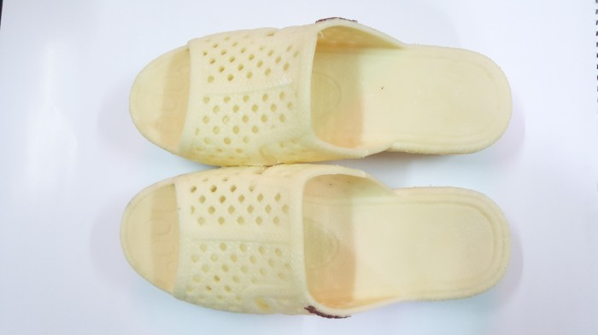

1. Test ngoại hình:
   1. Kiểm tra màu sắc
   2. Đo chiều dài, chiều rộng và độ dày của 2 chiếc dép
   3. Kiểm tra vị trí các mối nối của 2 chiếc dép xem có giống nhau không
   4. Kiểm tra chữ dập nổi của 2 chiếc dép xem có giống nhau (Màu sắc, vị trí, kích thước)
   5. Kiểm tra lỗ trên 2 chiếc dép (số lượng, vị trí)
   6. Kiểm tra mặt dép tiếp xúc lòng bàn chân (đường viền xung quanh, hoa văn…)
   7. Kiểm tra mặt dưới của dép
2. Test chức năng
   1. Ngâm dép trong mực, chất tẩy rửa, bùn đất… để kiểm tra độ nhuộm màu
   2. Độ thoải mái: đi thử dép
      1. Quai dép ngắn: chân đau, khó chịu
      2. Quai dép vừa: đi thoải mái, không khó chịu
      3. Quai dép rộng: đi dễ tuột, lòng bàn chân không bám sát đế
   3. Độ bền
      1. Kéo dãn dép theo chiều dài
      2. Kéo dãn dép theo chiều rộng
      3. Kéo dãn quai theo phương thẳng đứng
      4. Dùng kéo cắt đế, quai
      5. Dùng vật nhọn đâm vào đế
      6. Dùng vật nặng đè lên dép
      7. Đổ nước sôi, kiểm tra với lửa
      8. Ma sát đế dép
      9. Gập đôi chiếc dép

.........................................................................................................................................................................................................................................................................................................................................................................................................................................................................................................................................................

................................................................................................................................................................................... ................................................................................................................................................................................... ................................................................................................................................................................................... ................................................................................................................................................................................... ...................................................................................................................................................................................

...................................................................................................................................................................................

................................................................................................................................................................................... ................................................................................................................................................................................... ................................................................................................................................................................................... ................................................................................................................................................................................... ................................................................................................................................................................................... ................................................................................................................................................................................... ................................................................................................................................................................................... ............................................................................................................................................................................................................................................................................................................................................................................................................................................................................................................................................................................................................................................................................................................................................

................................................................................................................................................................................... ................................................................................................................................................................................... ................................................................................................................................................................................... ................................................................................................................................................................................... ...................................................................................................................................................................................

...................................................................................................................................................................................

**CÂU 3:** (30 điểm) Có 1 textbox tên **TB1**, Input kiểu dữ liệu đầu vào là **INT**,

* Nếu giá trị nhập vào (Input) **TB1** < 5 thì xuất ra kết quả (Output): **AA**
* Nếu giá trị Input 5 <= **TB1** < 10 thì Output: **BB**
* Nếu giá trị Input **TB1** >= 10 thì Output: **AB**



Hãy viết Checklist/Test case (high level) cho các trường hợp nói trên

Ex: Input 2 🡪 Output AA, Input 3 🡪 Output AA

Answer:

.. Input -4 🡪 output AA,

Input -3 🡪 output AA,

Input -2 🡪 output AA,

Input -1 🡪 output AA,

Input 0 🡪 output AA,

Input 4 🡪 output AA,

Input 5 🡪 Output BB,

Input 6 🡪 Output BB,

Input 7 🡪 output BB,

Input 8 🡪 Output BB,

Input 9 🡪 Output BB,

Input 10 🡪 output AB,

Input 11 🡪 Output AB,

Input 12 🡪 Output AB

Input 100 🡪 Output AB

Input 120 🡪 Output AB

.........................................................................................................................................................................................................................................................................................................................................................................................................................................................................................................................................................................................................................................................................................................................................................................................................................................................................................................................

................................................................................................................................................................................... ................................................................................................................................................................................... ................................................................................................................................................................................... ................................................................................................................................................................................... ................................................................................................................................................................................... ................................................................................................................................................................................... ................................................................................................................................................................................... ................................................................................................................................................................................... ................................................................................................................................................................................... ................................................................................................................................................................................... ................................................................................................................................................................................... ................................................................................................................................................................................... ................................................................................................................................................................................... ................................................................................................................................................................................... ................................................................................................................................................................................... ................................................................................................................................................................................... ................................................................................................................................................................................... ................................................................................................................................................................................... ................................................................................................................................................................................... ................................................................................................................................................................................... ................................................................................................................................................................................... ................................................................................................................................................................................... .

**CÂU 4 :** Cho bảng dữ liệu như sau:

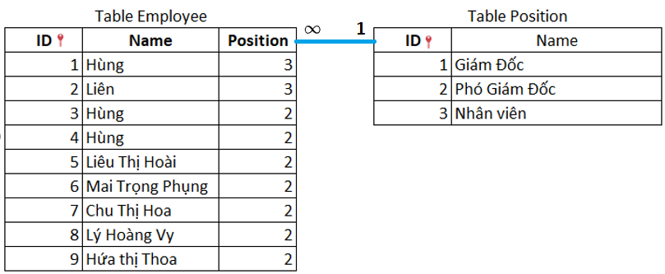

1. (20 điểm) Hãy viết câu query lấy **thông tin nhân viên** và thông tin chức vụ những người tên **"Hùng"** có chức vụ là **phó giám đốc**

Answer:

Select te.ID, te.Name, te.Position, tp.Name

from Table_employee te join Table_position tp on te.Position=tp.ID

where te.Name='Hùng' and tp.ID=2;

..................................................................................................................................................................................................................................................................................................................................................................................................................................................................................................................................................................................................................................................................................................................................................................................................................................................................................................................................................................................................................................................................................................................................................................................................................................................................................................................................................................................................................................................................................................................................................................................................................................................................................................................................................................................................................................................................................................................................................................................................................................................................................................................................................................................................................................................................................................................................................................................................................................................................................................................................................................................................................................................................................................................................................................................................................................................................................................................................................................................................................................................................................................................................................................................................................................................................................................................................................................................................................................................................................................................................................................................................................................................................................................................................................................................................................................................................................................................................................................................................................................................................................................

1. (5 điểm) Có bao nhiêu người **"Hùng"** sau khi thực hiện chạy câu a. Tại sao?

Answer:

..2

Vì chạy câu lệnh sau ta sẽ cho ra kết quả:

Select te.Name , COUNT(te.ID) as dem

from Table_employee te join Table_position tp on te.Position=tp.ID

where te.Name='Hùng' and tp.ID=2

group by te.Name;

.......................................................................................................................................................................................kết quả: 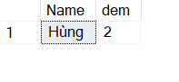.....................................................................................................................................................................................................................................................................................................................................................................................................................................................................................................................................................................................................................................................................................................................................................................................................................................................................................................................................................................................................................................................................................................

...................................................................................................................................................................................

**CÂU 5:** (5 điểm). Viết câu query lấy những người có **phần tên "ho"** Ví Dụ: Hoài

Answer:

select * from Table_employee

where Name not like 'Hùng' and Name not like 'Liên' ..........

kết quả:

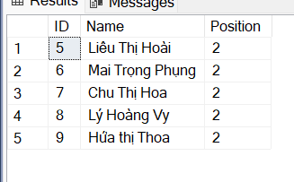............................................................................................................................................................................................................................................................................................................... .................................................................................................................................................................................................................................................................................................................................................................................................................................................................................................................................................................................................................................................................................................................................................................................................................................................................................................................................................................................................................................................................................................................. ................................................................................................................................................................................... ...................................................................................................................................................................................

**CÂU 6:** (5 điểm). Viết câu query lấy những người có **tên bắt đầu "H"** Ví Dụ: Hoài

Answer:

............................................................................................................................................................................................. select * from Table_employee

where Name like '%H_%'

......................................................................................................................................................................... ..................................................................................................................................................................................................................................................................................................................................................................................................................................................................................................................................................................................................................................................................................................................................................................................................................................................................................................................................................................................................................................................................................................................

................................................................................................................................................................................... ................................................................................................................................................................................... ...................................................................................................................................................................................

................................................................................................................................................................................... ...................................................................................................................................................................................

Hết / The End