Real-time quiz feature system design
- Architecture Diagram
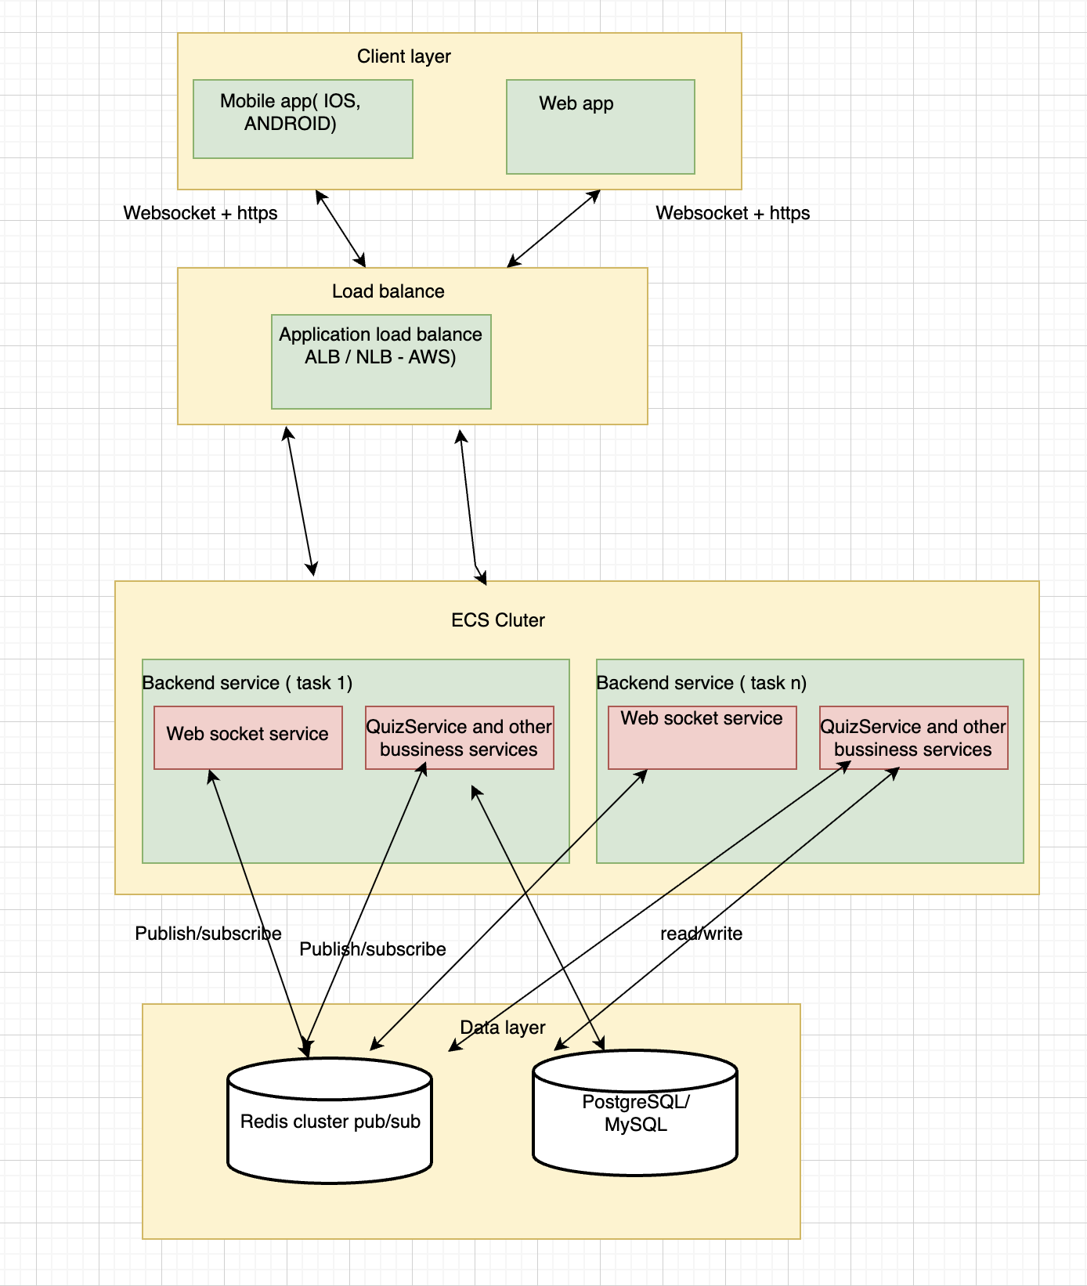
- Component description
  - Mobile app ( IOS,Android) , web app: the end user will use this to connect to the system to do the real time english quiz.will have a UI for users to:
- Join a quiz by ID
- Receive questions in real time
- Submit answers
- View live leaderboard
  - Load balance : the user’s requests will come to this first, the load balance will distribute the requests to the right server base on the current workload,availability of each backend server to avoid the bottle neck
  - Web socket service: use to connect the client with the back end server in real time so that the user can submit the answer and their score must be update in real -time, and can see their scores updated live on a leaderboard also
  - Redis Pub/Sub: Bridges different WebSocket servers to synchronize data when thousands of players are in different server clusters.
  - Quiz services: implement the bussiness logic to process with the real time quiz feature, such as check the answer, update the new score to redis and PostgreSQL data base,…
  - Redis database: will store all the questions relate to the quiz , the participants, the temporary score of each participant, the current standings of all participants , leaderboard cached,..
  - PostgreSQL : store the persistent data such as Users, Quizzes & questions, Answers history, Final results,…
- Data flow

Step 1 – User joins a quiz
- Client sends POST /join-quiz with quiz ID.
- Backend validates quiz and user.
- Backend registers user in Redis (active session).
- WebSocket connection is established.
- Server emits USER_JOINED event to the quiz room.

Step 2 – Quiz starts / new question
- Quiz Service selects the next question.
- Question is stored in Redis (current state).
- Real-time server broadcasts NEW_QUESTION event to all players.

Step 3 – User submits answer
- Client sends answer via WebSocket.
- Score Service validates answer.
- Score is updated in Redis.
- Answer is persisted asynchronously to database.

Step 4 – Leaderboard update
- Leaderboard Service recalculates ranking from Redis data.
- Updated leaderboard is cached.
- Real-time server broadcasts LEADERBOARD_UPDATED event.
- Clients instantly re-render the leaderboard.

Step 5 – Quiz ends
- Final results are written to database.
- Redis session is cleared.
- Clients receive QUIZ_FINISHED event.
- Technologies and Tools

4.1 Client Applications
- React / Next.js (web): fast UI, component-based, strong ecosystem.
- Flutter / React Native (optional mobile): shared logic, real-time friendly.
- WebSocket API: built-in browser support for real-time communication.

4.2 Backend / API
- Node.js (NestJS) or Java (Spring Boot) or Python (FastAPI)
  - All support WebSocket, REST, and async workloads.
  - Easy integration with Redis and relational DB.

4.3 Real-time Layer
- Socket.IO / native WebSocket: room-based broadcasting, reconnection handling.
- Redis Pub/Sub or Redis Streams: distribute events across multiple server instances.

4.4 Data Storage
- PostgreSQL: reliable relational storage, strong consistency, reporting friendly.
- Redis: ultra-low latency, ideal for leaderboards and session state.

