UNIVERSITY OF ECONOMIC AND FINANCE



FINAL PROJECT REPORT
Windows programming

Project name: Convenience shop management

Lecture: Ph.D Nguyễn Hà Giang

Team members:
Leader : Văn Hoàng Phúc (185050810 – A02E)
Lê Duy Khánh (185170616 – A02E)
Đinh Văn Hoàn (185050082 – A02E)
Đặng Nguyễn Kim Long(185050510 – A02E)

Ho Chi Minh City – 2020

Task plan
Name | Mission | Completion
Lê Duy Khánh | Slide for presentation + presentation | 100%
Đinh Văn Hoàn | Function of form(delete, update, search, filter) | 100%
Văn Hoàng Phúc | Design database, function of form(add, display, login) | 100%
Đặng Nguyễn Kim Long | Design interface + write report | 100%

Table of contents
1) Table of contents 2
2) Introduction to final project 3
3) Breif of user requirement, analysis, and design 5
a)User requirement 5
b)Analysis 5
c)Design 5
4)Results of the project 5
5) Conclusion 10
6) References 10
1.School’s subject document: 10
2.Connect database(SQL server) to Save and handling data: 10
3.Tutorial for C# Windows Form Application from indian youtubers: 10
4.Another documents: 10

Introduction to final project
Writing graphics applications in C# using “Windows Forms App (.NET Framework)” can be quite a daunting experience which requires understanding of some large libraries, and fairly advanced aspects of C#. In a graphical system, a windowing toolkit is usually responsible for providing a framework to make it relatively painless for a graphical user interface (GUI) to render the right bits to the screen at the right time. The windows form provide such a framework. In this report, we designed and developed a simple painter project used to enable user to draw any shape and any integrated graphic with any color using FreeHand (move the mouse using your hand to draw any shape and specify the coordinate in Panel). Several tools such as Undo and Redo process, Clear Panel, Set Background Color & set Foreground Color, Save paint (Panel) to file ( *. JPG; *. GIF; *.* ), and Open paint from image file are considered. The purpose of this project is to give you practice with graphical user interface programming in C#. This project implemented using the components from C# Windows forms library in the C# programming language (Visual Studio 2019). As the final result of our project is enabling you to use Free Hand to draw as an easy way to draw the Circle, Line, Rectangle, Square, and Oval , and integrated graphics such as a car , a street , a football stadium , traffic signals and others.
Convenience shop is a small retail business that stocks a range of everyday items such as coffee, groceries, snack foods, confectionery, soft drinks, tobacco products, over-the-counter drugs, newspapers, and magazines, convenience shop become a part of modern life, is a place that provide necessary things for people.
Convenience shop always using paper for manage like manage goods, protistic money, compare revenue every month or year, calculate money of bill, search and filter information very difficult and waste much time for this, with evolution of technology today, this work become easier, don’t waste too much time to do this because we have
Windows Form Application can design a easy to use, friendly, effective forms for manage shop and database to handling and save data, that make people saving more time for another work and the percentage of lost data lower, use paper sometime objective and subjective elements and some exception make paper can’t read and percentage of lost data very high, Windows Form Application’s convenience make any work of management become easier, more convenience and more effect, that is the reason we choose convenience shop management for our project.
In this project, we use C# Windows Forms App (.NET Framework) to make a convenience shop management app, connect app to database(SQL server) to save and handling data.
In this convenience shop management app, we have user requirement: decentralization account among admin and staffs, manage account, producer, bill, product’s status (in stock or out stock), this use case diagram will show detail about this

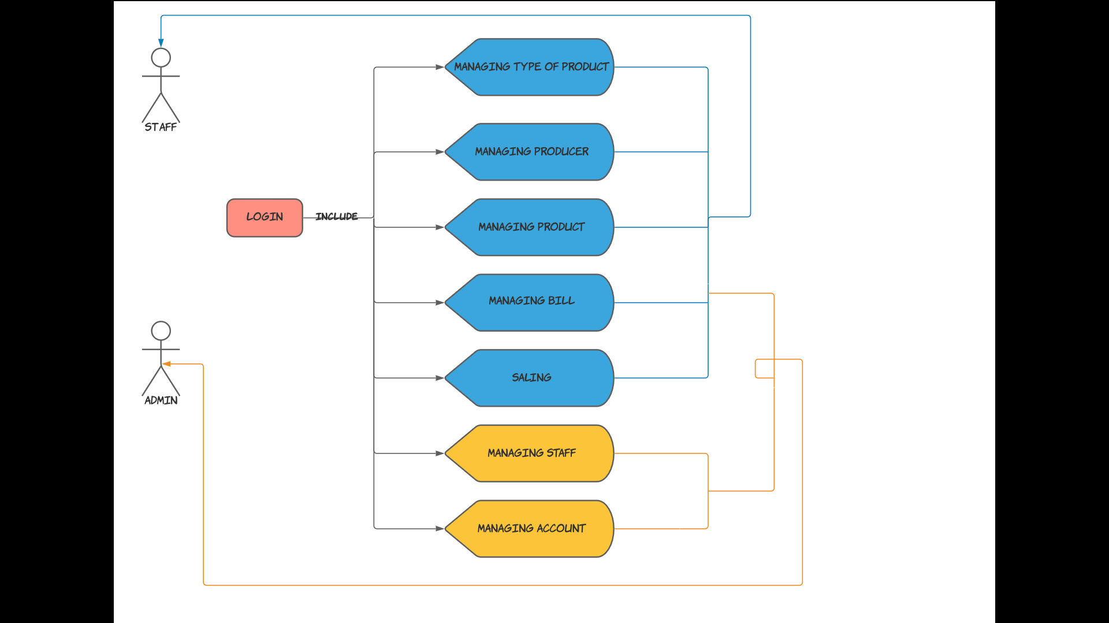

Breif of user requirement, analysis, and design
  - User requirement
    - Saling the products in convenience shop
    - Managing the products, manufacturers, staff, account, bills
    - Making bill statistics for convenience shop
  - Analysis
    - Application is easy to use
    - User have to login before use this app
    - Main function of application can help user sales the products and exports bills
    - Application can help manage the products, manufacturers, staff, account, bills and bill statistics ( managing staff and account only for manager)
  - Design
    - Interface of application is easy to use
    - This app includes 1 main form and 9 sub forms
    - Each form includes controllers such as textbox, combobox, date time picker , button , numeric up down and datagridview

Results of the project
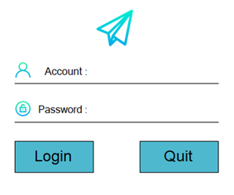

- This is the screen of login (type user name and password and click “Login”, data will compare account in database if contain go to menu else show error message)
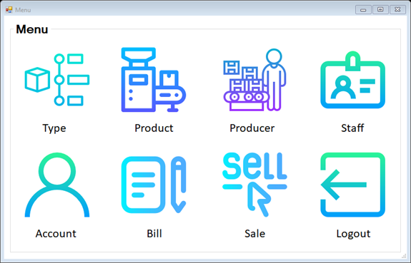

- This is the screen of menu (choose what you want to work with by click picture or label)
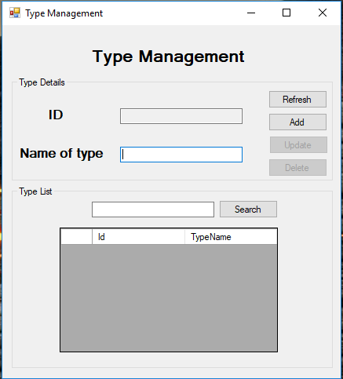

- This is the screen of type of product management, in this form we manage type by ID and name of type, “Refresh” will sort ascending , “Add” for insert new and you must be cell click to use “Update” and “Delete”, you must choose a row you want to update or delete if you don’t do that notification will show in message box, and search what you want by type a text in textbox and click search button for show result.
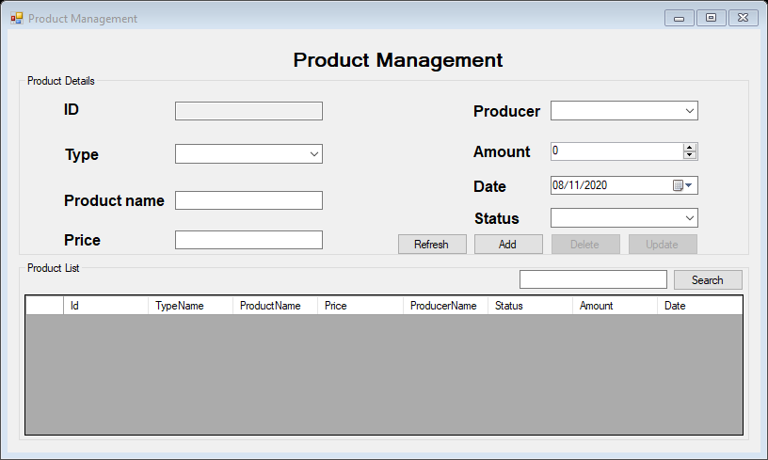

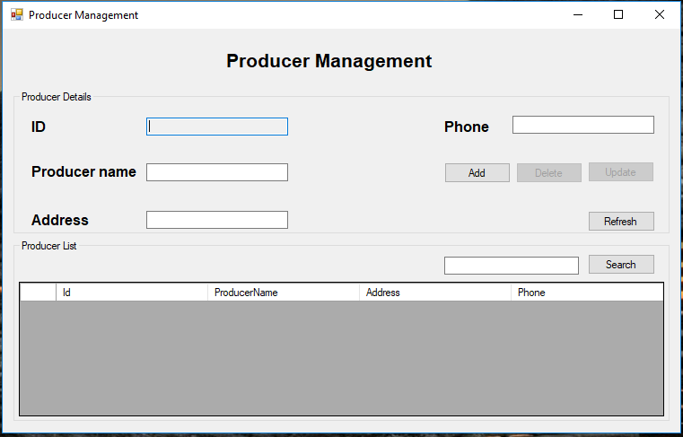

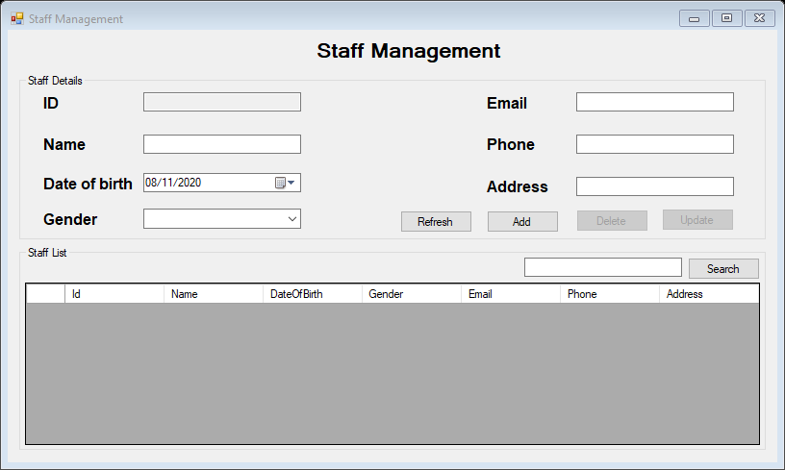

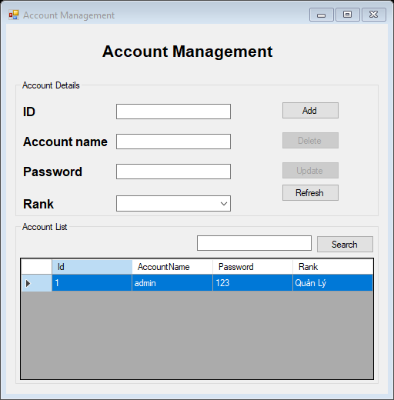

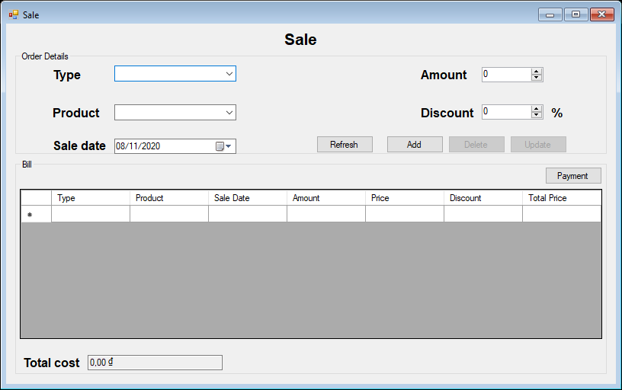

- The given screenshots illustrate performance of app in this forms we have basic fuctions like ”Add”, “Delete”, “Update”, “Refresh”, “Search” all of form, except form “Sale” doesn’t have funtion search but have “Payment” to print bill for customer and most special form is bill management, we use this form for protistic money. Almost forms we use “ID” as primary key for manage data betwwen forms and constraint every account, product, producer, staff, type of product only have one “ID”.

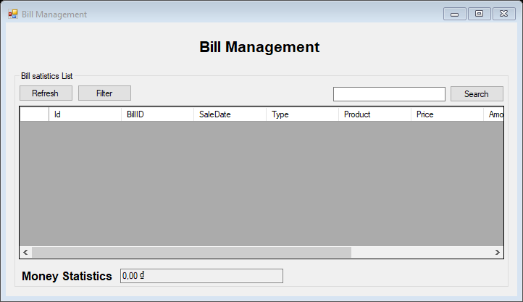

- This is screen of bill management, we have “Refresh”, “Filter” and “Search” for sort, filter and search bill what we want to see, why this is most speacial form? Because this is only form we use filter by passing data form another form (from form bill filter)

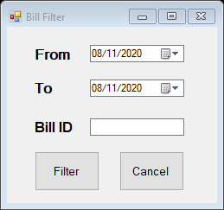

- This is bill filter form, you choose the day you want to show and bill “ID”, click filter and data from this form will pass to bill manage form, that is first reason.
- Second reason, this form is the most difficult form, we spend very much time to think and design true database and form, we have trouble when find ways to protistic money.
- Finally we finished this form and complete all funtions of convenience shop management app and finished my team’s project.

Conclusion

After completing this project on the topic (Convenience shop management). I can concluded that(Convenience shop management app).
This project have improve my skill very much which increases its realibility.Now i am able to talk any issue related with (Convenience shop management).
The whole credit goes to my subject teacher and my teamates, my friends, they refined my ideas and make this project wonderful, after this project we have more knowledge and skill for repare our future.

References

School’s subject document:

https://drive.google.com/drive/folders/1xxvdJRxPWlMIlIgJpwasf6rzpXEy93HI

Connect database(SQL server) to Save and handling data:

https://www.entityframeworktutorial.net/EntityFramework4.3/raw-sql-query-in-entity-framework.aspx?fbclid=IwAR1FLxO40b1ifWDJmXnMDxwPBTpi17Tt1RRwTwnKuGHEe5Enf0t7n6o4DWk

https://www.youtube.com/watch?v=X-IPIfHlrKY

Tutorial for C# Windows Form Application from indian youtubers:

https://www.youtube.com/watch?v=8ARnYQgShY8&list=PLxefhmF0pcPlDKe7smJMoHPNS1tJQ7w7q

https://www.youtube.com/watch?v=o0mCw92Wc0g&list=PLX4n-znUpc2bZraBfrocTU9SmQT4BE05B

https://www.youtube.com/watch?v=62igefFrZq4&list=PLX07l0qxoHFLuyuV-A1LmlMr5MhDhNfMG

https://www.youtube.com/watch?v=Vfr6dS8DjOY

https://www.youtube.com/watch?v=_sB0A6FIhUM

https://www.youtube.com/watch?v=YNeFKtgSgQY

Another documents:

https://stackoverflow.com/questions/8750290/how-can-i-check-multiple-textboxes-if-null-or-empty-without-a-unique-test-for-ea

https://stackoverflow.com/questions/43729884/concept-on-search-function

