**Topology**

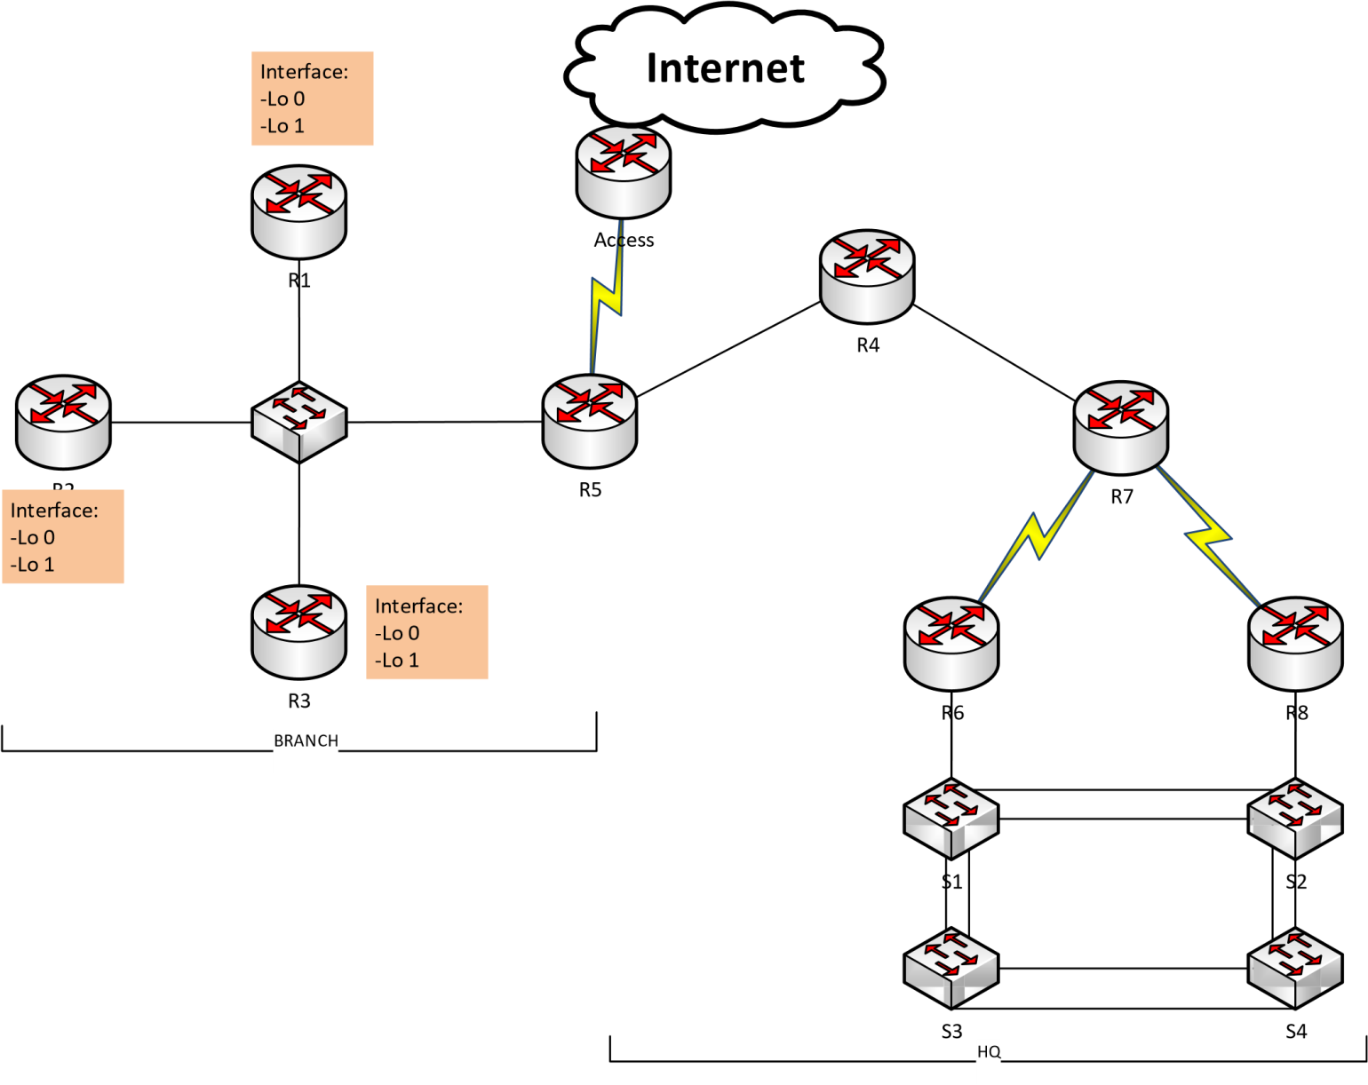

2019 . All rights reserved. This document is Cisco Public.

# Part 1: IPv4

## Addressing Scheme

**- X :Date**

**- A : Month**

**- Y = X+ 100**

**- B = A +5**

* HQ area is used network address X.X.X.X/A (7.0.0.0/8)
* Branch area is used network address Y.Y.Y.Y/B (107.104.0.0/13)
* Address table:

|  |  |
| --- | --- |
| Network | Address |
| R7  R6 | 202.0.100.0/30 |
| R7  R8 | 202.0.100.4/30 |
| R5  ACCESS | 202.0.100.8/30 |

* Host number requirement for VLAN HQ site

|  |  |  |  |  |  |  |  |  |
| --- | --- | --- | --- | --- | --- | --- | --- | --- |
| **Subnet Name** | **Needed Size** | **Allocated Size** | **Address** | **Dec Mask** | **Assignable Range** | **Broadcast** | **VLAN** | **Mask** |
| TEAM1 | 500 | 510 | 7.0.0.0 | 255.255.254.0 | 7.0.0.1 - 7.0.1.254 | 7.0.1.255 | 10 | /23 |
| TEAM2 | 200 | 254 | 7.0.2.0 | 255.255.255.0 | 7.0.2.1 - 7.0.2.254 | 7.0.2.255 | 20 | /24 |
| TEAM3 | 100 | 126 | 7.0.3.0 | 255.255.255.128 | 7.0.3.1 - 7.0.3.126 | 7.0.3.127 | 30 | /25 |
| GUEST | 100 | 126 | 7.0.3.128 | 255.255.255.128 | 7.0.3.129 - 7.0.3.254 | 7.0.3.255 | 40 | /25 |
| SERVERS | 50 | 62 | 7.0.4.0 | 255.255.255.192 | 7.0.4.1 - 7.0.4.62 | 7.0.4.63 | 50 | /26 |
| Management(Native) | 50 | 62 | 7.0.4.64 | 255.255.255.192 | 7.0.4.65 - 7.0.4.126 | 7.0.4.127 | 60 | /26 |

en

conf t

int vlan 10

ip add 7.0.0.1 255.255.254.0

int vlan 20

ip add 7.0.2.1 255.255.255.0

int vlan 30

ip add 7.0.3.1 255.255.255.128

int vlan 40

ip add 7.0.3.129 255.255.255.128

int vlan 50

ip add 7.0.4.1 255.255.255.192

int vlan 60

ip add 7.0.4.65 255.255.255.192

* Host number requirement for Branch site

|  |  |  |  |  |  |  |  |
| --- | --- | --- | --- | --- | --- | --- | --- |
| Device | Interface | **Address** | **Dec Mask** | **Mask** | Host Number | **Assignable Range** | **Broadcast** |
| R1 | Lo 0 | 107.104.2.1 | 255.255.255.0 | /24 | 200 | 107.104.2.1 - 107.104.2.254 | 107.104.2.255 |
| R1 | Lo 1 | 107.104.0.1 | 255.255.254.0 | /23 | 300 | 107.104.0.1 - 107.104.1.254 | 107.104.1.255 |
| R2 | Lo 0 | 107.104.4.1 | 255.255.255.128 | /25 | 100 | 107.104.4.1 - 107.104.4.126 | 107.104.4.127 |
| R2 | Lo 1 | 107.104.4.129 | 255.255.255.128 | /25 | 100 | 107.104.4.129 - 107.104.4.254 | 107.104.4.255 |
| R3 | Lo 0 | 107.104.3.1 | 255.255.255.0 | /24 | 200 | 107.104.3.1 - 107.104.3.254 | 107.104.3.255 |
| R3 | Lo 1 | 107.104.5.1 | 255.255.255.128 | /25 | 100 | 107.104.5.1 - 107.104.5.126 | 107.104.5.127 |
| R1-R2-R3-R5 | G0/0 | 107.104.5.129 | 255.255.255.248 | /29 | 4 | 107.104.5.129 - 107.104.5.134 | 107.104.5.135 |

R1:

en

conf t

hostname R1

int lo 0

ip add 107.104.2.1 255.255.255.0

int lo 1

ip add 107.104.0.1 255.255.254.0

int g0/0

ip add 107.104.5.129 255.255.255.248

no shut

R2:

en

conf t

hostname R2

int lo 0

ip add 107.104.4.1 255.255.255.128

int lo 1

ip add 107.104.4.129 255.255.255.128

int g0/0

ip add 107.104.5.130 255.255.255.248

no shut

R3:

en

conf t

hostname R3

int lo 0

ip add 107.104.3.1 255.255.255.0

int lo 1

ip add 107.104.5.1 255.255.255.128

int g0/0

ip add 107.104.5.131 255.255.255.248

no shut

R5:

en

conf t

hostname R5

int g4/0

ip add 107.104.5.132 255.255.255.248

no shut

## 2) PPP Connections

Configuration PPP connection between R7 and R6 router using PAP authentication

Configuration PPP connection between R7 and R8 router using CHAP authentication

* R7:

en

conf t

hostname R7

username R6 pass abcd

int s2/0

clock rate 128000

ip add 202.0.100.1 255.255.255.252

Encap ppp

Ppp authen pap

Ppp pap sent-user R7 pass abcd

No shut

conf t

username R8 pass abcd

int s3/0

clock rate 128000

ip add 202.0.100.5 255.255.255.252

Encap ppp

Ppp authen chap

No shut

* R6:

en

conf t

hostname R6

username R7 pass abcd

int s2/0

clock rate 128000

ip add 202.0.100.2 255.255.255.252

Encap ppp

Ppp authen pap

Ppp pap sent-user R6 pass abcd

No shut

- R8:

en

conf t

hostname R8

user R7 pass abcd

int s2/0

clock rate 128000

ip add 202.0.100.6 255.255.255.252

Encap ppp

Ppp authen chap

No shut

R5:

en

conf t

hostname R5

int s2/0

clock rate 128000

ip add 202.0.100.9 255.255.255.252

No shut

- Access:

conf t

hostname Access

int s2/0

clock rate 128000

ip add 202.0.100.10 255.255.255.252

No shut

## 3) Routing

* Configure OSPF routing protocol in HQ site

En

conf t

No router ospf 1

router ospf 1

log-adjacency-changes

network 202.0.100.0 0.0.0.255 area 0

network 7.0.0.0 0.255.255.255 area 0

* Configure static routing protocol in Branch site ip route 0.0.0.0 0.0.0.0 107.104.5.132
* On R5, configure a default route to ACCESS router and propagate it to OSPF process
* On R5, configure static route (use summary route) to Branch site and propagate OSPF process in HQ site.
* Set passive on appropriate interface

## 4) Switching :

S1:

en

conf t

hostname S1

vtp mode client

S2:

En

Conf t

Hostname S2

Vtp domain cisco

S3:

en

conf t

hostname S3

Vtp mode client

S4:

En

Conf t

Hostname S4

Vtp mode client

Int range f0/1-4

Sw mode trunk

* hostname Switch S2 is VTP Server, remain switchs are VTP client
* Change spanning tree protocol to Rapid PVST+ mode
* S1 is root bridge for VLAN 10, 20, 30, 40. S2 is root bridge for remain VLANs
* Use network address of Management VLAN assign to switch
* Configure SSH on all switches
* Configure router-on-a-stick Inter-VLAN routing on R6 for VLAN 10, 20, 30, 40 and R8 for VLAN 50,

60.

* Configure EtherChannel with LACP protocol for all links between switch.

## 5) NAT and DHCP

* Configure NAT overload on Access allow private addresses of HQ and Branch site can access Internet.
* Setup an Web in Servers VLAN, configure port forwarding allow hosts from Internet can access the HTTP and HTTPS service.
* Setup DHCP server on R4 to assign IP address and other parameters to host in VLAN 10, 20, 30, 40 automatically.

## 6) Other requirements

* Create ACL not allow users on GUEST VLAN access to all network of HQ and Branch but can use to the Internet.
* Create ACL allow only SERVERS VLAN can SSH to switches

# Part 2: IPv6

## 1) Address Scheme

* For the networks connect routers

|  |  |
| --- | --- |
| Network | Address |
| Access  R5 | 2001:ABBA:AAAA:1::/64 |
| R7  R6 | 2001:ABBA:CCCC:1::/64 |
| R7  R8 | 2001:ABBA:DDDD:1::/64 |
| R4  R5 | 2001:ABBA:EEEE:1::/64 |
| R4  R7 | 2001:ABBA:FFFF:1::/64 |

* Assign static link-local address for all interface using FE80::/10 range.
* Use the first five subnets of network 2001
* :ABBA:BBBB:/48 for five VLAN 10, 20, 30, 40, 50. The default gateway will be used the first IP address. Remark: assign appropriate static link-local address by yourself.

## 2) Routing

* Configure IPv6 static routing in HQ site.
* Configure a default route from R5 to Access and R5 is also default gateway for all remain networks
* Configure inter-VLAN routing using the same sub-interface for each VLAN in above IPv4 configuration.

## 3) DHCP

* Setup Stateless DHCPv6 on R7 router to assign IP address and other information for VLAN 10, 20,30 and 40 dynamically. Use 2001:4860:4860::8888 for DNS Server address.
* Configure relay agent on appropriate interfaces.