Scenario 2: The Bridge
Having lost control of the entertainment district, Empire forces have pulled back to the other side of the river. In the chaos of the retreat the empire troops dropped some wyrdstone before and after crossing the bridge. Scouting parties returning from the far side have discovered the wyrdstone but the rest of the warband remains spread out on the far side of the river. With other warbands arriving on scene, only quick reinforcement will ensure the prize is won. This scenario plays as a modified version of the Wyrdstone Hunt scenario.
Terrain
Setup up terrain as normal but mark out a 3” river as shown in the figure below (river is slightly offset to the top side such that the bottom river bank is 24” from the table edge) and place a bridge crossing the river in the center. Define the direction of flow as shown. Place four markers for wyrdstone on the far side of the bridge and two markers on the near side relative to the deployment zones. Place the markers within ~4-6” of the bridge, roughly as shown below. These markers represent wyrdstone lost by the retreating troops. The area within 2” of the river is the riverbank.
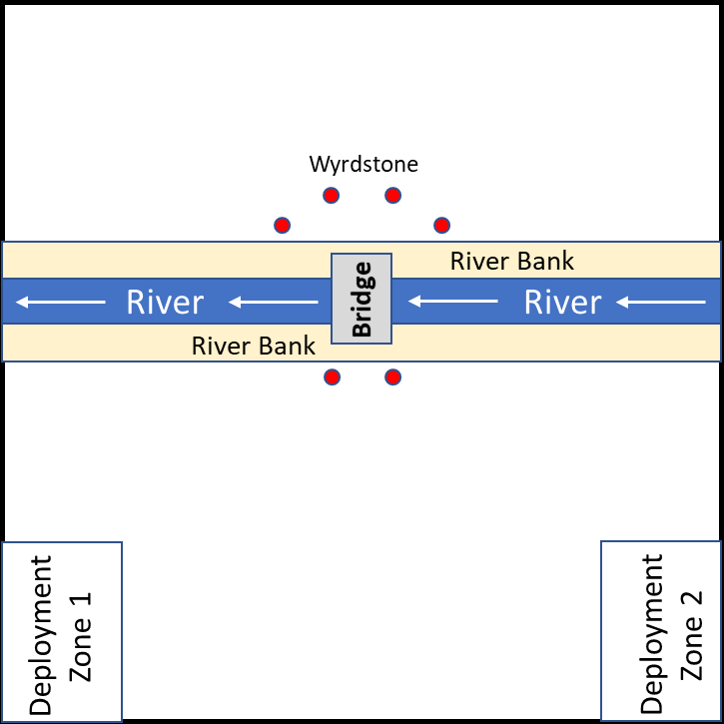
Setup
Roll for teams as normal but instead of rolling to determine sides and turn order, roll to determine who chooses between two options: pick starting zone, setup second and go second or let the other side pick the side and then setup and go first. The teams will setup in the deployment zones shown on the figure above (12x8” from the corner).
The River
The river running through Mordheim is polluted and difficult to cross. Any model may cross the river but will be at half movement in the water even if they have the aquatic ability since the river is so treacherous. Note that models cannot “run” while swimming across the river. Models in heavy armor can cross the river but do so at ¼ movement, though dwarves and models on horseback are exempt from this rule. Any model that is forced off of the board is immediately taken out of action and any wyrdstone they are carrying is lost, but will only roll for injuries after the game on a roll of 1-2 on a D6. Any model that is knocked down or stunned in the river will need to take a strength test in the recovery phase to recover (otherwise they remain knocked down or stunned), though a model that recovers from knocked down will not suffer additional movement penalties (i.e. the ½ movement penalty for recovery does not stack with the river penalty). Any model that spends any portion of their movement phase in the river will be swept downstream D6”. Resolve the downstream movement at the end of the model’s movement phase or prior to exiting the river whichever occurs first. Note that models with the aquatic ability roll D3” instead of D6” for downstream movement. The river bank is steeply sloped and challenging to cross and will be considered difficult terrain (1/2 movement but model can run) unless a model passes an initiative test when headed into the river and a strength test when getting out of the river. Any model that begins and ends its turn on the same river bank slips and falls back into the river. Immediately have them swept downriver d6" and place them at the center of the river.
Models cannot fight in the river or on the river banks. Models in the river cannot declare charges (swimming isn’t conducive to charging). Models in the river count as having cover, and only models within 12” of the river can shoot at a model in the river due to the steep banks. For the purposes of determining when a model is in the river/on the river bank, use the halfway point of the model’s base as the delineation, i.e. a model is only considered on the river bank or in the river if half or more of their base falls in the area.
Wyrdstone
Any non-animal model can pick up a wyrdstone by ending their movement at the marker. Models can only carry one wyrdstone and cannot pass it off to another model. If a model carrying a wyrdstone is knocked down, stunned or taken out of action, the wydstone is dropped and scatters D3” in a random direction. When a warband routes roll D6 for every wyrdstone carried by a model on the far side of the river on a roll of 1-2 the wyrdstone is lost as the warband member tries to flee back across the river. As with other scenarios any wyrdstone collected by one member of the team is credited to both warbands. Warbands add +1 to their leadership for route checks for each wyrdstone their warband holds (max +2), wyrdstone held by a teammate does not count.
Ending the game
The game ends when one team completely routes or when one of the teams successfully moves 3 or more wyrdstone off of the board. Models can only exit the board on the edge between the two deployment zones (i.e. the bottom edge on the figure above). Warbands automatically keep any wyrdstone that is successfully moved off the board, but they no longer get the leadership bonus for that wyrdstone.
Experience
+1 Survives. If a Hero or a Henchman group survives the battle they gain +1 Experience.
+1 Winning Leader. The leader of the winning warband gains +1 extra Experience.
+1 Per Enemy Out of Action. Any Hero earns +1 Experience for each enemy model he puts out of action. They earn an extra +1 XP (max 3 extra) if they were holding a wyrdstone when they take out an enemy model.
+1 Wyrdstone. Any model that leaves the board or finishes the game with a wyrdstone earns +1 XP.

