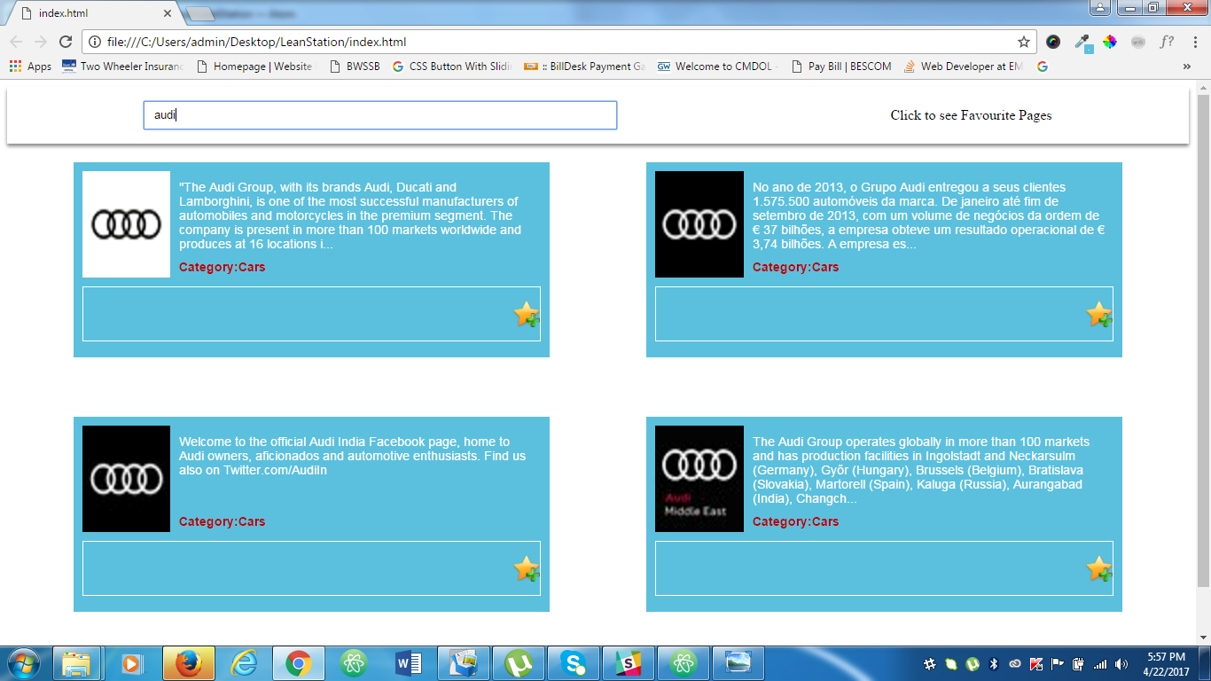

1)Enter the word in input and press enter(ex: audi).Then click on star icon to add to favorites. Click on link ‘Click to see favorite pages’. Page should reform the tiles showing the tiles which was added to favorites with Remove from favorite‘’ icon

