1) From problem statement

  


To find maximum value, we can find derivative of 



4.1) No. Because the difference between 2 scenarios is blocking and new channel. The blocking might be the cause.

4.2) No. Since 0.1 is greater than significant level at 0.05. That means we cannot reject  and we cannot conclude anything.

4.3) No. We cannot conclude that adding new channel has significance to number of visitors.

Yes. We can use hypothesis testing by adjusting the significant level of 4.2 to be 0.1.

5.1) : The die is fair, and the probability of rolling the selected number is   
 : The die is biased, and the probability of rolling the selected number is less than 

5.2) One-sided because the player is interested in whether the probability of rolling the selected number is less than  or not.

5.3) From the code below, the P value is not less than 0.1. So, we can’t reject 

5.4) The reject region is  times

5.5) the reject region is 

5.6) The lowest probability is 0.148

5.7) The lowest probability is 0.16664

7.1) 

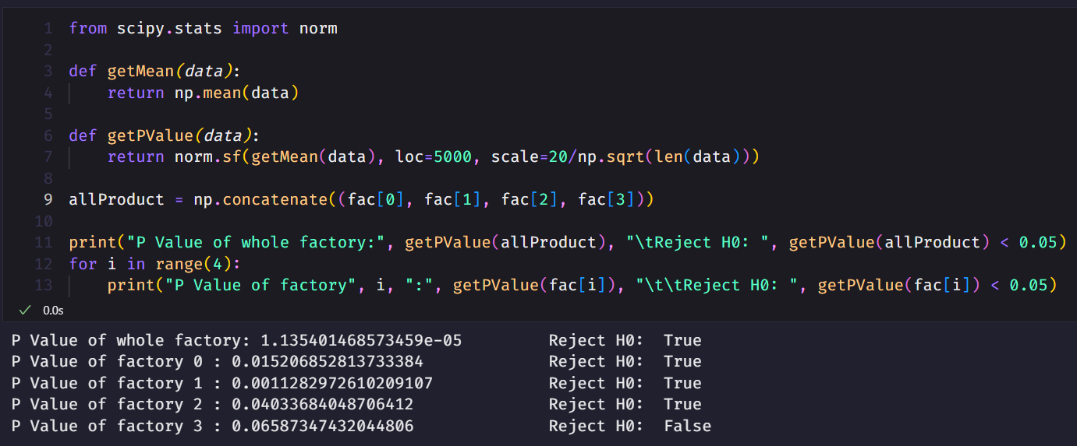

7.2) Yes, we can conclude that factory productivity increased as a whole. Since the P Value is less than significant level. So, we reject 

7.3) For factory 0, 1, 2, the P value is less than significant level. So, we reject  but for factory 3, the P value is greater than significant level. So, we can’t reject 

7.4) The result of reject  or not is the same as result from z-testing but the p value is a bit different since the student’s t distribution is a bit different from normal distribution.

