|  |
| --- |
| **Group No:** XX  **Group Member:**   1. นาย ภูมิพัฒน์ ชัยประเสริฐสุด 2. นาย ธนกฤต เป็นทุน 3. นาย ชยุต กฤตวีรนันท์ |

# Part 0: Preparation

* Download “Activity 1 Resources” from CourseVille.
* In Part 2, each group is assigned to work with the files: [YOUR_GROUP_NO].bmp, and [YOUR_GROUP_NO].gif in “02 Pic” folder
* Answer the questions in the box given and submit this file (.docx format) to CourseVille.

# Part 2 : Image Representation

## BMP Image Representation

(Use the file name: [YOUR_GROUP_NO].bmp in “02 Pic” folder)

1. Use “File Explorer” to observe the file
   * What is the file size (in bytes)?

|  |
| --- |
| 822 bytes |

* + Write the file size using a 2-byte Hexadecimal Notation.

|  |
| --- |
| 03 36 |

1. Open the BMP file assigned to your group in HexEdit
   * Under the “Template” menu item, apply the template you think will help you analyze the BMP file format.
   * 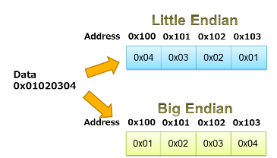By observing the Hex content of the file, explain at least 2 ways to know the size of the file in bytes. Is the size similar to what can be seen from “File Explorer”? (Hint: file size showing with little endian byte order)

|  |
| --- |
| 1 .Reverse size address to 00 00 03 36(hexadecimal) -> convert to decimal = 833 |
| 2.Get size of square pixel {16 bytes(width)*16 bytes(height)*3(RGB)}+54 bytes(offbit)= 768+54 =822 bytes |

* + What is the dimension of the image, and how can you find it in HexEdit?

|  |
| --- |
| 2 D,Because It have only width and height. |

* + What does the content at 01C - 01D represent?

|  |
| --- |
| Bit count |

* + Explain how is the color of a pixel encoded?

|  |
| --- |
| Each pixel use 3 bytes represent R G B value respectively. |

* + What is the RGB value (in hexadecimal) of the color used for the background in the image file?

|  |
| --- |
| FF FF FF |

* + What is the RGB value (in hexadecimal) of the color used for the outline of the shape in the image file?

|  |
| --- |
| D8 00 FF |

1. Edit the Hex content of the file so that the shape is filled with a color of your choice that is different from the color of the outline and the color of the background.
   * Explain the steps you did in completing the filling.

|  |
| --- |
| Replace all D8 to 3C. |

* + Save the new image with different filename. Insert the image (both original and edited version) in this answer box.

|  |
| --- |
| Original:  Edited: |