**UNIVERSITY OF CALIFORNIA, BERKELEY**

SANTA BARBARA • SANTA CRUZ

BERKELEY • DAVIS • IRVINE • LOS ANGELES • MERCED • RIVERSIDE • SAN DIEGO • SAN FRANCISCO



|  |  |
| --- | --- |
| Noah K. Whiteman, Ph.D.  Associate Professor, Department of Integrative Biology  Principal Investigator, Center for Computational Biology  Faculty Curator of Plant-Animal Coevolution, University and Jepson Herbaria  Affiliated Faculty, Museum of Vertebrate Zoology  3040 Valley Life Sciences Building  University of California, Berkeley |  |

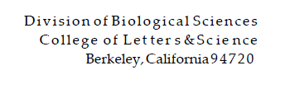

Drs Neufeld, Stein, and Watanabe, Editors-in-Chief September 29, 2020

Members of the Editorial Board, *ISME J*

Dear colleagues,

Enclosed please find our manuscript entitled “*Competitive hierarchies, antibiosis, and the distribution of bacterial life history traits in a microbiome”* for publication consideration as an Article for *ISME J.* While microbiome research is now integrated with nearly every field in biology, from medicine to crop protection and ecology to evolutionary biology, there remains a limited understanding of the nature of the interactions (antagonistic or otherwise) that occur between microbes that co-occur in native contexts. In particular, although microbiomes are being manipulated for ‘growth-promotion’ in crop plant systems, the basic biology, particularly the role that interactions among constituent microbes play in establishing a resident microbiome, is poorly known from natural systems. Without studies which measure how microbial traits mediate their interactions within microbiomes, we risk relying on a purely on observational and correlational foundation for understanding of population and community-level dynamics within host-associated microbiomes.

Uniquely, rather than leaning on on laboratory strains, our study provides a systematic description of the link between microbial traits and competitive outcomes using strains directly isolated from a native host. By linking independent measures of canonical resource usage traits with a systematic comparison of competitive outcomes in spatial microcosms, our study uncovers strong competitive asymmetrics between two major *Pseudomonas* sp. clades that predominate within a plant microbiome that has been studied extensively by our group from a variety of perspectives. Further, the underlying patterns of trait variants and covariance differ between bacterial clades, with separate axes of variation underlying competitive ability in each clade. Finally, the particular distribution of antibiosis and resistance traits discovered in this community predicts indirect facilitation of relatively weaker *P. syringae* competitors by 'keystone' *P. fluorescens* strains. Not only can *P. fluorescens* out-compete *P. syringae* in spatial microenvironments by way of spatial pre-emption *and* antibiosis, but they can potentially ensure that the surviving *P. syringae* genotypes are relatively weaker competitors via the indirect effects of antibiosis.

We conducted our study on bacterial strains derived from a native herbaceous plant, *Cardmine cordifolia*—a mustard that is closely related to *Arabidopsis thaliana*. Given the important literature oninteractions between *Arabidopsis* and the phytopathogen *P. syringae*, our work helps establish precedent for leaf-derived *P. fluorescens* to be strong and dominant competitive within this and potentially other widespread *Pseudomonas*-rich plant systems. This is a new role for *P. fluorescens*, and the remarkable variety of patterns of antibiosis we report represents a tremendous resource for the community to dissect.

Finally, harnessing the biotic or antibiotic properties of such *P. fluorescens* to shift community assembly towards certain outcomes (e.g., to bulwark against establishment of phytopathogenic *P. syringae*) would represent a boon for the field of microbiome engineering.

In summary, this work lays a solid ecological foundation for mechanistic tests of how broadly important microbial taxa assemble within the context of a native plant microbiome. Given the broad implications of our results, the simplicity and directness of our approach, and the unique approach to analysis used in our study, we believe that this work is well-suited to the broad readership of *ISME J.*

Sincerely,

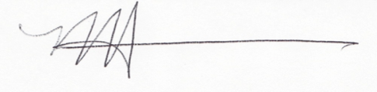

Noah K. Whiteman, Ph.D.

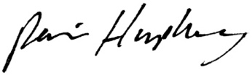

Parris Humphrey, Ph.D.