1. **Gradient Descent**
   * Gradient descent is an optimization algorithm used to find the values of parameters (coefficients) of a function ($f$) that minimizes a cost function ($cost$).
   * It is best used when the parameters cannot be calculated analytically (e.g. using linear algebra) and must be searched for by an optimization algorithm.

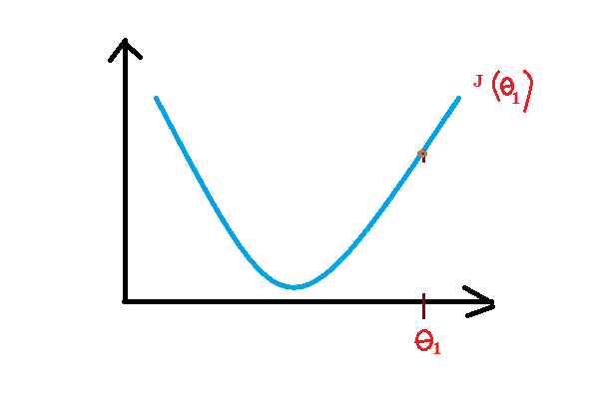

* + The goal of gradient descent algorithm is to try different values of the coefficients theta to minimize the cost. For example: the minimum of the cost function above.

1. **Gradient Descent Procedure**
   * Start off with an initial guess of the coefficient $θ$. For example: $θ=0$
   * The cost of the coefficient is evaluated by computing the function $f$ using coefficient $θ$.
 $$cost=eval(f\left(θ\right))$$  * In order to know the direction to move the coefficient value to minimize the cost, we need to compute the partial derivative of the cost function.
 $$delta=derivative(cost function)$$  * To get the next coefficient that is closer to the minimum of the cost function, we need a learning rate parameter (alpha) that controls how much the coefficients can change on each update.
 $$coefficient=coefficient-(alpha×delta)$$  * This procedure is repeated until an optimal solution is found.
2. **Batch Gradient Descent**

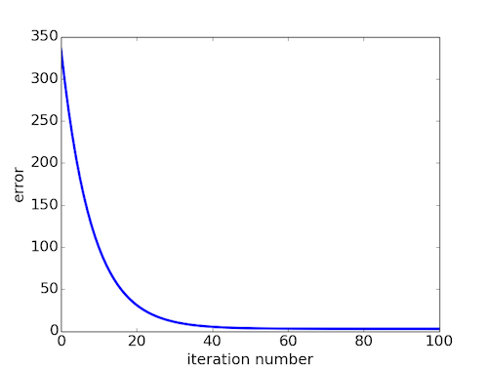

* + Batch gradient descent refers to calculating the derivative from all training data before calculating an update.
  + Different algorithms have different representations and different coefficients. Many of them require a process of optimization to find the set of coefficients that result in the best estimate of the target function
  + The cost function involves evaluating the coefficients in the machine learning model by calculating a prediction for each training instance in the dataset and comparing the predictions to the actual output values then calculating a sum or average error.
  + From the cost function a derivative can be calculated for each coefficient
  + The cost is calculated for a machine learning algorithm over the entire training dataset for each iteration of the gradient descent algorithm
  + One iteration of the algorithm is called one batch and this form of gradient  
    descent is referred to as batch gradient descent.
  + Batch gradient descent is the most common form of gradient descent described in machine learning.

1. **Stochastic Gradient Descent**

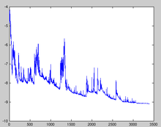

* + Gradient descent can be slow to run on very large datasets
  + In situations when you have large amounts of data, you can use a variation of gradient descent called stochastic gradient descent.
  + Stochastic gradient descent refers to calculating the derivative from each training data instance and calculating the update immediately.
  + In this variation, the gradient descent procedure described above is run but **the update to the coefficients is performed for each training instance, rather than at the end of the batch of instances.**
  + The first step of the procedure requires that the order of the training dataset is randomized to mix up the order that updates are made to the coefficients.
  + The update procedure for the coefficients is the same as that above, except **the cost is not summed or averaged over all training patterns, but instead calculated for one training pattern**
  + The learning can be much faster with stochastic gradient descent for very large training datasets and often you only need a small number of passes through the dataset to reach a good or good enough set of coefficients