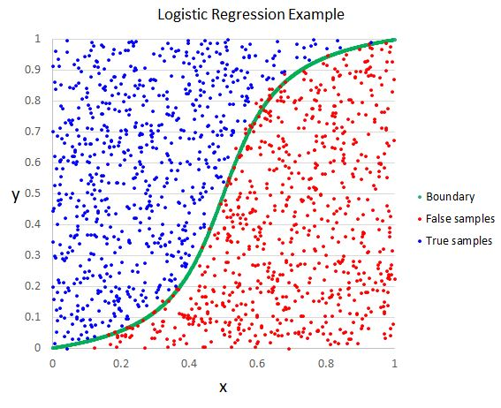

**Summary**: Logistic regression is used in a classification problem. For example: determine whether a tumor is benign or malignant. The output of the classifier is a value 0 or 1 (for a binary classification problem). That means:

$$y∈\{0,1\}$$

$$0: “negative class” (i.e. benign tumor)$$

$$1: “positive class” (i.e. malignant tumor)$$

If $y∈\{0,1,2,…\}$, we call this a multi-class classification problem. In classification problem, the output should be either 0 or 1 (for binary classification problem). It should not output value $0≤h\left(x\right)≤1$.

1. **Notation**
   * $m$: number of training examples
   * $n$: number of features
   * $x$: input variable
   * $y$: output variable
   * $x^{(i)}$: input features of ith training example
   * $x_{j}^{(i)}$: value of feature j in ith training example
   * $y^{(i)}$: output of ith training example
   * ($x^{(i)},y^{(i)})$: ith training example
2. **Hypothesis**
 $$h_{θ}\left(x\right)=g\left(θ^{T}x\right)$$ $$g\left(z\right)=\frac{1}{1+e^{-z}}$$ * The function $g\left(x\right)$ is called a sigmoid function.

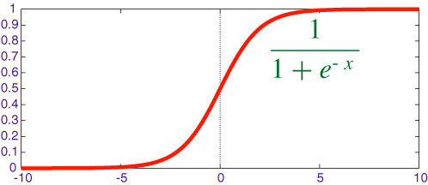

* + **Interpretation of the output of the hypothesis function:**
    - $h_{θ}\left(x\right)$ is the estimated probability that $y=1$ on input x
    - Example:
      * If $x=\left[\begin{matrix}x_{0} \\ x_{1}\end{matrix}\right]=\left[\begin{matrix}1 \\ tumorSize\end{matrix}\right] and h_{θ}\left(x\right)=0.7$
      * It tells the patient that there is a 70% chance the tumor is malignant
    - 🡪 The probability that $y=1$, given $x$, parameterized by $θ$.

1. **Decision Boundary**
   * Consider this graph below:

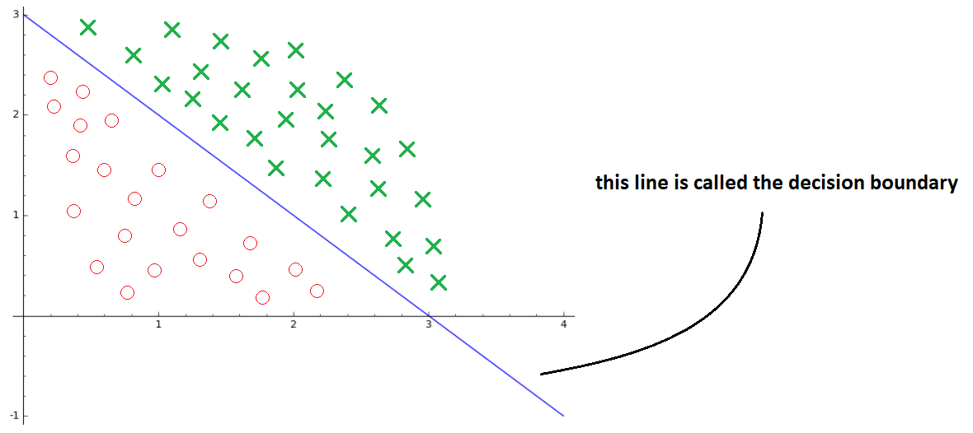

* + We have the decision boundary of the form $x_{1}+x_{2}=3$ and the hypothesis $h_{θ}=g(θ_{0}+θ_{1}x_{1}+θ_{2}x_{2})$. That means this graphs is predicting “ $y=1"$ if $-3+x_{1}+x_{2}≥0$
  + Some other examples:

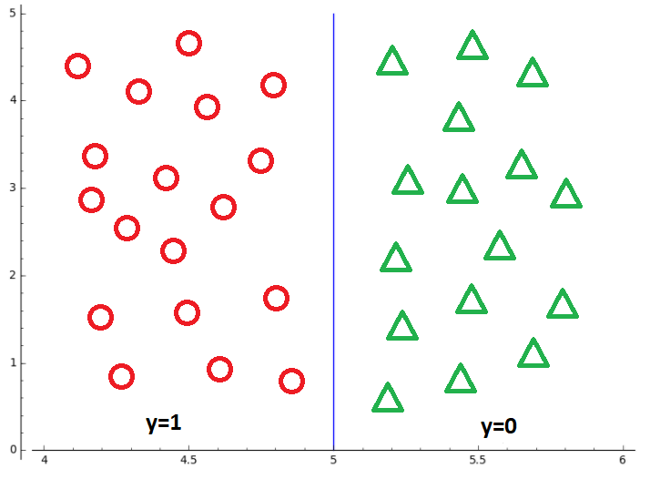

$$h_{θ}\left(x\right)=g(5-x_{1})$$

$$θ^{T}x=5-x_{1}$$

$$→\left\{\begin{aligned}x_{1}≤5: y=1 \\ x_{1}>5: y=0\end{aligned}\right.$$

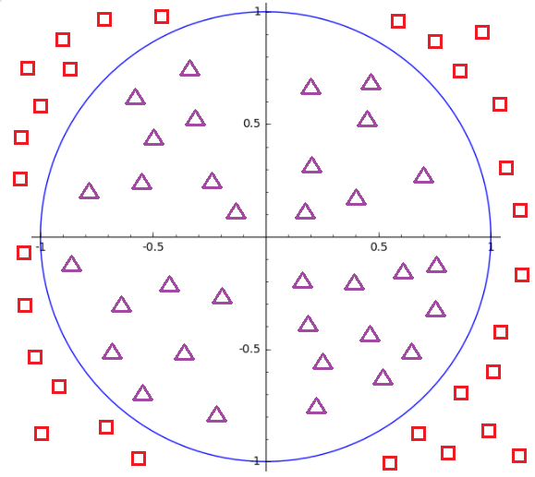

$$h_{θ}\left(x\right)=g(x_{1}^{2}+x_{2}^{2}-1)$$

$$θ^{T}x=x_{1}^{2}+x_{2}^{2}-1$$

$$→\left\{\begin{aligned}x_{1}^{2}+x_{2}^{2}≥1: y=1 \\ x_{1}^{2}+x_{2}^{2}<1: y=0\end{aligned}\right.$$

1. **Cost Function**
   * Given a training set: $\left\{\left(x^{\left(1\right)},y^{\left(1\right)}\right), \left(x^{\left(2\right)},y^{\left(2\right)}\right),…,\left(x^{\left(m\right)},y^{\left(m\right)}\right)\right\}$ with $m$ examples and:
 $$x∈\left[\begin{matrix}x_{0} \\ ⋮ \\ x_{n}\end{matrix}\right]∈R^{n+1}, x_{0}=1$$ $$y∈\{0,1\}$$ $$h_{θ}\left(x\right)=\frac{1}{1+e^{θ^{T}x}}$$* Consider the cost function $J\left(θ\right)$ in linear regression:
 $$J\left(θ\right)=\frac{1}{2m}\sum_{i=1}^{m}{{\left(h_{θ}\left(x^{\left(i\right)}\right)-y^{\left(i\right)}\right)}^{2}}$$ $$=\frac{1}{m}\sum_{i=1}^{m}{\frac{1}{2}{\left(h_{θ}\left(x^{\left(i\right)}\right)-y^{\left(i\right)}\right)}^{2}}$$ $$=\frac{1}{m}\sum_{i=1}^{m}{cost(h_{θ}\left(x\right),y)}$$ $$→cost\left(h_{θ}\left(x\right),y\right)=\frac{1}{2}{\left(h_{θ}\left(x\right)-y\right)}^{2}$$* If we apply the cost function from simple linear regression to logistic regression, it would result in a non-convex function.

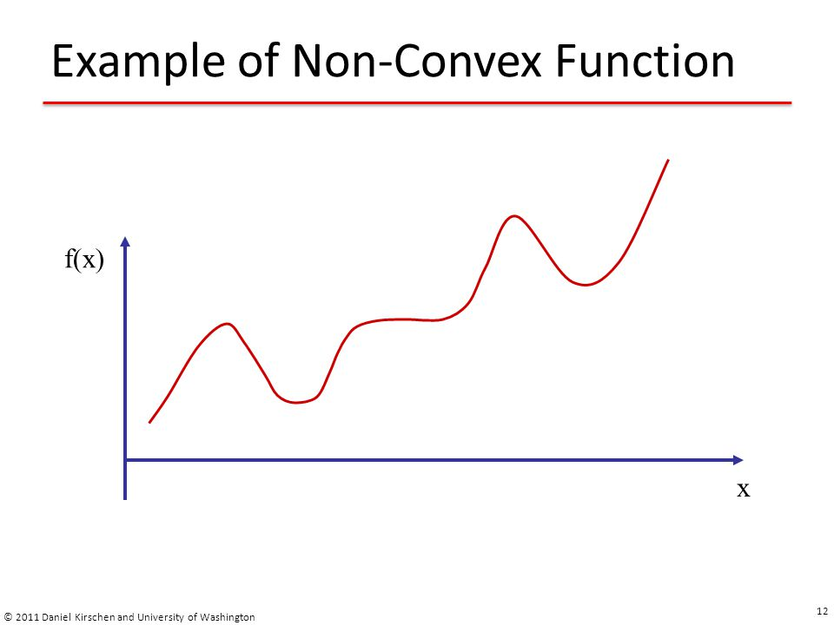

* + Therefore, we need to come up with a new cost function.

$$cost\left(h_{θ}\left(x\right),y\right)=\left\{\begin{aligned}-\log\left(h_{θ}\left(x\right)\right) if y=1 \\ -\log\left(1-h_{θ}\left(x\right)\right) if y=0\end{aligned}\right.$$

|  |  |
| --- | --- |
|  | When $y=1$: $if h_{θ}\left(x\right)=1, cost=0$  * As $h_{θ}\left(x\right)→0, cost→∞$ |
|  | When $y=0$: $if h_{θ}\left(x\right)=0, cost=0$ As |

* + We can re-write the function above as following:
 $$cost\left(h_{θ}\left(x\right),y\right)=-y\log\left(h_{θ}\left(x\right)\right)-\left(1-y\right)log\left(1-h_{θ}\left(x\right)\right)$$

 $$→J\left(θ\right)=-\frac{1}{m}\sum_{i=1}^{m}{\left[y^{\left(i\right)}\log\left(h_{θ}\left(x^{\left(i\right)}\right)\right)+\left(1-y^{\left(i\right)}\right)\log\left(1-h_{θ}\left(x^{\left(i\right)}\right)\right)\right]}$$

+ To fit parameters $θ$, we need to minimize $J(θ)$
  + To make a prediction on a new input x:

$$output h_{θ}\left(x\right)=P(y=1|x;θ)=\frac{1}{1+e^{-θ^{T}x}}$$

1. **Gradient Descent Algorithm**
   * We have:
 $$J\left(θ\right)=-\frac{1}{m}\sum_{i=1}^{m}{\left[y^{\left(i\right)}\log\left(h_{θ}\left(x^{\left(i\right)}\right)\right)+\left(1-y^{\left(i\right)}\right)\log\left(1-h_{θ}\left(x^{\left(i\right)}\right)\right)\right]}$$ $$→\frac{∂J}{∂θ_{j}}=\frac{1}{m}\sum_{i=1}^{m}{\left(h_{θ}\left(x^{\left(i\right)}\right)-y^{\left(i\right)}\right)x_{j}^{\left(i\right)}} for j=0…n$$ * We then have the gradient descent algorithm as follow:

Repeat {

$$θ_{j}≔θ_{j}-\frac{α}{m}\sum_{i=1}^{m}{\left(h_{θ}\left(x^{\left(i\right)}\right)-y^{\left(i\right)}\right)x_{j}^{\left(i\right)}} for j=0…n$$

}

1. **Vectorized Implementation**
   * A strategy to optimize gradient descent:
$$θ≔θ-\frac{α}{m}X^{T}\left(g\left(Xθ\right)-Y\right)$$

$$θ∈R^{n+1} Y∈R^{m}$$

$$X∈M_{m×\left(n+1\right)} → X^{T}∈M_{\left(n+1\right)×m}$$

2. **Optimization Algorithm**
   * Some available optimization algorithms:
     + Gradient descent
     + Conjugate gradient
     + BFGS
     + L-BFGS
   * Advantages of the last 3 algorithms:
     + No need to manually pick learning rate $α$. They automatically pick the best learning rate for each iteration
     + Often faster than gradient descent
   * Disadvantages:
     + More complex
3. **Multiclass Classification**
   * Examples:
     + Email foldering/tagging: work, friends, family, etc
     + Weather: sunny, cloudy, rain, snow

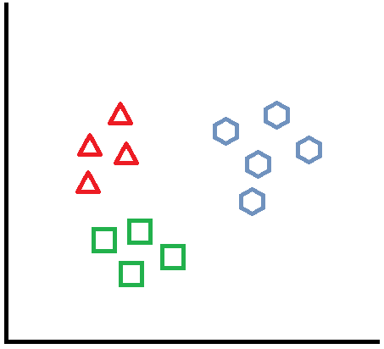

* + One strategy to solve a multiclass classification problem is One-vs-all (one-vs-rest) classification. In the example above, we can set:
    - Class 1: triangle
    - Class 2: hexagon
    - Class 3: square
  + Then break the problem above into 3 smaller binary classification problems

|  |  |
| --- | --- |
|  |  |
|  |  |
|  |  |

* + In one-vs-all classification, we train logistic regression classifiers $h_{θ}^{\left(i\right)}$ for each class $i$ to predict the probability that $y=i$
  + On new input $x$, to make a prediction, pick the class $i$ that maximizes the probability
 $$\max_{i}{h_{θ}^{\left(i\right)}\left(x\right)}$$

 + For a logistic regression problem with $n$ classes, using one-vs-all classification, we’ll need to break it into $n$ binary classification problems.

1. **Problem of Overfitting**
   * Underfitting: poor performance on the training data, high bias, and poor performance on test data
   * Overfitting: fit the training data very well but has a poor performance on the test set, which fail to generalize new examples. Overfitting has a high variance.
   * There are 2 options to solve overfitting:
     + Reduce the number of features (manually or automatically)
     + Regularization
       - Keep all the features, but reduce the magnitude/values of the parameters $θ$
       - Work well when we have lots of features, each of which contributes a bit to the prediction of $y$
2. **Regularization – Cost Function**
   * The ideas of regularization:
     + Penalize the parameters $θ$ (make the values small)
     + 🡪 Get a “simpler” hypothesis
     + 🡪 Less prone to overfitting
 $$J\left(θ\right)=\frac{1}{2m}\left\{\left[\sum_{i=1}^{m}{{\left(h_{θ}\left(x^{\left(i\right)}\right)-y^{\left(i\right)}\right)}^{2}}\right]+λ\sum_{j=1}^{n}{θ_{j}^{2}}\right\}$$ $$λ:regularization parameter$$ * If $λ$ is set too large, we’ll have
     + 🡪
     + 🡪 We’ll encounter underfitting problem
   * Note:
     + We only penalize $θ_{1},θ_{2},…,θ_{n}$ (Since $θ_{0}$ is set to be 1 by default)
3. **Regularized Linear Regression**
   * Consider the regularized cost function $J\left(θ\right)$ that we want to minimize
 $$J\left(θ\right)=\frac{1}{2m}\left\{\left[\sum_{i=1}^{m}{{\left(h_{θ}\left(x^{\left(i\right)}\right)-y^{\left(i\right)}\right)}^{2}}\right]+λ\sum_{j=1}^{n}{θ_{j}^{2}}\right\}$$  * Gradient descent for linear regression is written as follows:



* + Consequently, we can re-write the gradient descent algorithm for regularized linear regression as follows:



* + Notes:
    - 🡪 which means this term will shrink $θ_{j}$
  + Consider normal equation method for linear regression, applying regularization to this method, we’ll have:
 $$θ={\left(X^{T}X+λ\left[\right]\right)}^{-1}X^{T}Y$$

 $$Is a \left(n+1\right)×\left(n+1\right) identity matrix with first value on diagonal line being 0$$

+ Regularization will take care of the non-invertibility issue in normal equation method, making the matrix become an invertible.

1. **Regularized Logistic Regression**
   * Consider the cost function $J\left(θ\right)$ for logistic regression in section 4 together with the regularized cost function $J\left(θ\right)$ in section 10:
 $$J\left(θ\right)=\frac{1}{2m}\sum_{i=1}^{m}{{\left(h_{θ}\left(x^{\left(i\right)}\right)-y^{\left(i\right)}\right)}^{2}}=-\left\{\frac{1}{m}\sum_{i=1}^{m}{y^{\left(i\right)}\log\left[h_{θ}\left(x^{\left(i\right)}\right)\right]+\left(1-y^{\left(i\right)}\right)\log\left[1-h_{θ}\left(x^{\left(i\right)}\right)\right]}\right\}$$ $$J\left(θ\right)=\frac{1}{2m}\left\{\left[\sum_{i=1}^{m}{{\left(h_{θ}\left(x^{\left(i\right)}\right)-y^{\left(i\right)}\right)}^{2}}\right]+λ\sum_{j=1}^{n}{θ_{j}^{2}}\right\}=\frac{1}{2m}\left[\sum_{i=1}^{m}{{\left(h_{θ}\left(x^{\left(i\right)}\right)-y^{\left(i\right)}\right)}^{2}}\right]+\frac{λ}{2m}\sum_{j=1}^{n}{θ_{j}^{2}}$$ * We can come up with a regularized cost function for logistic regression as follows:
 $$J\left(θ\right)=-\left\{\frac{1}{m}\sum_{i=1}^{m}{y^{\left(i\right)}\log\left[h_{θ}\left(x^{\left(i\right)}\right)\right]+\left(1-y^{\left(i\right)}\right)\log\left[1-h_{θ}\left(x^{\left(i\right)}\right)\right]}\right\}+\frac{λ}{2m}\sum_{j=1}^{n}{θ_{j}^{2}}$$  * The gradient descent algorithm for regularized logistic regression can be written as follows:



* + Note: the algorithm looks identical to the gradient descent algorithm for regularized linear regression, however, the hypothesis $h_{θ}$ for logistic regression is not the same.

1. **Mathematical Interpretation of The Partial Derivative of The Cost Function $J(θ)$**

$$cost\left(h_{θ}\left(x\right),y\right)=\left\{\begin{aligned}-\log\left(h_{θ}\left(x\right)\right) if y=1 \\ -\log\left(1-h_{θ}\left(x\right)\right) if y=0\end{aligned}\right.$$

$$=-ylog\left(h_{θ}\left(x\right)\right)+\left(y-1\right)\left(\log\left(1-h_{θ}\left(x\right)\right)\right)$$

$$=-y\log\left(h_{θ}\left(x\right)\right)+y\left[\log\left(1-h_{θ}\left(x\right)\right)\right]-\log\left(1-h_{θ}\left(x\right)\right)$$

$$=y\left[\log\left(1-h_{θ}\left(x\right)\right)-\log\left(h_{θ}\left(x\right)\right)\right]-\log\left(1-h_{θ}\left(x\right)\right)$$

$$=y\left[\log\left(\frac{e^{{-θ}^{T}x}}{1+e^{{-θ}^{T}x}}\right)-\log\left(\frac{1}{1+e^{{-θ}^{T}x}}\right)\right]-\log\left(\frac{e^{{-θ}^{T}x}}{1+e^{{-θ}^{T}x}}\right)$$

$$=y\left[\log\left(e^{{-θ}^{T}x}\right)-\log\left(1+e^{{-θ}^{T}x}\right)+\log\left(1+e^{{-θ}^{T}x}\right)\right]-\log\left(e^{{-θ}^{T}x}\right)+\log\left(1+e^{{-θ}^{T}x}\right)$$

$$=y\log\left(e^{{-θ}^{T}x}\right)-\log\left(e^{{-θ}^{T}x}\right)+\log\left(1+e^{{-θ}^{T}x}\right)$$

$$=\log\left(e^{{-θ}^{T}x}\right)(y-1)+\log\left(1+e^{{-θ}^{T}x}\right)$$

$$J\left(θ\right)=\frac{1}{m}\sum_{i=1}^{m}{cost\left(h_{θ}\left(x^{(i)}\right),y\right)}$$

$$=\frac{1}{m}\sum_{i=1}^{m}{\left[\log\left(e^{{-θ}^{T}x^{\left(i\right)}}\right)(y^{(i)}-1)+\log\left(1+e^{{-θ}^{T}x^{(i)}}\right)\right]}$$

$$→\frac{∂J}{∂θ_{j}}=\frac{1}{m}\sum_{i=1}^{m}{\left[\frac{\left(e^{{-θ}^{T}x^{\left(i\right)}}\right)\left(-x_{j}^{(i)}\right)}{e^{{-θ}^{T}x^{\left(i\right)}}}(y^{(i)}-1)+\frac{\left(e^{{-θ}^{T}x^{\left(i\right)}}\right)\left(-x_{j}^{(i)}\right)}{1+e^{{-θ}^{T}x^{(i)}}}\right]}$$

$$=\frac{1}{m}\sum_{i=1}^{m}{\left[\left(-x_{j}^{(i)}\right)(y^{(i)}-1)+\frac{\left(e^{{-θ}^{T}x^{\left(i\right)}}\right)\left(-x_{j}^{(i)}\right)}{1+e^{{-θ}^{T}x^{(i)}}}\right]}$$

$$=\frac{1}{m}\sum_{i=1}^{m}{\left[\left(x_{j}^{\left(i\right)}\right)\left(1-y^{\left(i\right)}-\frac{e^{{-θ}^{T}x^{\left(i\right)}}}{1+e^{{-θ}^{T}x^{\left(i\right)}}}\right)\right]}$$

$$=\frac{1}{m}\sum_{i=1}^{m}{\left[\left(x_{j}^{\left(i\right)}\right)\left(\frac{1+e^{{-θ}^{T}x^{\left(i\right)}}}{1+e^{{-θ}^{T}x^{\left(i\right)}}}-\frac{e^{{-θ}^{T}x^{\left(i\right)}}}{1+e^{{-θ}^{T}x^{\left(i\right)}}}-y^{\left(i\right)}\right)\right]}$$

$$=\frac{1}{m}\sum_{i=1}^{m}{\left[\left(x_{j}^{\left(i\right)}\right)\left(\frac{1}{1+e^{{-θ}^{T}x^{\left(i\right)}}}-y^{\left(i\right)}\right)\right]}$$

$$=\frac{1}{m}\sum_{i=1}^{m}{\left[\left(x_{j}^{\left(i\right)}\right)\left(h_{θ}\left(x^{(i)}\right)-y^{\left(i\right)}\right)\right]} for all j=0…n$$