1. **What is machine learning?**
   * A field of study that gives computers the ability to learn without being explicitly being programmed
   * A computer is said to learn from experience E with respect to some tasks T and some performance measure P, if its performance on T, as measured by P, improves with experience E.
   * Machine learning algorithms are described as learning a **target function $(f)$** that best maps input variables $(X)$ to an output variable $(Y )$.
$$Y=f(X)$$

2. **Machine learning algorithms:**
   * **Parametric Machine Learning Algorithms** 
     + Algorithms that simplify the function to a known form are called parametric machine learning algorithms.
     + The algorithms involve two steps:   
       1. Select a form for the function.  
       2. Learn the coefficients for the function from the training data.
     + Examples:
       - Logistic Regression
       - Linear Discriminant Analysis
       - Perceptron
   * **Nonparametric Machine Learning Algorithms**
     + Algorithms that do not make strong assumptions about the form of the mapping function.
     + Examples:
       - Decision Trees like CART and C4.5
       - Naive Bayes
       - Support Vector Machines
       - Neural Networks
   * Supervised learning
   * Unsupervised learning
   * Others: reinforcement learning, recommender systems

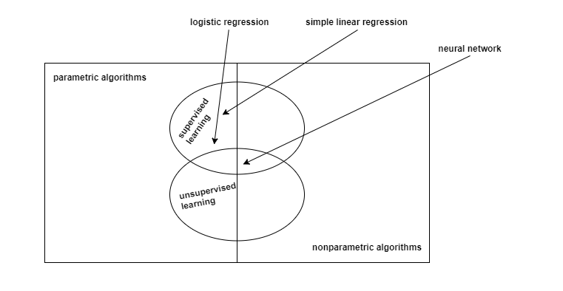

1. **Example of machine learning problems:** 
   * Playing checkers
     + E = the experience of playing many games of checkers
     + T = the task of playing checkers
     + P = the probability that the program will win the next game

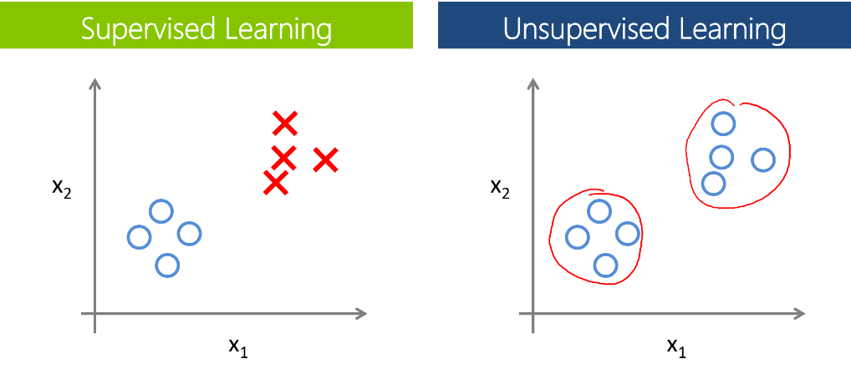

1. **Supervised learning**
   * Example: housing price prediction
   * In supervised learning, we are given a data set (training data) and already know what our correct output should look like, having the idea that there is a relationship between the input and output.
   * Supervised learning problems are categorized into:
     + Regression problem:
       - Predict results within a continuous output (maps input variables to some continuous function)
       - Example: housing price prediction
     + Classification problem:
       - Predict result in a discrete output (maps input variables into discrete categories)
       - Example: determine whether a tumor is benign our malignant
2. **Unsupervised learning**
   * Idea: given a data set, can we find some structure within it?
   * Unsupervised learning is where you only have input data (X) and no corresponding output variables.
   * The goal for unsupervised learning is to model the underlying structure or distribution in the data in order to learn more about the data.
   * There is no correct answers and there is no teacher. Algorithms are left to their own devises to discover and present the interesting structure in the data
   * Example:
     + Organize computer cluster
     + Social network analysis
     + Market segmentation
     + Astronomical data analysis
   * Unsupervised learning problems can be further grouped into clustering and association problems.
     + Clustering:
       - A clustering problem is where you want to discover the inherent groupings in the data
       - Example: grouping customers by purchasing behavior.
     + Association:
       - An association rule learning problem is where you want to discover rules that describe large portions of your data
       - Example: people that buy A also tend to buy B.
   * Unsupervised learning allows us to approach problems with little or no idea what our results should look like
   * We can derive structure from data where we don’t necessarily know the effect of the variables
   * We can derive the structure by clustering the data based on relationships among the variables in the data
   * With unsupervised learning, there’s no feedback based on the prediction results.
3. **Bias-Variance Trade-Off**
   * **Bias Error**
     + Bias are the simplifying assumptions made by a model to make the target function easier to learn.
     + Parametric algorithms have a high bias 🡪 fast to learn and easier to understand but less flexible.
     + Some example algorithms that have high bias include: Linear regression, logistic regression.
     + Example of low bias algorithms: Decision trees, support vector machine.
     + **Low Bias**: Suggest more assumptions about the form of the target function
     + **High-bias**: Suggest less assumptions about the form of the target function
   * **Variance Error**
     + Variance is the amount that the estimate of the target function will change if different training data was used.
     + **Low Variance**: Suggests small changes to the estimate of the target function with changes to the training dataset
     + **High Variance**: Suggests large changes to the estimate of the target function with changes to the training dataset.
     + Generally nonparametric machine learning algorithms that have a lot of flexibility have a high bias.
   * **Bias-Variance Trade-Off**
     + The goal of any supervised machine learning algorithm is to achieve low bias and low variance, however:
       - Increasing the bias will decrease the variance.
       - Increasing the variance will decrease the bias.
     + Parametric or linear machine learning algorithms often have a high bias but a low variance.
     + Nonparametric or nonlinear machine learning algorithms often have a low bias but a high variance.
4. **Overfitting and Underfitting**
   * Poor performance in machine learning is either overfitting or underfitting the data.
   * **Overfitting:**
     + Overfitting refers to a model that models the training data too well.
     + It has good performance on the training data but poor generalization to other data
     + The noise or random fluctuations in the training data is picked up and learned as concepts by the model.
     + Overfitting is more likely with nonparametric and nonlinear models that have more flexibility when learning a target function.
     + There are two techniques that you can use when evaluating machine learning algorithms to limit overfitting:
       - **Resampling technique to estimate model accuracy**
         * Using cross validation is a gold standard in applied machine learning for estimating model accuracy on unseen data.
         * Example: **k-fold cross validation**: allows you to train and  
           test your model k-times on different subsets of training data and build up an estimate of the performance of a machine learning model on unseen data.
       - **Hold back a validation dataset**
         * A validation dataset is a subset of the training set that you hold back from your algorithm until the end of the project.
         * You can evaluate the learned models on the validation dataset to get a final objective idea of how the models might perform on unseen data.
   * **Underfitting:**
     + Underfitting refers to a model that can neither model the training data nor generalize to new data.
     + An underfit machine learning model is not a suitable model and will have poor performance on the training data.
     + It has poor performance on the training data and poor generalization to other data