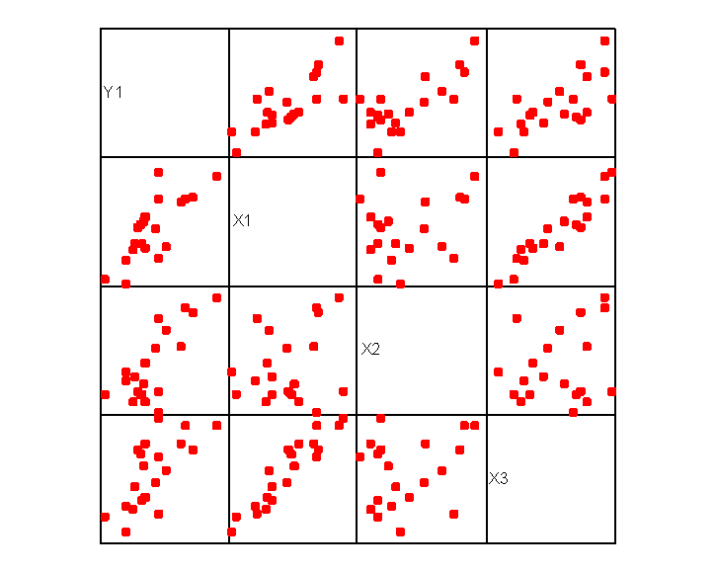

1. **Notation**
   * $m$: number of training examples
   * $n$: number of features
   * $x$: input variable
   * $y$: output variable
   * $x^{(i)}$: input features of ith training example
   * $x_{j}^{(i)}$: value of feature j in ith training example
   * $y^{(i)}$: output of ith training example
   * ($x^{(i)},y^{(i)})$: ith training example

|  |  |  |  |  |  |
| --- | --- | --- | --- | --- | --- |
| $$x_{0}$$ | $x_{1}$: size | $x_{2}$: # of bedrooms | $x_{3}$: # of floors | $x_{4}$: age of house | $$y$$ |
| 1 | 2104 | 5 | 1 | 45 | 460 |
| 1 | 1416 | 3 | 2 | 40 | 232 |

* + This example shows a training data with:
    - 2 training examples
    - 4 features (by convention, there will always be feature 0 & it will always be 1)
    - $x_{3}^{(2)}$: feature 3 of the second training example, which is 2

1. **Hypothesis**
   * Multivariate linear regression equation:
 $$h_{θ}\left(x\right)=θ_{0}x_{0}+θ_{1}x_{1}+θ_{2}x_{2}+…+θ_{n}x_{n}$$

    + Note: we can write $h_{θ}\left(x\right)$ as following:
 $$x=\left(\begin{matrix}x_{0} \\ x_{1} \\ \begin{matrix}⋮ \\ x_{n}\end{matrix}\end{matrix}\right)∈R^{n+1} θ=\left(\begin{matrix}θ_{0} \\ θ_{1} \\ \begin{matrix}⋮ \\ θ_{n}\end{matrix}\end{matrix}\right)∈R^{n+1}$$ $$h_{θ}\left(x\right)={\left(θ\right)}^{T}x=\left(\begin{matrix}θ_{0} & θ_{1} & \begin{matrix}… & θ_{n}\end{matrix}\end{matrix}\right)\left(\begin{matrix}x_{0} \\ x_{1} \\ \begin{matrix}⋮ \\ x_{n}\end{matrix}\end{matrix}\right)$$ * Polynomial regression equation (some examples):
$$h_{θ}\left(x\right)=θ_{0}x_{0}+θ_{1}x_{1}^{1}+θ_{2}x_{2}^{2}+…+θ_{n}x_{n}^{n}$$

$$h_{θ}\left(x\right)=θ_{0}x_{0}+θ_{1}x_{1}^{\frac{1}{2}}+θ_{2}x_{2}^{\frac{1}{4}}+…+θ_{n}x_{n}^{\frac{1}{2n}}$$

2. **Cost Functions**
   * Squared error (SE) cost function:
$$J\left(θ_{0},θ_{1}\right)=\frac{1}{2m}\sum_{i=1}^{m}{{\left(h_{θ}\left(x^{\left(i\right)}\right)-y^{\left(i\right)}\right)}^{2}}$$

$$=\frac{1}{2m}\sum_{i=1}^{m}{{\left({\left(θ\right)}^{T}x^{(i)}-y^{\left(i\right)}\right)}^{2}}$$

$$=\frac{1}{2m}\sum_{i=1}^{m}{{\left(\left(\sum_{j=0}^{n}{θ_{j}x_{j}^{(i)}}\right)-y^{\left(i\right)}\right)}^{2}}$$

3. **Gradient Descent Algorithm Using SE Loss Function for Multivariate Regression**

Repeat until convergence {

}

* + Note:

$$\frac{∂}{∂θ_{j}}J(θ)=\frac{1}{m}\sum_{i=1}^{m}{\left(h_{θ}\left(x^{\left(i\right)}\right)-y^{\left(i\right)}\right)\left(x_{j}^{\left(i\right)}\right)}$$

1. **Feature Scaling**
   * Make sure that the features are on similar scale (i.e. Data normalization)
   * Feature scaling helps making the contour plot of the cost function less skewed. Thus, helping the gradient descent move through a much direct path
   * Here are some formulas used for features scaling:
 $$x_{i}=\frac{x_{i}-\overline{x}}{max⁡(x)}$$ $$x_{i}=\frac{x_{i}-\overline{x}}{\max\left(x\right)-min⁡(x)}$$ $$x_{i}=\frac{x_{i}-\overline{x}}{s}$$* Note: we don’t apply feature scaling to feature 0 (i.e. $x_{0}$) because by convention, it will always be 1
2. **Normal Equation**
   * A method to solve for $θ$ analytically
   * We can apply the following formula to solve for $θ$:
 $$θ={(X^{T}X)}^{-1}X^{T}Y$$  * Example:

|  |  |  |  |  |  |
| --- | --- | --- | --- | --- | --- |
| $$x_{0}$$ | $x_{1}$: size | $x_{2}$: # of bedrooms | $x_{3}$: # of floors | $x_{4}$: age of house | $$y$$ |
| 1 | 2104 | 5 | 1 | 45 | 460 |
| 1 | 1416 | 3 | 2 | 40 | 232 |
| 1 | 1534 | 3 | 2 | 30 | 315 |
| 1 | 852 | 2 | 1 | 36 | 178 |

Construct a matrix $X$ and $Y$ from the data:

$$X=\left[\begin{matrix}\begin{matrix}1 \\ 1 \\ \begin{matrix}1 \\ 1\end{matrix}\end{matrix} & \begin{matrix}2104 \\ 1416 \\ \begin{matrix}1534 \\ 852\end{matrix}\end{matrix} & \begin{matrix}\begin{matrix}5 \\ 3 \\ \begin{matrix}3 \\ 2\end{matrix}\end{matrix} & \begin{matrix}1 \\ 2 \\ \begin{matrix}2 \\ 1\end{matrix}\end{matrix} & \begin{matrix}45 \\ 40 \\ \begin{matrix}30 \\ 36\end{matrix}\end{matrix}\end{matrix}\end{matrix}\right] Y=\left[\begin{matrix}460 \\ \begin{matrix}232 \\ 315 \\ 178\end{matrix}\end{matrix}\right]$$

From here, we can solve for …

* + Note:
    - Using normal equation method does not require us to do feature scaling.
    - There are some pros and cons of normal equation method

|  |  |
| --- | --- |
| **Gradient descent** | **Normal equation** |
| * Need to choose $α$ | * No need to choose $α$ |
| * Need many iterations | * Don’t need to iterate |
| * Works well even when n is large | * Slow when n is large because it needs to compute the inverse of $X^{T}X$ (~ $O(n^{3}))$ |
|  | $X^{T}X$* may not be invertible |

* + - If the matrix is not invertible, we can try:
      * Pseudoinverse the matrix (?)
      * Remove redundant features (linearly dependent features)
      * Have fewer features (Could affect the correctness)

1. **Note**
   * In multivariate regression, two problems may arise:
     + Overfitting: caused by adding too many independent variables; they account for more variance but add nothing to the model
     + Multicollinearity: happens when some/all of the independent variables ($x_{1}, x_{2},…$) are correlated with each other 🡪 we want to eliminate multicollinearity.