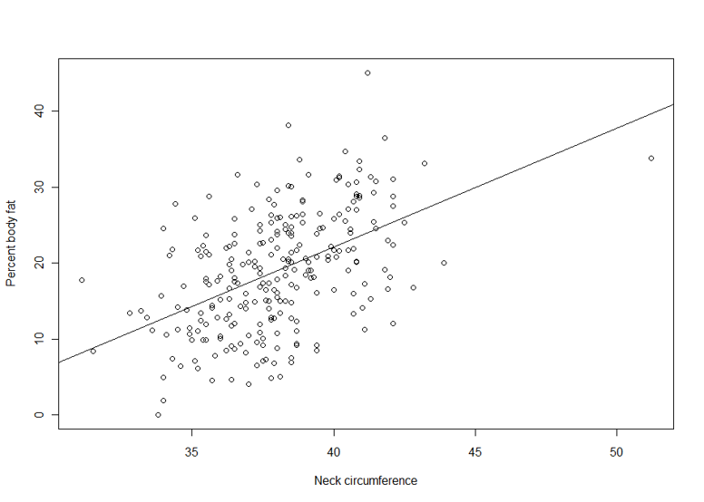

Simple linear regression model

1. **Notation:**
   * $m$: number of training examples
   * $x$: input variable
   * $y$: output variable
   * $x^{(i)}$: input of ith training example
   * $y^{(i)}$: output of ith training example
   * ($x^{(i)},y^{(i)})$: ith training example
2. **Hypothesis: $$h_{θ}\left(x\right)=θ_{0}+θ_{1}x$$**
3. **Cost (Loss) Functions:** 
   * Squared error (SE) cost function: $$J\left(θ_{0},θ_{1}\right)=\frac{1}{2m}\sum_{i=1}^{m}{{\left(h_{θ}\left(x^{\left(i\right)}\right)-y^{\left(i\right)}\right)}^{2}}$$
   * Sum squared error (SSE) cost function:
 $$J\left(θ_{0},θ_{1}\right)=\sum_{i=1}^{m}{{\left(h_{θ}\left(x^{\left(i\right)}\right)-y^{\left(i\right)}\right)}^{2}}$$  * Mean squared error (MSE) cost function:
 $$J\left(θ_{0},θ_{1}\right)=\frac{1}{m}\sum_{i=1}^{m}{{\left(h_{θ}\left(x^{\left(i\right)}\right)-y^{\left(i\right)}\right)}^{2}}$$  * Root mean squared error (RMSE) cost function:
     + For classification problem, RMSE is not a good choice for loss function
$$J\left(θ_{0},θ_{1}\right)=\sqrt{\frac{\sum_{i=1}^{m}{{\left(h_{θ}\left(x^{\left(i\right)}\right)-y^{\left(i\right)}\right)}^{2}}}{m}}$$

4. **General Gradient Descent Algorithm for Simple Linear Regression:**

Repeat until convergence {

$$θ_{j}∶=θ_{j}-α\frac{∂}{∂θ_{j}}J\left(θ_{0},θ_{1}\right) ; \left(for j=0, 1\right)$$

}

1. **Gradient Descent Algorithm Using SE Loss Function in SLR:**

Repeat until convergence {

$$θ_{0}∶=θ_{0}-α\frac{1}{m}\sum_{i=1}^{m}{\left[\left(1\right)×\left(h_{θ}\left(x^{\left(i\right)}\right)-y^{\left(i\right)}\right)\right]}$$

$$θ_{1}∶=θ_{1}-α\frac{1}{m}\sum_{i=1}^{m}{\left[\left(x^{i}\right)×\left(h_{θ}\left(x^{\left(i\right)}\right)-y^{\left(i\right)}\right)\right]}$$

}

1. **Note:**
   * We have a cost function and we want to minimize the cost function to obtain an optimal solution for the hypothesis function 🡪 Use gradient descent algorithm to continuously finding $θ_{0},θ_{1}$ values that are closest to the $\min{J(θ_{0},θ_{1})}$
   * The $α$ value is called: learning rate.
     + It determines the aggressiveness of the learning algorithm
     + If $α$ is too small 🡪 gradient descent can be slow
     + If $α$ is too big 🡪 gradient descent can overshoot the minimum. It may fail to converge, or even diverge

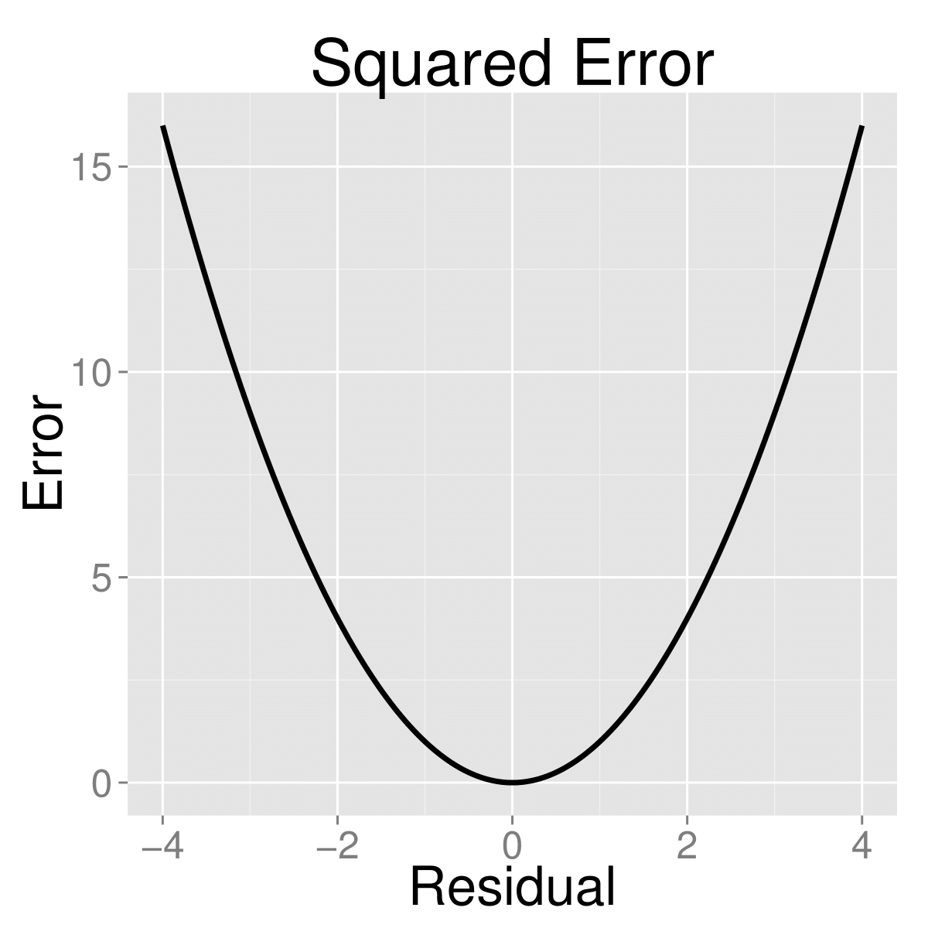

Example of the squared-error loss function

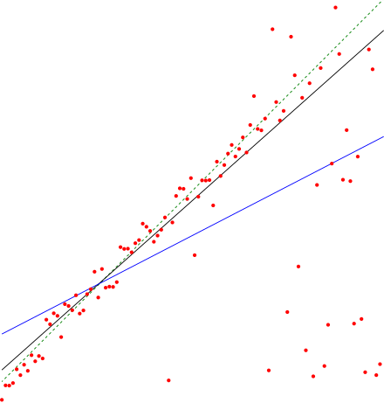

Example of different hypothesis base on different set of

* + For SLR, when we plot the cost function $J\left(θ_{0},θ_{1}\right)$, the resulting graph is a convex function (has only 1 global minimum). Because of this, another approach from using gradient descent is to set the partial derivative with respect to $θ_{0},θ_{1}$ to be 0 in order to find the minimum.
  + Another approach to find the hypothesis function would be using Pearson’s R correlation coefficient (PCC):
 $$θ_{0}=\overline{y}-θ_{1}\overline{x}$$

 $$θ_{1}=r\left(\frac{s_{y}}{s_{x}}\right)$$

$$r= \frac{\sum_{i=1}^{m}{\left(z_{x^{(i)}}\right)\left(z_{y^{(i)}}\right)}}{m-1}$$

$$s_{x}=\sqrt{\frac{\sum_{i=1}^{m}{{\left(x^{(i)}-\overline{x}\right)}^{2}}}{m-1}} s_{y}=\sqrt{\frac{\sum_{i=1}^{m}{{\left(y^{(i)}-\overline{y}\right)}^{2}}}{m-1}}$$

$$z_{x^{(i)}}=\frac{x^{\left(i\right)}-\overline{x}}{s_{x}} z_{y^{(i)}}=\frac{y^{\left(i\right)}-\overline{y}}{s_{y}}$$

$$\overline{x}=\frac{\sum_{i=1}^{m}{x^{(i)}}}{m} \overline{y}=\frac{\sum_{i=1}^{m}{y^{(i)}}}{m}$$

+ Before deciding whether we should apply SLR or not, if we compute the Pearson’s R correlation coefficient and find that $\left|r\right|≥\frac{2}{\sqrt{m}}$, then we can say that a linear relationship exists