 Translated from Vietnamese to English - www.onlinedoctranslator.com

PRICE LIST FOR MACHINES
April 8, 2026
- Customer name:LIMITED LIABILITY COMPANYMOONPO DEVELOPMENT VIETNAM
- Address: Lot CN-01, Dong Van IV Industrial Zone, Le Ho Ward, Ninh Binh Province, Vietnam
- Tax ID: 0700834811
INTRODUCE
Hung Cuong Industrial Machinery and Equipment Co., Ltd. would like to express our gratitude to our valued customers for using the solutions and equipment we provide! We wish you good health, peace, and prosperity!
I. Company Information
1. Company name: Hung Cuong Industrial Machinery and Equipment Co., Ltd.
- Address: No. 24, Lane 50, Nguyen Huu Tho Street, Dinh Cong Ward, Hanoi City, Vietnam.
- Office:
Hanoi Branch: 19 Dai Tu Street, Dinh Cong Ward, Hanoi City. Ho Chi Minh City Branch: 25/4 HT13 Street, Quarter 28, Tan Thoi Hiep Ward, Ho Chi Minh City.
- Hotline: 0961.408.068
- Email: sales04.hungcuong@gmail.com

PART 1: QUOTATION
1. Detailed equipment price list
Unit of measurement: Vietnamese Dong
No. | Name of machine/device | Note | SL | Unit price | Total amount before tax
1 | Fiber laser engraving machine, 20W laser power, with automatic conveyor belt. | Warranty: 12 months | 01 | 68,000,000 | 68,000,000
2 | Fiber laser engraving machine, 50W laser power, with integrated camera. | Warranty: 12 months | 01 | 145,000,000 | 145,000,000
Total amount |  |  |  |  | 213,000,000
VAT (0%)
Total payment |  |  |  |  | 213,000,000
- The quotation is valid for 10 days from the date of submission. Installation and transportation costs are included.
- Delivery time: 25-30 days from the date of deposit receipt, for custom-made orders.
2. Terms of Trade
- Pay:
ButThe Buyer shall pay 50% of the Contract value in advance after both parties sign the Sales Contract.
ButThe Buyer shall pay the remaining 50% of the Contract value within 15 days after the Seller delivers the machine, provides user instructions, and issues the VAT invoice.
ACB Bank – Dinh Cong Branch – Phap Van Transaction Office
Account Number: 559455955596
– CTK: HUNG CUONG INDUSTRIAL MACHINERY AND EQUIPMENT CO., LTD.
- Commit:
+ The goods and equipment supplied by Hung Cuong Industrial Machinery and Equipment Co., Ltd. are guaranteed to be 100% brand new. The technical specifications and machine structure comply with the manufacturer's standards and are clearly shown in this quotation.
PART 2: MACHINE IMAGES
Fiber laser engraving machine with integrated camera
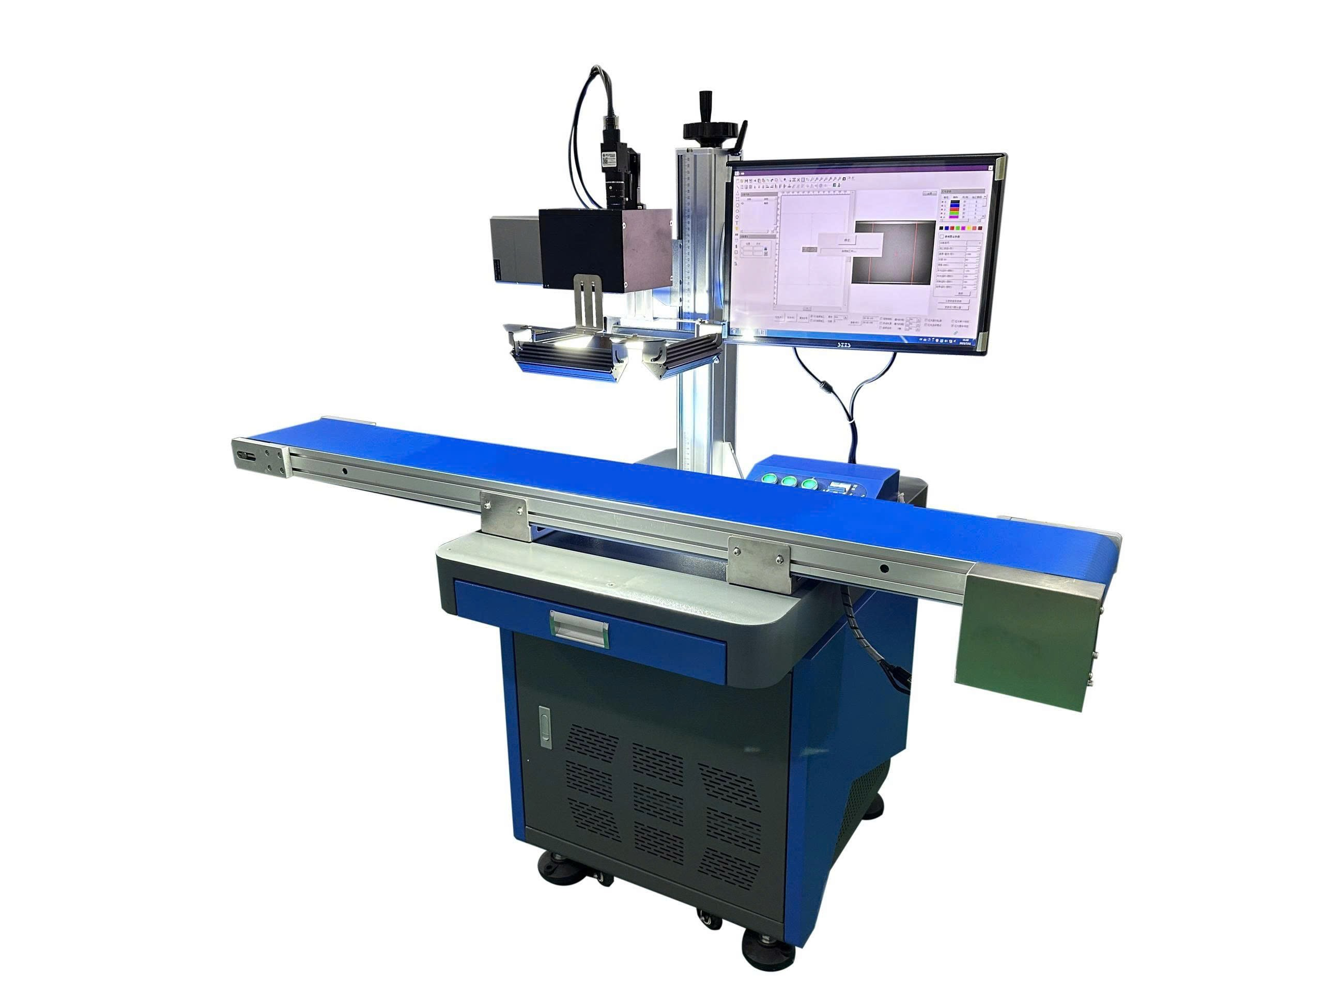

Specifications:
Type | Fiber optic laser
Laser power | 50W, engraving area 200x140mm
Hardware industry | High molecular weight polyethylene materials, such as those used in food, beverages, pipes, daily chemicals, etc.
Engraving method | Simultaneous X-axis and Y-axis scanning
Static engraving | Multiple products can be marked at the same time.
Camera specifications | Hikvision 10 Million Pixels
Lens specifications | V2528-MPY-10 Million Pixels
Wavelength | 1064 nm
Frequency | 20 – 80 KHz
Beam width | 0.01 mm
Smallest character | 0.1 mm
Engraving depth | 0 – 1 mm
Engraving speed | 7000 mm/s
Repeatability | 0.001 mm
Positioning head | M2: 1.2~1.8
Content | Characters, letters, numbers, logos, images, barcodes, etc.
Format support | BMP/DXF/JPEG/PLT/AI/GIF….
Power source | AC220V/50-60Hz
Power consumption | 1200W
Protection level | IP55
Operating temperature | But10℃-45℃ (non-condensing)
Working humidity | 10%-85% (non-condensing)
Life expectancy | 100,000 hours

Fiber laser engraving machine with conveyor belt
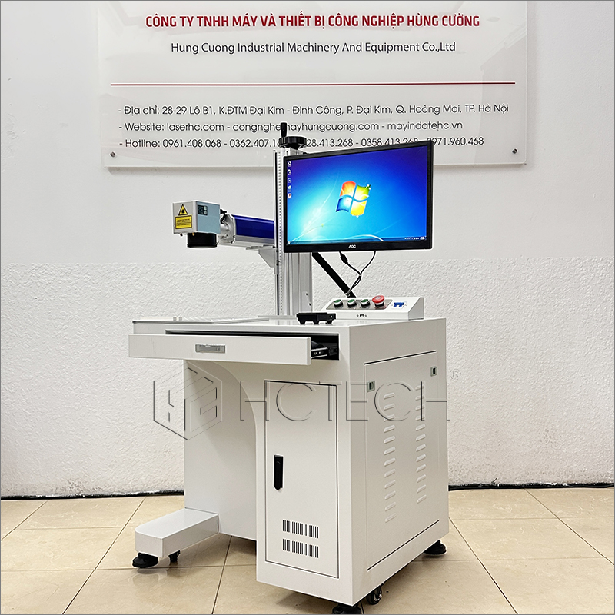

Specifications:
Application sector | Electronic products, metal hardware, motorcycle parts, wires and cables and pipes, and other industries.
Marking materials | Metals, non-metals, PVC, PE, PC, CPP, PA, PPO, etc.
Characteristics of laser engraving machines | Machine material | Aluminum, sheet metal
Characteristics of laser engraving machines | Laser power | 20W
Characteristics of laser engraving machines | Wavelength | 1064nm
Characteristics of laser engraving machines | Marking speed | ≤7000mm/s
Characteristics of laser engraving machines | Operating system | Windows
Characteristics of laser engraving machines | Cooling method | Cools the air to normal temperature (no compressed air required).
Characteristics of laser engraving machines | Marking system | Yellow orange
Characteristics of laser engraving machines | Operating platform | Industrial computers
Characteristics of laser engraving machines | Connection port | USB2.0
Characteristics of laser engraving machines | Data protection | Ensure user data is not lost in the event of a sudden power outage.
Characteristics of laser engraving machines | Rotate the lens | The scanning head can rotate 90 degrees.
Characteristics of laser engraving machines | Power source | AC220V, 50-60Hz:
Characteristics of laser engraving machines | Power | 700W
Characteristics of laser engraving machines | Protection level | IP54
Characteristics of laser engraving machines | Machine weight | 80kg
Characteristics of laser engraving machines | Machine dimensions | 650mm*520mm*1480mm
Characteristics of laser engraving machines | Pollution level | The marking process itself does not produce any chemicals.
Environmental resistance | Storage temperature | -10℃-45℃ (non-condensing)
Environmental resistance | Operating temperature | -10℃-45℃ (non-condensing)
Environmental resistance | Storage humidity | 10%-85% (non-condensing)
Environmental resistance | Working humidity | 10%-85% (non-condensing)
Lens specifications | Engraving range | Standard 110*110mm
Lens specifications | Type of marker | Matrix of points, vector
Lens specifications | Minimum line width | 0.01mm
Lens specifications | Repeatability | 0.01mm
Lens specifications | Location method | Red light positioning, red light focusing
Lens specifications | Number of lines of highlighted characters | Freely edit within the markup area.
Character type | Supported font types | Single-line fonts/two-line fonts/bit matrix fonts
Character type | Graphic file format | PLT formatted vector file input/output
Character type | File format | BMP/DXF/JPEG/PLT
Character type | Graphic elements | Points, lines, curved text, rectangles, circles
Character type | Transform file | Serial number, time, date, counter, shift
Character type | Barcode | Code39, Code93, Code128, EAN-13…
Character type | QR | QR Code, Data Matrix…
Customize the software. | The software can be customized and developed to meet the different control requirements of the user's production line.
Sincerely, we look forward to cooperating with you!

