Đây là bài thực hành DATAPATH

Sum = 0+1+2+…+n

N input

Int Sum = 0;

While(n!=0)

{

Sum += n;

n--

}

Output = Sum

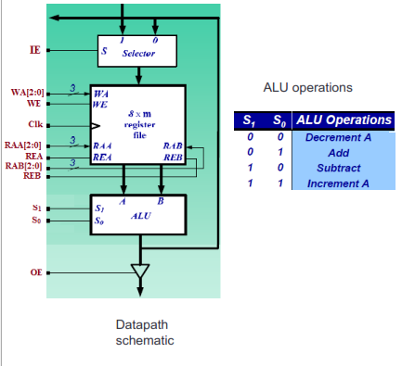

1. 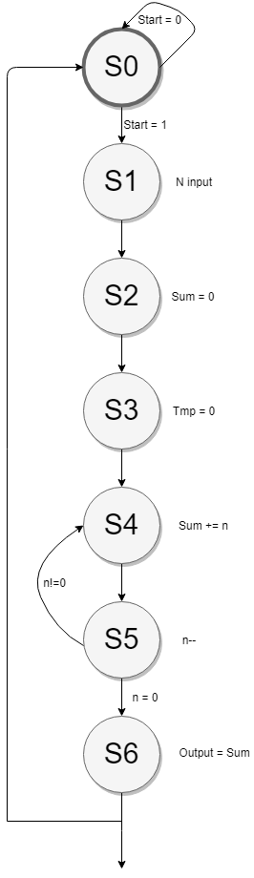N input
2. Sum = 0
3. Tmp = 0

While ( n!= 0 ) repeat

4.Sum = Sum + n

5. n--

End while

6. Ouput = Sum

R0 : tmp

R1 : N

R2 : Sum

R3 : Output

Repeat while n!=0

|  |  |  |  |  |  |  |  |
| --- | --- | --- | --- | --- | --- | --- | --- |
| Control  Words | IE | Write Address | Read Address A | Read Address B | Alu Operation | Shift Operation | OE |
| 1 | 1 | R1 | X | X | X | X | 0 |
| 2 | 0 | R2 | R2 | R2 | Sub | X | 0 |
| 3 | 0 | R0 | R0 | R0 | Sub | X | 0 |
| 4 | 0 | R2 | R2 | R1 | Add | X | 0 |
| 5 | 0 | R1 | R1 | 0 | Decrement | X | 0 |
| 6 | 0 | R3 | R2 | 0 | Add | X | 1 |

|  |  |  |  |  |  |  |  |  |  |  |  |  |  |  |  |  |  |  |
| --- | --- | --- | --- | --- | --- | --- | --- | --- | --- | --- | --- | --- | --- | --- | --- | --- | --- | --- |
|  |  | | |  | Write Address | | | | Read Address A | | | | Read Address B | | | | ALU | |
| State | Q2 | Q1 | Q0 | IE | WA2 | WA1 | WA0 | WE | RAA2 | RAA1 | RAA0 | REA | RAB2 | RAB1 | RAB0 | REB | S1 | S0 | OE |
| S0 | 0 | 0 | 0 | 0 | X | X | X | 0 | X | X | X | 0 | X | X | X | 0 | X | X | 0 |
| S1 | 0 | 0 | 1 | 1 | 0 | 0 | 1 | 1 | X | X | X | 0 | X | X | X | 0 | X | X | 0 |
| S2 | 0 | 1 | 0 | 0 | 0 | 1 | 0 | 1 | 0 | 1 | 0 | 1 | 0 | 1 | 0 | 1 | 1 | 0 | 0 |
| S3 | 0 | 1 | 1 | 0 | 0 | 0 | 0 | 1 | 0 | 0 | 0 | 1 | 0 | 0 | 0 | 1 | 1 | 0 | 0 |
| S4 | 1 | 0 | 0 | 0 | 0 | 1 | 0 | 1 | 0 | 1 | 0 | 1 | 0 | 0 | 1 | 1 | 0 | 1 | 0 |
| S5 | 1 | 0 | 1 | 0 | 0 | 0 | 1 | 1 | 0 | 0 | 1 | 1 | X | X | X | 0 | 0 | 0 | 0 |
| S6 | 1 | 1 | 0 | 0 | 0 | 1 | 1 | 1 | 0 | 1 | 0 | 1 | 0 | 0 | 0 | 1 | 0 | 1 | 1 |
| S7 | 1 | 1 | 1 | X | X | X | X | X | X | X | X | X | X | X | X | X | X | X | X |

IE = Q2’Q1’Q0

WA2 = 0

WA1 = Qo’

WA0 = Q1’Q0 + Q2Q1

WE = Q2 + Q1 + Q0  
RAA2 = Q1’Q2’

RAA1 = Q0’

RAA0 = Q2Q0

REA = Q2 + Q1

RAB2 = RAA0

RAB1 = Q2’Q0’

RAB0 = Q1’

REB = Q1 + Q2Q0’

S1 = Q2’

S0 = Q2Q0’

OE = Q2Q1

Next state table

|  |  |  |  |  |  |  |  |  |  |  |  |  |  |  |  |  |
| --- | --- | --- | --- | --- | --- | --- | --- | --- | --- | --- | --- | --- | --- | --- | --- | --- |
| States | Q2Q1Q0 | | | Start,(n = 0) | | | | | | | | | | | | |
| 00 | | | 01 | | | 10 | | | 11 | | | |
| S0 | 0 | 0 | 0 | 0 | 0 | 0 | 0 | 0 | 0 | 0 | 0 | 1 | 0 | 0 | 1 |
| S1 | 0 | 0 | 1 | 0 | 1 | 0 | 0 | 1 | 0 | 0 | 1 | 0 | 0 | 1 | 0 |
| S2 | 0 | 1 | 0 | 0 | 1 | 1 | 0 | 1 | 1 | 0 | 1 | 1 | 0 | 1 | 1 |
| S3 | 0 | 1 | 1 | 1 | 0 | 0 | 1 | 0 | 0 | 1 | 0 | 0 | 1 | 0 | 0 |
| S4 | 1 | 0 | 0 | 1 | 0 | 1 | 1 | 0 | 1 | 1 | 0 | 1 | 1 | 0 | 1 |
| S5 | 1 | 0 | 1 | 1 | 0 | 0 | 1 | 1 | 0 | 1 | 0 | 0 | 1 | 1 | 0 |
| S6 | 1 | 1 | 0 | 0 | 0 | 0 | 0 | 0 | 0 | 0 | 0 | 0 | 0 | 0 | 0 |
| S7 | 1 | 1 | 1 | X | X | X | X | X | X | X | X | X | X | X | X |

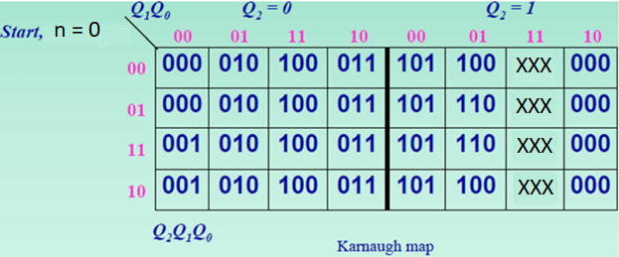

Q2+ = Q2Q1’ + Q1Q0Q2’

Q1+ = (n=0)Q1’Q0 + Q1’Q0Q2’ + Q1Q0’Q2’

= (n=0)Q1’Q0 + Q2’(Q1 or Q0)

Q0+ = (Start)Q1’Q0’ + Q1Q0’Q2’ + Q1’Q0’Q2

= (Start)Q1’Q0’ + Q0’(Q1 or Q2)

