1.Đây là một bài tập ví dụ trước khi vào làm LAB01.

Đề bài :

1. Thực hiện bộ đếm từ 0 -> 15
2. Thực hiện bộ đếm từ 0 -> 10
3. Thực hiện bộ đếm từ 5 -> 10

* Bên trong bộ package COUNT0to15 là 4 FFD với chức năng nhận giá trị từ ngõ INPUT D và đưa ra giá trị ở OUTPUT Q với RST và CLR đồng bộ.
* Khi RST và CLR tích cực mức thấp thì COUNT0to15 xuất giá trị ở OUTPUT Q.
* Khi một giá trị được xuất ra thì giá trị này sẽ được nối với các ngõ input A của package ADD1 (đây là bộ cộng một)
* Sau đó ngõ ra OUTPUT B của ADD1 sẽ tăng thêm 1 giá trị ứng với ngõ vào INPUT A rồi gán ngược lại cho input D của COUNT0to15. Cứ như thế cho đến giá trị 15 rồi tự RESET về 0

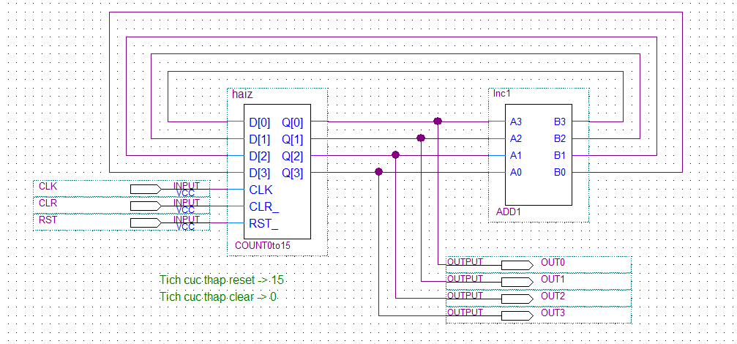

**Bộ đếm từ 0 -> 15**

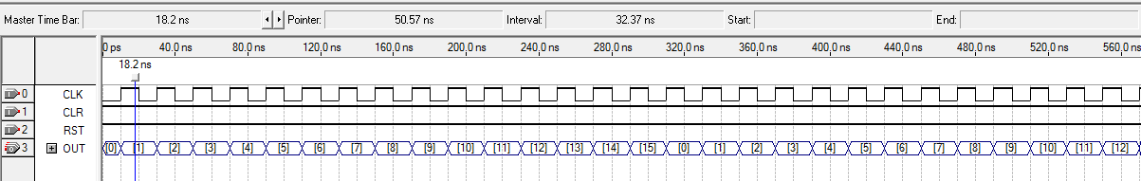

**Waveform test Bộ đếm từ 0 -> 15**

* Bên trong bộ package COUNT0to10 là 4 FFD với chức năng nhận giá trị từ ngõ INPUT D và đưa ra giá trị ở OUTPUT Q với RST và CLR đồng bộ.
* Ban đầu ta cho RST tích cực mức thấp để khởi tạo giá trị lần đầu cho CLR bằng cách cho select ở MUX2to1b , nếu không mạch sẽ không chạy. thì OUTPUT luôn bằng 15
* Tiếp đến ta cho RST tích cực mức cao , MUX2to1b sẽ nhận giá trị từ MUX2to1a. MUX2to1a có nhiệm vụ so sánh và cho ra giá trị phù hợp khi nhận từ OUTPUT của ADD1. Khi giá trị bằng 12 tức 1100 thì bộ đếm sẽ reset về 0 .Cứ như thế cho đến giá trị 10 rồi RESET về 0

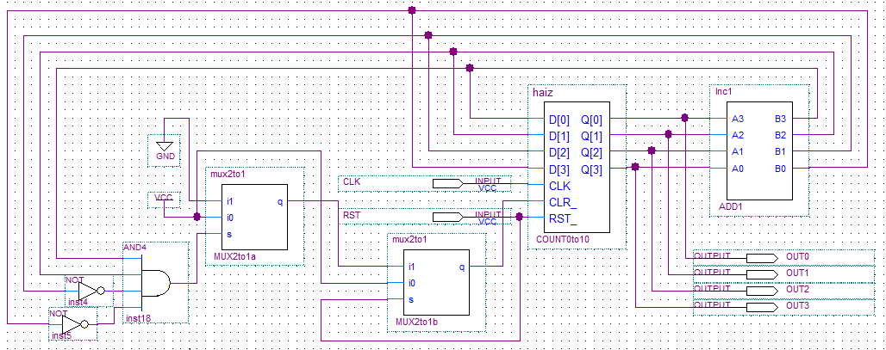

**Bộ đếm từ 0 -> 10**

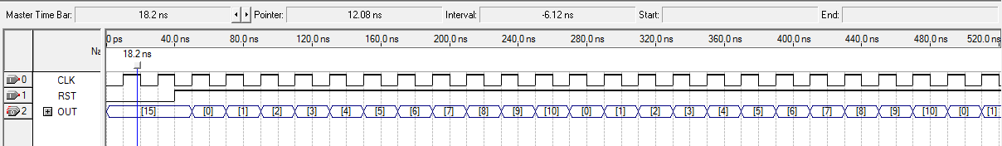

**Waveform test Bộ đếm từ 0 -> 10**

1. Đếm từ 5->10 => 6states => 3FFD

Mã hoá S0,S1,S3,S7,S6,S4 ứng với mỗi states

|  |  |  |  |  |  |  |  |  |  |
| --- | --- | --- | --- | --- | --- | --- | --- | --- | --- |
| Current State | | | Next State(Q+ = D ) | | | OUTPUT | | | |
| Q2 | Q1 | Q0 | Q2+ | Q1+ | Q0+ | Y3 | Y2 | Y1 | Y0 |
| 0 | 0 | 0 | 0 | 0 | 1 | 0 | 1 | 0 | 1 |
| 0 | 0 | 1 | 0 | 1 | 1 | 0 | 1 | 1 | 0 |
| 0 | 1 | 1 | 1 | 1 | 1 | 0 | 1 | 1 | 1 |
| 1 | 1 | 1 | 1 | 1 | 0 | 1 | 0 | 0 | 0 |
| 1 | 1 | 0 | 1 | 0 | 0 | 1 | 0 | 0 | 1 |
| 1 | 0 | 0 | 0 | 0 | 0 | 1 | 0 | 1 | 0 |

Phương trình ngõ vào INPUT

|  |  |  |  |  |
| --- | --- | --- | --- | --- |
| Q1 Q0  Q2 | 00 | 01 | 11 | 10 |
| 0 |  |  | 1 |  |
| 1 |  |  | 1 | 1 |

D2 = Q2Q1 + Q1Q0

|  |  |  |  |  |
| --- | --- | --- | --- | --- |
| Q1 Q0  Q2 | 00 | 01 | 11 | 10 |
| 0 |  |  | 1 | 1 |
| 1 |  |  |  | 1 |

D1 = Q1Q0 + Q2’Q0

|  |  |  |  |  |
| --- | --- | --- | --- | --- |
| Q1 Q0  Q2 | 00 | 01 | 11 | 10 |
| 0 |  | 1 | 1 | 1 |
| 1 |  |  |  |  |

D0 = Q2’Q1’ + Q2’Q0 = Y2

Phương trình OUTPUT

|  |  |  |  |  |
| --- | --- | --- | --- | --- |
| Q1 Q0  Q2 | 00 | 01 | 11 | 10 |
| 0 |  |  |  |  |
| 1 | 1 |  | 1 | 1 |

Y3 = Q2Q1 + Q2Q0’

|  |  |  |  |  |
| --- | --- | --- | --- | --- |
| Q1 Q0  Q2 | 00 | 01 | 11 | 10 |
| 0 |  | 1 | 1 |  |
| 1 | 1 |  |  |  |

Y1= Q2Q1’Q0’ + Q2’Q0

|  |  |  |  |  |
| --- | --- | --- | --- | --- |
| Q1 Q0  Q2 | 00 | 01 | 11 | 10 |
| 0 | 1 |  | 1 |  |
| 1 |  |  |  | 1 |

Y0= Q2’Q1’Q0’ + Q2’Q1Q0 + Q2Q1Q0’

= Q2(Q1 xor Q0)’ + Q2Q1Q0’

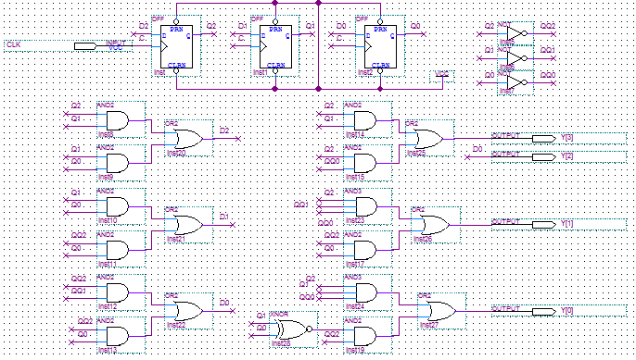

**Bộ đếm từ 5 - > 10**

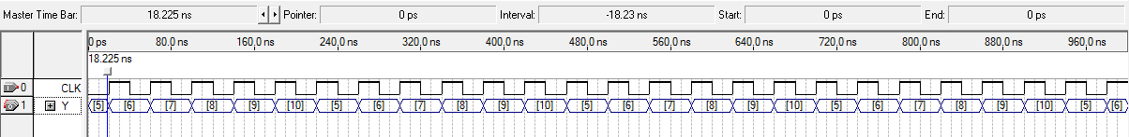

**Waveform test Bộ đếm từ 5 -> 10**

2. Đây là bài thực hành LAB01 ứng với bài thực hành trong file thực hành môn TKLLS.

|  |  |  |  |  |  |  |  |  |
| --- | --- | --- | --- | --- | --- | --- | --- | --- |
| Current State | | | Next State = OUTPUT | | | INPUT | | |
| Q2 | Q1 | Q0 | Q2+ | Q1+ | Q0+ | T2 | T1 | T0 |
| 0 | 0 | 0 | 1 | 1 | 0 | 1 | 1 | 0 |
| 0 | 0 | 1 | 1 | 1 | 0 | 1 | 1 | 1 |
| 0 | 1 | 0 | 1 | 1 | 1 | 1 | 0 | 1 |
| 0 | 1 | 1 | 0 | 0 | 0 | 0 | 1 | 1 |
| 1 | 0 | 0 | 1 | 1 | 1 | 0 | 1 | 1 |
| 1 | 0 | 1 | 0 | 1 | 0 | 1 | 1 | 1 |
| 1 | 1 | 0 | 1 | 0 | 0 | 0 | 1 | 0 |
| 1 | 1 | 1 | 0 | 1 | 1 | 1 | 0 | 0 |

|  |  |  |  |  |
| --- | --- | --- | --- | --- |
| Q1 Q0  Q2 | 00 | 01 | 11 | 10 |
| 0 | 1 | 1 |  | 1 |
| 1 |  | 1 | 1 |  |

T2 = Q2’Q0’ + Q1’Q0 + Q2Q0

= (Q2 xor Q0)’ + Q1’Q0

|  |  |  |  |  |
| --- | --- | --- | --- | --- |
| Q1 Q0  Q2 | 00 | 01 | 11 | 10 |
| 0 | 1 | 1 | 1 |  |
| 1 | 1 | 1 |  | 1 |

T1 = Q1’ + Q2’Q0 + Q2Q0’

= Q1’ + (Q2 xor Q0)

|  |  |  |  |  |
| --- | --- | --- | --- | --- |
| Q1 Q0  Q2 | 00 | 01 | 11 | 10 |
| 0 |  | 1 | 1 | 1 |
| 1 | 1 | 1 |  |  |

T0 = Q1’Q0 + Q2Q1’ + Q2’Q1

= Q1’Q0 + (Q2 xor Q1)

|  |  |  |  |  |  |
| --- | --- | --- | --- | --- | --- |
| Load | Q | Enable | Q+ | Pre | Clr |
| 0 | 0 | 0 | 0 | 1 | 1 |
| 0 | 0 | 1 | 0 | 1 | 0 |
| 0 | 1 | 0 | 1 | 1 | 1 |
| 0 | 1 | 1 | 0 | 1 | 0 |
| 1 | 0 | 0 | 0 | 1 | 1 |
| 1 | 0 | 1 | 1 | 0 | 1 |
| 1 | 1 | 0 | 1 | 1 | 1 |
| 1 | 1 | 1 | 1 | 0 | 1 |

|  |  |  |  |  |
| --- | --- | --- | --- | --- |
| Q1 Q0  Q2 | 00 | 01 | 11 | 10 |
| 0 | 1 | 1 | 1 | 1 |
| 1 | 1 | 0 | 0 | 1 |

|  |  |  |  |  |
| --- | --- | --- | --- | --- |
| Q1 Q0  Q2 | 00 | 01 | 11 | 10 |
| 0 | 1 | 0 | 0 | 1 |
| 1 | 1 | 1 | 1 | 1 |

Pre = Enable’ + Load’ Clr = Enable’ + Load

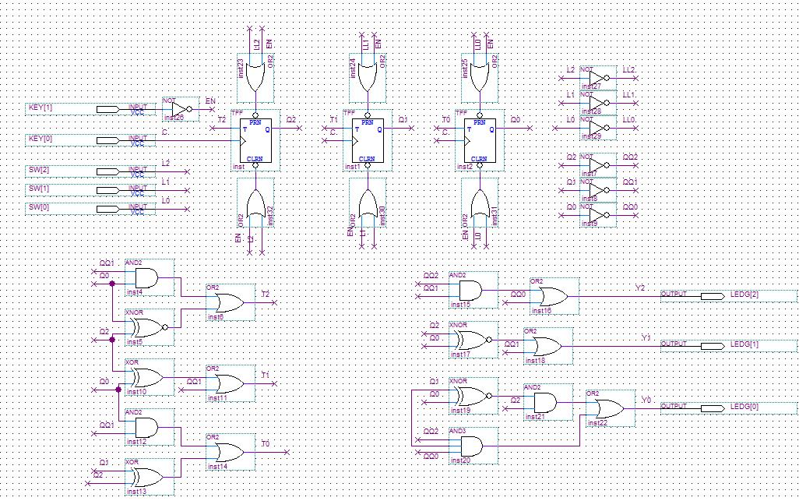

**Bộ đếm BĐB**

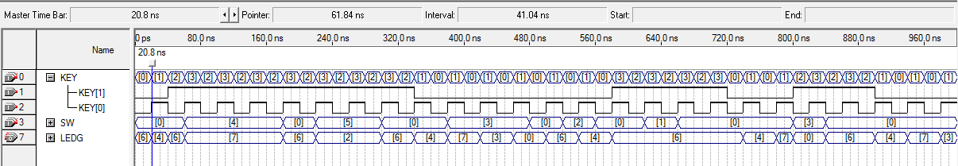

**Waveform test Bộ đếm BĐB**

3.Đây là bài thực hành đầu tiên tạo thanh ghi 1 ghi 1 đọc

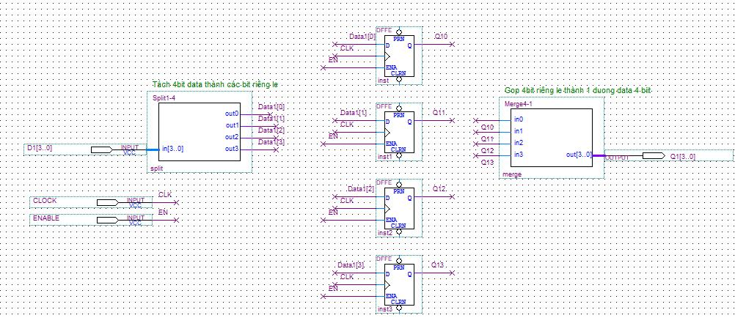

**Thanh ghi 4 bit**

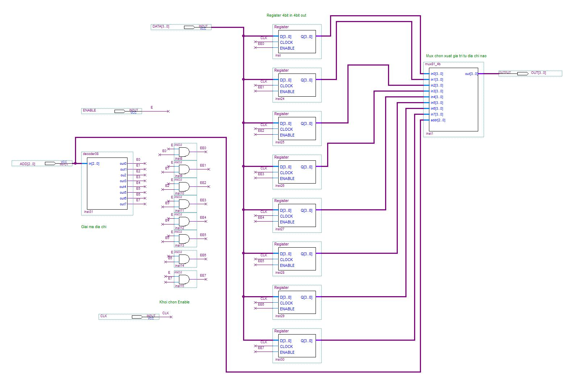

**Sơ đồ để tạo thanh ghi có 1 đường ghi 1 đường đọc**

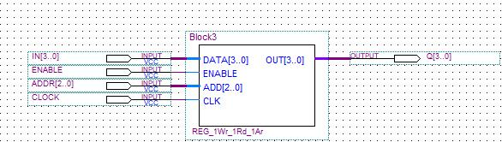

**Mạch đóng gói cuối cùng**

4. Đây là bài thực hành thứ 2 tạo thanh ghi 2 ghi 2 đọc



**Thanh ghi 4 bit**

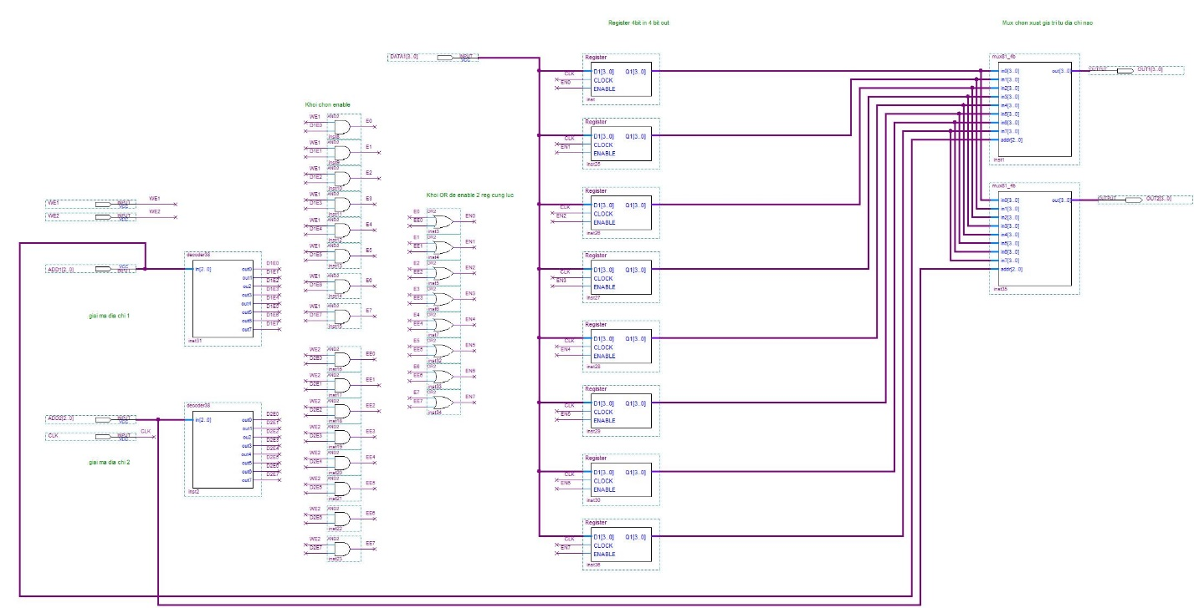

**Sơ đồ để tạo thanh ghi có 2 đường ghi 2 đường đọc**

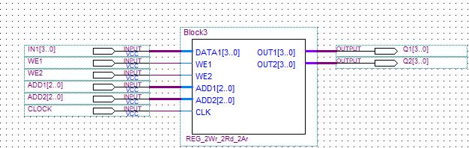

**Mạch đóng gói cuối cùng**

5.Đây là bài thực hành DATAPATH : Sum = 0+1+2+…+n

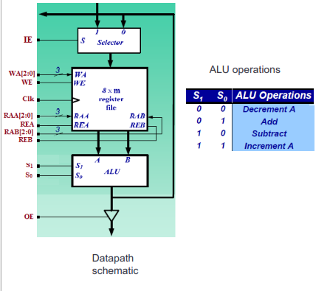

N input

Int Sum = 0;

While(n!=0)

{ Sum += n;

n--; }

Output = Sum

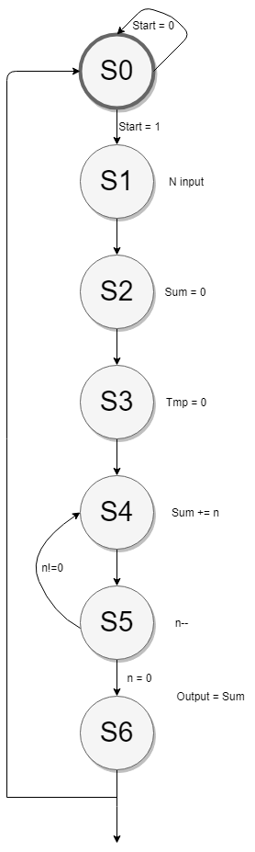

1. N input
2. Sum = 0
3. Tmp = 0

While ( n!= -1 ) repeat

4.Sum = Sum + n

5. n--

End while

6. Ouput = Sum

R0 : tmp

R1 : N

R2 : Sum

R3 : Output

Repeat while n!=0

|  |  |  |  |  |  |  |  |
| --- | --- | --- | --- | --- | --- | --- | --- |
| Control  Words | IE | Write Address | Read Address A | Read Address B | Alu Operation | Shift Operation | OE |
| 1 | 1 | R1 | X | X | X | X | 0 |
| 2 | 0 | R2 | R2 | R2 | Sub | X | 0 |
| 3 | 0 | R0 | R0 | R0 | Sub | X | 0 |
| 4 | 0 | R2 | R2 | R1 | Add | X | 0 |
| 5 | 0 | R1 | R1 | 0 | Decrement | X | 0 |
| 6 | 0 | R3 | R2 | 0 | Add | X | 1 |

|  |  |  |  |  |  |  |  |  |  |  |  |  |  |  |  |  |  |  |
| --- | --- | --- | --- | --- | --- | --- | --- | --- | --- | --- | --- | --- | --- | --- | --- | --- | --- | --- |
|  |  | | |  | Write Address | | | | Read Address A | | | | Read Address B | | | | ALU | |
| State | Q2 | Q1 | Q0 | IE | WA2 | WA1 | WA0 | WE | RAA2 | RAA1 | RAA0 | REA | RAB2 | RAB1 | RAB0 | REB | S1 | S0 | OE |
| S0 | 0 | 0 | 0 | 0 | X | X | X | 0 | X | X | X | 0 | X | X | X | 0 | X | X | 0 |
| S1 | 0 | 0 | 1 | 1 | 0 | 0 | 1 | 1 | X | X | X | 0 | X | X | X | 0 | X | X | 0 |
| S2 | 0 | 1 | 0 | 0 | 0 | 1 | 0 | 1 | 0 | 1 | 0 | 1 | 0 | 1 | 0 | 1 | 1 | 0 | 0 |
| S3 | 0 | 1 | 1 | 0 | 0 | 0 | 0 | 1 | 0 | 0 | 0 | 1 | 0 | 0 | 0 | 1 | 1 | 0 | 0 |
| S4 | 1 | 0 | 0 | 0 | 0 | 1 | 0 | 1 | 0 | 1 | 0 | 1 | 0 | 0 | 1 | 1 | 0 | 1 | 0 |
| S5 | 1 | 0 | 1 | 0 | 0 | 0 | 1 | 1 | 0 | 0 | 1 | 1 | X | X | X | 0 | 0 | 0 | 0 |
| S6 | 1 | 1 | 0 | 0 | 0 | 1 | 1 | 1 | 0 | 1 | 0 | 1 | 0 | 0 | 0 | 1 | 0 | 1 | 1 |
| S7 | 1 | 1 | 1 | X | X | X | X | X | X | X | X | X | X | X | X | X | X | X | X |

IE = Q2’Q1’Q0

WA2 = 0

WA1 = Qo’

WA0 = Q1’Q0 + Q2Q1

WE = Q2 + Q1 + Q0  
RAA2 = Q1’Q2’

RAA1 = Q0’

RAA0 = Q2Q0

REA = Q2 + Q1

RAB2 = RAA0

RAB1 = Q2’Q0’

RAB0 = Q1’

REB = Q1 + Q2Q0’

S1 = Q2’

S0 = Q2Q0’

OE = Q2Q1

**Next state table**

|  |  |  |  |  |  |  |  |  |  |  |  |  |  |  |  |  |
| --- | --- | --- | --- | --- | --- | --- | --- | --- | --- | --- | --- | --- | --- | --- | --- | --- |
| States | Q2Q1Q0 | | | Start,(n = 0) | | | | | | | | | | | | |
| 00 | | | 01 | | | 10 | | | 11 | | | |
| S0 | 0 | 0 | 0 | 0 | 0 | 0 | 0 | 0 | 0 | 0 | 0 | 1 | 0 | 0 | 1 |
| S1 | 0 | 0 | 1 | 0 | 1 | 0 | 0 | 1 | 0 | 0 | 1 | 0 | 0 | 1 | 0 |
| S2 | 0 | 1 | 0 | 0 | 1 | 1 | 0 | 1 | 1 | 0 | 1 | 1 | 0 | 1 | 1 |
| S3 | 0 | 1 | 1 | 1 | 0 | 0 | 1 | 0 | 0 | 1 | 0 | 0 | 1 | 0 | 0 |
| S4 | 1 | 0 | 0 | 1 | 0 | 1 | 1 | 0 | 1 | 1 | 0 | 1 | 1 | 0 | 1 |
| S5 | 1 | 0 | 1 | 1 | 0 | 0 | 1 | 1 | 0 | 1 | 0 | 0 | 1 | 1 | 0 |
| S6 | 1 | 1 | 0 | 0 | 0 | 0 | 0 | 0 | 0 | 0 | 0 | 0 | 0 | 0 | 0 |
| S7 | 1 | 1 | 1 | X | X | X | X | X | X | X | X | X | X | X | X |

|  |  |  |  |  |  |  |  |  |  |  |  |  |  |  |  |  |
| --- | --- | --- | --- | --- | --- | --- | --- | --- | --- | --- | --- | --- | --- | --- | --- | --- |
| States | Q2Q1Q0 | | | Start,(n = 0) | | | | | | | | | | | | |
| 00 | | | 01 | | | 10 | | | 11 | | | |
| S0 | 0 | 0 | 0 | 0 | 0 | 0 | 0 | 0 | 0 | 0 | 0 | 1 | 0 | 0 | 1 |
| S1 | 0 | 0 | 1 | 0 | 1 | 0 | 0 | 1 | 0 | 0 | 1 | 0 | 0 | 1 | 0 |
| S2 | 0 | 1 | 0 | 0 | 1 | 1 | 1 | 1 | 0 | 0 | 1 | 1 | 1 | 1 | 0 |
| S3 | 0 | 1 | 1 | 1 | 0 | 0 | 1 | 0 | 0 | 1 | 0 | 0 | 1 | 0 | 0 |
| S4 | 1 | 0 | 0 | 1 | 0 | 1 | 1 | 0 | 1 | 1 | 0 | 1 | 1 | 0 | 1 |
| S5 | 1 | 0 | 1 | 1 | 0 | 0 | 1 | 1 | 0 | 1 | 0 | 0 | 1 | 1 | 0 |
| S6 | 1 | 1 | 0 | 0 | 0 | 0 | 0 | 0 | 0 | 0 | 0 | 0 | 0 | 0 | 0 |
| S7 | 1 | 1 | 1 | X | X | X | X | X | X | X | X | X | X | X | X |

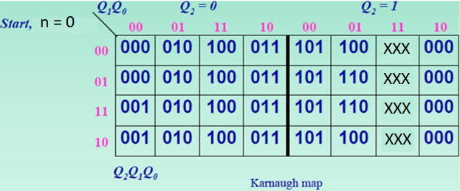

Q2+ = Q2Q1’ + Q1Q0

Q1+ = (n=0)Q1’Q0 + Q1’Q0Q2’ + Q1Q0’Q2’

= (n=0)Q1’Q0 + Q2’(Q1 xor Q0)

Q0+ = (Start)Q1’Q0’ + Q1Q0’Q2’ + Q1’Q0’Q2

= (Start)Q1’Q0’ + Q0’(Q1 xor Q2)



Q2+ = Q2Q1’ + Q1Q0 + Start’(n=0)Q1Q2’ + Start(n=0)’Q1Q2’

= Q2Q1’ + Q1Q0 + Q1Q2’(Start xor (n=0))

Q1+ = (n=0)Q1’Q0 + Q1’Q0Q2’ + Q1Q0’Q2’

= (n=0)Q1’Q0 + Q2’(Q1 xor Q0)

Q0+ = (Start)Q1’Q0’ + Q1Q0’Q2’ + Q1’Q0’Q2

= (Start)Q1’Q0’ + Q0’(Q1 xor Q2)

Q0+ = q1’q0’Q2 + StartQ1’Q0’ + Start’n=0’q2’q0’q1 + startn=0q2’q0’q1 = q2’q0’q1(start xnor n=0)

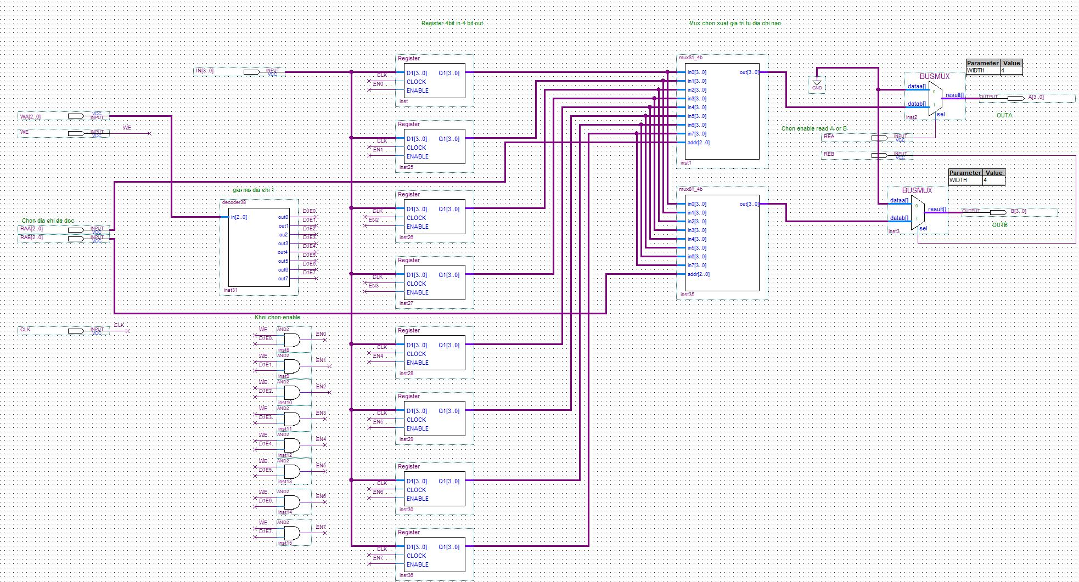

**Register File**

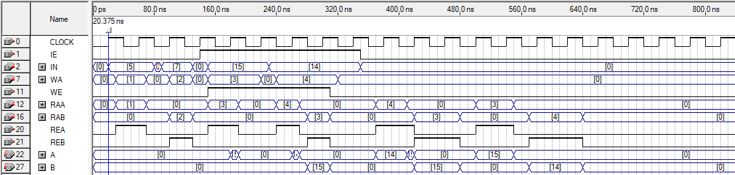

**Waveform test Register File**

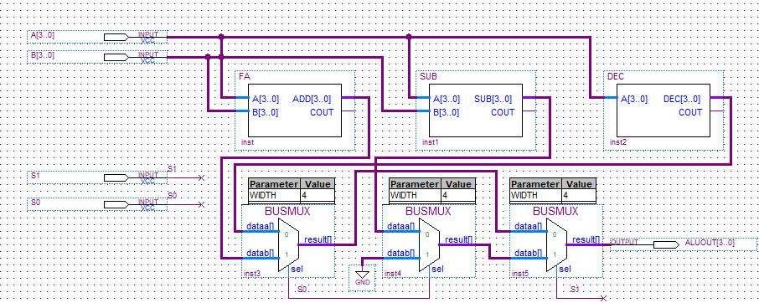

**ALU**

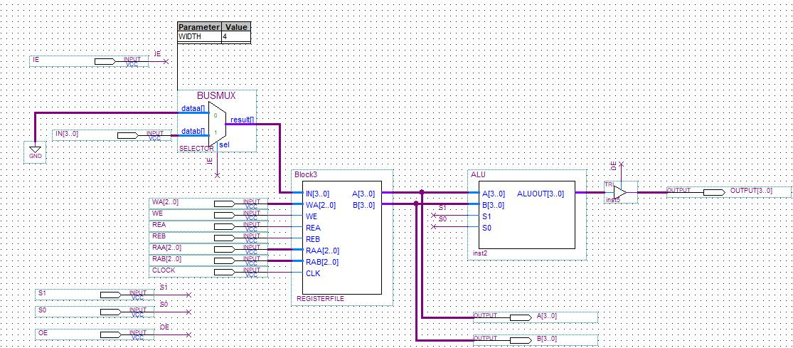

**Datapath**

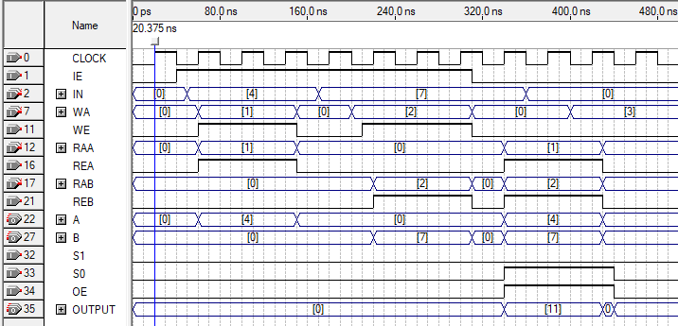

**Waveform Datapath**

|  |  |  |  |  |
| --- | --- | --- | --- | --- |
| **Current** | **Next state** | | **Control & Datapath** | |
|  | **Con** | **State** | **Con** | **State** |
| **(0000) S0** | **Start = 0 S0**  **Start = 1 S1** | | **Done = 0**  **Output = Z** | |
| **(0001) S1** | **Q15 = 0 S1**  **Q15 = 1 S2** | | **Shift Left** | |
| **(0010) S2** | **Q5 = 1 S2**  **Q5 = 0 , Flick = 1 S3  Q5 = 0 , Flick = 0 S4** | | **Shift Right** | |
| **(0011) S3** | **Q15 = 0 S3**  **Q15 = 1 S5** | | **Shift Left** | |
| **(0100) S4** | **Q10 = 0 S4 Q10 = 1 S5** | | **Shift Left** | |
| **(0101) S5** | **Q0 = 1 S5**  **Q0 = 0 , Flick = 1 S6**  **Q0 = 0 , Flick = 0 S7** | | **Shift Right** | |
| **(0110) S6** | **Q10 = 0 S6**  **Q10 = 1 S8** | | **Shift Left** | |
| **(0111) S7** | **Q5 = 0 S7**  **Q5 = 1 S8** | | **Shift Left** | |
| **(1000) S8** | **Q0 = 1 S8  Q0 = 0 S9** | | **Shift Right** | |
| **(1001) S9** | **S0** | | **Done = 1** | |

**Q3+ [S8,S9]= S6(Q10=1) + S7(Q5=1) + S8(Q0=1) + S8(Q0=0)**

**= S6Q10 + S7Q5 + S8**

**= Q3’Q2Q1Q0’q10 + Q3’Q2Q1Q0q5 + Q3Q2’Q1’Q0’**

**Q2+ [S4 S5 S6 S7]= S2(Q5=0)(Flick=0) + S4(Q10=0) + S3(Q15=1) + S4(Q10=1) + S5(Q0=1) + S5(Q0=0)(Flick=1) + S6(Q10=0) + S5(Q0=0)(Flick=0) + S7(Q5=0)**

**= S2Q5’Flick’ + S4 + S3Q15 + S5+ S6Q10’ + S7Q5’**

**= Q3’Q2’Q1Q0’q5’Flick’ + Q3’Q2Q1’Q0’ + Q3’Q2’Q1Q0q15 + Q3’Q2Q1’Q0 + Q3’Q2Q1Q0’q10’ + Q3’Q2Q1Q0q5’**

**Q1+ [S2 S3 S6 S7] = S1(Q15=1) + S2(Q5=1) + S2(Q5=0)(Flick=1) + S3(Q15=0) + S5(Q0=0)(Flick=1) + S6(Q10=0) + S5(Q0=0)(Flick=0) + S7(Q5=0)**

**= S1q15 + S2q5 + S2q5’Flick + S3q15’ + S5q0’ + S6q10’ + S7q5’**

**= Q3’Q2’Q1’Q0q15 + Q3’Q2’Q1Q0’q5 + Q3’Q2’Q1Q0’q5’Flick + Q3’Q2’Q1Q0q15’ + Q3’Q2Q1’Q0q0’ + Q3’Q2Q1Q0’q10’ + Q3’Q2Q1Q0q5’**

**Q0+ [S1 S3 S5 S7 S9] = S0(Start=1) + S1(Q15=0) + S2(Q5=0)(Flick=1) + S3(Q15=0) + S3(Q15=1) + S4(Q10=1) + S5(Q0=1) + S5(Q0=0)(Flick=0) + S7(Q5=0) + S8(Q0=0)**

**= S0Start + S1Q15’ + S2Q5’Flick + S3 + S4Q10 + S5Q0 + S5Q0’Flick’ + S7Q5’ + S8Q0’**

**=Q3’Q2’Q1’Q0’Start + Q3’Q2’Q1’Q0q15’+ Q3’Q2’Q1Q0’q5’Flick + Q3’Q2’Q1Q0 + Q3’Q2Q1’Q0’q10 + Q3’Q2Q1’Q0q0 + Q3’Q2Q1’Q0q0’Flick’ + Q3’Q2Q1Q0q5’ + Q3Q2’Q1’Q0’q0’**

**CONTROL WORD**

|  |  |  |
| --- | --- | --- |
| **Q3Q2Q1Q0** | **S0** | **S1** |
| **0000** | **0** | **0** |
| **0001** | **0** | **1** |
| **0010** | **1** | **1** |
| **0011** | **0** | **1** |
| **0100** | **0** | **1** |
| **0101** | **1** | **1** |
| **0110** | **0** | **1** |
| **0111** | **0** | **1** |
| **1000** | **1** | **1** |
| **1001** | **0** | **0** |

|  |  |  |  |  |
| --- | --- | --- | --- | --- |
| Q1 Q0  Q3Q2 | 00 | 01 | 11 | 10 |
| 00 |  |  |  | 1 |
| 01 |  | 1 |  |  |
| 11 |  |  |  |  |
| 10 | 1 |  |  |  |

**S0 = Q3Q2’Q1’Q0’ + Q3’Q2Q1’Q0 + Q3’Q2’Q1Q0’**

|  |  |  |  |  |
| --- | --- | --- | --- | --- |
| Q1 Q0  Q3Q2 | 00 | 01 | 11 | 10 |
| 00 |  | 1 | 1 | 1 |
| 01 | 1 | 1 | 1 | 1 |
| 11 |  |  |  |  |
| 10 | 1 |  |  |  |

**S1 = Q3’Q2 + Q3’Q0 + Q3’Q1 + Q3Q2’Q1’Q0’**

**= Q3’(Q2+Q0+Q1) + Q3Q2’Q1’Q0’**

|  |  |  |  |  |
| --- | --- | --- | --- | --- |
| **Current** | **Next state** | | **Control & Datapath** | |
|  | **Con** | **State** | **Con** | **State** |
| **(000) S0** | **Start’ S0**  **Start S1** | | **Done = 0**  **Output = Z** | |
| **(001) S1** | **Q15’ S1**  **Q15 S2** | | **Shift Left** | |
| **(010) S2** | **Q5 S2**  **Q5’ , Flick’ S3  Q5’, Flick S1** | | **Shift Right** | |
| **(011) S3** | **Q10’ S3**  **Q10 S4** | | **Shift Left** | |
| **(100) S4** | **Q0 S4**  **Q0’,Flick’ S5**  **Q0’,Flick S3** | | **Shift Right** | |
| **(101) S5** | **Q4’ S5**  **Q4 S6** | | **Shift Left** | |
| **(110) S6** | **Q0 S6**  **Q0’ S7** | | **Shift Right** | |
| **(111) S7** | **S0** | | **Done = 1** | |

**Q2 = S3q10 + S4q0 + S4q0’F’ + S5q4’ + S5q4 + S6q0 + S6q0’**

**= Q2’Q1Q0q10 + Q2Q1’Q0’q0 + Q2Q1’Q0’q0’F’+ Q2Q1’Q0 + Q2Q1Q0’**

**=Q2’Q1Q0q10 + Q2Q1’Q0’q0 + Q2Q1’Q0’q0’F’ + Q2(Q1 xor Q0)**

**Q1 = S1q15 + S2q5 + S2q5’F’ + S3q10’ + S4q0’Flick + S5q4 + S6q0 + S6q0’**

**= Q2’Q1’Q0q15 + Q2’Q1Q0’q5 + Q2’Q1Q0’q5’F’ + Q2’Q1Q0q10’ + Q2Q1’Q0’q0’Flick + Q2Q1’Q0q4 + Q2Q1Q0’**

**Q0 = S0Start + S1q15’ + S2q5’F + S2q5’F’ + S3q10’ + S4q0’Flick + S4q0’F’ + S5q4’ + S6q0’**

**= Q2’Q1’Q0’Start + Q2’Q1’Q0q15’ + Q2’Q1Q0’q5’ + Q2’Q1Q0q10’ + Q2Q1’Q0’q0’ + Q2Q1’Q0q4’ + Q2Q1Q0’q0’**

**CONTROL WORD**

|  |  |  |
| --- | --- | --- |
| **Q3Q2Q1Q0** | **S1** | **S0** |
| **0000** | **0** | **0** |
| **0001** | **1** | **0** |
| **0010** | **1** | **1** |
| **0011** | **1** | **0** |
| **0100** | **1** | **1** |
| **0101** | **1** | **0** |
| **0110** | **1** | **1** |
| **0111** | **0** | **0** |

|  |  |  |  |  |
| --- | --- | --- | --- | --- |
| Q1 Q0  Q2 | 00 | 01 | 11 | 10 |
| 0 | 0 | 0 | 0 | 1 |
| 1 | 1 | 0 | 0 | 1 |

**S0 = Q1Q0’ + Q0’Q2**

|  |  |  |  |  |
| --- | --- | --- | --- | --- |
| Q1 Q0  Q2 | 00 | 01 | 11 | 10 |
| 0 | 0 | 1 | 1 | 1 |
| 1 | 1 | 1 | 0 | 1 |

**S1 = Q1’Q2 + Q2’Q0 + Q1Q0’**