ER Diagram

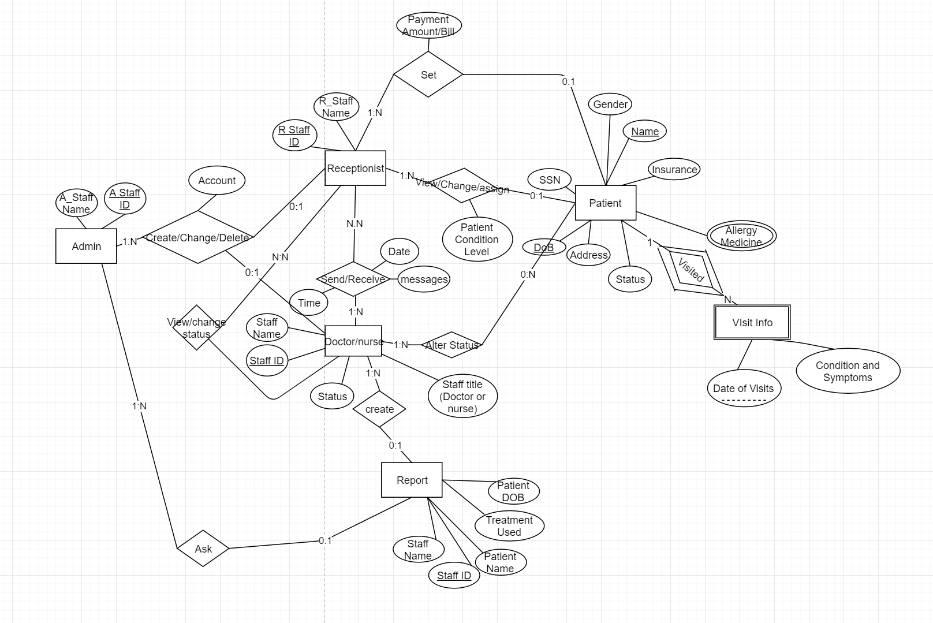

Processing Needs

**5.  PROCESSING NEEDS**

The processing needs of the hospital database characterized with respect to the operations between a patient, receptionists, doctors, nurses, admin, and misc queries.

**5.1  FORMS**

|  |  |
| --- | --- |
| **Form Name** | **Description** |
| **Form** 1: | |
| **Patient Check In** | **Receptionist is responsible for checking in the patient. They submit the required patient information (ex: patient name, patient dob, patient gender, ssn, address, insurance, status) into the database for the doctor and nurses to see when they treat a patient.** |
| **Form** 2: | |
| **Bill Payment** | **Receptionists is responsible for sending out the bill to the patient. The form enclosed will include receptionistID (who sent the bill out), payment amount, patient name, patient dob.** |
| **Form** 3: | |
| **Medical prescription** | Patients are seen by a doctor and nurse to review their symptoms. Based on that, the doctor or nurse are able to prescribe the medicine, daily dose, name of the patient, refill option and the location of the pharmacy for the patient. |
| **Form** 4: | |
| **Database Configuration** | Admins have the highest privilege in the database environment. They can add or change receptionists, nurses, and doctors account. |

**5.2  REPORTS**

|  |  |
| --- | --- |
| **Report Name** | **Description** |
| Report 1 | |
| **Doctor and Nurses Report** | **For the admin to obtain a report of the patients that doctors and nurses treated and the treatments they gave to the patients. The report also shows the patient's name, staffname, patient dob, treatment used, report number.** |
| Report 2 | |
| **Receptionist Report** | **Receptionist is creating a form to show patient dob, patient name, and patient conditional level.** |

**5.3   QUERIES**

|  |  |
| --- | --- |
| **Query Name** | **Description** |
| Query 1: Doctor | |
| **Patient with Severe Condition Information** | **For each doctor to retrieve the names and symptoms of patients who have a severe condition.** |
| **Query 2: Doctor** | |
| **Receptionist Messages** | **For each doctor to retrieve the receptionist's messages from the past 3 days.** |
| Query 3: Doctor | |
| **Patient Older than 50 with Heart Disease** | For each doctor to retrieve the names and gender of patients who older than 50 with have heart disease. |
| **Query 4: Receptionist** | |
| **Doctor with Off-Duty Status** | **Retrieve the names of the doctor who has an off-duty status.** |
| Query 5: Receptionist | |
| **Patient with Check-in Status Information** | Retrieve the names, insurance, SSN, and symptoms of patients who have a check-in status. |