**Project Set Up**

**Top Deal Auto Website**

**Company:** Top Deal Auto Melbourne, Australia

**Software:** Car Selling Website

**Team name:** Prestige K/DA

**Team Members:**

| **Name** | **ID** | **Roles** |
| --- | --- | --- |
| Pham Duc Linh | 103792371 | Product Owner - BA |
| Pham Anh Vu | 103806447 | Solutions, IT Architect |
| Nguyen Thanh Dat | 103804881 | Project Manager - Scrum Master |
| Tran Tuan Nam | 103792643 | Lead Developer (BE) |
| Phung Xuan Tung | 103792054 | Lead Developer (FE) |

**Tutorial class:** Fri 1:00 PM DT7.2

**Tutor’s Name:** Dr. Pham Thi Kim Dzung

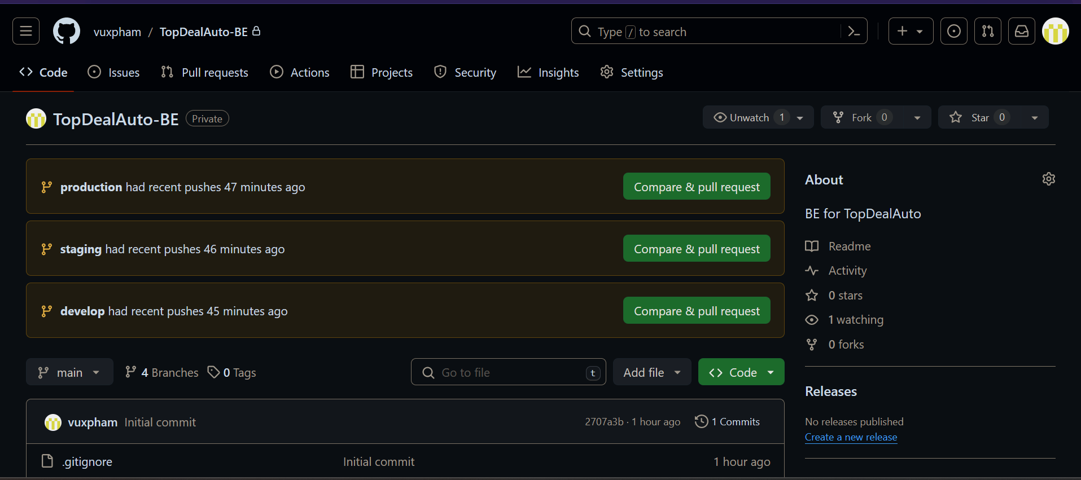

*Github Repository for BackEnd*

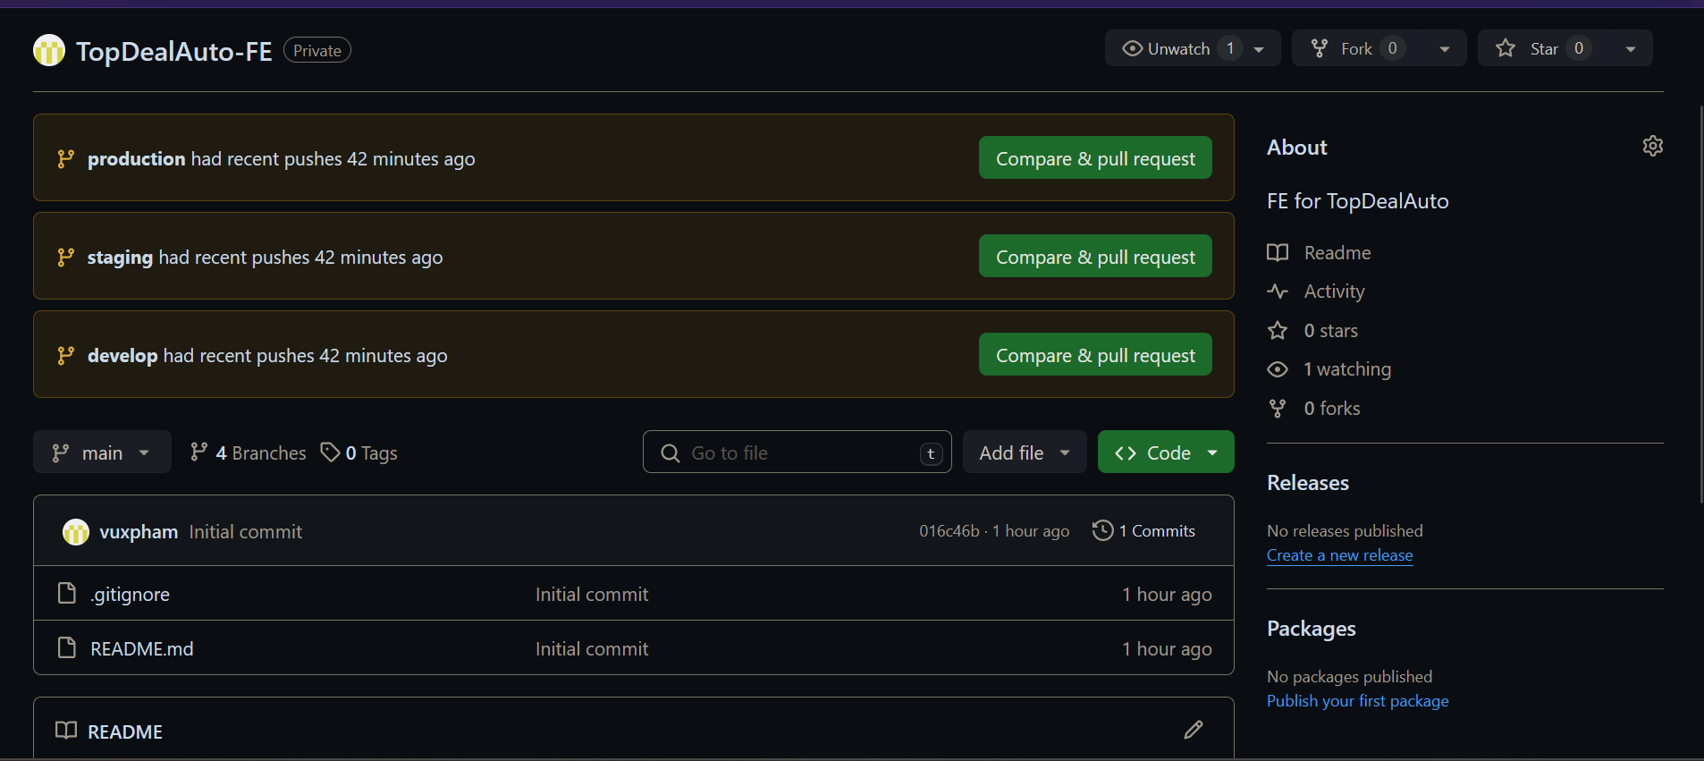

*Github Repository for FrontEnd*

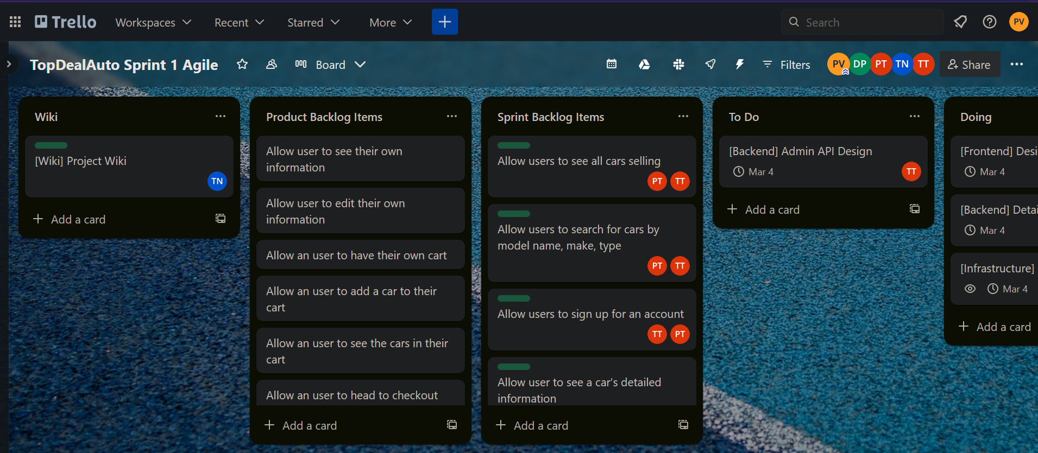

*Trello Board for the project*

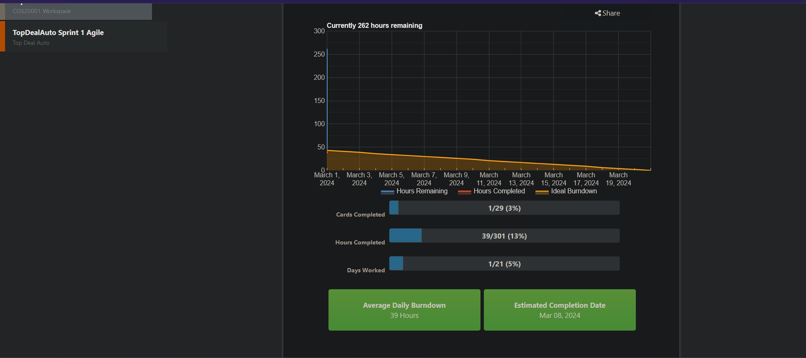

*Burndown Chart*