**CS 248 Winter 2012**

**Philip Hunter McCurry**

Final Assignment Proposal

**Team Members:**

Philip Hunter McCurry (SUNet ID: hmccurry)

**Concept:** The proposed project has roots in two very separate worlds: music and its associated compositional and performance practice, and computer gaming with its immersive sound, graphics and player control. The goal is that the project be defined neither as strictly music, nor as strictly game, but as a controllable compositional environment that is richly interactive and inherently musical.

Going back centuries, the practice of music composition has involved writing notation out with pen and paper in a fixed form that is to be later read and performed by a trained musician. However, by replacing this traditional and static score with an animated representation of music notation using computer displays, we can achieve a performable composition that incorporates change, improvisation, and interactivity.

Unlike some current music games such as Guitar Hero that use an instrument-like interface as a controller, this project will use an actual instrument such as a clarinet or violin, with an attached microphone. Using custom audio software running amplitude and pitch tracking on the audio input stream, the player will be able to have direct control over the software based on what notes they play, how loud they play them and what tempo they play. The graphical elements on the screen will serve both as a visualization of what is played, but also as a type of musical score, suggesting what melodic and harmonics paths might be played next. The visual feedback should feel quite immediate and responsive, just as traditional game controllers do.

**Graphics Features:**

* Stylized, “2-and-a-half-D” non-photorealistic rendering of notes and connections, using textures and lighting
* Background and foreground textures involving particle motions
* Non-physical “physics” engine involving spring-like node clustering, avoidance
* Fluid and seamless camera motion to follow/track the motion of the player through the note-graph
* Motion-blur

**Audio Features:**

* Realtime audio analysis of pitch, amplitude and tempo in audio software such as ChucK, MaxMSP, or Pure Data.
* Network communication between graphics and audio software over OSC
* Background sound design elements act as “accompaniment” and thus respond to pitches, melodies, harmonies played in by user
* Sound playback elements comprised partly of audio recorded live from the player’s instrument

**Simple Concept Sketches:**

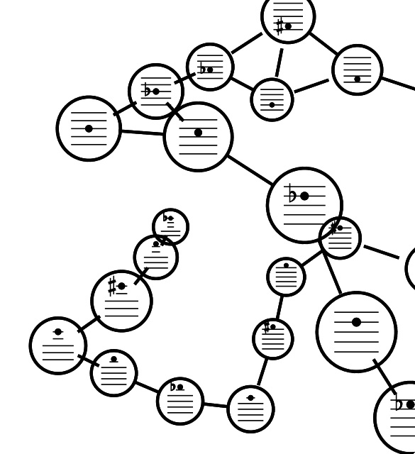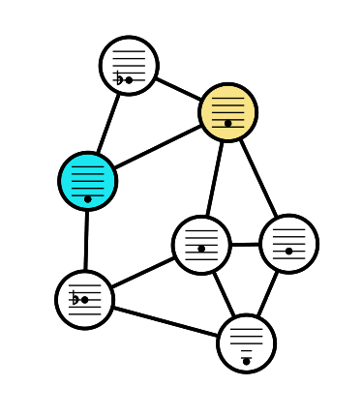

The player can traverse through the graph by playing a note connected to the currently played note, to create custom melodies within the structure. The graph will grow and break apart based on choices made both by the player and by the computer. Amplitude and tempo will alter the characteristics of the graph such as connection line lengths and node movement properties. The graphs will be flexible, stretchy, but will have some rigidity and strength built in.