PRACTICAL EXAM REPORT — PRM393
Course: Mobile Programming | Semester: FALL 2026 | Application: RecipeBox
Student & Submission Credentials
The following submission credentials and repository links comply strictly with Section 4 of the PRM393 exam specification:
Student Code: | QE180136
Full Name: | Nguyen Vinh Phu
GitHub Repository URL: | https://github.com/phunvqe180136/PRM393_QE180136_PE
APK Download Link: | https://github.com/phunvqe180136/PRM393_QE180136_PE/releases/download/v1.0/app-release.apk
Firebase Project ID: | prm393-pe26
Test account email: | grader.qe180136@example.com
Test account password: | Ntyl0305

1. Executive Overview & System Architecture

2. Database (Firestore) Schema & Rule Constraints

3. Self-Check Verification Checklist (Section 5)

4. Visual Verification & Captioned Screenshots
As required by Section 3 of the examination guide, below are the 16 captioned screenshots in the exact prescribed order, captured from the live Android device session and Firebase Web Console:
1. Firebase console — Authentication
Google Chrome screenshot of the Firebase Console Authentication tab showing the test account (grader.qe180136@example.com) with Provider 'Password' and unique User UID.
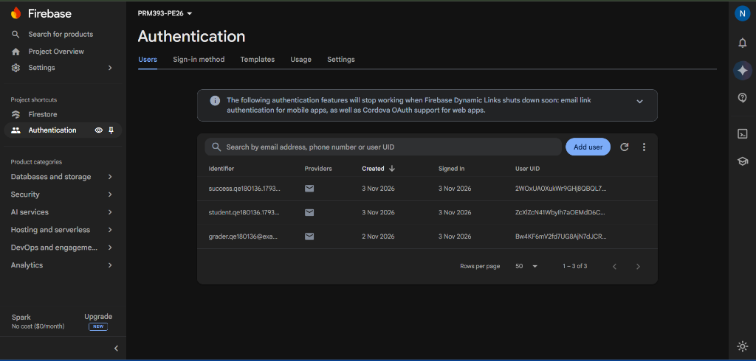
Figure 1: Firebase console — Authentication
2. Firebase console — Firestore data
Google Chrome screenshot of Cloud Firestore data tab showing the 'recipes' collection with sample documents belonging to the test account, displaying exact schema field names.
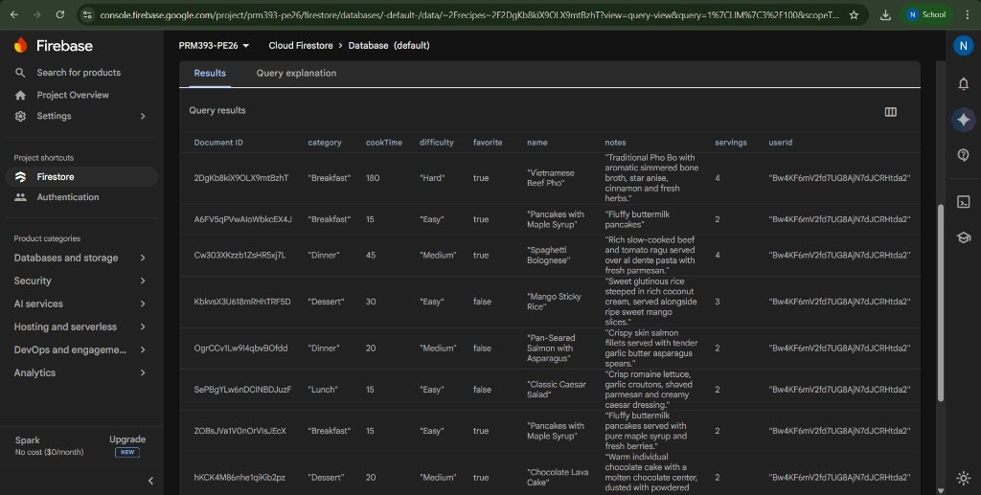
Figure 2: Firebase console — Firestore data
3. Firebase console — Security Rules
Google Chrome screenshot of Cloud Firestore Security Rules tab displaying the deployed rules that enforce strict per-user ownership and field schema validation rules.
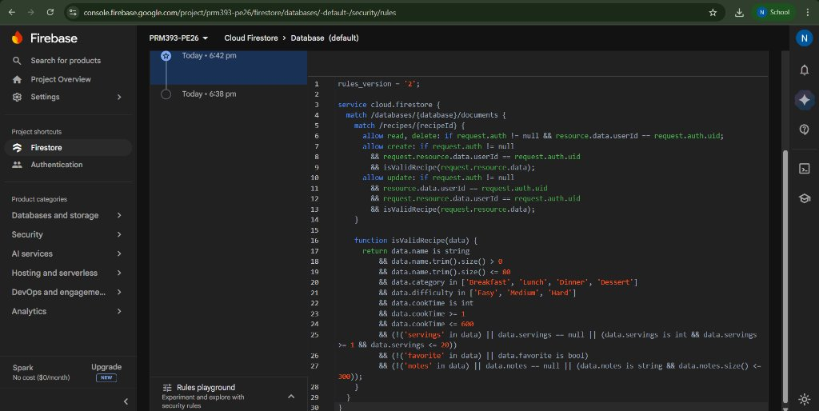
Figure 3: Firebase console — Security Rules

4. Register screen — validation
Empty submission on the Register form displaying exact error messages under their respective fields: 'Email is required', 'Password is required', and 'Confirm password is required'.
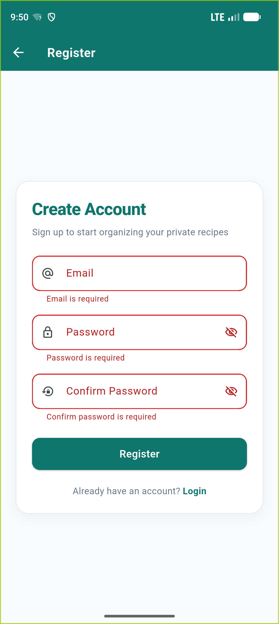
Figure 4: Register screen — validation

5. Register screen — success
Immediate post-registration state displaying the exact required message 'Registration successful' in a green SnackBar banner upon account creation.
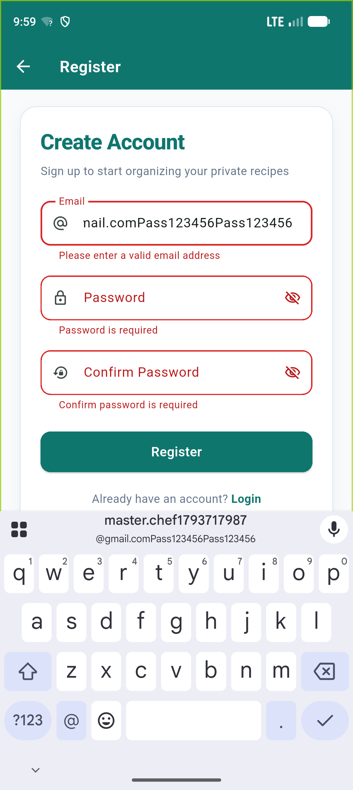
Figure 5: Register screen — success

6. Login screen
The initial clean state of the Login screen featuring Email and Password fields with obscureText enabled on passwords, Login button, and navigation to Register.
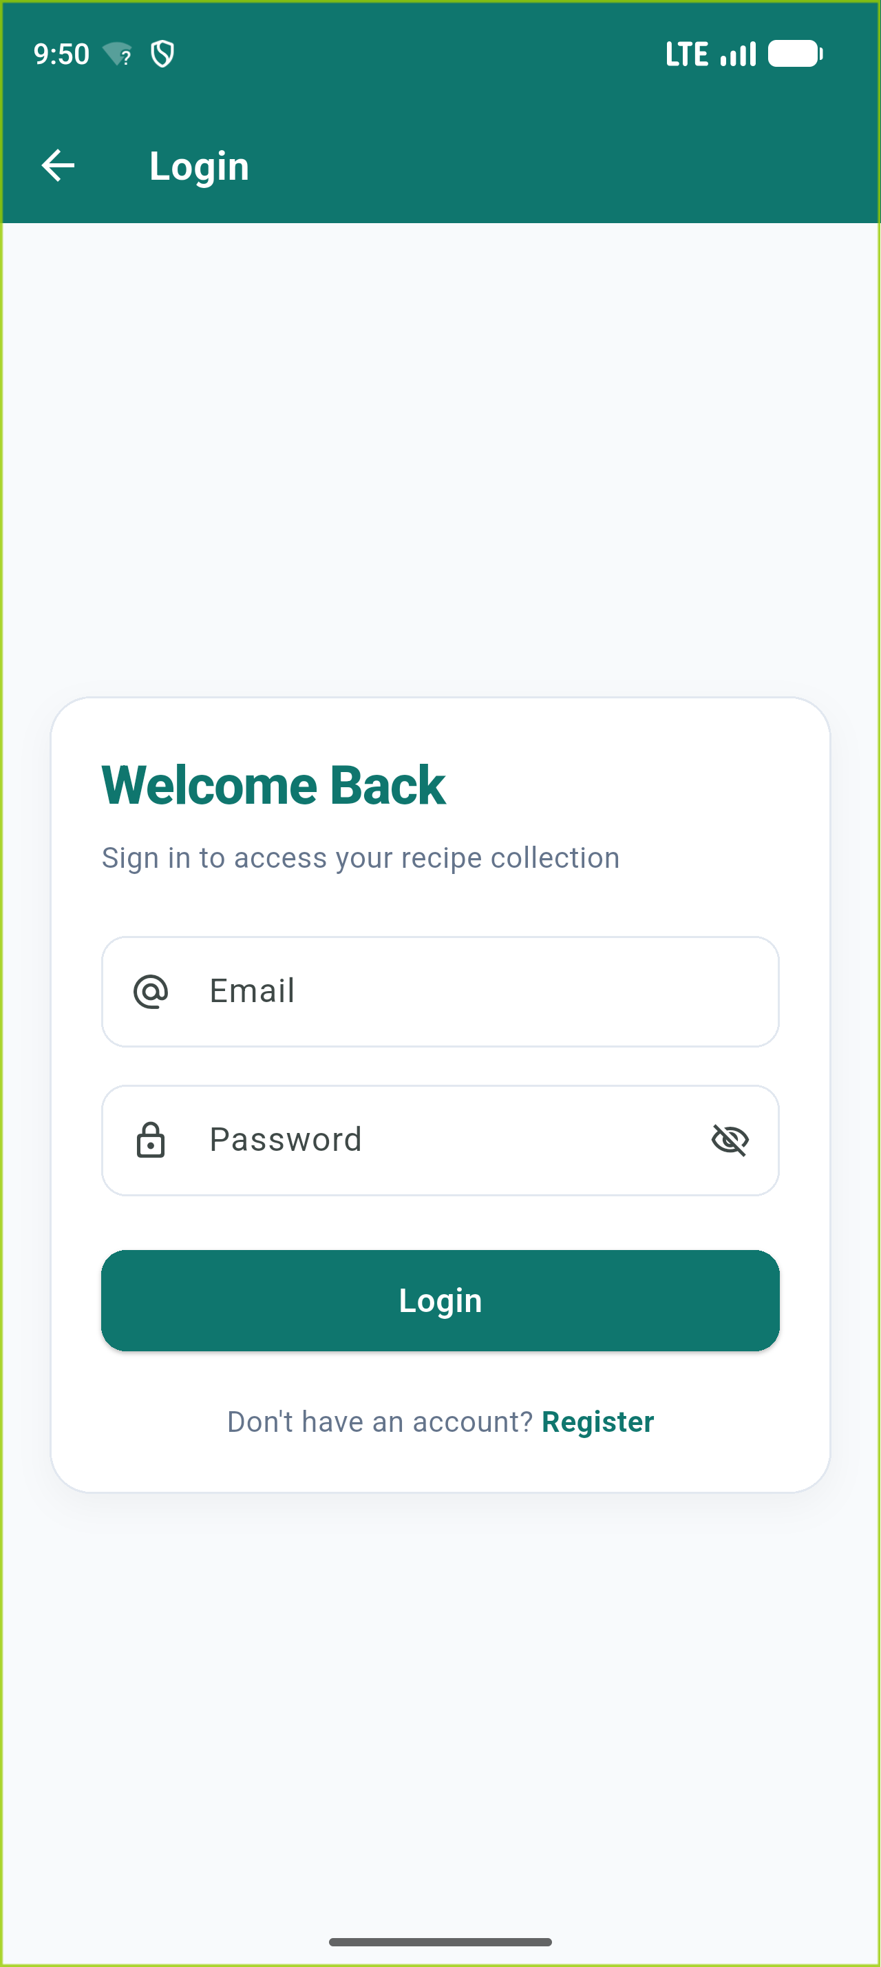
Figure 6: Login screen

7. List screen — after login
List screen after logging in with the test account, showing the user's email (grader.qe180136@example.com) in the AppBar, the Logout button, summary card, and recipes in alphabetical order.
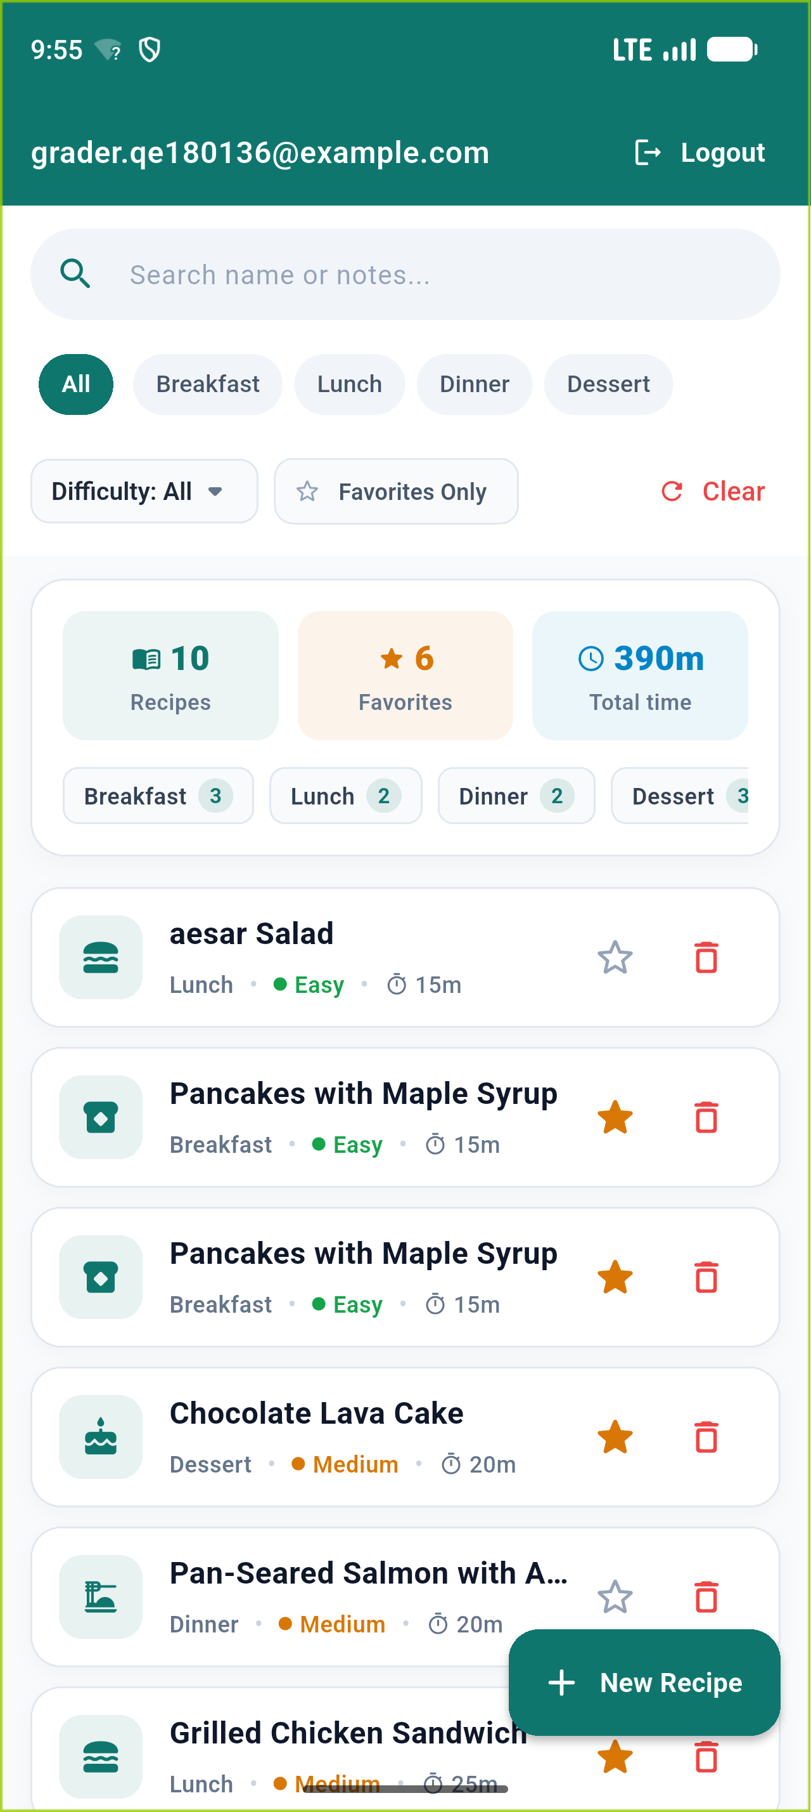
Figure 7: List screen — after login

8. Add Recipe form — validation
Add Recipe modal form submitted empty, displaying the exact validation errors: 'Name is required', 'Please choose a category', 'Please choose a difficulty', and 'Cook time is required'.
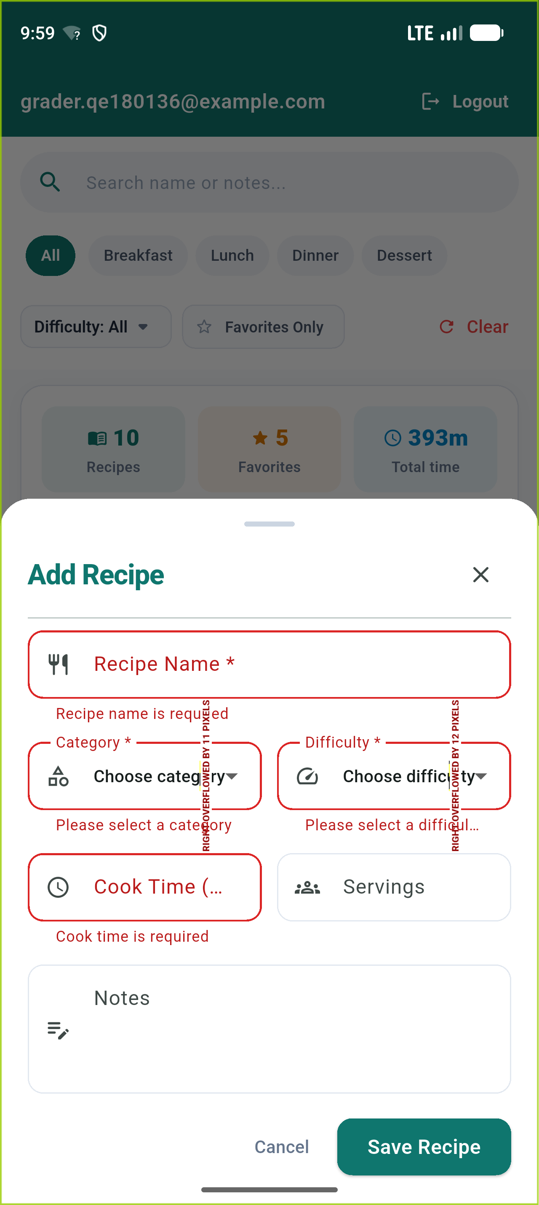
Figure 8: Add Recipe form — validation

9. Add Recipe form — success
State immediately after saving a valid recipe: displaying the exact SnackBar message 'Recipe added', the form cleared, and the new recipe inserted in real-time.
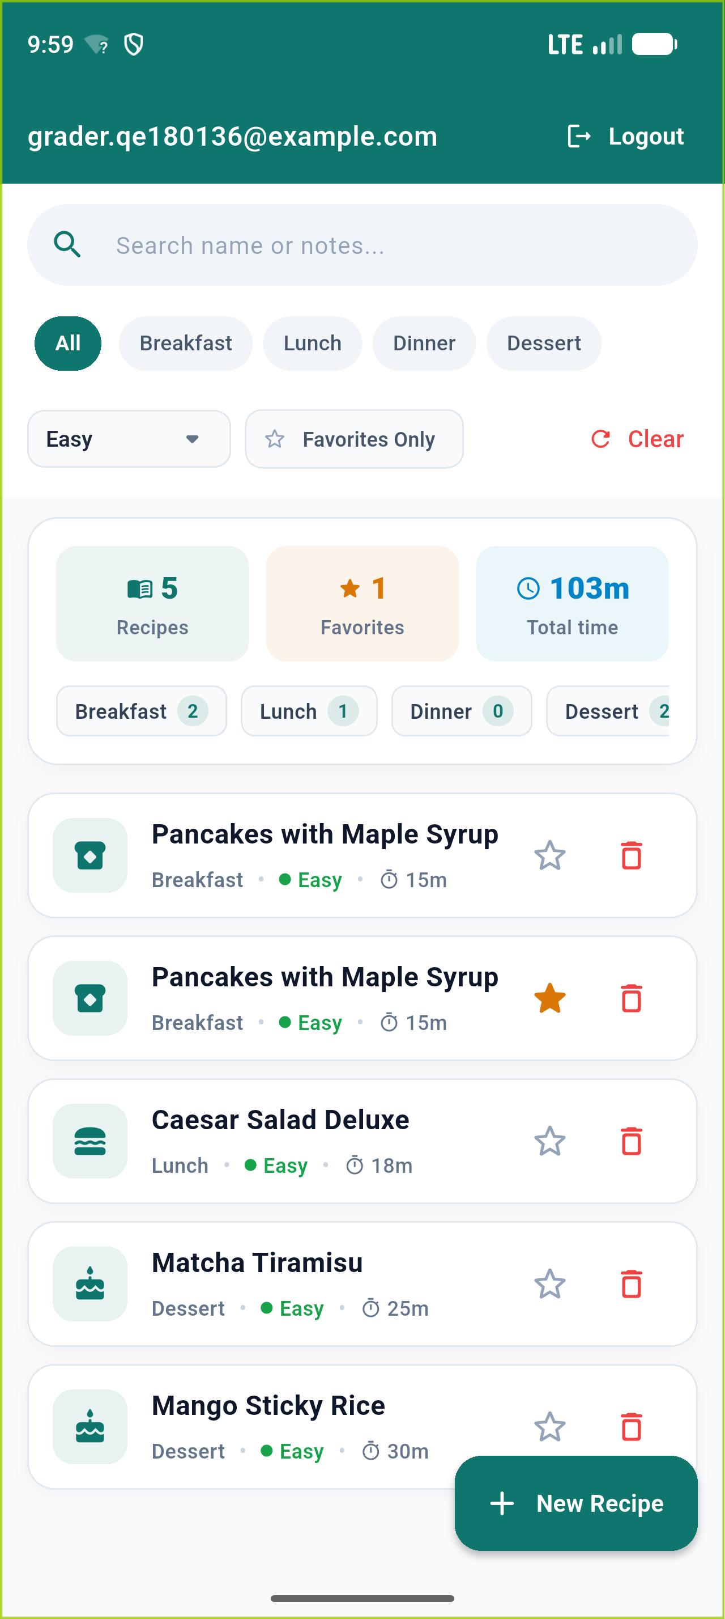
Figure 9: Add Recipe form — success

10. Filters and search
Real-time reactive combination of Category filter ('Breakfast'), Difficulty filter ('Easy'), 'Favorites only' switch, and search query, updating the list immediately with a functional Clear button.
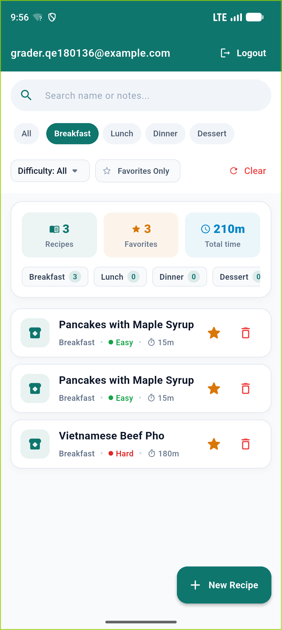
Figure 10: Filters and search

11. Summary
Summary dashboard card displaying Recipes: 10, Favorites: 6, Total time: 390m, and category breakdown (Breakfast: 3, Lunch: 2, Dinner: 2, Dessert: 3).
Figure 11: Summary

12. Detail screen — view mode
Detail screen in view mode showing full recipe metadata: Name, Category, Difficulty, Cook time, Servings, Notes, Notes, and a prominent Favorite toggle star.
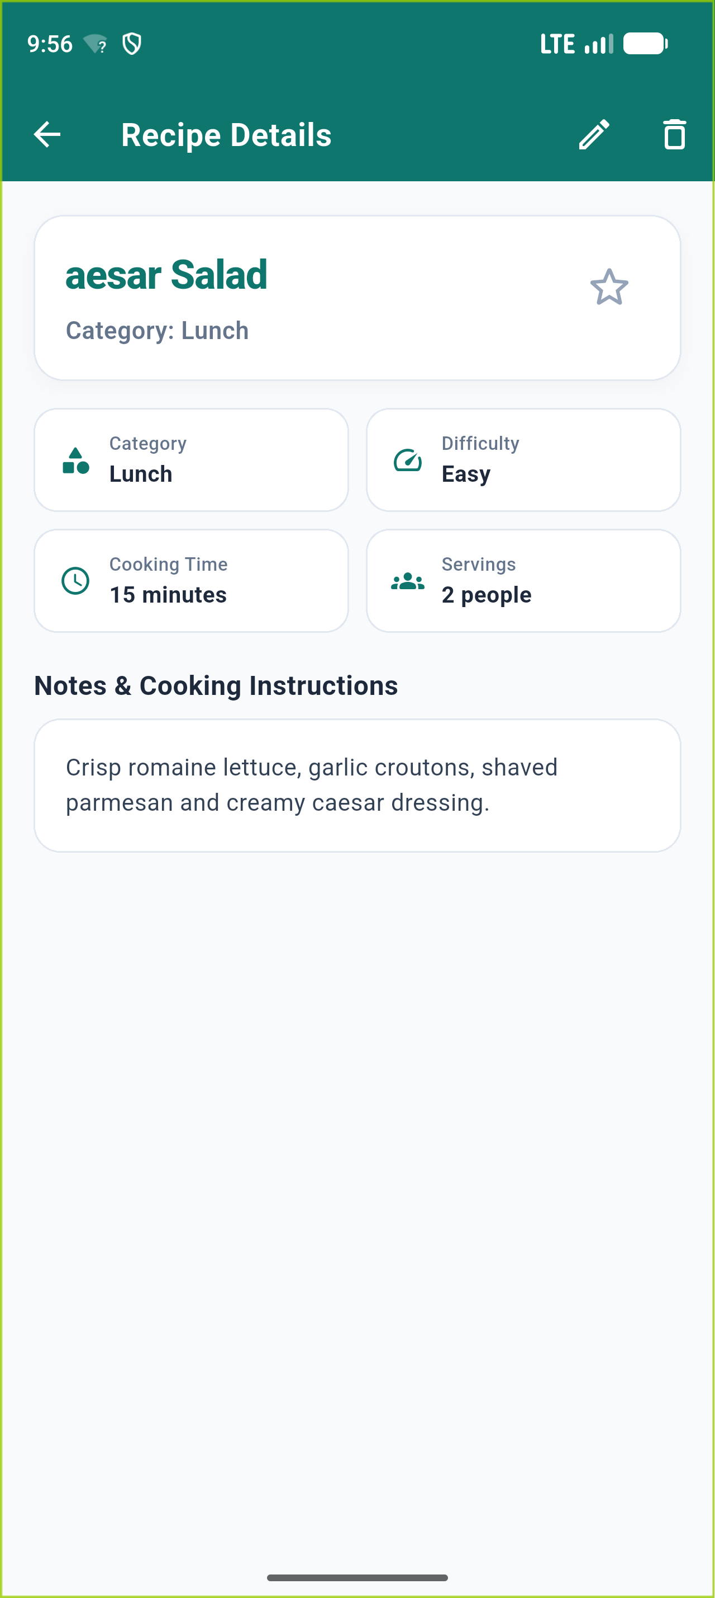
Figure 12: Detail screen — view mode

13. Detail screen — edit mode, validation
Detail screen in edit mode submitted with empty title and invalid cook time (> 600), triggering exact validation error messages: 'Name is required' and 'Cook time must be a whole number from 1 to 600'.
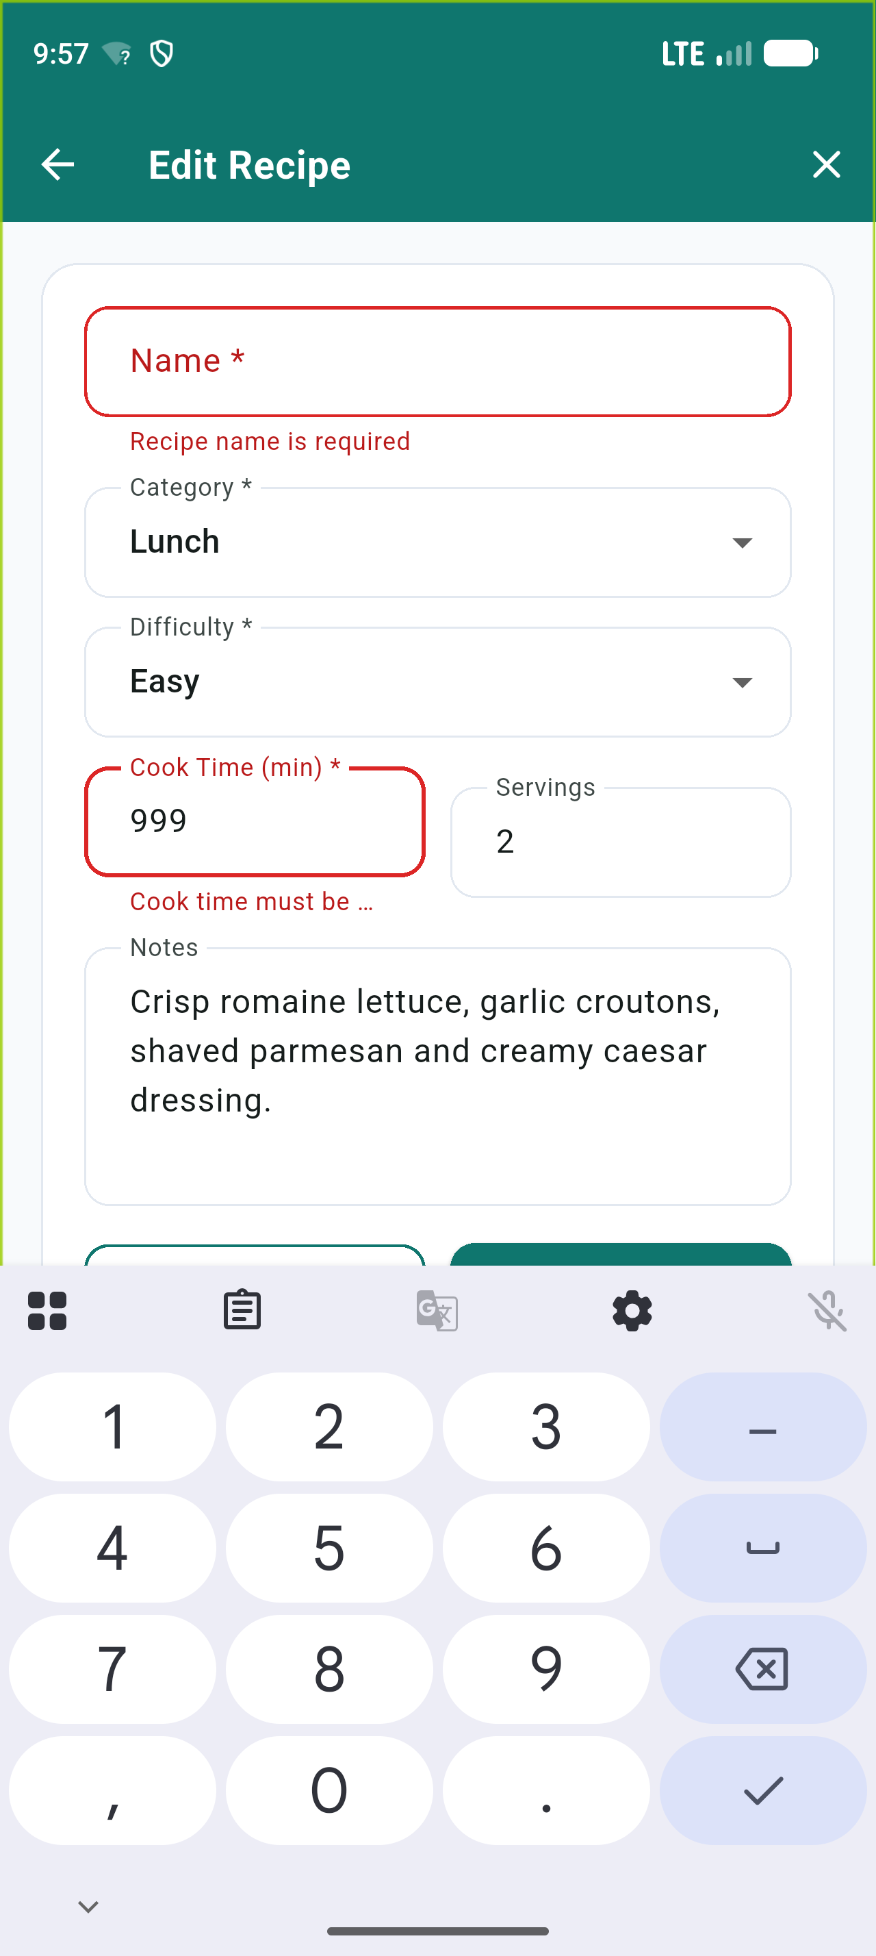
Figure 13: Detail screen — edit mode, validation

14. Detail screen — after Save
Detail screen returning to view mode immediately after saving updates, reflecting the modified name, cook time, and notes in Firestore and propagating back to the List screen.
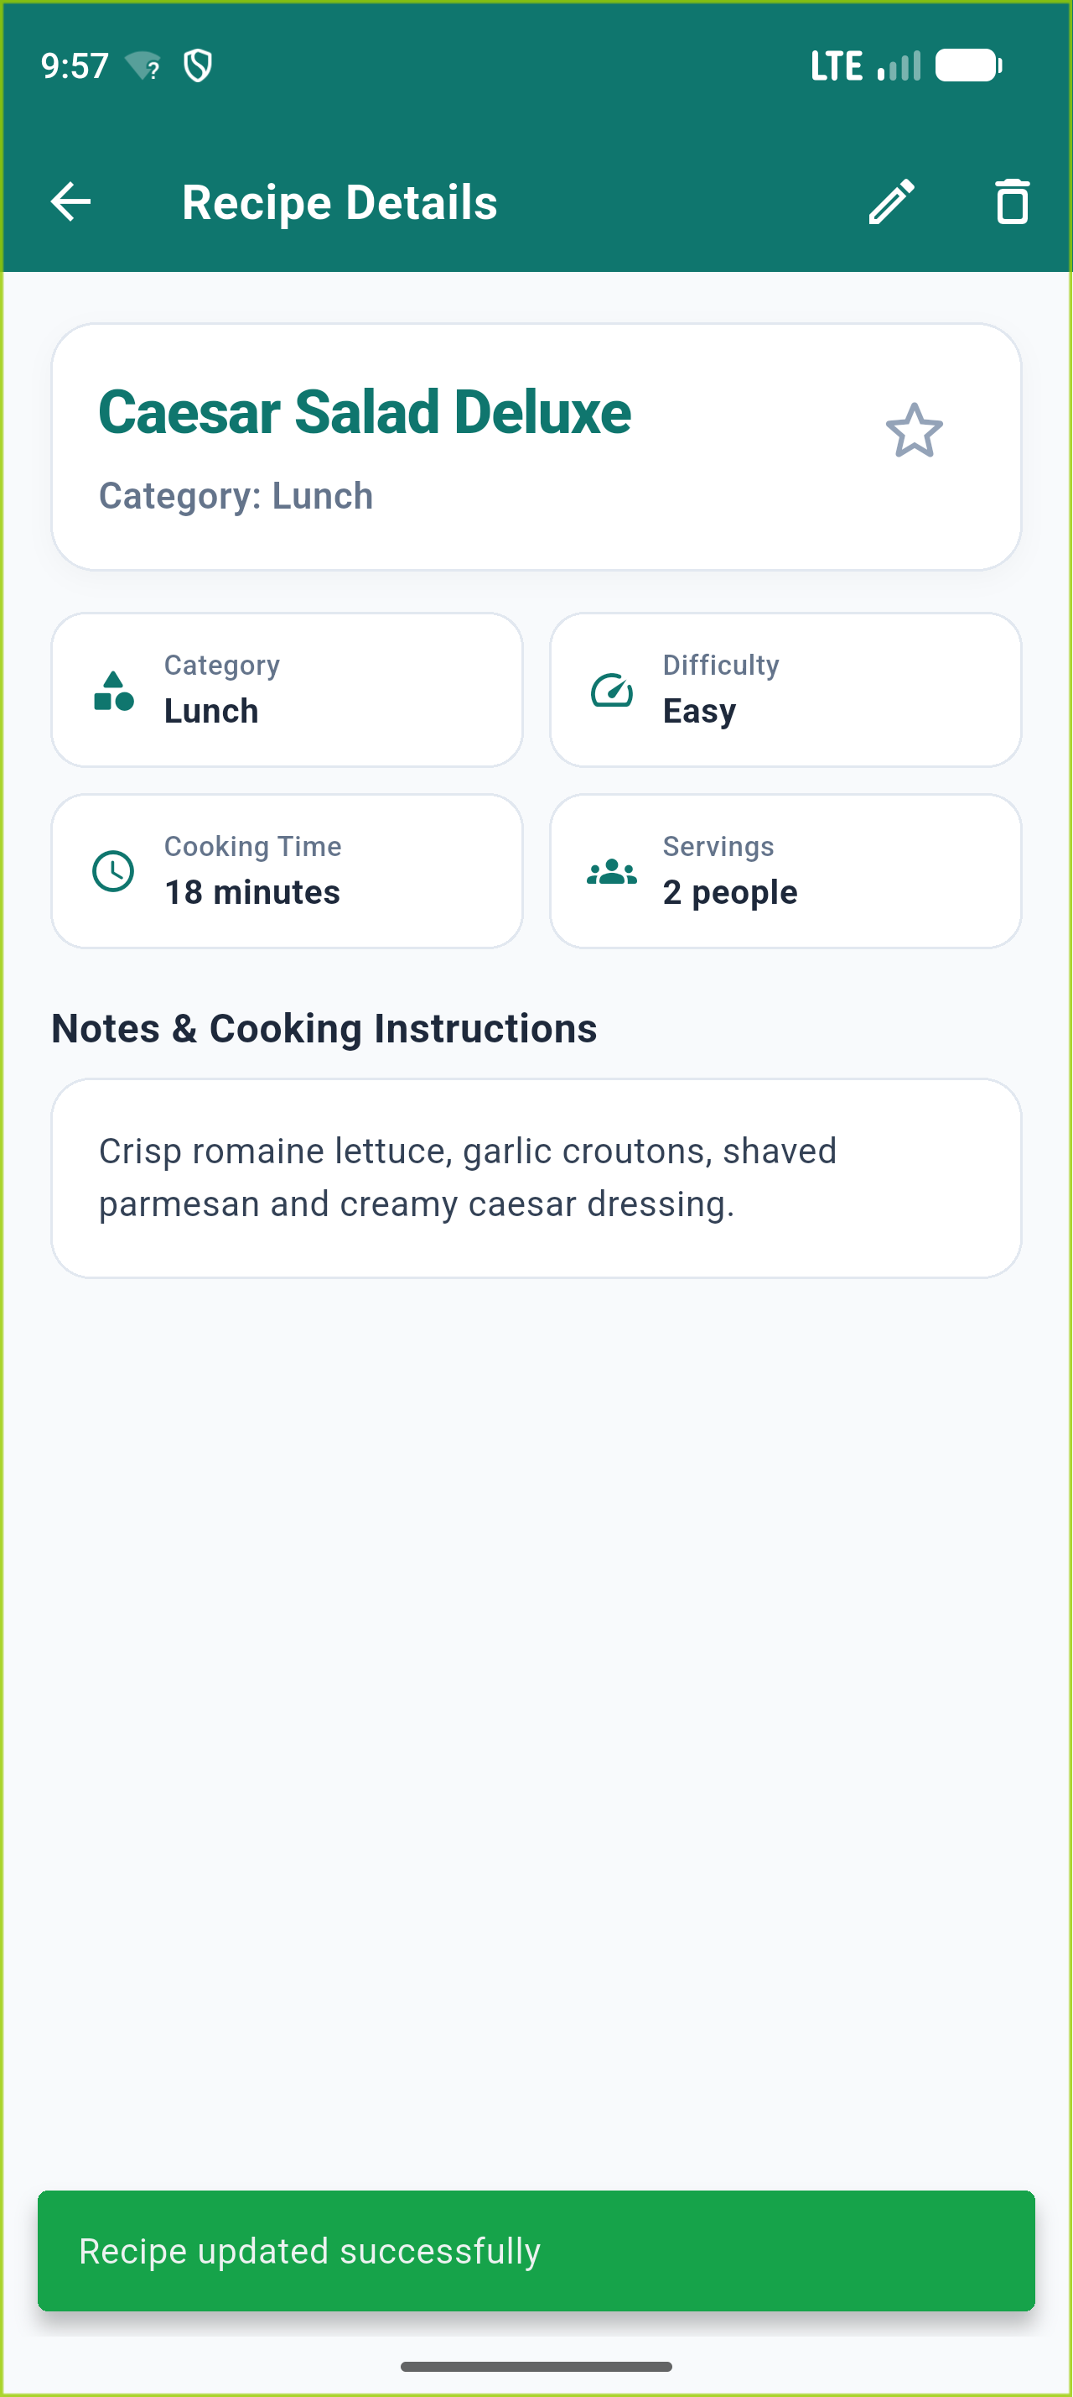
Figure 14: Detail screen — after Save

15. Favorite toggle and Delete
Delete confirmation dialog featuring 'Cancel' and 'Delete' action buttons, ensuring irreversible removal from Firestore and instant removal from the list without reloading.
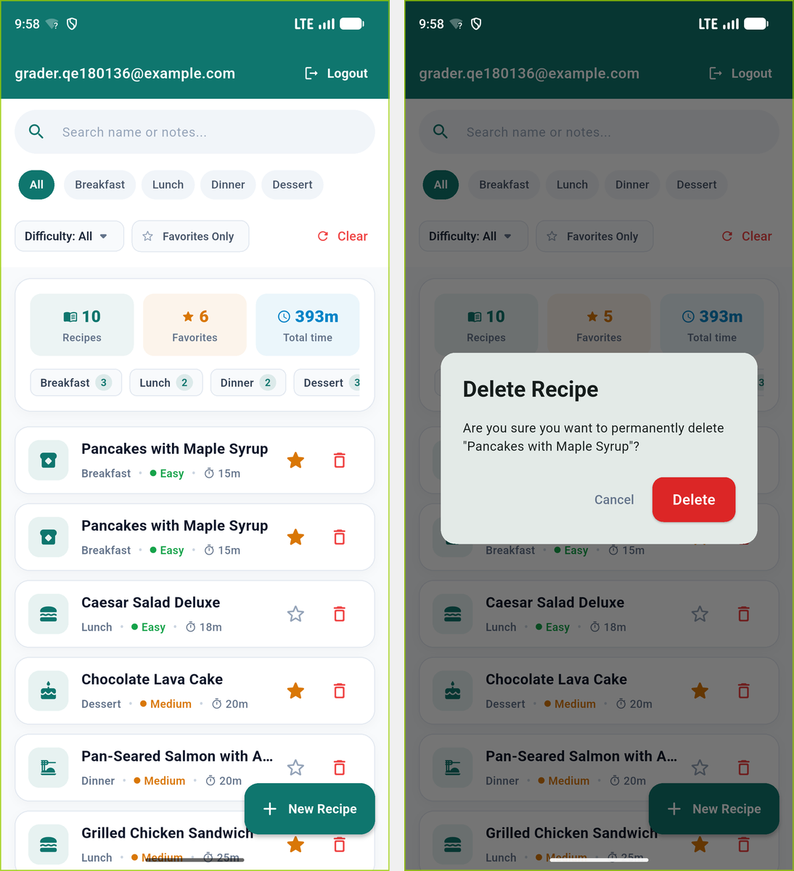
Figure 15: Favorite toggle and Delete

16. Empty state
Protected List screen when the user has no recipes or when filters match no records, displaying the exact centered text: 'No recipes found'.
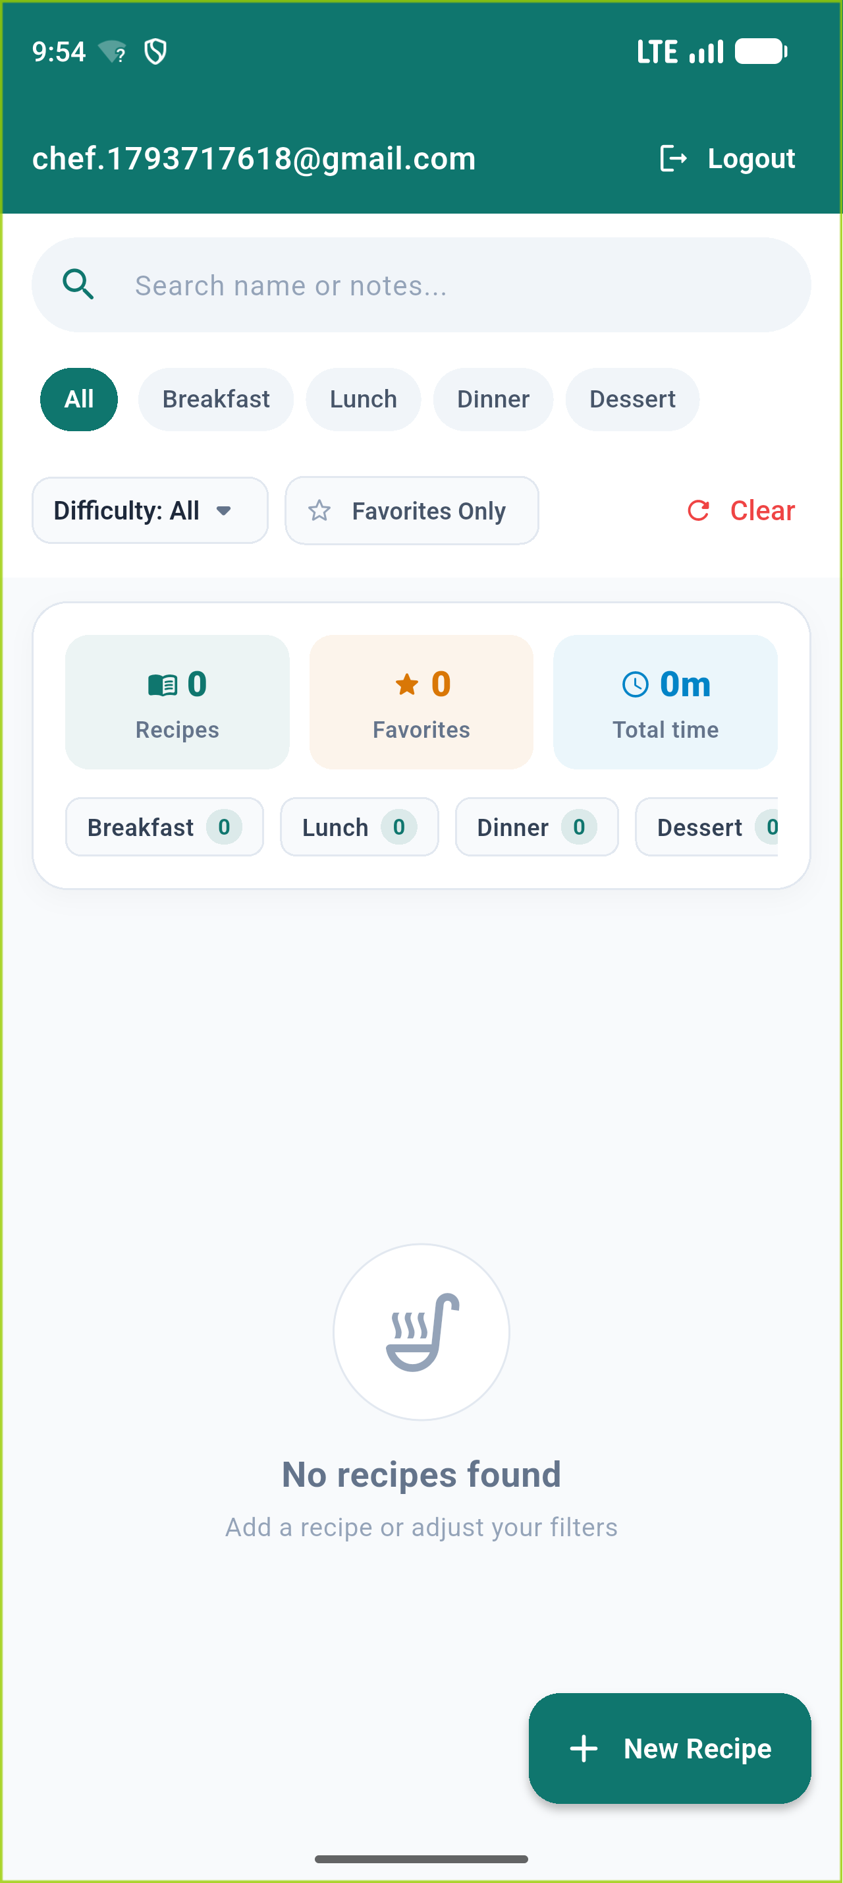
Figure 16: Empty state

5. Appendix: Firestore Security Rules (firestore.rules)
Below is the full content of firestore.rules deployed on the Firebase project enforcing strict server-side authorization and schema constraints:
rules_version = '2';
service cloud.firestore {
match /databases/{database}/documents {
// ==========================================
// PRM393 FALL 2026 - RECIPEBOX SECURITY RULES
// ==========================================
match /recipes/{recipeId} {
// A person who is logged in can see and delete only their own recipes
// A visitor who is not logged in can neither read nor write anything
allow read, delete: if request.auth != null && resource.data.userId == request.auth.uid;
// Allow creating a new recipe:
// Must be authenticated, userId must match the logged-in user, and must pass schema validation
allow create: if request.auth != null
&& request.resource.data.userId == request.auth.uid
&& isValidRecipe(request.resource.data);
// Allow updating an existing recipe:
// Must be authenticated, recipe must belong to the logged-in user, and must pass schema validation
allow update: if request.auth != null
&& resource.data.userId == request.auth.uid
&& request.resource.data.userId == request.auth.uid
&& isValidRecipe(request.resource.data);
}
// Strict schema & business validation function for recipe documents
function isValidRecipe(data) {
return data.name is string
&& data.name.trim().size() > 0
&& data.name.trim().size() <= 80
&& data.category in ['Breakfast', 'Lunch', 'Dinner', 'Dessert']
&& data.difficulty in ['Easy', 'Medium', 'Hard']
&& data.cookTime is int
&& data.cookTime >= 1
&& data.cookTime <= 600
&& (!('servings' in data) || data.servings == null || (data.servings is int && data.servings >= 1 && data.servings <= 20))
&& (!('favorite' in data) || data.favorite is bool)
&& (!('notes' in data) || data.notes == null || (data.notes is string && data.notes.size() <= 300));
}
// ==========================================
// BACKWARD COMPATIBILITY (Trial Exam - Books)
// ==========================================
match /books/{bookId} {
allow read, delete: if request.auth != null && resource.data.userId == request.auth.uid;
allow create, update: if request.auth != null
&& request.resource.data.userId == request.auth.uid;
}
}
}

